Conversation Service
Low Level Design (LLD)
GraphGPT Platform — Production-Scale Engineering Specification
Covers: internal module design · class contracts · state machines
database & cache algorithms · outbox/inbox patterns · gRPC/SSE internals
error handling · configuration · observability · testing · runbook
Companion document to: Conversation Service — High Level Design
Document Version 1.0

Table of Contents

Chapter 1 — Purpose & Scope
The companion High Level Design (HLD) document establishes what the Conversation Service does, which technologies it uses, and why (Kafka for business events, Cassandra for message persistence, Redis for transient state, gRPC for LLM token streaming, SSE for browser delivery). This Low Level Design (LLD) goes one level deeper: it defines how the service is internally structured — module boundaries, class contracts, exact algorithms, data structures, configuration values, and failure-mode behavior — to the point where an engineering team could implement it without further architectural ambiguity.

1.1 What This Document Adds Beyond the HLD
- Concrete module/package layout and dependency direction between internal components.
- Class-level interfaces (method signatures, inputs/outputs, side effects) for every internal component.
- State machines for Message and Conversation lifecycle, with exact transition triggers.
- Field-level API validation rules and a complete HTTP error-code reference.
- Exact CQL statements, consistency levels, and connection-pool configuration for Cassandra.
- Exact Redis key formats, data structures, TTLs, and the cache-aside algorithm in pseudocode.
- The Transactional Outbox and Inbox (deduplication) algorithms written out step by step.
- gRPC client deadlines, retry policy, and backpressure handling.
- SSE connection ownership across pods, heartbeat protocol, and reconnect/resume behavior.
- Concurrency model, environment configuration reference, observability fields, and a test plan.

1.2 Non-Goals
- This document does not re-derive capacity planning math (see HLD §12) or repeat the full technology-selection rationale (see HLD §4, §9, §17) — it assumes those decisions as given.
- LLM prompt-construction internals belong to the LLM Service's own LLD, not this one.

Chapter 2 — Service Recap (from the HLD)
For context: the Conversation Service is the single source of truth for conversation and message state. It never performs LLM inference itself — it persists user messages, publishes a business event, receives generated tokens from the LLM Service over gRPC, and forwards them to the browser over Server-Sent Events (SSE). Kafka is used only for durable, replayable business events (chat.message.created, chat.response.completed, etc.), not for the token stream itself.
Concern | Technology | Owned By This Service?
Conversation/message persistence | Apache Cassandra | Yes — exclusive owner
Transient state (cache, locks, idempotency) | Redis | Yes — exclusive owner
Business events | Kafka | Yes (producer) / partial (consumer for title & summary events)
LLM token generation | LLM Service via gRPC streaming | No — consumed only
Browser delivery of tokens | Server-Sent Events (SSE) | Yes — exclusive owner

Chapter 3 — Codebase & Module Structure
The service is a single deployable FastAPI application internally organized into clearly separated packages so that business logic (core/), infrastructure adapters (repositories/, events/, grpc_client/), and the HTTP/SSE surface (api/) never leak into one another. This mirrors a Hexagonal / Ports-and-Adapters style: core/ defines the ports (interfaces); repositories/, events/, and grpc_client/ provide the adapters.
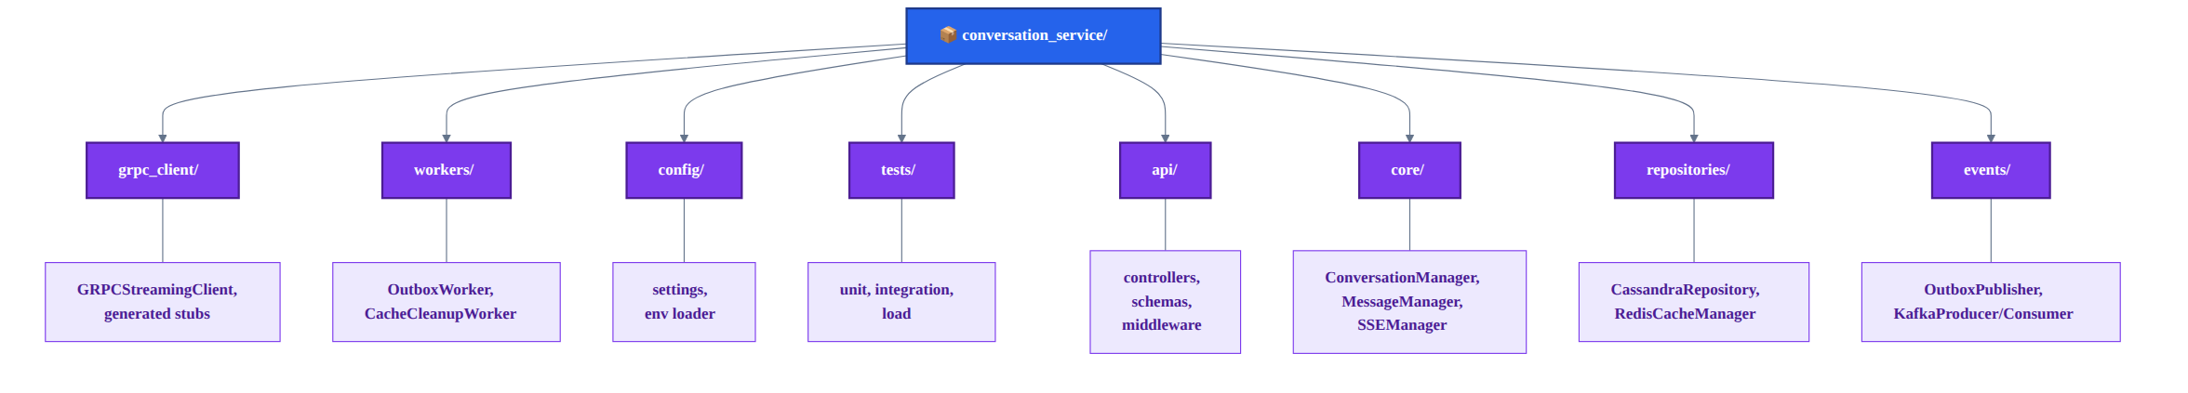
Figure 3.1 — Package layout and dependency direction

3.1 Package Responsibilities
Package | Contains | Depends On
api/ | FastAPI routers (ConversationController, MessageController, StreamController), Pydantic request/response schemas, auth middleware | core/
core/ | ConversationManager, MessageManager, SSEManager — pure business logic, no direct DB/Kafka imports | repositories/, events/, grpc_client/ (via interfaces)
repositories/ | CassandraRepository, RedisCacheManager — the only files allowed to import the Cassandra/Redis drivers | external drivers only
events/ | OutboxPublisher, KafkaProducerAdapter, KafkaConsumerAdapter | repositories/ (outbox table), external Kafka client
grpc_client/ | GRPCStreamingClient and generated protobuf stubs | external gRPC channel to LLM Service
workers/ | OutboxWorker (background poll loop), CacheCleanupWorker | events/, repositories/
config/ | Pydantic Settings class, environment variable loading, secrets resolution | none (leaf package)
tests/ | Unit tests per package, integration tests against test-containers, load-test scripts (Locust/k6) | all packages (test-only)

3.2 Dependency Rule
core/ never imports repositories/, events/, or grpc_client/ directly — only their interfaces. Concrete adapters are injected at startup via FastAPI's dependency-injection container. This keeps ConversationManager and MessageManager fully unit-testable with in-memory fakes.

Chapter 4 — Internal Component Design
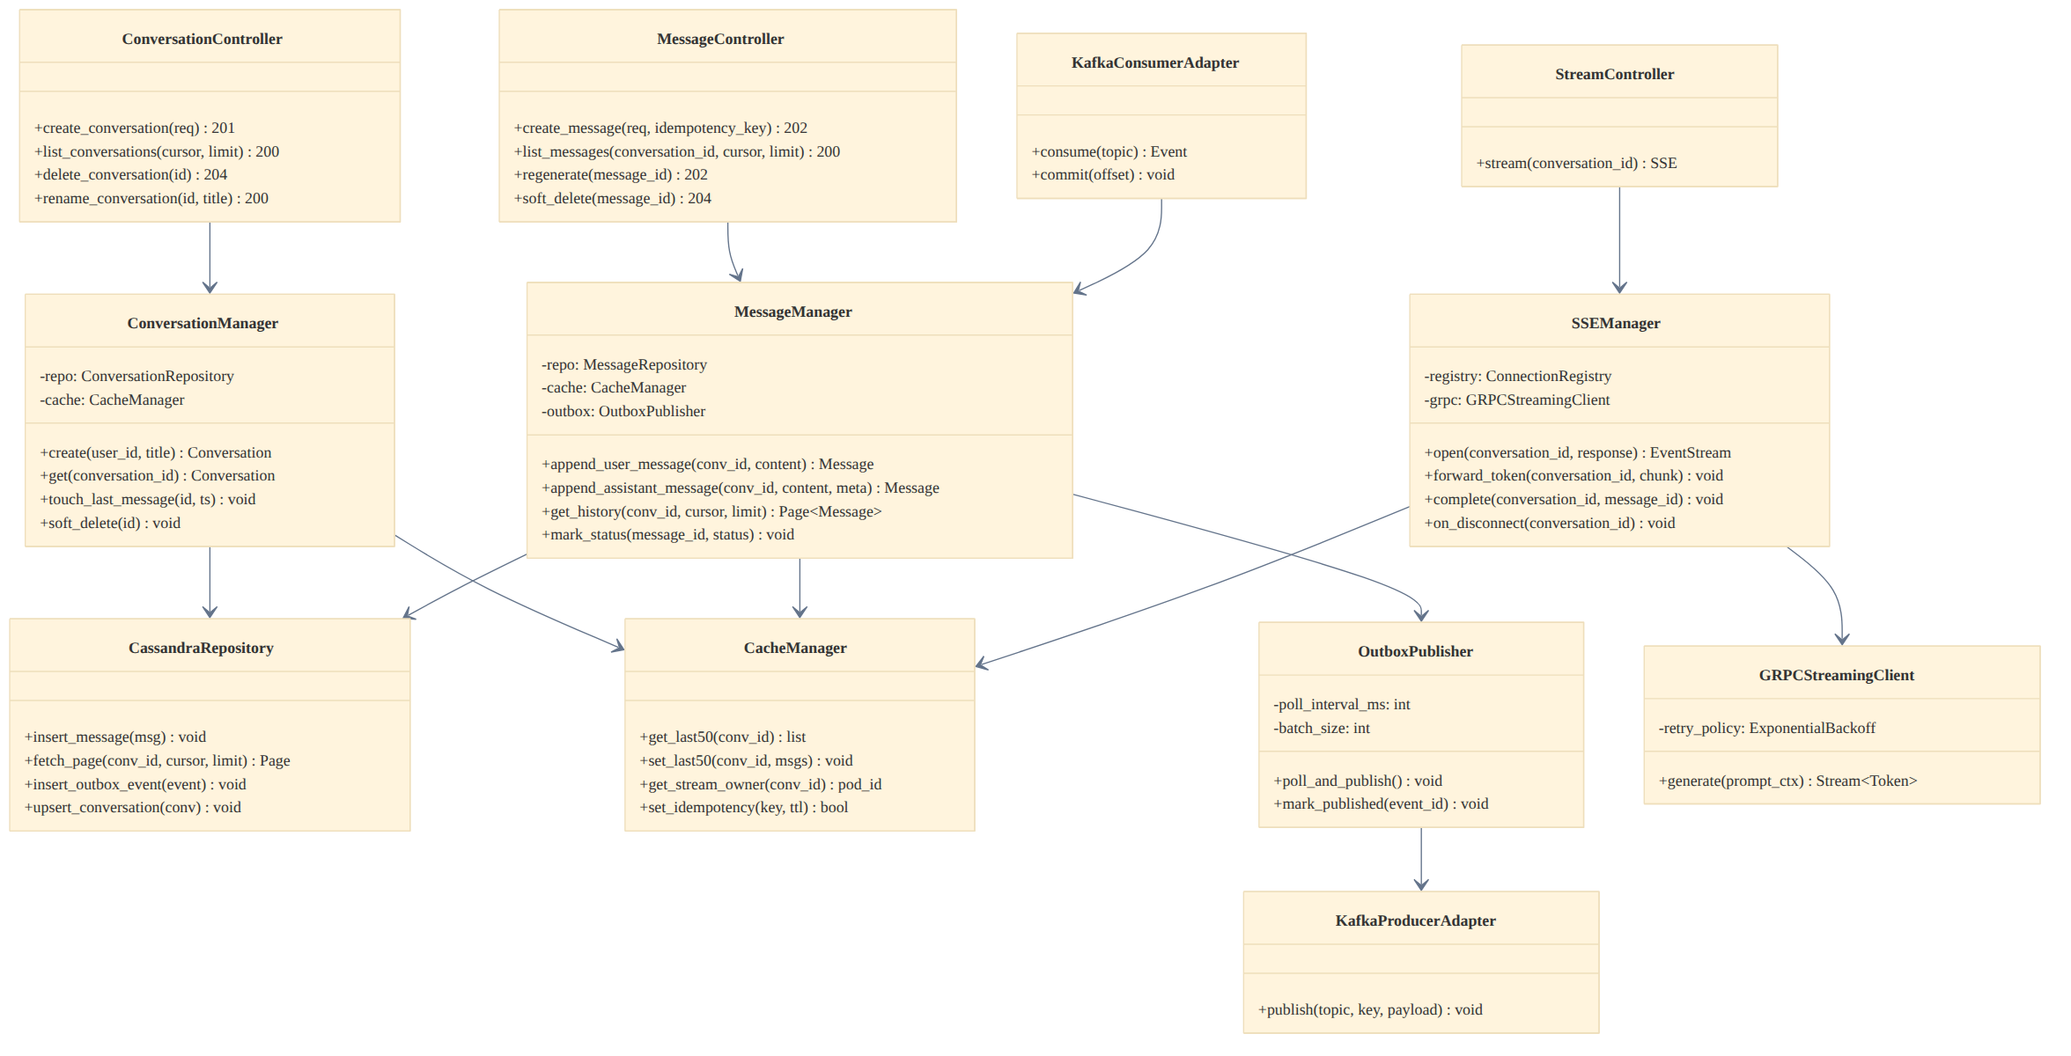
Figure 4.1 — Internal class / component diagram

4.1 Controllers (api/)
Controllers are thin: they validate the request shape (Pydantic), extract the authenticated user_id from the JWT (attached by auth middleware), and delegate to the corresponding manager in core/. No business logic lives here.
Method | Signature | Behavior
ConversationController.create_conversation | (req: CreateConversationRequest, user: AuthUser) -> 201 | Delegates to ConversationManager.create; returns conversation_id + created_at
ConversationController.list_conversations | (cursor: str|None, limit: int=20, user: AuthUser) -> 200 | Delegates to ConversationManager, enforces limit <= 100
MessageController.create_message | (req: CreateMessageRequest, idempotency_key: str|None, user: AuthUser) -> 202 | Checks idempotency key in Redis first; delegates to MessageManager.append_user_message
MessageController.regenerate | (message_id: UUID, user: AuthUser) -> 202 | Verifies ownership + status=active; delegates to MessageManager regenerate flow
StreamController.stream | (conversation_id: UUID, user: AuthUser) -> SSE | Delegates to SSEManager.open; keeps connection alive until complete/disconnect

4.2 ConversationManager (core/)
class ConversationManager:
def __init__(self, repo: ConversationRepositoryPort, cache: CachePort): ...

async def create(self, user_id: UUID, title: str) -> Conversation:
conv = Conversation.new(user_id, title)
await self.repo.upsert_conversation(conv) # conversations + conversations_by_user
return conv

async def get(self, conversation_id: UUID, user_id: UUID) -> Conversation:
conv = await self.cache.get_conversation(conversation_id) \
or await self.repo.fetch_conversation(conversation_id)
if conv.user_id != user_id: raise OwnershipError()
return conv

async def touch_last_message(self, conversation_id: UUID, ts: datetime) -> None:
await self.repo.update_updated_at(conversation_id, ts) # rewrites conversations_by_user row
await self.cache.invalidate_conversation(conversation_id)

4.3 MessageManager (core/)
class MessageManager:
def __init__(self, repo: MessageRepositoryPort, cache: CachePort,
outbox: OutboxPort): ...

async def append_user_message(self, conversation_id, content) -> Message:
msg = Message.new(conversation_id, sender='user', content=content, status='pending')
await self.repo.insert_message(msg)
await self.outbox.write_event('chat.message.created', msg.to_event_payload())
await self.cache.push_last50(conversation_id, msg)
return msg

async def get_history(self, conversation_id, cursor, limit=50) -> Page[Message]:
if cursor is None and (cached := await self.cache.get_last50(conversation_id)):
return Page(items=cached[:limit], next_cursor=cached[limit-1].message_id if len(cached) > limit else None)
return await self.repo.fetch_page(conversation_id, cursor, limit)

4.4 SSEManager (core/)
Holds an in-process ConnectionRegistry (dict[conversation_id -> asyncio.Queue]) and coordinates with Redis so exactly one pod is considered the "owner" of a conversation's active stream at any time (detailed in Chapter 13).

Chapter 5 — State Machines

5.1 Message Lifecycle
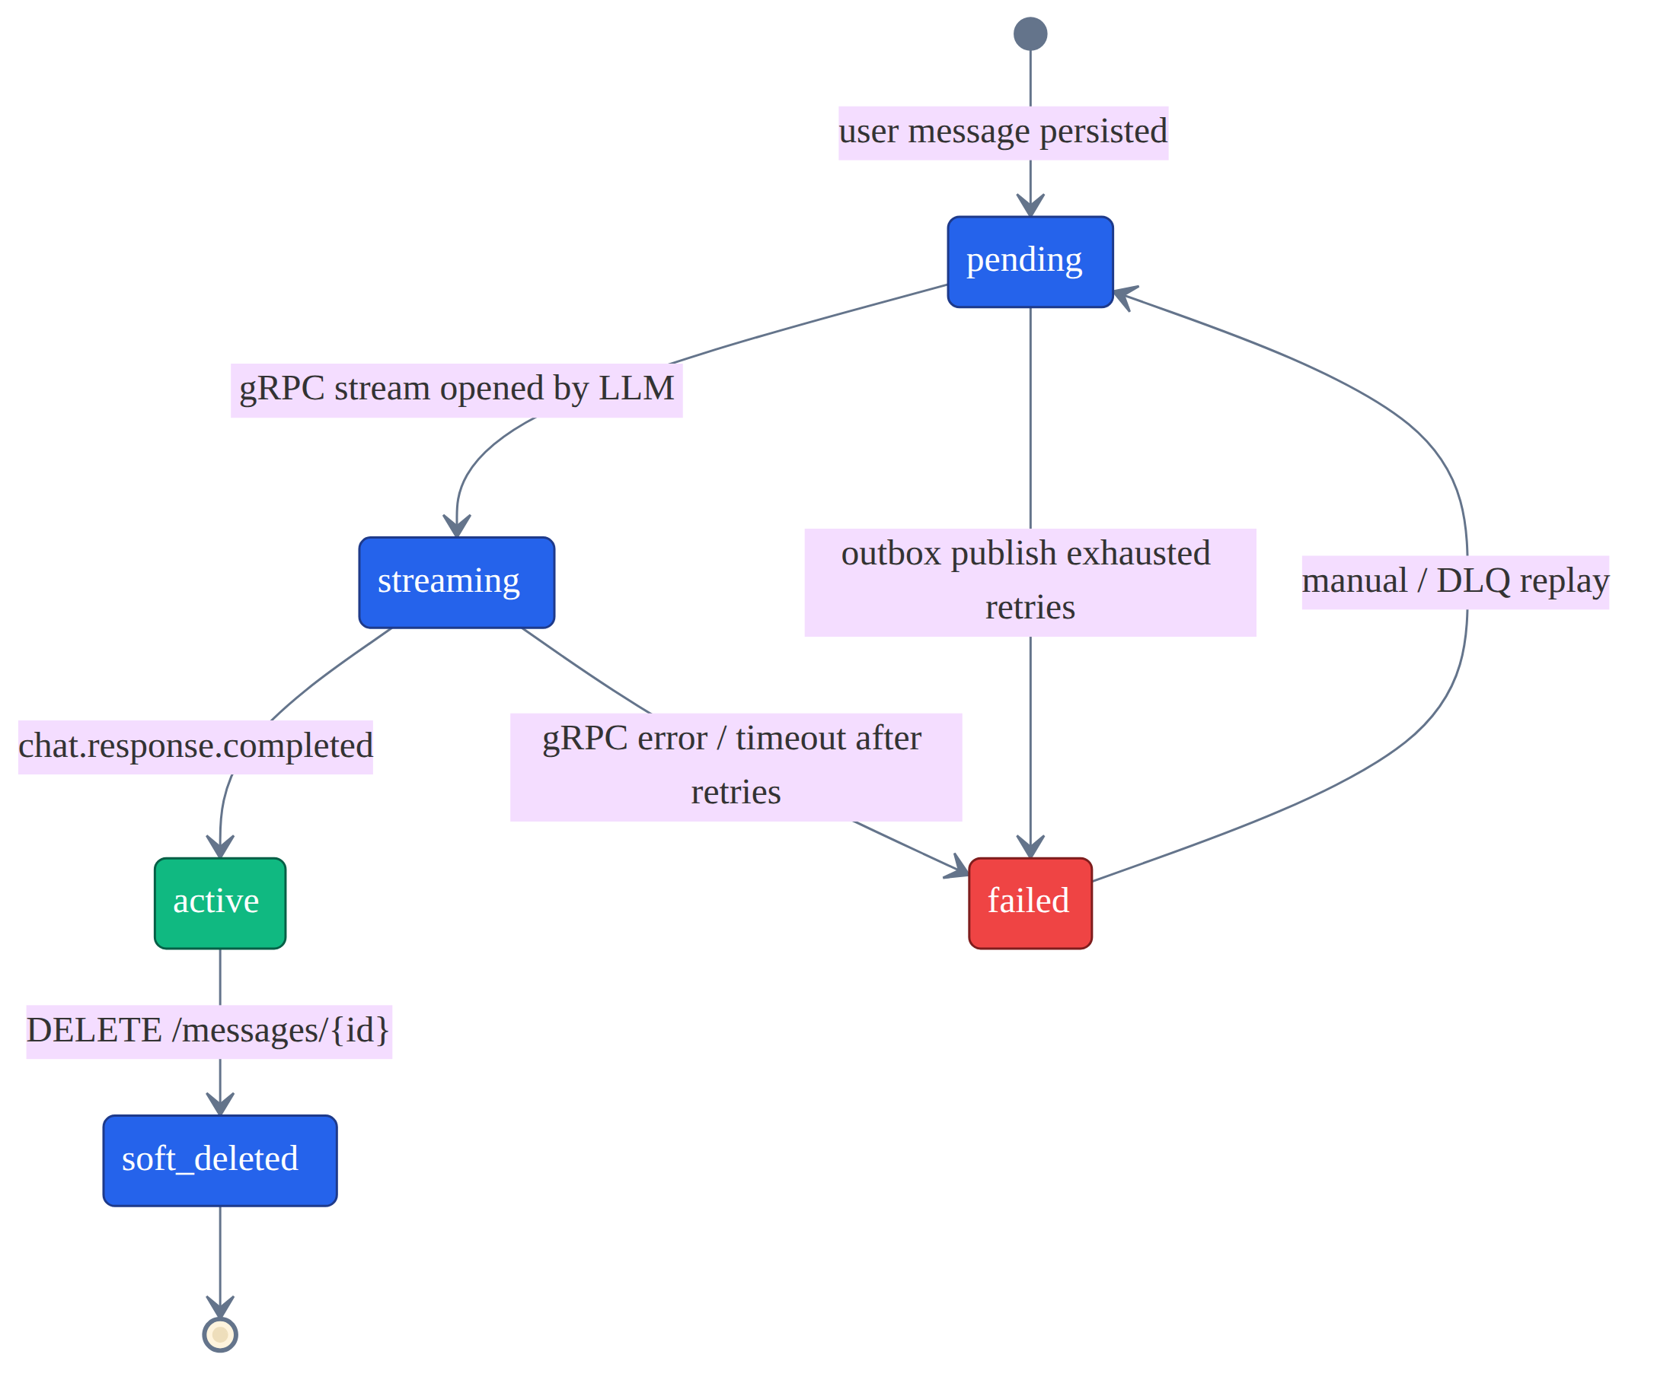
Figure 5.1 — Message status transitions
From | To | Trigger
(none) | pending | User message persisted (POST /messages)
pending | streaming | gRPC stream opened after LLM consumes chat.message.created
streaming | active | chat.response.completed consumed, full content persisted
streaming | failed | gRPC error/timeout after retry policy exhausted (Ch. 12)
pending | failed | Outbox publish retries exhausted (rare — DLQ path)
failed | pending | Manual/automated DLQ replay
active | soft_deleted | DELETE /messages/{id}

5.2 Conversation Lifecycle
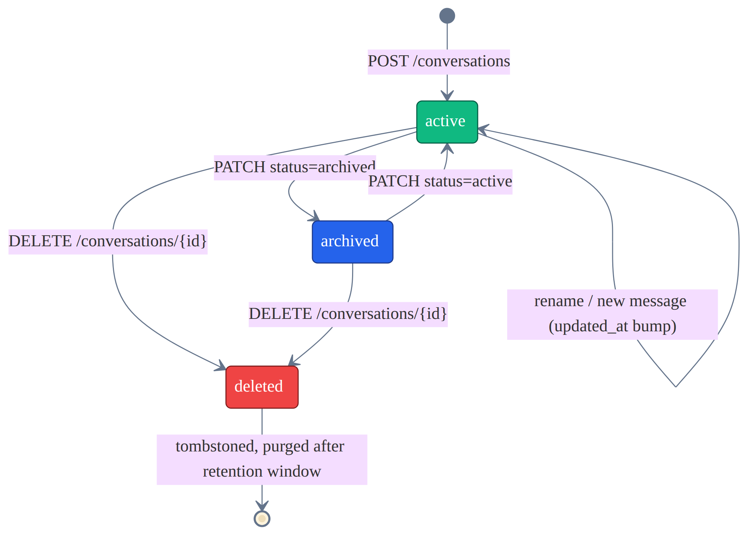
Figure 5.2 — Conversation status transitions
Conversation status is a simple three-state machine (active, archived, deleted). Deletion is always a soft delete — a tombstone status flag plus a scheduled purge job — never an immediate hard delete, so that the Outbox/Inbox reconciliation described in Chapter 9 always has a consistent row to operate against.

Chapter 6 — Detailed API Contract
This expands the HLD's endpoint list with field-level validation and the full error surface. All endpoints require Authorization: Bearer <JWT>; the service performs its own fine-grained verification independent of any coarse-grained check the API Gateway may already have done.

6.1 POST /messages — Field Validation
Field | Type | Rule | Failure Response
conversation_id | UUID (path/body) | Must exist and be owned by the authenticated user | 404 if not found, 403 if not owner
content | string | 1–8,000 characters after trim; rejected if empty or only whitespace | 422 Unprocessable Entity
X-Idempotency-Key | header, UUID | Optional; if present, must be a valid UUIDv4 | 400 if malformed

6.2 Complete Error Code Reference
HTTP Status | Meaning | Example Cause
400 Bad Request | Malformed request syntax | Invalid UUID format, invalid JSON body
401 Unauthorized | Missing/invalid/expired JWT | No Authorization header, signature mismatch
403 Forbidden | Authenticated but not authorized | User does not own the conversation/message
404 Not Found | Resource does not exist | conversation_id / message_id not found
409 Conflict | State conflict | Regenerate requested on a message that is already streaming
422 Unprocessable Entity | Semantically invalid payload | Empty content, content exceeds max length
429 Too Many Requests | Rate limit exceeded | Per-user or per-IP sliding-window limit hit
500 Internal Server Error | Unhandled server fault | Unexpected exception, logged with correlation id
503 Service Unavailable | Downstream dependency down and no fallback available | Cassandra cluster entirely unreachable

6.3 Rate Limiting Rule
Enforced via Redis sliding-window counters keyed rate:{user_id}: 60 message-creation requests per rolling 60-second window per user, and 300 read requests per rolling 60-second window per user. Exceeding either returns 429 with a Retry-After header computed from the window's remaining TTL.

Chapter 7 — Database Layer (Cassandra) — Low Level
All access goes through CassandraRepository, the only module permitted to import the Cassandra driver. Every query below is a prepared statement, bound and reused across calls to avoid re-parsing overhead.

7.1 Driver & Connection Configuration
Setting | Value | Reason
Driver | DataStax Python/Java driver (async wrapper) | Token-aware routing, native multi-DC support
Load Balancing Policy | TokenAwarePolicy(DCAwareRoundRobinPolicy(local_dc)) | Routes to replica holding the token, avoids coordinator hop
Consistency Level (Writes) | LOCAL_QUORUM | Strong local consistency without cross-region latency
Consistency Level (Reads) | LOCAL_QUORUM (history) / LOCAL_ONE (cache-miss fallback) | Balances read-your-writes vs. latency
Connection Pool | 2 connections/host (core), 8 max requests per connection | Matches driver defaults tuned for async throughput
Statement Timeout | 2000 ms | Fails fast rather than blocking the request thread
Retry Policy | DowngradingConsistencyRetryPolicy on read timeout only | Avoids retrying writes blindly (non-idempotent risk)

7.2 Repository Method → Exact CQL
-- insert_message(msg)
INSERT INTO messages_by_conversation
(conversation_id, message_id, sender, content, created_at, status)
VALUES (?, ?, ?, ?, ?, 'pending')
USING TIMESTAMP ?; -- client-side timestamp for LWW correctness

-- fetch_page(conversation_id, cursor, limit)
SELECT message_id, sender, content, created_at, status
FROM messages_by_conversation
WHERE conversation_id = ?
AND message_id < ? -- cursor; omitted clause on first page
LIMIT ?; -- clustering order DESC gives latest-first

-- upsert_conversation(conv)
BEGIN BATCH
INSERT INTO conversations (conversation_id, user_id, title, created_at, updated_at, status)
VALUES (?, ?, ?, ?, ?, 'active');
INSERT INTO conversations_by_user (user_id, updated_at, conversation_id, title, created_at, status)
VALUES (?, ?, ?, ?, ?, 'active');
APPLY BATCH; -- logged batch: both tables denormalize the same row

7.3 Batch Usage Warning
The logged batch above spans two tables that share the same partition intent (one logical conversation) — this is the one acceptable use of Cassandra batches here. Batches must never be used to write across unrelated partitions purely for "atomicity"; that pattern silently kills write throughput at scale.

Chapter 8 — Cache Layer (Redis) — Low Level
Key Pattern | Data Structure | TTL | Written By | Read By
conversation:{id} | Hash (title, status, updated_at) | 1 hour, refreshed on write | ConversationManager | ConversationManager.get
conversation:{id}:last50 | List (JSON-serialized messages, capped at 50) | 1 hour, refreshed on new message | MessageManager.append_* | MessageManager.get_history
stream:{conversation_id} | String (pod_id) | 60s, heartbeat-renewed every 20s | SSEManager.open | SSEManager on reconnect
idempotency:{request_id} | String (cached response JSON or sentinel) | 24 hours | MessageController.create_message | MessageController.create_message (dedupe check)
rate:{user_id}:{bucket} | Integer counter (INCR + EXPIRE) | 60s sliding window | Rate limit middleware | Rate limit middleware

8.1 Cache-Aside Algorithm (Read Path)
async def get_history(conversation_id, cursor, limit):
if cursor is None: # only the "latest" page is cacheable
cached = await redis.lrange(f'conversation:{conversation_id}:last50', 0, limit-1)
if cached:
record_cache_hit()
return deserialize(cached)
record_cache_miss()
rows = await cassandra_repo.fetch_page(conversation_id, cursor, limit)
if cursor is None:
await redis.rpush(f'conversation:{conversation_id}:last50', *serialize(rows))
await redis.expire(f'conversation:{conversation_id}:last50', 3600)
return rows

8.2 Circuit Breaker Around Redis
A circuit breaker wraps every Redis call. After 5 consecutive failures within a 10-second window, the breaker opens for 30 seconds: during this period all cache reads/writes are skipped and requests fall straight through to Cassandra, degrading latency but never availability. A background probe attempts a single PING every 30 seconds to decide when to move the breaker to half-open.

Chapter 9 — Outbox & Inbox Patterns — Detailed Algorithms

9.1 Transactional Outbox (Guarantees Zero Message Loss)
-- outbox table (same keyspace, written in the same logical unit as the message insert)
CREATE TABLE transactional_outbox (
bucket int, -- e.g. hash(event_id) % 32, spreads the poll query
event_id timeuuid,
event_type text,
payload text, -- JSON
published boolean,
created_at timestamp,
PRIMARY KEY (bucket, event_id)
) WITH CLUSTERING ORDER BY (event_id ASC);

9.2 OutboxWorker Poll Loop
async def poll_and_publish():
while True:
for bucket in range(32): # parallelizable across worker instances
rows = await repo.fetch_unpublished(bucket, limit=200)
for row in rows:
try:
await kafka_producer.publish(
topic=row.event_type,
key=row.payload['conversation_id'], # ordering guarantee
value=row.payload,
)
await repo.mark_published(row.bucket, row.event_id)
except KafkaTimeoutError:
break # leave unpublished; retry next poll cycle
await asyncio.sleep(poll_interval_ms / 1000) # default 250ms

The Kafka partition key is always conversation_id, guaranteeing that every event for a given conversation is processed in order by a single consumer partition — this is what keeps message ordering correct end to end (see HLD §12, "Kafka partition key").

9.3 Inbox Pattern (Deduplicates Kafka Redelivery)
CREATE TABLE inbox_events (
event_id uuid PRIMARY KEY,
processed_at timestamp
) WITH default_time_to_live = 604800; -- 7-day retention is enough to cover any redelivery window

async def handle_event(event):
if await repo.inbox_exists(event.event_id):
return # already processed — skip (at-least-once -> effectively-once)
await process(event)
await repo.inbox_insert(event.event_id)

Chapter 10 — Idempotency Key Handling
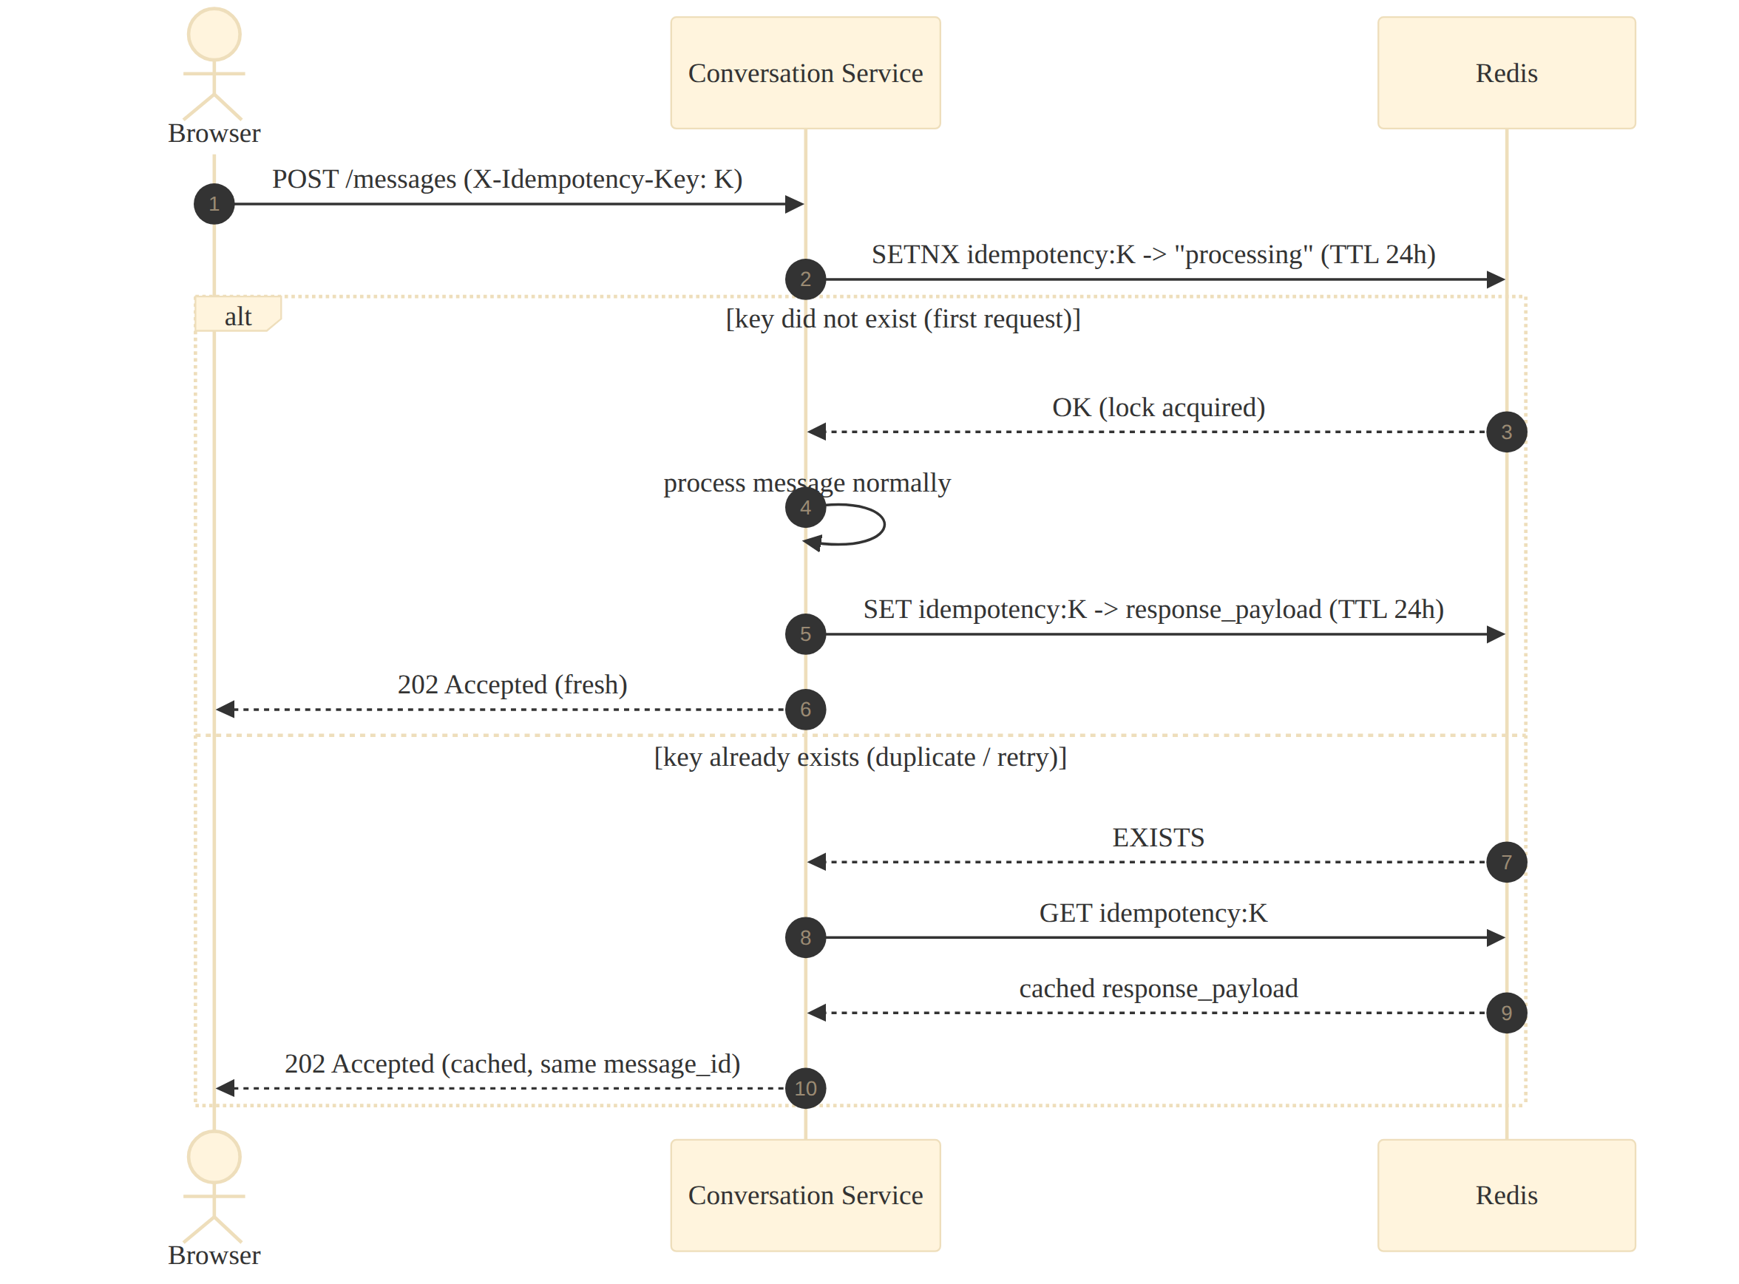
Figure 10.1 — Idempotent duplicate-request handling
Redis SETNX (SET key value NX) provides the atomic "claim this key or fail" primitive needed here. If the client retries a POST /messages call (e.g., after a network timeout where the first request actually succeeded), the second request finds the key already set and returns the identical cached response instead of creating a second message.
Step | Redis Command | Purpose
1 | SET idempotency:{key} "processing" NX EX 86400 | Atomically claim the key; fails if already claimed
2a (won the claim) | SET idempotency:{key} {response_json} EX 86400 | Overwrite placeholder with the real response once processing completes
2b (lost the claim) | GET idempotency:{key} | Return whatever the first request already produced (or 409 if still "processing")

Chapter 11 — Kafka Producer / Consumer — Low Level
Setting | Value | Reason
Serialization | JSON (Avro considered for v2, schema registry not yet required at current event volume) | Simplicity, human-debuggable payloads
Partition key | conversation_id | Guarantees per-conversation ordering
Producer acks | acks=all | Durability — write is only confirmed once all in-sync replicas have it
Producer idempotence | enable.idempotence=true | Prevents duplicate records from producer-side retries
Consumer group id | conversation-service.chat-events.v1 | Versioned group id allows safe reprocessing on schema change
Offset commit | Manual commit after successful handler execution (not auto-commit) | Avoids acknowledging an offset whose side effect didn't complete
Max poll records | 50 | Bounds per-batch processing time to stay under session timeout

11.1 Consumed Topics
Topic | Handler | Idempotency Guard
conversation.summary.generated | MessageManager.attach_summary | inbox_events check by event_id
conversation.title.generated | ConversationManager.set_title | inbox_events check by event_id
chat.response.completed | MessageManager.finalize_assistant_message | inbox_events check by event_id

Chapter 12 — gRPC Streaming Client — Low Level

12.1 Proto Sketch
service GenerationService {
rpc Generate(GenerationRequest) returns (stream TokenChunk);
}

message GenerationRequest {
string conversation_id = 1;
string message_id = 2;
string prompt_context = 3; // pre-built by LLM Service's own memory/RAG layer
}

message TokenChunk {
string message_id = 1;
string chunk = 2;
bool is_final = 3;
}

12.2 Client Configuration
Setting | Value | Reason
Deadline per stream | 60 seconds total, reset on each received chunk | Bounds worst-case hang while tolerating slow-but-alive generation
Retry policy | 3 attempts, exponential backoff (1s, 2s, 4s) — only before the first chunk is received | Retrying mid-stream would duplicate partial output; only safe pre-first-byte
Keepalive | gRPC keepalive ping every 20s, timeout 10s | Detects half-open TCP connections quickly
Flow control | Consumer applies backpressure by not calling next() until the SSE write buffer drains | Prevents an unbounded in-memory token queue if the browser is slow

12.3 Failure Behavior
If all retries are exhausted before the first token arrives, the stream is aborted, an SSE error event is sent to the browser, and the message is routed to the chat.message.dlq Kafka topic for manual/offline recovery (matches HLD §13.3). If the stream fails after some tokens have already been forwarded, the partial content is persisted with status=failed rather than active, and the same DLQ path is used — never silently discarding partial output.

Chapter 13 — SSE Connection Manager — Low Level
Because the service is deployed as many stateless pods, and a browser's SSE connection is pinned to exactly one pod at a time, the SSEManager must track — via Redis, not just in-process memory — which pod currently owns the active stream for a given conversation.
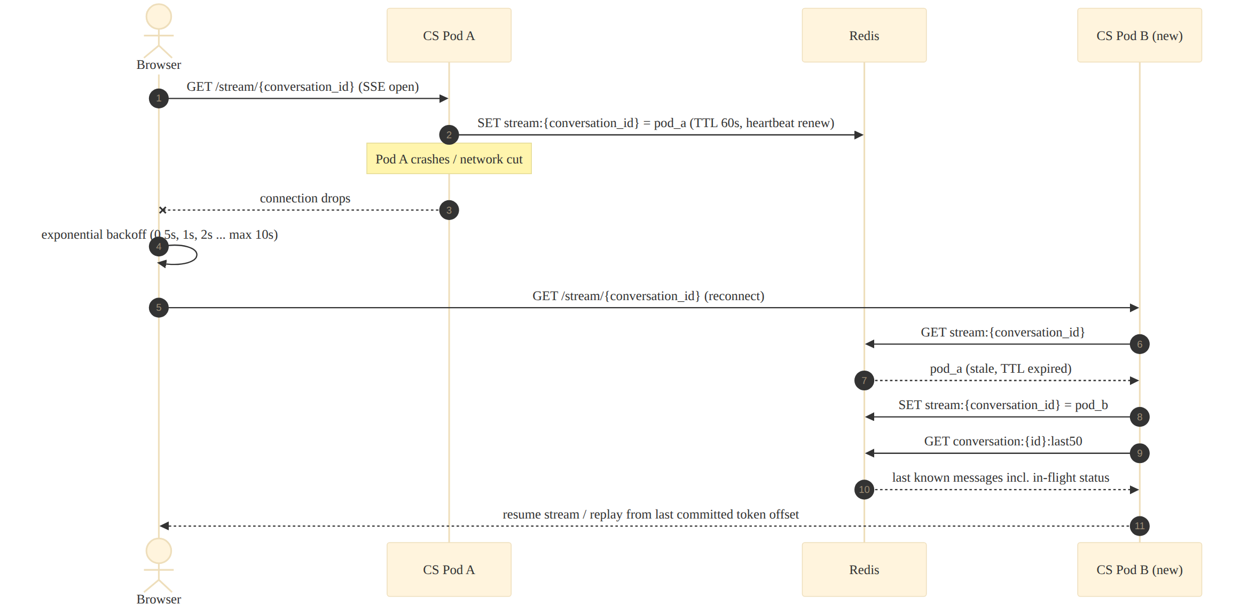
Figure 13.1 — Reconnect after pod failure

13.1 Ownership Protocol
- On SSE open: SET stream:{conversation_id} = {pod_id} EX 60.
- Heartbeat: every 20 seconds while the connection is open, the owning pod renews the TTL (EXPIRE stream:{conversation_id} 60).
- On graceful close: DEL stream:{conversation_id}.
- On pod crash: no DEL is sent, so the key simply expires after 60 seconds — the next reconnect claims it.
- On reconnect to a different pod: the new pod overwrites the key with its own pod_id and resumes serving from Redis-cached state (last50 + any in-flight message status).

13.2 Client Reconnect Behavior
The browser's EventSource (or a thin wrapper around it) retries with exponential backoff — 0.5s, 1s, 2s, 4s, capped at 10s — and always reissues GET /stream/{conversation_id}. Because message status (pending/streaming/active) is durable in Cassandra and mirrored in Redis, the reconnecting pod can immediately tell the client whether generation is still in progress, already complete, or failed, rather than the client guessing from a dropped connection.

Chapter 14 — Regenerate Flow — Detailed
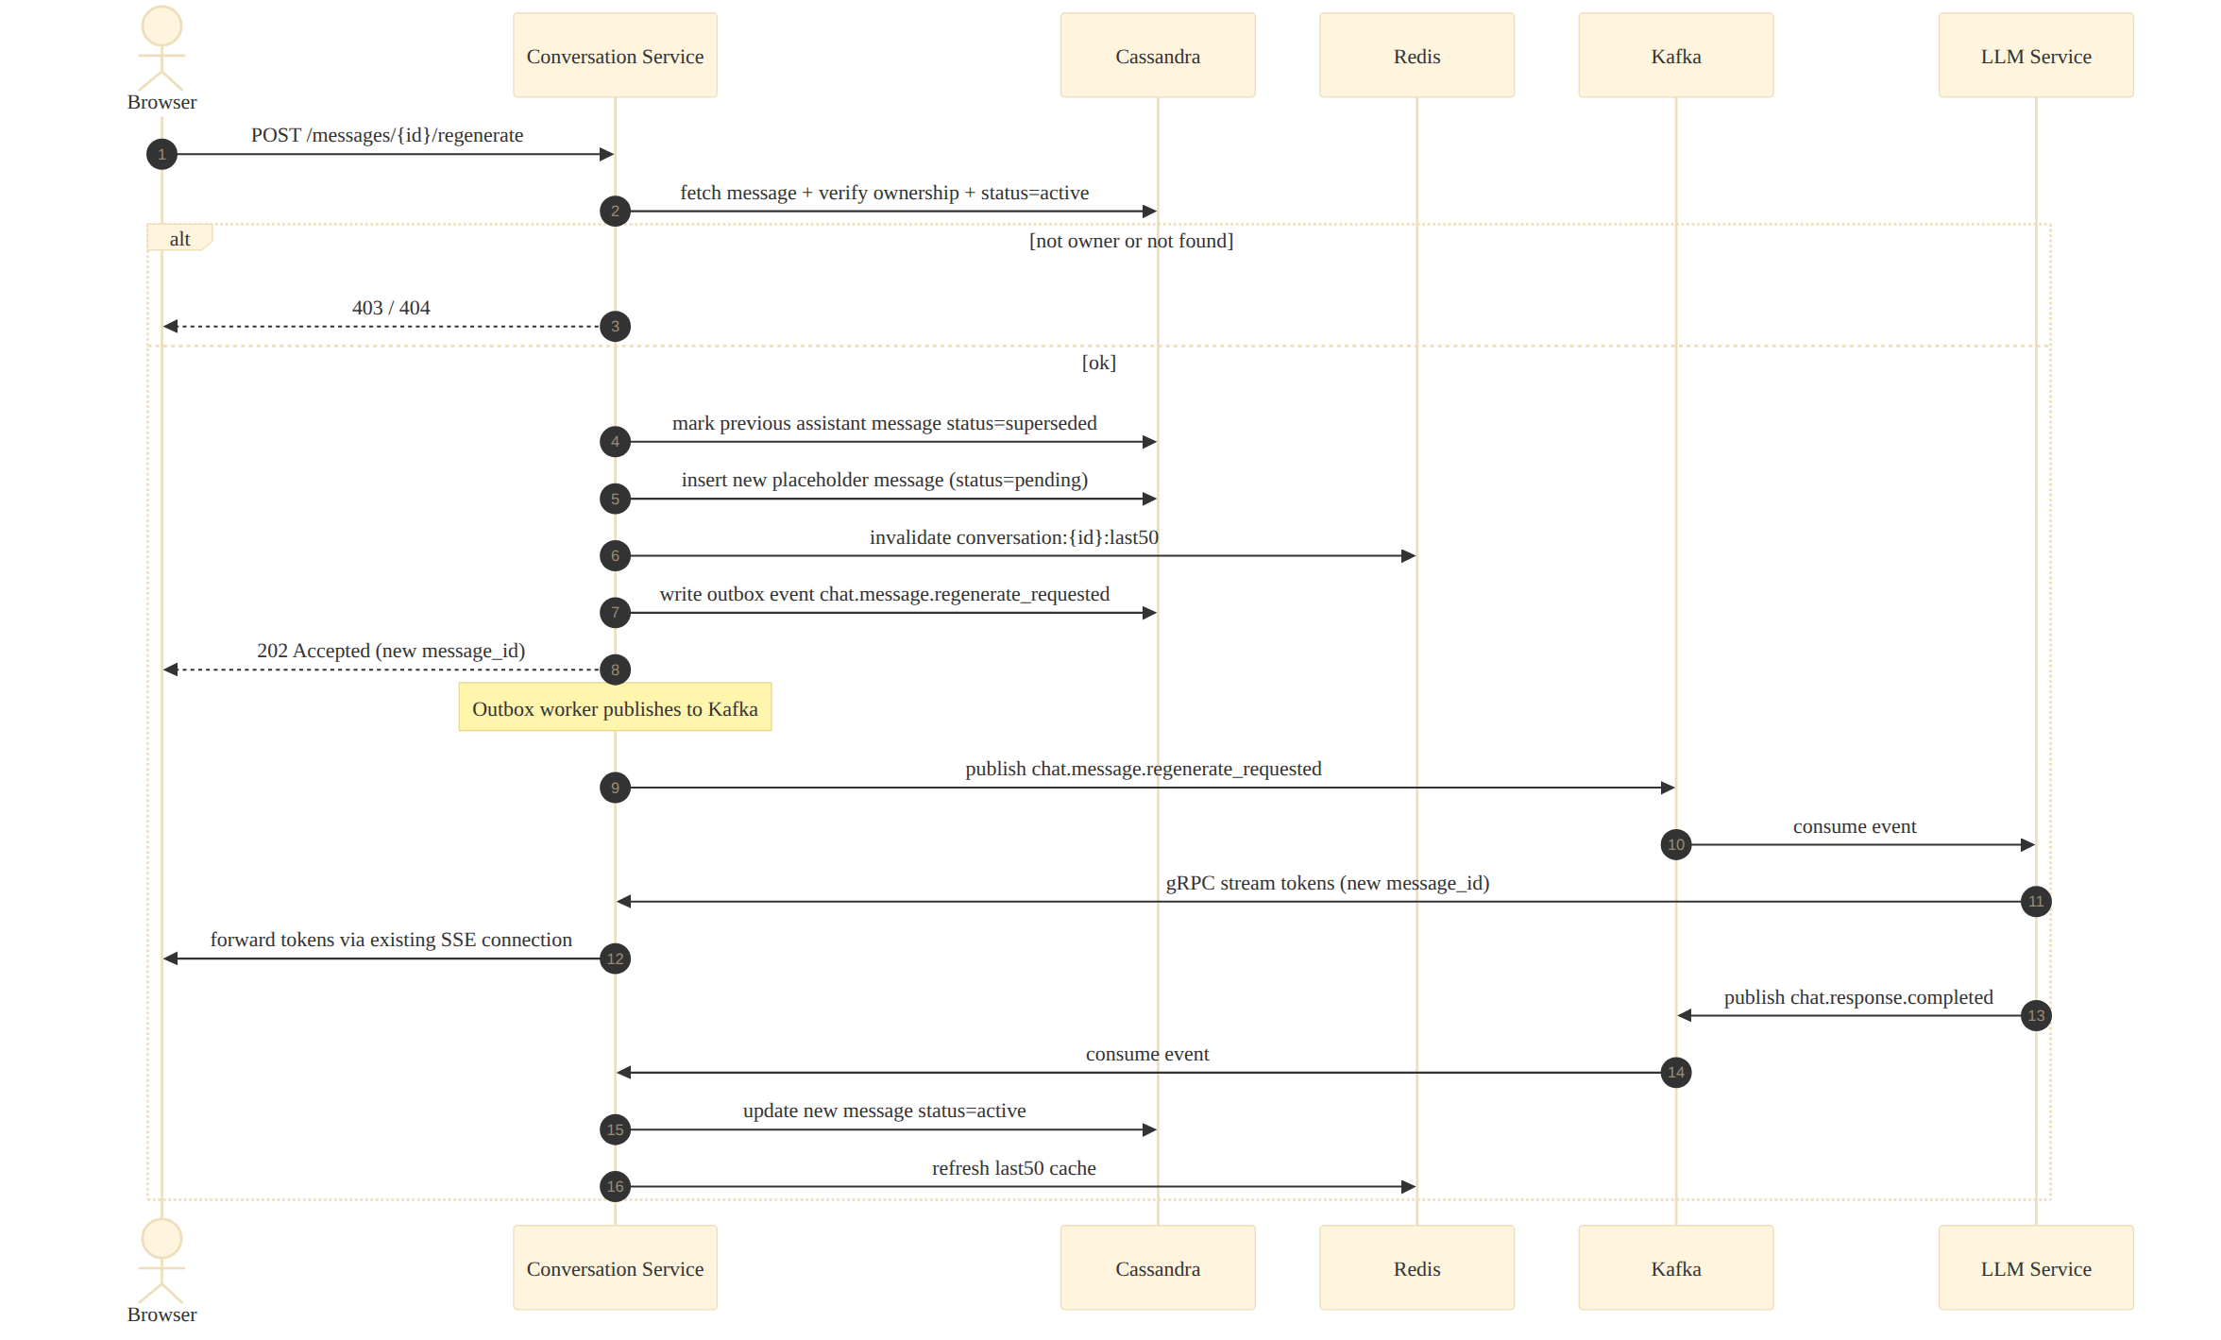
Figure 14.1 — Regenerate response sequence
Regeneration never mutates the original assistant message; instead the prior message is marked superseded and a new message row is created. This preserves full history (useful for the Memory service and for audit) while still presenting the user with a single "current" answer per turn in the UI.

Ownership & State Preconditions
- The caller must own the conversation the message belongs to (403 otherwise).
- The target message must currently be status=active (409 Conflict if it is pending/streaming/failed — regeneration only applies to a completed answer).

Chapter 15 — Error Handling Strategy
- All exceptions raised in core/ are domain exceptions (OwnershipError, NotFoundError, ConflictError, ValidationError) — never raw driver exceptions leaking upward.
- A single FastAPI exception-handler layer maps domain exceptions to the HTTP codes in Chapter 6.2, attaching a correlation_id to every error body.
- Unhandled exceptions are caught at the outermost middleware, logged at ERROR with full stack trace + correlation_id, and returned to the client as a generic 500 with no internal detail leaked.
- Every error response body follows the same shape: {"error": {"code": "...", "message": "...", "correlation_id": "..."}}.

Chapter 16 — Concurrency Model
- The service runs on a single asyncio event loop per pod (Uvicorn worker); all I/O (Cassandra, Redis, Kafka, gRPC) uses async drivers so no request thread ever blocks on network I/O.
- CPU-bound work (JSON serialization of large payloads, token counting) is negligible here and stays on the event loop; nothing in this service warrants a separate thread/process pool.
- Per-pod concurrency limits: max 5,000 concurrent SSE connections (enforced by a semaphore; beyond this, new stream requests get 503 and the client retries against another pod via the Ingress) and max 200 in-flight Cassandra requests (bounded by the driver's max-requests-per-connection × connections-per-host).
- Backpressure: if the SSE write buffer for a slow client grows beyond 64KB, the SSEManager pauses reading further gRPC chunks for that stream until the buffer drains (see Chapter 12.2).

Chapter 17 — Configuration Reference
Env Var | Default | Description
CASSANDRA_CONTACT_POINTS | cassandra-0,cassandra-1,cassandra-2 | Seed nodes for driver discovery
CASSANDRA_LOCAL_DC | us-east-1 | Local datacenter for DCAwareRoundRobinPolicy
CASSANDRA_CONSISTENCY_WRITE | LOCAL_QUORUM | Write consistency level
REDIS_URL | redis://redis-cluster:6379/0 | Redis Cluster connection string
KAFKA_BROKERS | kafka-0:9092,kafka-1:9092,kafka-2:9092 | Bootstrap servers
KAFKA_CONSUMER_GROUP | conversation-service.chat-events.v1 | Versioned consumer group id
OUTBOX_POLL_INTERVAL_MS | 250 | OutboxWorker poll frequency
OUTBOX_BATCH_SIZE | 200 | Rows fetched per bucket per poll cycle
GRPC_LLM_SERVICE_ADDR | llm-service.internal:50051 | LLM Service gRPC endpoint
GRPC_STREAM_DEADLINE_SECONDS | 60 | Max time per generation stream
SSE_HEARTBEAT_SECONDS | 20 | TTL-renewal interval for stream:{id} ownership key
RATE_LIMIT_WRITES_PER_MIN | 60 | Per-user message-creation rate limit
RATE_LIMIT_READS_PER_MIN | 300 | Per-user read-endpoint rate limit
IDEMPOTENCY_TTL_SECONDS | 86400 | How long an idempotency key is honored

Chapter 18 — Observability — Low Level

18.1 Structured Log Fields (every log line)
- correlation_id — propagated from the incoming request header (or generated if absent) and forwarded on every downstream call (Kafka header, gRPC metadata).
- user_id, conversation_id, message_id — attached whenever available, never logged with message content.
- event — machine-readable event name, e.g. message.persisted, outbox.published, sse.reconnected.
- duration_ms — for any operation that talks to Cassandra, Redis, Kafka, or gRPC.

18.2 Key Metrics (Prometheus)
Metric | Type | Labels
conversation_service_http_request_duration_seconds | Histogram | route, method, status_code
conversation_service_sse_active_connections | Gauge | pod
conversation_service_outbox_lag_seconds | Gauge | bucket
conversation_service_kafka_consumer_lag | Gauge | topic, partition
conversation_service_redis_cache_hit_ratio | Gauge | key_pattern
conversation_service_grpc_stream_duration_seconds | Histogram | status

18.3 Tracing
Every request creates a root OpenTelemetry span at the API layer; child spans wrap each Cassandra query, Redis call, Kafka publish, and gRPC stream, so a single trace shows exactly where time was spent for any given request — critical for diagnosing tail-latency regressions in production.

Chapter 19 — Testing Strategy
Level | Scope | Tooling | Example Cases
Unit | core/ managers with fake repository/cache/outbox | pytest + fakes/mocks | State-transition correctness, ownership checks, validation rules
Integration | Full stack against ephemeral Cassandra/Redis/Kafka | Testcontainers | Outbox publish → Kafka → Inbox dedupe end to end
Contract | API request/response schemas | schemathesis / Pydantic schema tests | Every documented error code is actually reachable
Load | Throughput & latency under target TPS | k6 / Locust | 57,870 writes/sec peak scenario from HLD §12
Chaos | Failure-mode behavior | Manual fault injection / Chaos Mesh | Kill Redis mid-traffic, kill a Cassandra node, kill a pod mid-SSE-stream

Chapter 20 — Local Development & Deployment Runbook

20.1 Local Development
A docker-compose.yml spins up single-node Cassandra, single-node Redis, and a single-broker Kafka (KRaft mode) alongside the FastAPI app in reload mode, plus a stub LLM Service that echoes tokens back with artificial latency — enough to exercise the full request → outbox → Kafka → gRPC-stream → SSE loop without any cloud dependency.

20.2 Deployment Checklist
- Cassandra schema migrations applied (CREATE TABLE IF NOT EXISTS, additive only — no destructive migrations without a separate backfill plan).
- Kafka topics pre-created with the partition counts from HLD §12 (chat.message.created, chat.response.completed, etc.).
- Readiness probe (/ready) passes — verifies live connectivity to Cassandra, Redis, and Kafka, not just process liveness.
- HPA thresholds and Pod Disruption Budget applied per HLD §17.1 before traffic is shifted.
- Dashboards (Chapter 18 metrics) and alert rules (Kafka consumer lag, outbox lag, SSE connection saturation) are live before rollout completes.

20.3 Rollback Plan
Because the service is stateless and all schema changes are additive, rollback is a standard Kubernetes rolling-update revert to the previous image — no data migration reversal is required for typical releases.

Appendix

A. Related Diagrams from the HLD (for cross-reference)
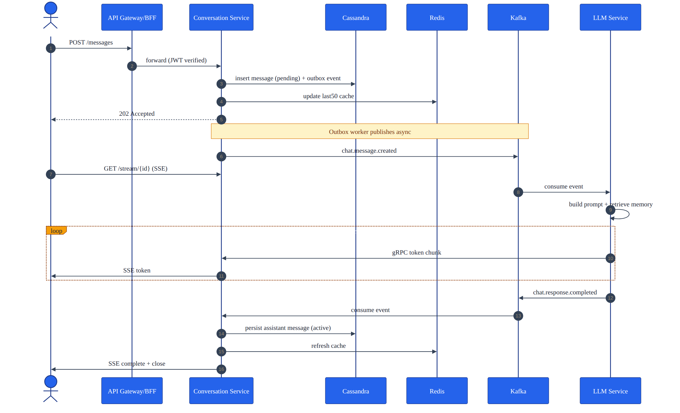
Figure A.1 — End-to-end request flow (recap, colorized)

B. Glossary
Term | Meaning
LLD | Low Level Design — implementation-ready specification of internal structure and algorithms
Outbox Pattern | Writes an event to the same store as the business row, published later by a background worker, guaranteeing no event is lost if the message broker is temporarily down
Inbox Pattern | Records processed event IDs so at-least-once delivery from Kafka never causes duplicate side effects
Cache-Aside | Application checks the cache first, falls back to the database on a miss, and populates the cache afterward
Token-Aware Routing | Cassandra driver routes a query directly to the node owning the relevant partition, skipping an extra network hop
Backpressure | Slowing or pausing upstream production of data to match a slower consumer's processing rate

