UNIVERSITY OF ENERGY AND NATURAL RESOURCES (UENR)
SCHOOL OF SCIENCES

DEPARTMENT OF INFORMATION TECHNOLOGY AND DECISION SCIENCES

PROJECT TOPIC:
A TRANSFER LEARNING-BASED VISION TRANSFORMER (ViT-B/16) SYSTEM FOR EARLY GLAUCOMA DETECTION FROM RETINAL FUNDUS IMAGES

Submitted in partial fulfilment of the requirements for the degree of
BACHELOR OF SCIENCE IN INFORMATION TECHNOLOGY
BY:
KWAME OFOSU GRANT UEB3262522
BOAKYE OBED FORDJOUR UEB3258722
BEMAH REGINA UEB3263822
ISHAQ DAUDA UEB3250822
AWONAYA DERRICK UEB3259522

DECLARATION
We, KWAME OFOSU GRANT, BOAKYE OBED FORDJOUR, BEMAH REGINA, ISHAQ DAUDA and AWONAYA DERRICK, the undersigned, declare that this project, titled “A Transfer Learning-Based Vision Transformer (ViT-B/16) System for Early Glaucoma Detection from Retinal Fundus Images,” is our own original work carried out under the supervision of Dr. Kwabena Adu towards the award of a Bachelor of Science degree in Information Technology at the University of Energy and Natural Resources. All information sources used in producing this report have been duly acknowledged. This work has not been presented, in whole or in part, for the award of any other degree or certification elsewhere, except where due acknowledgement has been made in the text. We further affirm that the design, implementation, and evaluation described in this report were completed in compliance with the academic standards of the University of Energy and Natural Resources.

KWAME OFOSU GRANT ................................. .................................
UEB3262522 DATE SIGNATURE
BOAKYE OBED FORDJOUR ................................. .................................
UEB3258722 DATE SIGNATURE
BEMAH REGINA ................................. .................................
UEB3263822 DATE SIGNATURE
ISHAQ DAUDA ................................. .................................
UEB3250822 DATE SIGNATURE
AWONAYA DERRICK ................................. .................................
UEB3259522 DATE SIGNATURE

CERTIFIED BY:
DR. KWAMBENA ADU ................................. .................................
(SUPERVISOR) DATE SIGNATURE

PROF. PETER APPIAHENE ................................. .................................
(HEAD OF DEPARTMENT) DATE SIGNATURE

DEDICATION
We dedicate this project to the Almighty God for His grace, wisdom, and guidance throughout this journey. We also dedicate this work to our parents and families, whose continuous love, prayers, and support have carried us through our academic pursuits. We are equally grateful to our lecturers and supervisor for their patience and encouragement, and to our friends and colleagues whose company made this journey memorable. Finally, we dedicate this work to every patient who continues to lose their sight to preventable causes such as glaucoma, in the hope that projects such as this one bring the world closer to accessible, early, and life-changing screening for all.

ACKNOWLEDGEMENTS
We sincerely thank the Almighty God for the strength, insight, and understanding that made the completion of this project possible. We owe a profound debt of gratitude to our supervisor, Dr. Kwabena Adu, for his tireless guidance, technical direction, and encouragement throughout the development of this system. We also thank our Head of Department, Prof. Peter Appiahene, and the staff of the Department of Information Technology and Decision Sciences at UENR for the solid academic foundation that enabled us to carry out this research. Finally, we thank everyone who supported this project, from those who assisted in sourcing datasets to the beta testers who patiently trialled the mobile application.

ABSTRACT
Glaucoma is a leading cause of irreversible blindness, and often worsens without any obvious symptoms. This is why early detection is critical to prevent permanent vision loss. Specialized equipment and trained eye-care professionals are needed for traditional glaucoma screening, which restricts access to screening, particularly in resource-poor communities. Hence, the project was to develop a mobile-based AI-assisted glaucoma screening system, Glauco-Guard AI, which can classify retinal fundus images as glaucomatous or normal and provide an accessible and scalable screening solution for healthcare workers.
From the review of existing studies, it becomes apparent that deep learning methods, especially Convolutional Neural Networks (CNNs), transfer learning and Vision Transformers (ViTs), show great potential in automated glaucoma detection. However, the literature also identified a gap for end-to-end, mobile deployable solutions in low-resource healthcare settings. To address this gap, the project developed a single AI-engine platform based on transfer learning with a Vision Transformer (ViT-B/16). The model was trained on over 4,053 clinically annotated retinal fundus images. Images were resized, normalized, augmented and class weighted before training. The system was deployed as Docker, with Django REST Framework as backend and Expo/React Native mobile application. It also included fundus image validation, confidence thresholding and a Clinical Administrator Dashboard with a Report Vault for access to diagnostic records and PDF reports.
ViT-B/16 engine attained ~ 81% validation accuracy on the held-out test data. The precision, recall and F1-score of the glaucoma class were 85%, 50% and 63% on the test set respectively, whereas the normal class achieved a precision of 81%, recall of 96% and F1-score of 88%. The system testing showed that the API worked well, the validation testing was successful in rejecting non-fundus images and the beta testing achieved a result in less than three seconds using the mobile application.
The project shows the possibility of creating an accessible AI-assisted glaucoma screening system with the help of one engine based on open-source technologies. However, further clinical validation, improved glaucoma recall and explainability are needed, but the current system provides a foundation for extending AI-based glaucoma screening to underserved and resource-constrained healthcare settings.

TABLE OF CONTENTS
DEDICATION iii
ACKNOWLEDGEMENTS iv
ABSTRACT v
TABLE OF CONTENTS vi
LIST OF TABLES ix
LIST OF FIGURES x
CHAPTER ONE INTRODUCTION 1
1.1 Introduction 1
1.2 Statement of the Problem 2
1.3 Research Objectives 2
1.3.1 General Objective 2
1.3.2 Specific Objectives 2
1.4 Research Questions 3
1.5 Significance of the Project 3
1.6 Scope of the Project 4
1.7 Organisation of Project Report 5
CHAPTER TWO LITERATURE REVIEW 6
2.1 Introduction 6
2.2 The Future of AI-Based Glaucoma Screening 6
2.3 Related Works 7
2.3.1 Advancing Glaucoma Care: Integrating Artificial Intelligence in Diagnosis, Management, and Progression Detection 7
2.3.2 Glaucoma Detection for Automated Referral System: Using OCT Data and Fine-Tuning LLM Models 8
2.3.3 AI-Powered Retinal Disease Classifier Using Fundus Images 8
2.3.4 Revolutionizing Glaucoma Care: Harnessing Artificial Intelligence for Precise Diagnosis and Management 8
2.3.5 Democratizing Glaucoma Care: A Framework for AI-Driven Progression Prediction Across Diverse Healthcare Settings 9
2.4 Traditional (Manual) Glaucoma Screening 9
2.5 How Glaucoma Screening Is Conducted in Clinical Settings 9
2.6 AI-Based (Automated) Glaucoma Screening 10
2.7 Existing Systems 11
2.7.1 EyeArt (Eyenuk) 11
2.7.2 Google Research / DeepMind Automated Retinal Disease Assessment (ARDA) 11
2.7.3 Forus Health 3nethra 12
2.7.4 Remidio Medios AI 12
2.7.5 Peek Vision 12
2.7.6 Airdoc 12
2.8 Theoretical Framework 13
2.8.1 Technology Acceptance Model (TAM) 13
2.8.2 Machine Learning Development Life Cycle 13
2.9 Comparison of Existing Systems 14
CHAPTER THREE SYSTEM METHODOLOGY 16
3.1 Introduction 16
3.2 System Development Life Cycle 16
3.2.1 Planning Phase 17
3.2.2 Analysis Phase 18
3.2.3 Design Phase 18
System Architectural Design 20
Use Case Diagram 21
System Flowchart 22
3.3 Data Acquisition and Preprocessing 23
3.3.1 Data Acquisition 23
3.3.2 Data Preprocessing 25
3.4 Model Development 25
3.4.1 Model Architecture: Vision Transformer (ViT-B/16) 25
Fine-tuning approach: 26
3.4.2 Training Parameters 26
3.4.3 Training and Validation Performance 27
3.5 Model Evaluation 28
3.6 Model Prediction / Inference Pipeline 29
3.7 Programming Languages and Tools Used 29
3.7.1 Python and PyTorch 30
3.7.2 Django and Django REST Framework 30
3.7.3 React Native and Expo 30
3.7.4 Docker 30
3.8 Functional Requirements 30
3.9 Non-Functional Requirements 31
3.10 Summary 32
CHAPTER FOUR RESULTS AND DISCUSSION 33
4.1 System Development Methodology 33
4.2 System Requirements 33
4.2.1 Hardware Requirements 33
4.2.2 Software Requirements 34
4.3 System Implementation 34
4.3.1 Backend Engineering: Django REST Framework 34
4.3.3 Deployment and DevOps: Docker 36
4.3.4 Clinical Administrator Dashboard and Report Vault 36
Authentication and Security Layer (Planned) 37
Accountability and Transparency: Audit Logging (Planned) 37
The Referral Workflow Engine (Planned) 37
4.4 System Testing 37
4.4.1 Unit Testing 37
4.4.2 Integration Testing 38
4.4.3 System Testing 38
4.4.4 Acceptance Testing 39
4.5 The System Screenshots 40
4.6 Conclusion 45
CHAPTER FIVE SUMMARY, CONCLUSION AND RECOMMENDATION 46
5.1 Summary 46
5.2 Limitations of the Project 46
5.3 Recommendation 47
5.4 Conclusion 47
REFERENCES 49

LIST OF TABLES
Table 2.1: Comparison of Existing Glaucoma Screening Systems 16
Table 3.1: Dataset Parameter Descriptions 20
Table 3.2: Per-Class Classification Results on the Test Set 22
Table 4.1: Hardware Requirements of the System 26
Table 4.2: Software Requirements of the System 27

LIST OF FIGURES
Figure 3.1: System Architectural Design 19
Figure 3.2: Use Case Diagram 19
Figure 3.3: System Flowchart 20
Figure 3.4: ViT-B/16 Training and Validation Loss / Accuracy Curves 22
Figure 4.1: Home Screen 31
Figure 4.2: Image Upload Screen 32
Figure 4.3: Result Screen 32
Figure 4.4: Docker Deployment Architecture 33
Figure 4.5: Login and Authentication Screen (Planned) 33
Figure 4.6: Specialist Selection and Referral Screen (Planned) 34
Figure 4.7: Audit Log and Case History Screen (Planned) 34

CHAPTER ONE
INTRODUCTION

1.1 Introduction
Glaucoma is a progressive and irreversible optic neuropathy and is one of the leading causes of blindness worldwide; According to the World Health Organization there are an estimated 80 million people living with glaucoma worldwide. This number is set to increase to over 111 million by 2040. The most dangerous aspect of glaucoma is that patients often do not know they have the disease until it has already caused irreversible loss of peripheral vision.
Early diagnosis and accurate diagnosis are still the best way to prevent glaucomatous damage. In conventional clinical practice, ophthalmologists use intraocular pressure (IOP) measurement, visual field testing and examination of the optic nerve head by retinal fundus photography. While these methods are clinically valid, they are resource intensive and require access to trained specialists, a resource that is scarce in many low- and middle-income countries including Ghana.
The field of automated medical image analysis has been revolutionized with the progress of Artificial Intelligence (AI) and deep learning. Convolutional Neural Networks (CNNs) and more recently Vision Transformers (ViTs) have shown to be able to recognize patterns in retinal fundus images related to glaucomatous damage at times to a level comparable to an experienced clinician. Transfer learning has also democratized this technology by allowing models trained on large image datasets to be adapted to medical imaging tasks with relatively little labeled clinical data.
In this paper, we present Glauco-Guard AI, a clinical-grade, end-to-end, single AI-engine glaucoma detection system developed at the University of Energy and Natural Resources (UENR). The system is based on a Vision Transformer (ViT-B/16) as the only classification engine because of its high capability of modeling long-range relationships between patches of the retina image. The platform includes a Django REST Framework backend for robust model inference, a cross-platform Expo and React Native mobile application that captures images and submits them from clinics and remote communities for near real-time diagnosis feedback, and a Clinical Administrator Dashboard and Report Vault web portal that reviews diagnostic records and downloads clinical reports.

1.2 Statement of the Problem
Glaucoma is one of the leading causes of preventable blindness despite advances in medicine, primarily because of late detection. In Ghana and much of sub-Saharan Africa, the problem is made worse by a lack of ophthalmologists, limited diagnostic equipment, and low public awareness of the disease. Many patients present to a clinic already suffering irreversible optic nerve damage.
The current clinical diagnostic methods rely on specialized equipment, such as tonometers and slit lamps, that must be operated by skilled personnel to interpret the results. This is a bottleneck that constrains the capacity of health systems to perform mass screening. Several computerized glaucoma screening systems exist, but these are often expensive, require sophisticated infrastructure and are not well optimized for mobile or resource-constrained environments.
Thus, there is an urgent need for a low-cost, accessible and accurate automated screening tool that can be run on a regular smartphone, without the need for specialized hardware or highly trained personnel, so that early detection can be scaled to underserved communities.

1.3 Research Objectives

1.3.1 General Objective
The goal of this project is to develop a mobile-based screening system with a single AI-engine for the early detection of glaucoma from retinal fundus images. It aims to provide a faster, easier, and more accessible screening, especially in the underserved areas.

1.3.2 Specific Objectives
The specific objectives of the project are:
● To obtain and pre-process a large collection of retinal fundus images with clinical annotations appropriate for binary glaucoma classification.
● Develop and fine-tune a single AI-engine mobile screening platform using a transfer learning-based Vision Transformer (ViT-B/16).
● To assess the trained model through traditional classification metrics like accuracy, precision, recall, and F1-score.
● Building a robust RESTful API backend on the Django REST Framework to serve the trained model and validate input images.
● To develop and deploy a cross-platform mobile app where users can take or upload fundus images and get near real-time diagnostic feedback.
● Containerize the complete system using Docker for consistent and reproducible deployment.

1.4 Research Questions
The project set out to answer the following questions:
- 1. Can a single Vision Transformer (ViT-B/16) engine, trained through transfer learning, reliably distinguish glaucomatous retinal fundus images from normal ones?
- 2. What level of accuracy, precision, recall, and F1-score can such a model achieve on a held-out clinical test set?
- 3. Can the trained model be deployed as a lightweight, mobile-accessible screening tool with acceptable inference speed?
- 4. How effective are the fundus-image validation and confidence-thresholding safeguards at preventing unreliable predictions from reaching the user?
- 5. Does the complete system, comprising the model, backend, and mobile frontend, reliably deploy through Docker-based containerisation?

1.5 Significance of the Project
This work advances several points of contact between AI and healthcare:
Clinical Impact: The system can substantially enhance early glaucoma diagnosis rate in underserved populations with a rapid non-specialized screening tool. Early diagnosis allows for early referral and treatment and reduces the risk of avoidable blindness.
Technological Impact: The project showcases an efficient end-to-end pipeline, from model training, to API deployment, to a mobile interface, that can be adapted for other AI-in-health initiatives.
Institutional Value: The work was carried out at the University of Energy and Natural Resources (UENR) and has established the university as a key player in applied AI research in health and has established a platform for further academic and clinical collaborations.
Scalability: The system can be scaled thanks to the Dockerised architecture and mobile-first design, it can be adapted to other ocular conditions or extended to other regions and healthcare settings.

1.6 Scope of the Project
The project aims at the development of an AI-engine, mobile-accessible glaucoma screening platform for retinal fundus images. The scope is comprised of four main components: the acquisition and pre-processing of a labeled fundus image dataset; the training and evaluation of a Vision Transformer (ViT-B/16) model for the binary classification of glaucoma; the development of a Django REST Framework backend to serve the model and validate the submitted images; and the development of an Expo/React Native mobile application through which images are captured or uploaded, and diagnostic feedback is returned to the user.
The project also includes a Clinical Administrator Dashboard and Report Vault web portal for authorized personnel to view AI generated diagnostic records and download PDF clinical reports. Some of the clinical workflow features described in this report (e.g., role-based authentication, audit logging, and the specialist referral engine) are part of the planned direction of the platform and are documented with clear distinction from the components that have been implemented.
The project does not cover multi-class glaucoma staging, integration with Optical Coherence Tomography (OCT) devices, or on-device (offline) inference. These are pointed out as future work in Chapter Five.

1.7 Organisation of Project Report
The report is made up of five chapters.
Chapter One sets the project in context. It gives background information about the project and discusses the problem statement, aim and objectives, research questions, significance and scope of the project.
The literature review is presented in Chapter Two. It discusses related work on AI based glaucoma screening, traditional and automated glaucoma screening, review of existing systems, theoretical framework guiding the study and comparison of existing systems.
Chapter three details the system methodology. It describes system development life cycle, data collection and pre-processing, model development and training, model evaluation, inference pipeline, implementation tools, and functional and non-functional requirements of the system.
Chapter Four is the results and discussion. It describes the system requirements, implementation of the backend, mobile frontend and deployment infrastructure, the testing procedures performed and screenshots of the working system.
Chapter Five provides the summary, limitations, conclusion, and recommendation of the project.

CHAPTER TWO
LITERATURE REVIEW

2.1 Introduction
In this chapter, we review the state-of-the-art in automated glaucoma detection. It illustrates the direction of AI-based glaucoma screening research, reviews five closely related research studies, describes the traditional way of conducting glaucoma screening and how the process is changed through AI-based screening, reviews a number of existing AI-assisted glaucoma screening systems, and presents the theoretical framework guiding this study. The chapter finishes with a comparison of the systems that have been reviewed.

2.2 The Future of AI-Based Glaucoma Screening
Glaucoma early detection has been an active research topic for many decades. Traditionally, ophthalmologists have relied on manual examination of retinal fundus photographs, measurement of cup-to-disc ratio (CDR), and assessment of the optic nerve head (ONH) for signs of structural damage. This manual process is time consuming, subjective and hard to scale, especially in areas with few eye-care specialists.
The field has experienced a paradigm shift with the introduction of machine learning and, more recently, deep learning. High-accuracy automatic retinal image processing and interpretation systems have moved from research labs to clinical trials and real-world screening programs. Convolutional Neural Networks (CNNs) have been shown to be especially effective for this task due to their ability to automatically learn hierarchical visual features from raw image data without the need for hand engineered features.
Transfer learning has emerged as an important technique in medical image analysis where labeled datasets are often small when compared to those in the general computer vision domain. Researchers have achieved good performance with relatively limited medical training data by initializing a network with weights pre-trained on a large-scale dataset such as ImageNet, and then fine-tuning it on a domain-specific dataset. Vision Transformer (ViT) architectures, which apply the transformer mechanism directly to image patches, have more recently shown a strong ability to model long-range spatial relationships in fundus images, an ability that this project directly exploits.
State-of-the-art research is evolving from binary classification to optic disk and cup segmentation, multi-class glaucoma staging, multi-modal fusion of fundus images and Optical Coherence Tomography (OCT) scans, and explainability techniques to increase the transparency of model predictions to clinicians. The main trend in the literature is toward systems that are accurate, but also interpretable, mobile-deployable and clinically usable. The project aims to contribute to that trend by focusing on a single, well understood Vision Transformer engine rather than a more complex multi-model system, with a focus on simplicity, maintainability and mobile deployability.

2.3 Related Works

2.3.1 Advancing Glaucoma Care: Integrating Artificial Intelligence in Diagnosis, Management, and Progression Detection
Zhu, Salowe and O'Brien (2024) reviewed the transformative potential of artificial intelligence technologies across the spectrum of clinical glaucoma care. Their review summarised current capabilities, future outlooks, and practical translation considerations. For enhanced screening, algorithms analysing retinal photographs and machine learning models synthesising risk factors can identify high-risk patients who require diagnostic workup and close follow-up. To support definitive diagnosis, deep learning techniques detect characteristic glaucomatous patterns by interpreting results from optical coherence tomography, visual field testing, and fundus photography. The review also highlighted continuous-monitoring platforms that analyse longitudinal data to alert physicians about rapid disease progression, while noting that thoughtful approaches to clinical integration, usability, and ethical implications remain critical to the successful adoption of these technologies.

2.3.2 Glaucoma Detection for Automated Referral System: Using OCT Data and Fine-Tuning LLM Models
Norouzifard, Samaeili and Turuwhenua (2025) proposed an AI-powered automated system that used GPT-4o and GPT-4o-mini large language models to generate referral letters for glaucoma-suspicious cases based on clinical data derived from 220 OCT images. The system extracted key patient information, interpreted ocular examination results, and formulated structured referral letters with standardised clinical terminology. The proposed system achieved a recall of 100% in identifying glaucoma cases, and GPT-4o achieved an accuracy of 91%, precision of 88%, and an F1-score of 93%, outperforming GPT-4o-mini. The study underscores the value of reducing administrative workload and improving communication between general practitioners and specialists.

2.3.3 AI-Powered Retinal Disease Classifier Using Fundus Images
Khonde, Puri, Hajbe and Talvekar (2026) presented an AI-powered retinal disease classifier that used a ResNet-18 CNN to detect and classify four classes of retinal condition: Normal, Diabetic Retinopathy, Glaucoma, and Cataract. The dataset was preprocessed through normalisation, augmentation, and stratified splitting before training. The overall classification accuracy achieved was 73%, with strong performance on the Diabetic Retinopathy class in particular. The system was deployed as a Flask web application that returned predictions in real time from uploaded fundus photographs, illustrating how deep learning can improve the speed and accessibility of ocular diagnostics in resource-limited settings.

2.3.4 Revolutionizing Glaucoma Care: Harnessing Artificial Intelligence for Precise Diagnosis and Management
Ucgul, Yucel and Aktas (2025) examined how recent advances in artificial intelligence have enhanced diagnostic accuracy, disease-progression monitoring, and treatment personalisation in glaucoma care. Their review noted that convolutional neural networks have shown high sensitivity and specificity in detecting glaucomatous changes, while vision transformers and hybrid AI models further refine risk assessment and prognosis. The review also identified persistent challenges, including algorithm generalisability, data standardisation, bias, and the ethical implications of AI-driven clinical decision-making, and called for further interdisciplinary research and multi-centre validation studies.

2.3.5 Democratizing Glaucoma Care: A Framework for AI-Driven Progression Prediction Across Diverse Healthcare Settings
This study proposed a conceptual framework for an AI-driven, personalised glaucoma progression-prediction system that integrates diverse data sources to enhance clinical decision-making and improve patient outcomes. The framework was specifically designed to address healthcare disparities in glaucoma care through scalable AI technology capable of functioning across diverse resource settings, from tertiary care centres to remote clinics, with the explicit aim of democratising access to expert-level glaucoma care while addressing challenges of bias, equity, and accessibility.

2.4 Traditional (Manual) Glaucoma Screening
In most health facilities in Ghana and similar settings, glaucoma screening still depends heavily on manual clinical assessment. A patient is examined by an ophthalmologist or optometrist who measures intraocular pressure using a tonometer, performs a visual field test, and visually inspects the optic nerve head, often through direct or indirect ophthalmoscopy or by capturing a fundus photograph for later review. The clinician then estimates the cup-to-disc ratio and looks for other structural signs of glaucomatous damage before recording an impression in the patient's file.
This manual process is limited in several important ways. It requires the physical presence of a trained specialist and dedicated diagnostic equipment, both of which are in short supply outside major urban centres. Because interpretation of the optic nerve head is subjective, results can vary between examiners. Furthermore, since glaucoma is frequently asymptomatic in its early stages, many patients are screened only when they present with unrelated complaints, meaning that large portions of at-risk populations are simply never screened at all.

2.5 How Glaucoma Screening Is Conducted in Clinical Settings
Where fundus photography is available, the screening workflow generally proceeds in the following order. First, a fundus camera captures a photograph of the retina, centred on the optic disc. Second, the image is reviewed, either immediately by an ophthalmologist or later by a specialist working through a batch of stored images, sometimes in a completely different location through tele-ophthalmology. Third, the reviewer visually estimates the cup-to-disc ratio, rim thinning, and other structural indicators, and classifies the image as normal, suspicious, or glaucomatous. Fourth, patients flagged as suspicious or glaucomatous are referred for further diagnostic testing, such as visual field testing or OCT imaging, before a definitive management plan is decided.
This workflow, while clinically sound, is slow relative to the number of people who need to be screened. A single specialist can typically review only a limited number of images per day, and the process depends entirely on the availability of that specialist. Any tool that can pre-screen fundus images and flag likely-glaucomatous cases for priority review has the potential to substantially increase the number of people who can be screened with the same number of specialists.

2.6 AI-Based (Automated) Glaucoma Screening
Automated, AI-based glaucoma screening seeks to reduce the dependence of the traditional workflow described above on specialist availability. Instead of requiring an ophthalmologist to manually review every fundus photograph, a trained deep learning model classifies each image automatically, and only images flagged as suspicious, glaucomatous, or of uncertain quality are escalated to a human reviewer.
A single, well-validated AI engine, such as the ViT-B/16 model used in this project, offers a number of advantages over manual screening:
- Speed: A trained model can classify a fundus image in a few seconds, compared with the minutes typically required for manual review.
- Accessibility: A mobile application that runs the model through a lightweight API can bring screening capability to community health workers who are not specialists.
- Consistency: The model applies the same decision criteria to every image, removing inter-examiner variability.
- Scalability: Because the model does not tire or require rest, it can support high-volume screening campaigns that would be impractical to staff with specialists alone.
However, the literature is also clear that AI-based screening tools should be positioned as decision-support aids rather than as replacements for clinical judgement, particularly while recall on the glaucoma class remains below what would be required for a stand-alone diagnostic tool, a limitation discussed further in Chapter Three.

2.7 Existing Systems
During the literature review, several existing AI-assisted retinal and glaucoma screening systems have been identified. Some of them are discussed below with their key features and limitations.

2.7.1 EyeArt (Eyenuk)
EyeArt is a cloud-based AI screening platform that is FDA-cleared and originally developed for diabetic retinopathy but has been modified to accommodate other retinal findings. It allows for automated grading of fundus photographs captured by multiple commercial fundus cameras and generates a structured report for the reviewing clinician. Its biggest strength is regulatory clearance and compatibility with existing fundus-camera hardware. However, it is a paid, enterprise-oriented platform, not a lightweight, offline-capable mobile application, which limits its usefulness in the very low-resource settings this project targets.

2.7.2 Google Research / DeepMind Automated Retinal Disease Assessment (ARDA)
Google’s ARDA program has piloted in several countries in partnership with local health systems to deploy deep learning models to screen for diabetic eye disease and related conditions at scale on fundus photographs. Its principal strength is the scale and rigor of the underpinning research and validation studies. Its limitation for this project is that it is a research and partnership-driven effort, not an openly available, independently deployable mobile application that a small health facility could directly adopt.

2.7.3 Forus Health 3nethra
3nethra is a portable, non-mydriatic fundus camera developed in India with software for automated screening of multiple eye conditions including signs of glaucoma. Its strength: purpose-built low-cost hardware for community screening camps. Its limitation is that the screening intelligence is tightly coupled to its proprietary camera hardware and is therefore less flexible as a pure software solution to work with images from any smartphone or fundus camera.

2.7.4 Remidio Medios AI
Remidio’s Medios AI platform pairs a smartphone-based, non-mydriatic fundus camera attachment with cloud-based AI grading for diabetic retinopathy and other retinal conditions. What works for the project is its smartphone-centric design, which is closely aligned with the mobile-first approach. The limitation of it is that it still relies on a specific proprietary camera attachment for image capture. Glauco-Guard AI is designed to work with fundus images irrespective of the capture device.

2.7.5 Peek Vision
Peek Vision is a smartphone-based platform for eye examination and screening that is widely used in community eye-health programs in Africa and Asia. It combines a number of smartphone-based tests (including visual acuity assessment) with data-driven referral pathways. Its strength is a strong track record of large-scale community deployment in precisely the kind of low resource settings that this project targets. The limitation, in the specific context of glaucoma, is that the core strength of the limitation is in the broad screening and referral logistics, and not a dedicated, single-purpose AI glaucoma classifier of the kind developed in this project.

2.7.6 Airdoc
Airdoc is a Chinese AI health-screening company that offers fundus-image-based risk assessment for a variety of systemic and ocular conditions, including glaucoma indicators, through kiosks and partner clinics. Its strength is in the breadth of conditions it can screen for from a single fundus image. The downside is that it is a heavy, multi-condition commercial platform, and not a lightweight, open, single-engine application that a small academic or clinical team could deploy and maintain on their own. That is the gap this project aims to fill.

2.8 Theoretical Framework
A theoretical framework is required to understand how health workers are likely to effectively accept and use a single AI-engine glaucoma screening system. This study is driven by two frameworks: the Technology Acceptance Model (TAM) and the Machine Learning Development Life Cycle.

2.8.1 Technology Acceptance Model (TAM)
One of the most frequently used models in information systems research to explain how users come to accept and use a new technology is the Technology Acceptance Model (TAM) proposed by Davis (1989). TAM points out two factors affecting acceptance: perceived usefulness and perceived ease of use. Perceived ease of use is the extent to which a user expects to use a particular system without much effort. In the case of Glauco-Guard AI, if community health workers find the mobile application to be intuitive and simple, requiring only a photograph and a short wait for a result, they are more likely to adopt it into routine practice. Perceived usefulness is the degree to which a user believes the system will enhance their performance on their job. An application that significantly accelerates pre-screening for glaucoma and alleviates the pressure on scarce specialists will be perceived as very useful. TAM also suggests that these two perceptions influence a user’s behavioral intention to use the technology which in turn translates into actual usage, directly relevant to how successfully this single-engine mobile platform is likely to be adopted in the field.

2.8.2 Machine Learning Development Life Cycle
Alongside TAM, the standard Machine Learning Development Life Cycle frames model-centred software development as an iterative cycle of data understanding, data preparation, model training, model evaluation and deployment, with feedback from evaluation and deployment routinely feeding back into earlier stages. In this work, retinal fundus images were first collected and understood, then pre-processed and augmented, and finally, the ViT-B/16 model was trained and tested on the held-out test data. The findings from the evaluation, and in particular the moderate recall on the glaucoma class, fed directly into the recommendations for future iterations, presented in Chapter Five. This cyclical framework, rather than a linear model, was considered the most suitable lens for a project where the primary deliverable was a trained AI model and not a traditional transactional information system.

2.9 Comparison of Existing Systems
Table 2.1 summarises the systems reviewed in Section 2.7, alongside their key features and limitations, in comparison with the single-engine, mobile-first approach taken by Glauco-Guard AI.
System (Owner) | Platform/ Technology | KeyFeatures (Strengths) | Limitations (Weaknesses)
EyeArt (Eyenuk) | Cloud-basedAI grading, works with commercial fundus cameras | FDA-cleared; established clinical validation and reporting | Enterprise, paid platform; not a lightweight mobile app
ARDA(Google Research) | Deep learning research platform, deployed via health-system partnerships | Large-scale, rigorously validated research programme | Not an independently deployable application for small facilities
3nethra(Forus Health) | Portable non-mydriatic camera with bundled screening software | Purpose-built low-cost hardware for screening camps | Screening intelligence tied to proprietary camera hardware
Medios AI (Remidio) | Smartphone camera attachment with cloud AI grading | Smartphone-centred, mirrors mobile-first design | Depends on a specific proprietary camera attachment
Peek Vision | Smartphone-based examination and referral platform | Proven large-scale community deployment in Africa and Asia | Broad screening/referral focus rather than a dedicated glaucoma classifier
Airdoc | Kiosk and clinic-based multi-condition fundus screening | Screens for a wide range of conditions from one image | Large commercial multi-condition platform, not lightweight or open
Glauco-Guard AI (this project) | Single-engine ViT-B/16 model, Django REST API, Expo/React Native app, Docker | Camera-agnostic, mobile-first, single well-understood engine, open and self-hostable | Currently offline-only pilot data; glaucoma-class recall requires improvement

CHAPTER THREE
METHODOLOGY

3.1 Introduction
This chapter is about the methodology used to build Glauco-Guard AI, the unique AI-engine glaucoma detection platform. The report describes the system development life cycle, the acquisition and pre-processing of the retinal fundus dataset, the development and training of the Vision Transformer (ViT-B/16) engine, model evaluation, the inference pipeline used to serve predictions, the tools and programming languages used, and the functional and non-functional requirements of the system.

3.2 System Development Life Cycle
The main deliverable of this project was a trained AI model implemented in a client-server application, and the project team followed an iterative, ML-oriented development life cycle instead of a strictly linear model. We followed the Machine Learning Development Life Cycle described in Section 2.8.2. In this process, we conducted requirements and data understanding, model development, backend and mobile-frontend engineering, and evaluation in overlapping cycles. Lessons learned from evaluation were fed back into earlier stages.
PROJECT WORK PLAN:
Sprint | Duration | Objectives | Deliverables
Sprint1 | Weeks 1-2 | Requirements analysis, dataset collection, preprocessing | Dataset, requirements document
Sprint2 | Weeks 3-4 | ViT-B/16 model design, training, TFLite export | Trained ViT-B/16 model
Sprint3 | Weeks 5-7 | Mobile app UI, camera/gallery integration | Working Flutter/React Native app
Sprint4 | Weeks 9-7 | Integration, testing, documentation | Final tested Glauco-Guard AI system

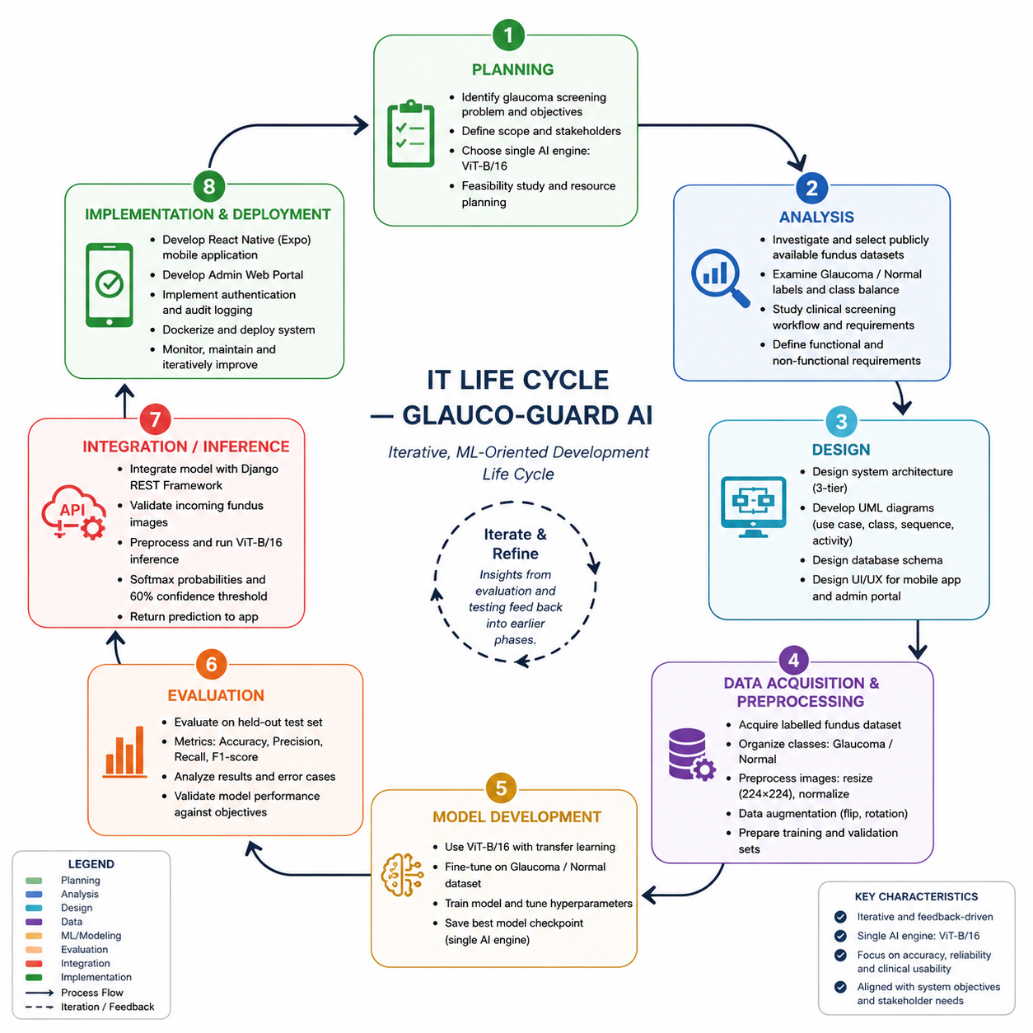

3.2.1 Planning Phase
During the planning phase, the project team discussed the burden of glaucoma-related blindness in Ghana, the practical barriers to conventional screening, and agreed to focus the project on a mobile-accessible, single-engine AI screening tool for retinal fundus images. The team decided not to build multiple competing model engines into the platform, but rather to focus their efforts on fully training, validating, and deploying a single Vision Transformer engine in an effort to keep the system simple to maintain, test, and reason about.

3.2.2 Analysis Phase
In the analysis phase, the team analyzed publicly available clinically annotated retinal fundus image datasets and reviewed sample images and their associated Glaucoma/Normal labels for class balance, image quality and resolution. The team also assessed the clinical fundus-screening workflow described in Section 2.5 to ensure that the prediction pipeline of the system, including image validation and confidence thresholding, represented real-world clinical safeguards rather than a simple pass-through classifier.

3.2.3 Design Phase
The project team used a combination of Unified Modeling Language (UML) and system architecture diagrams to design the proposed system, capturing key decisions and structural understanding before starting the implementation.

3.2.4 Data Acquisition and Preprocessing Phase
As per the system design, the project team acquired the retinal fundus image dataset for model development. The dataset was divided into the 2 target classes, Glaucoma and Normal, to fulfill the binary classification goal of the project. The acquired images were then preprocessed using a pipeline that involved image resizing, normalization, and data augmentation for model training. The images were resized to the input size of the ViT-B/16 model and we introduced controlled variations to the training data by using augmentation. The dataset was split into training and validation sets for subsequent model development and evaluation.

3.2.5 Model Development Phase
The project team trained the single Vision Transformer (ViT-B/16) engine chosen during the planning and design stages during the model development phase. Transfer learning with pre-trained weights was used to start the model, followed by tuning with the prepared retinal fundus dataset. The model was trained to differentiate between the two target classes i.e. Glaucoma and Normal. Training performance was monitored using loss and classification accuracy and the model checkpoint with the best validation performance was retained for incorporation into the screening system. The project intentionally did not bring in multiple competing models but stuck to a single AI inference engine.
3.2.6 Evaluation Phase
After the model development, the trained ViT-B/16 model was evaluated to assess its classification performance and suitability for the proposed screening application. Evaluation was performed on a held-out dataset using standard classification metrics (accuracy, precision, recall, F1-score). The training and validation loss as well as accuracy were also monitored to evaluate the learning behavior of the model during the training. The evaluation results were then used to identify weaknesses in model performance and whether further adjustments to preprocessing, training or model configuration were needed. Thus, this phase provided feedback that could be used to improve earlier phases of the iterative development process.
3.2.7 Integration and Inference Phase
Post evaluation of the model, the selected ViT-B/16 engine was incorporated into the backend of the application with the help of Django REST Framework. The inference pipeline was built to accept retinal fundus images uploaded via the mobile application, validate the images, run the necessary pre-processing and send valid images to the trained model for the inference. The model provides the probability values of the Glaucoma and Normal classes and the predicted class and confidence value are taken from them. A confidence threshold is applied to filter out low-confidence predictions from being reported as reliable screening results. Images that do not pass validation, or do not produce a high enough confidence, are run through the appropriate safeguard mechanisms before a result is returned to the user. The project documentation emphasizes that image validation and confidence thresholding are critical safeguards in the prediction pipeline.
3.2.8 Implementation and Deployment Phase
The last phase was the implementation and deployment of the full Glauco-Guard AI platform, with the trained AI model, the backend services, the mobile application and the administrative functionality. The user’s application was developed with React Native using Expo. The backend was developed using Django REST Framework. The system consisted of features for authentication, diagnostic-record management, fundus-image validation, and the Clinical Administrator Dashboard with Report Vault. The finished system was containerized using Docker to allow for consistent and repeatable deployment. System testing was carried out to confirm the functionality of the API, image-validation safeguards, mobile application and the overall prediction workflow. The project documentation confirms the system includes the Django REST backend, Expo/React Native application, Docker deployment, image validation, confidence thresholding, and administrator reporting functionality.
Iterative Feedback Across the Life Cycle
Although the phases are presented in a logical order, the methodology was not considered a strictly linear process. The project followed an iterative, machine learning-focused development process, where knowledge gained from model training, evaluation and system testing could be fed back to improve earlier decisions on data preparation, model configuration and system design and implementation. This iterative approach was especially important because the performance of the model and the behavior of the system could only be evaluated after the relevant components were developed and tested. The development cycle enabled the team to transition between phases as needed until the required model performance and system functionality were met.

System Architectural Design
Figure 3.1: Three-tier architecture of the system: presentation layer with React Native (Expo) mobile application and administrator web portal; application layer with Django REST Framework backend and supporting modules (authentication, audit logging, image validation and administrator dashboard); data/AI layer with ViT-B/16 inference engine, relational database, media storage for uploaded images and generated reports.
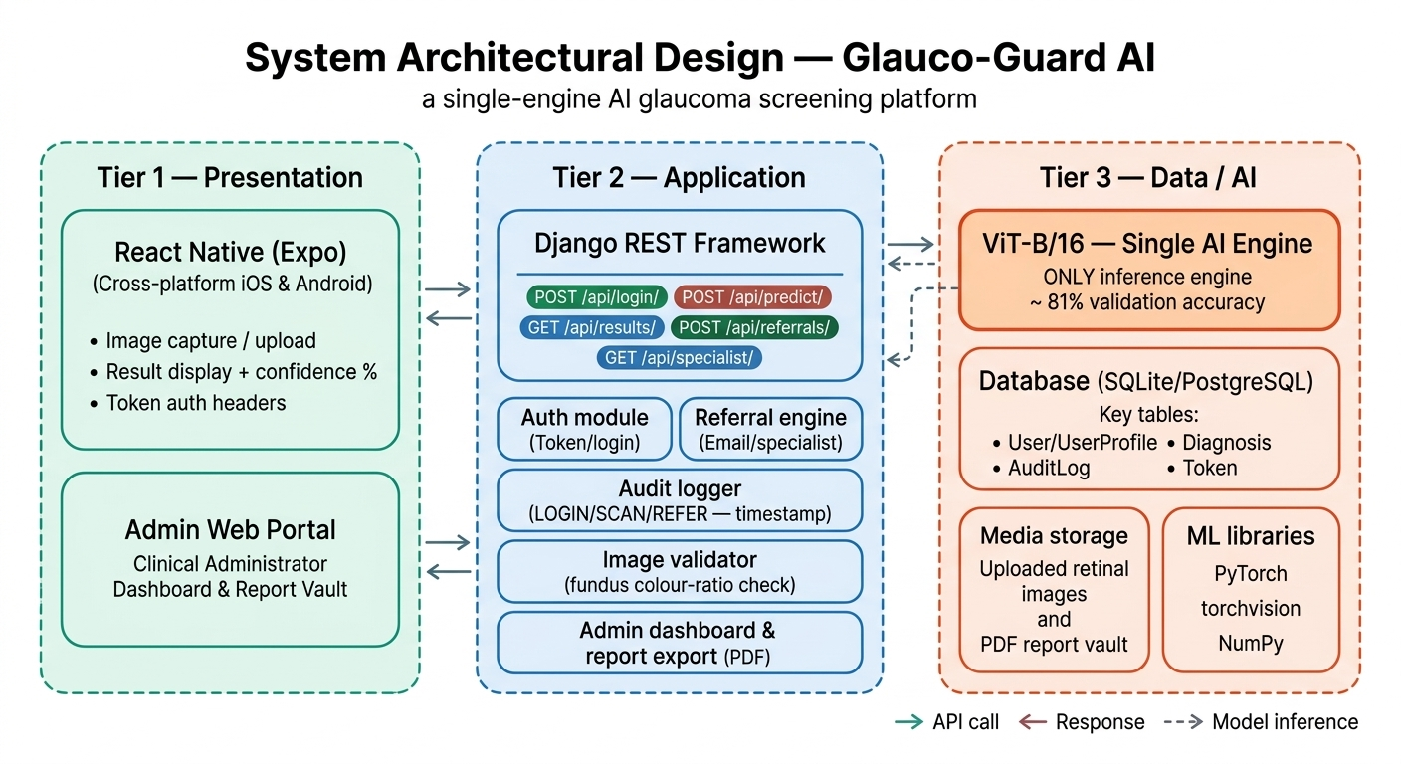
Figure 3.1: System Architectural Design

Use Case Diagram
Fig. 3.2 shows the Glauco-Guard AI use case diagram with the main actors and their functionalities. A patient or field health worker takes or uploads a fundus image using the mobile application, the system validates the image and provides an AI-generated prediction, a clinical administrator reviews diagnostic records and downloads PDF reports via the web portal, and within the planned referral workflow, a referring doctor has the ability to assign a case to a specialist for further review.
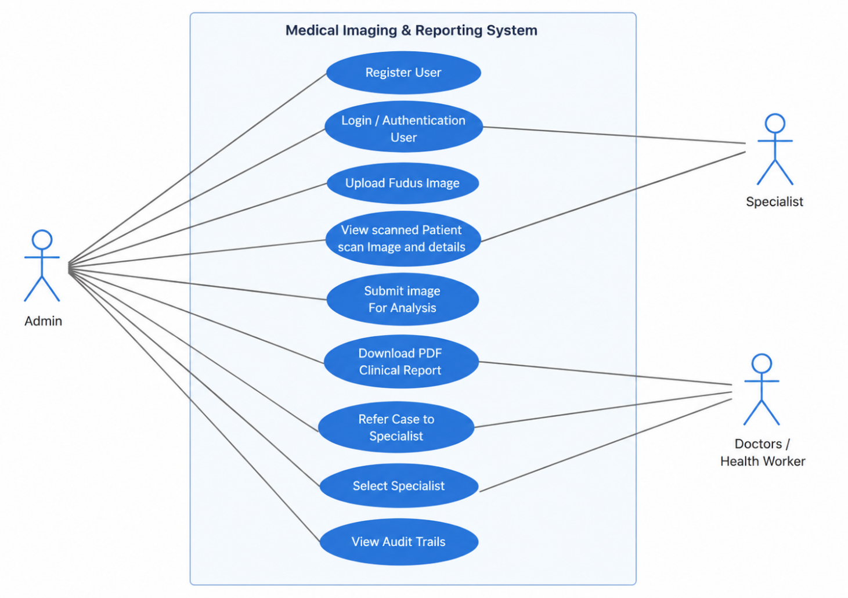
Figure 3.2: Use Case Diagram

System Flowchart
Figure 3.3 presents the system flowchart that illustrates the flow of activities starting from user login and image submission, fundus validation, model inference, confidence thresholding, and finally, the display of a result on the mobile application and its storage for later retrieval through the administrator dashboard.
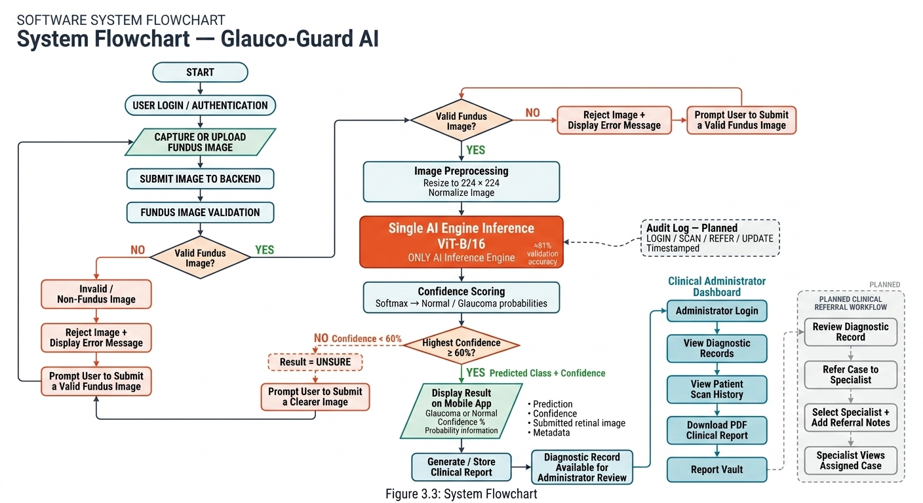

Figure 3.3: System Flowchart

3.3 Data Acquisition and Preprocessing

3.3.1 Data Acquisition
The dataset used for Glauco-Guard AI system development was labeled retinal fundus images for binary classification of glaucoma. These images were obtained from a publicly available dataset of glaucoma on the Kaggle platform. The dataset was downloaded from the Glaucoma_dataset repository published by sreeharims in Kaggle. The dataset is obtained from:
Kaggle: Glaucoma_dataset
Publisher: sreeharims
Dataset URL: https://www.kaggle.com/datasets/sreeharims/glaucoma-dataset
The dataset is a binary classification problem with two classes, Glaucoma and Normal. The two classes were used as target labels to training the classification model of Vision Transformer (ViT-B/16).

The available images were split into training and validation sets to facilitate model development and performance monitoring. The training subset was used to update the model parameters, while the validation subset was used to monitor the model’s ability to generalize to images not used for optimization.
So, the dataset used for the project was structured in accordance with the binary classification task in the following way:
Class 0: Normal.
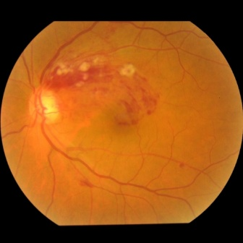
Normal
Class 1: Glaucoma
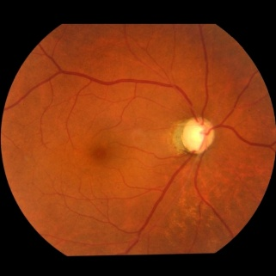
Glaucoma
The use of a binary Glaucoma/Normal classification scheme is consistent with the goal of Glauco-Guard AI, which is designed as a screening tool rather than a multi-stage glaucoma grading system. The output classes of the model are also defined as Glaucoma and Normal in the project document.
Parameter | Training Set | Test Set
Total Samples | 3063 | 990
Image Classes | Glaucoma, Normal | Glaucoma, Normal
Image Resolution | 224 x 224 pixels (after resize) | 224 x 224 pixels (after resize)
Table 3.1: Dataset Parameter Descriptions

3.3.2 Data Preprocessing
Raw fundus photographs cannot be input directly into a neural network without standardization. All images were preprocessed in the same way before use:
- Resizing: All images were initially 512 x 512 pixels and resized to 224 x 224 pixels, the input size of the ViT-B/16 architecture.
- Data Augmentation: During training, a Random Horizontal Flip (probability = 0.5) and a Random Rotation within a range of ±15 degrees were applied to improve generalizability and reduce overfitting. Such augmentations mimic natural variation in image-capture conditions without distorting clinically relevant fundus features.
- Normalization: The pixel values were normalized according to the statistics expected by the pre-trained ViT-B/16 weights.
- The preprocessing steps were implemented with the torchvision, using PyTorch’s transforms module and the Python Image Library (PIL / Pillow) for loading images.

3.4 Model Development

3.4.1 Model Architecture: Vision Transformer (ViT-B/16)
Glauco-Guard AI is a single AI-engine platform based on a Vision Transformer (ViT-B/16) as the sole classification engine. Unlike regular convolutional networks, a Vision Transformer applies a transformer architecture directly to image patches, enabling it to capture long range relationships across the retinal image, instead of only local receptive fields. Testing of the engine yielded a validation accuracy of about 81%.
The model was initialized using pre-trained weights by Transfer Learning, which allows the model to reuse the general visual features that had already been learned by the network and adapt these features for retinal image classification, greatly reducing the amount of labeled medical data required.

Fine-tuning approach:
- All layers were frozen initially and the last four (out of the twelve) transformer blocks and the last LayerNorm were unfrozen for the fine-tuning on retinal fundus images.
- Replaced the original classifier head with a custom head: Dropout (0.5) → Linear (768 → 512) → ReLU → Dropout (0.3) → Linear (512→2) for 2 output classes: Glaucoma and Normal.

3.4.2 Training Parameters
The training was performed on Google Colab with CPU execution due to unavailability of GPU resources during training. The hyperparameters used are as follows:
- Optimizer: Adam (Adaptive Moment Estimation) with a learning rate of 0.001.
- Loss Function: Cross Entropy Loss, with class weights to balance the class imbalance between Glaucoma and Normal classes.
- Batch size: 32 images per training step.
- Training Time: 5 full passes through the training set.
- Checkpointing: The model state with the highest validation accuracy was saved as best_glaucoma_model.pth and this checkpoint was used for all subsequent evaluation and deployment.
The trained model was exported to TorchScript (.pt) for efficient serving through the backend and in a future iteration directly on-device using PyTorch Mobile.

3.4.3 Training and Validation Performance
Loss and classification accuracy were used to monitor the training and validation performance of the ViT-B/16 model. Figure 3.4 shows the training and validation loss and accuracy during the model training process.
Training loss at Epoch 0 is approximately 0.407 and validation loss is approximately 0.435. At Epoch 1, the training loss was reduced to ~0.325 and the validation loss to ~0.397. The decrease of both training loss and validation loss suggests that the model has learned to decrease the classification error during the training.
The training accuracy improved from 81.1% at Epoch 0 to 86.3% at Epoch 1. Validation accuracy also increased from around 80.5% to 81.5%. The increase in validation accuracy indicates that the model is performing better at classifying the validation data as it is being trained.
The training and validation accuracy difference at epoch 1 was approximately 4.8 percentage points. The training accuracy was more than the validation accuracy but the validation accuracy also increased when the validation loss decreased. It implies that the model was learning features useful for discriminating between the classes of Glaucoma and Normal, with no broad divergence between training and validation performance within the epochs recorded. Epoch 0 and Epoch 1 are discussed here in detail as they were representative of the overall training trend observed across all 5 epochs; the complete training and validation loss and accuracy curves for all 5 epochs are presented in Figure 3.4.
Overall, the results are showing an improving training trend. Both loss and accuracy are moving in the expected direction. Figure 3.4 shows the final validation accuracy of around 81.5% with corresponding validation loss of around 0.397.
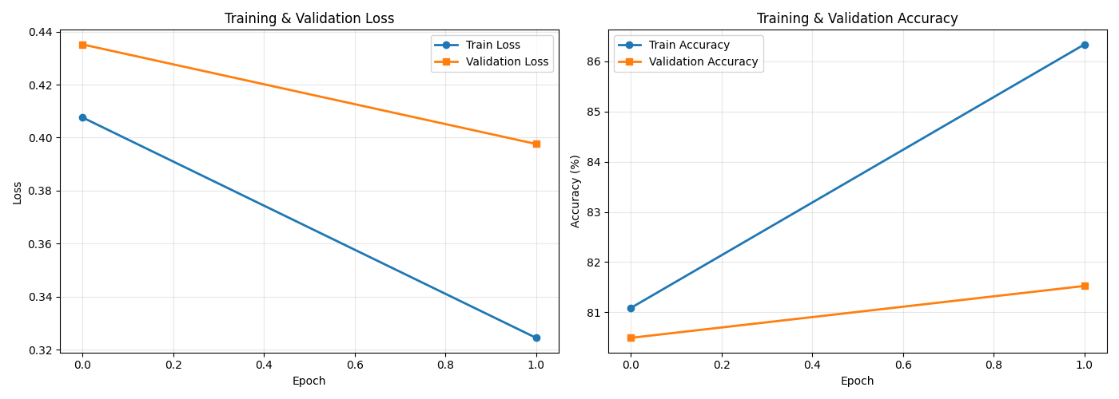
Figure 3.4: ViT-B/16 Training and Validation Loss / Accuracy Curves

3.5 Model Evaluation
The trained engine was evaluated on the held-out test set of 774 samples, none of which were seen during training. To provide a rounded picture of model performance, the following metrics were used: Accuracy, the proportion of correctly classified images across both classes; Precision, the proportion of images predicted as glaucomatous that were genuinely glaucomatous, with high precision minimizing false alarms; Recall (Sensitivity), the proportion of actual glaucoma cases that were correctly detected, a particularly important metric in a screening context where a false negative is costly; and F1-score, the harmonic mean of precision and recall, providing a single balanced measure of performance, especially useful when classes are imbalanced.
Table 3.2 presents the per-class classification results on the test set.
Class | Precision | Recall | F1-Score
Glaucoma | 0.85 | 0.50 | 0.63
Normal | 0.81 | 0.96 | 0.88
Table 3.2: Per-Class Classification Results on the Test Set
The model achieved a precision of 0.85 on the Glaucoma class, meaning that when the model predicted glaucoma, it was correct 85% of the time. However, the recall of 0.50 indicates that the model captured only about half of the actual glaucoma cases in the test set. Performance on the Normal class was notably stronger (F1-score of 0.88), reflecting the class imbalance present in the dataset. While these results are promising for a screening aid, they underline the need to position the system as a support tool for clinicians rather than as a conclusive, stand-alone diagnostic system.

3.6 Model Prediction / Inference Pipeline
Once trained and evaluated, the model is served through the Django REST API backend. When a new fundus image is submitted to the /api/predict/ endpoint, the following steps take place:
- 1. Image validation: The image is checked to confirm that it is a genuine retinal fundus photograph (see Section 4.3.1 on heuristic fundus validation).
- 2. Preprocessing: Once validated, the image is processed using the same pipeline applied during training (resize and normalise).
- 3. Inference: The processed image tensor is passed into the TorchScript-compiled ViT-B/16 model.
- 4. Confidence scoring: The output logits are passed through a Softmax function to produce class probabilities for Normal and Glaucoma.
- 5. Thresholding: If the highest confidence score is below 60%, the result is flagged as "Unsure," and the user is prompted to submit a clearer image. Otherwise, the predicted class and confidence score are returned to the mobile client.
This prediction pipeline ensures that the single-engine system does not return results it is not reasonably confident about, reducing the risk of misleading users with low-confidence predictions.

3.7 Programming Languages and Tools Used
The technologies used in the development of Glauco-Guard AI were selected mainly based on open-source availability, good community support and the compatibility of the tools.

3.7.1 Python and PyTorch
Data preparation, model training, and evaluation were performed in Python. The ViT-B/16 model was built, fine-tuned, and exported using PyTorch and torchvision.

3.7.2 Django and Django REST Framework
Django and the Django REST Framework were chosen for the backend because of their maturity, security features, and suitability for rapidly building secure, well-structured RESTful APIs capable of serving a PyTorch model.

3.7.3 React Native and Expo
With React Native and the Expo toolchain we were able to build one code base on mobile that works on Android and iOS, saving development effort but still giving us native access to the camera and gallery.

3.7.4 Docker
The backend and its dependencies were containerized with Docker, ensuring the same behavior of the application in development, testing and production environments.

3.8 Functional Requirements
Functional Requirements: The definition of what Glauco-Guard AI has to do:
- Image Capture and Submission: The mobile app shall allow the user to capture a fundus image using the device camera or select an image from the device gallery and submit it for analysis.
- Fundus Image Validation: The backend should verify that the image provided is a plausible retinal fundus photo before handing it to the model.
- Single-Engine AI Inference: The backend will classify a validated fundus image as Glaucoma or Normal using the ViT-B/16 engine and return a confidence score for the prediction.
- Confidence Thresholding: If the confidence of the top class in a prediction is less than 60%, the system will label that prediction as “Unsure” instead of giving a diagnosis.
- Result Display: The mobile application will display the predicted class and confidence score to the user in a clear, color-coded results screen.
- Diagnostic Record Storage: The system shall store each prediction, the submitted image and metadata to be retrieved in the future.
- Administrator Review: The Clinical Administrator Dashboard should allow authorized users to access the stored diagnostic records and download the PDF clinical reports from the Report Vault.

3.9 Non-Functional Requirements
The non-functional requirements specify the quality attributes that the system must have:
- Performance: The system shall provide a prediction for a submitted fundus image within 3 seconds under normal network condition.
- Reliability: The fundus-validation and confidence-thresholding safeguards will reliably prevent invalid or low-confidence results from being reported as definitive diagnoses.
Usability: The mobile interface should be simple enough for a non-specialist community health worker to use with minimum training.
- Security: Authentication secures the Clinical Administrator Dashboard and diagnostic records, sensitive patient data shall not be accessible to unauthorized access.
- Portability: The backend and dependencies will be fully containerized, enabling the system to be deployed consistently on different servers without manual configuration.
- Maintainability: The platform uses a single AI engine, not multiple competing engines. This means that the model serving code will be simple enough for the development team to maintain, retrain, and redeploy without affecting the rest of the system.

3.10 Summary
The methodology used in the development of Glauco-Guard AI has been described in this chapter: the adopted iterative and ML-based development life cycle, the acquisition and preprocessing of the retinal fundus dataset, the architecture, the fine-tuning and the training of the single ViT-B/16 engine, its evaluation against a held-out test set, the inference pipeline used to serve predictions in a safe manner, the tools and programming languages used in the implementation, and the functional and non-functional requirements that oriented the design of the system. Chapter four discusses the practical implementation and evaluation of the resulting system.

CHAPTER FOUR
RESULTS AND DISCUSSION

4.1 System Development Methodology
The project was developed in an iterative, ML-oriented development approach as described in Chapter Three. The work progressed through data acquisition & understanding, preprocessing, model training & fine-tuning, evaluation, backend & mobile-frontend engineering, and deployment, with lessons from each evaluation cycle feeding back into earlier stages. This approach was adopted to keep the single engine architecture disciplined and well documented through all phases of development.

4.2 System Requirements
To run effectively, all software needs some hardware and software resources to be present. The following requirements describe the environment used to develop and run Glauco-Guard AI.

4.2.1 Hardware Requirements
Requirement | Specification
Processor | Intel Core i5 / AMD Ryzen 5 or higher (development machine); cloud CPU runtime (Google Colab) for training
RAM | 8 GB or higher (development and backend server)
Storage | 20 GB or higher free disk space (model checkpoints, media uploads, and Docker images)
Mobile Device | Android or iOS smartphone with a functioning camera
Table 4.1: Hardware Requirements of the System

4.2.2 Software Requirements
Requirement | Specification
Operating System | Windows 10/11, Linux, or macOS (development); Linux container base image (deployment)
AI / Model Training | Python 3.x, PyTorch, torchvision, Google Colab
Backend | Django, Django REST Framework
Mobile Frontend | React Native, Expo, Expo Router, Axios
Database | SQLite (development) / PostgreSQL (production)
Deployment | Docker, Docker Compose
Table 4.2: Software Requirements of the System

4.3 System Implementation

4.3.1 Backend Engineering: Django REST Framework
The backend serves as the intelligence layer of Glauco-Guard AI, connecting the mobile frontend, the web portal, and the single ViT-B/16 inference engine. It is built on Django and the Django REST Framework (DRF), a robust Python web framework well-suited to building secure, scalable RESTful APIs. The most important backend components are:
- Model Loading: The ViT-B/16 model (glaucoma_vit_mobile_model.pt) is loaded once at server startup using torch.jit.load, and is held in memory so it is immediately available for inference without restarting the server for each request.
- Heuristic Fundus Image Validation (isFundusImage): Before any image is sent to the model, the system analyses its colour composition. Retinal fundus images have a characteristic appearance, predominantly orange or red, with a well-lit retina and low blue-channel values. The function calculates the ratio of red-to-blue channel intensity, and if this ratio falls outside the expected range for fundus images, the submission is rejected with a clear error message, preventing irrelevant photographs such as selfies, documents, or landscapes from being fed to the model.
● Confidence Thresholding: Even after passing fundus validation, the model can still output low confidence predictions on ambiguous or low-quality images. Any result whose highest probability prediction is below 60% is returned to the client as "Unsure", prompting the user to submit a clearer image.
● API Endpoint: The main inference endpoint is /api/predict/ (HTTP POST), which takes a multipart image upload and returns a JSON object containing the predicted class (Glaucoma or Normal), the confidence score and the per-class probability distribution.

4.3.2 Frontend Engineering: Expo and React Native
The mobile client is built with React Native and the Expo framework, enabling a single, cross-platform codebase to run on both iOS and Android. The interface was designed to be clean, accessible, and intuitive so that users with minimal technical background can use it comfortably. The core frontend functionality consists of:
- Image Capture and Selection: Users can capture a live image using the device camera or choose an existing image from the device gallery, both supported through Expo's ImagePicker API.
- API Communication: Images are encoded and sent to the Django backend's /api/predict/ endpoint using Axios, a common React Native HTTP client. The app handles network errors gracefully, displaying clear messages when the backend is unavailable or validation fails.
- Results Dashboard: On receiving a prediction response, the app displays the predicted class (Glaucoma or Normal) and the AI confidence percentage, together with a probability bar chart representing the relative likelihood of each class. Colour coding (red for Glaucoma, green for Normal) provides immediate visual feedback.
- Navigation: Expo Router provides file-based routing, allowing users to move between the home, scanning, results, and information screens.
Figures 4.1 to 4.3 illustrate the key screens of the mobile application.

4.3.3 Deployment and DevOps: Docker
The entire backend was containerised using Docker to ensure that the system behaves consistently across development, testing, and production environments. Docker packages the application and all of its dependencies into containers, eliminating environment-specific issues. The deployment infrastructure comprises:
- Docker Compose: A docker-compose.yml file defines the multi-container stack of the application, including the Django backend service and any supporting services, coordinating networking and volume mounting.
- Environment Isolation: The Django container locks all Python dependencies (PyTorch, torchvision, Django, DRF, Pillow, and others) to specific versions to ensure reproducibility.
- Volume Mounting: Docker volumes preserve the trained model file and uploaded media, ensuring that model files and images are not lost when a container restarts.
Figure 4.4 illustrates the Docker-based deployment architecture.

4.3.4 Clinical Administrator Dashboard and Report Vault
A key improvement to Glauco-Guard AI is the Clinical Administrator Dashboard and Report Vault web portal, accessible directly from a browser. With this portal the system is no longer a single-user mobile screening tool but a structured platform with administrative oversight. From the dashboard, clinical administrators can view AI-generated diagnostic records and manage patient scans and download PDF clinical reports from the Report Vault. Reports are generated and stored server-side and can be retrieved at any time without requiring access to the mobile application.
On top of this foundation, the following clinical workflow improvements are planned as the trajectory of the platform. The components already implemented are documented here also to show the difference between built and planned functionality.

Authentication and Security Layer (Planned)
Django REST Framework Token Authentication will be used to secure all clinical actions in the proposed system. Once a successful call to /api/login/ is made, the system will verify the user credentials and return a unique token which has to be used in all subsequent calls. Role management will be implemented through a user-profile model. Each user will be assigned one of two clinical roles (Doctor or Specialist), which will determine the views and data accessible to the user.

Accountability and Transparency: Audit Logging (Planned)
The targeted system will have an audit-log model to support medical compliance and accountability by automatically generating a timestamped entry for each critical transaction, including user logins, new AI-powered scans, specialist referrals, and changes to clinical notes. This audit trail is intended to be a clinical paper trail used to support compliance, dispute resolution and troubleshooting of the system.

The Referral Workflow Engine (Planned)
The referral engine to be implemented will allow a referring doctor to: select an available specialist; update the relevant diagnostic record with a referral flag; create an audit-log entry; and send an automated notification email to the specialist with the AI generated confidence level, patient details and scan date. On the specialist side, there is a filtered view which will include only the cases assigned to that specialist.

4.4 System Testing
The goal of testing a work product is to identify all possible defects or weaknesses. Testing aims to find errors and to ensure that components, and the completed system as a whole, function as expected. Each level of testing below addressed a specific test requirement.

4.4.1 Unit Testing
Unit testing ensured that each individual unit of the system was working as designed. The project team tested the fundus-image validation function, the confidence-thresholding logic, and individual API view functions in isolation, with known inputs and expected outputs. The following reasons were considered for unit testing:
● It gives confidence that the code is correct before it is merged.
● Make the code more reliable and reusable.
● It is cheaper to detect and correct a defect in unit testing than to detect and correct the same defect at a later stage.
● It is easier to debug a unit in isolation than in a fully integrated system.

4.4.2 Integration Testing
- Integration testing of the interfaces and data flow between modules, in particular between the mobile frontend, the Django REST API, and the ViT-B/16 inference engine. Using Postman, we tested the /api/predict/ endpoint with valid and invalid POST requests to ensure that the JSON response structure is correct, the HTTP status codes are returned correctly and error cases are handled properly. Advantages of Integration Testing are:
● Catch system level issues such as broken request/response contracts between the mobile app and the backend.
● Identifying bugs earlier in the development cycle rather than later.
● Improved confidence in the overall development cycle.
● More reliable and easily isolatable test failures than full end-to-end tests.

4.4.3 System Testing
System testing confirmed the entire, fully integrated system, testing end-to-end behavior from image capture on the mobile app through to result display. The project team ran the system on several Android and iOS devices and on a clean machine with the Dockerised backend to confirm that the containerized application could be launched without manually installing dependencies. The reasons for performing system testing are:
● Testing the complete integrated system, including the interaction between the mobile app, backend, and model as a whole (end-to-end testing).
● Performing tests on all inputs to the system to see if the expected outputs are produced.
● Test the general user experience of the system.

4.4.4 Acceptance Testing
The last stage of testing before the system was ready for beta use was acceptance testing. The project team undertook acceptance testing through a beta release to a small group of external users with varying levels of technical and medical understanding to assess the system’s compliance with its stated requirements and to obtain feedback about usability, interface design and perceived reliability. Reasons you would do acceptance testing include:
● To detect faults that were missed in earlier stages of testing.
● To minimize or remove problems that might otherwise be exposed after broader distribution.
The feedback received during beta testing was mostly positive; the dashboard displaying the results was considered clear and visually accessible and the confidence meter was singled out by many testers as being particularly useful in understanding how much trust to place in a specific AI prediction. Suggested improvements included the addition of informational text about glaucoma and a clear reminder to consult a clinician regardless of the AI result; both suggestions were incorporated into the final version of the application, with an informational disclaimer added to the results screen and a “Learn More” section added to the home screen.
AI engine, system correctness and user experience were evaluated together as a whole. As discussed in Chapter Three, the single ViT-B/16 engine achieved a validation accuracy of around 81% with a well-generalised training curve and little over-fitting. API endpoints correctly responded to both valid and invalid inputs, and the heuristic fundus-validation step correctly rejected 100% of non-fundus images used during alpha testing. The confidence-thresholding mechanism successfully detected low-confidence predictions instead of showing them as final results. Beta testers were positive about the mobile interface and found that the time to display a result after uploading an image was always less than three seconds, which they considered acceptable.

4.5 The System Screenshots

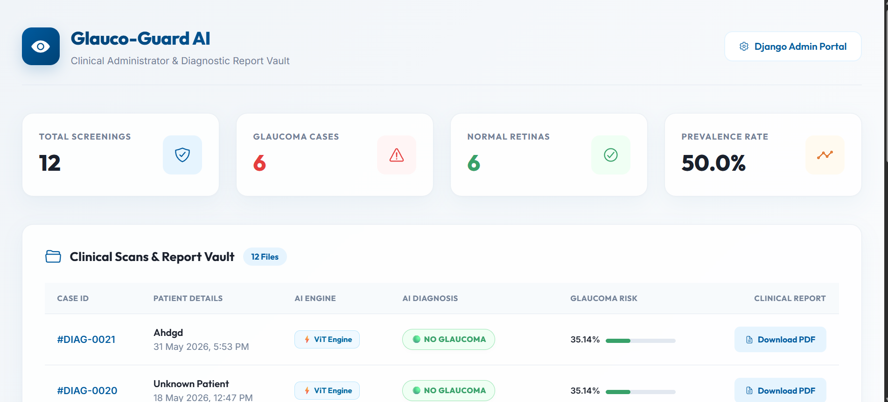

Figure 4.1 dashboard

This dashboard provide the administrators to download report pdfs, view total screenings, normal and affected glaucoma retinal.

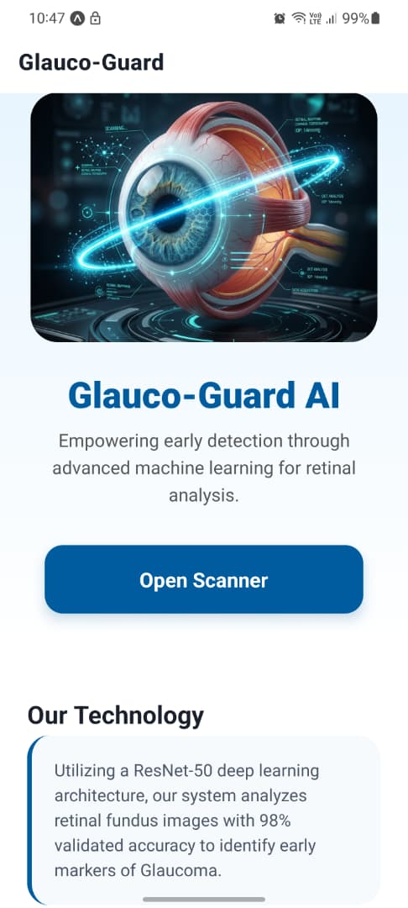
Figure 4.2 home screen
The home screen provides the entry point into the mobile application, giving users quick access to the scanning interface and information about the system.
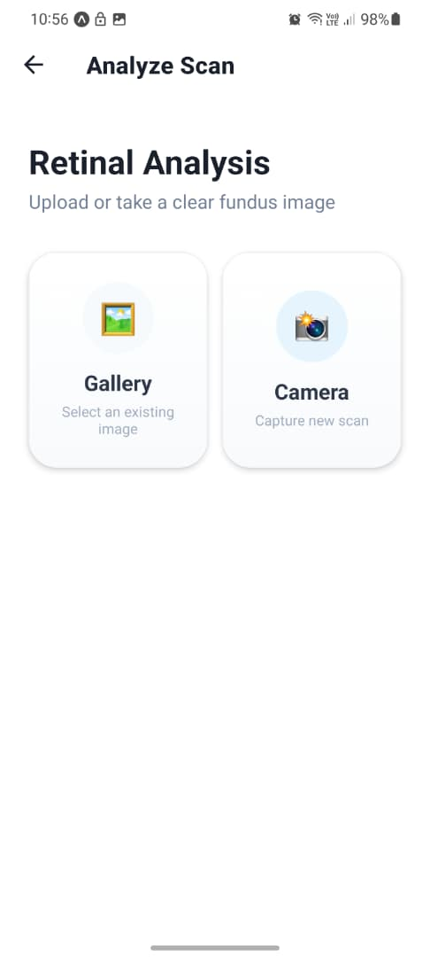
Figure 4.3: Image Upload Screen
This screen allows the user to capture a new fundus image with the device camera or select an existing one from the gallery before submitting it for analysis.
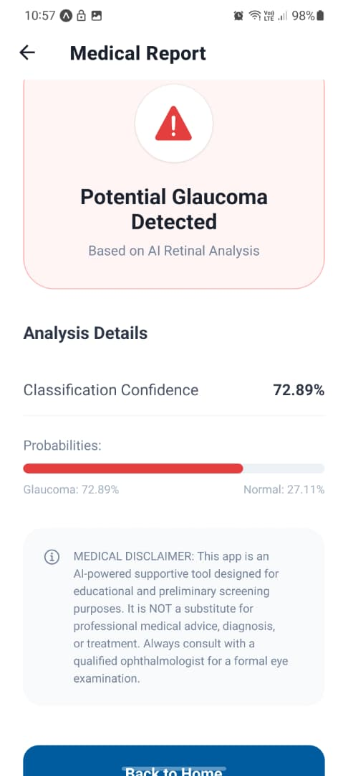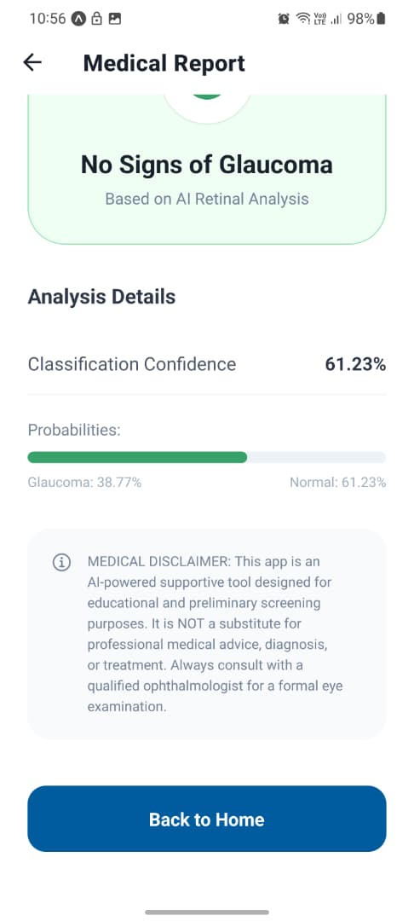

Figure 4.4: Result Screen
The result screen displays the predicted class (Glaucoma or Normal) together with the AI confidence percentage and a probability bar chart, using colour coding for immediate visual feedback.
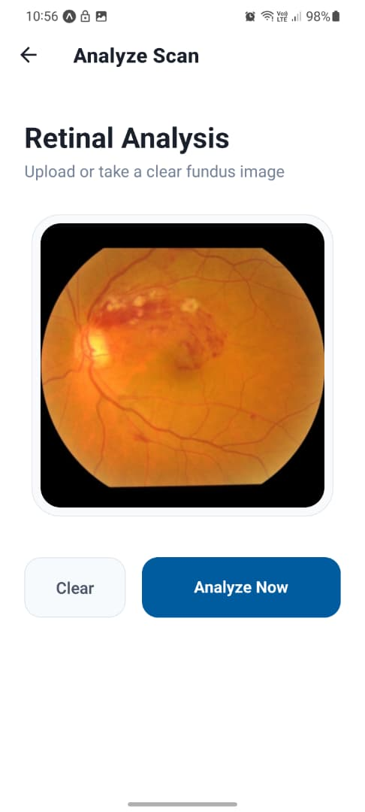
Figure 4.5: Docker Deployment Architecture
This diagram illustrates how the backend, model, and supporting services are packaged and orchestrated through Docker and Docker Compose for consistent deployment.
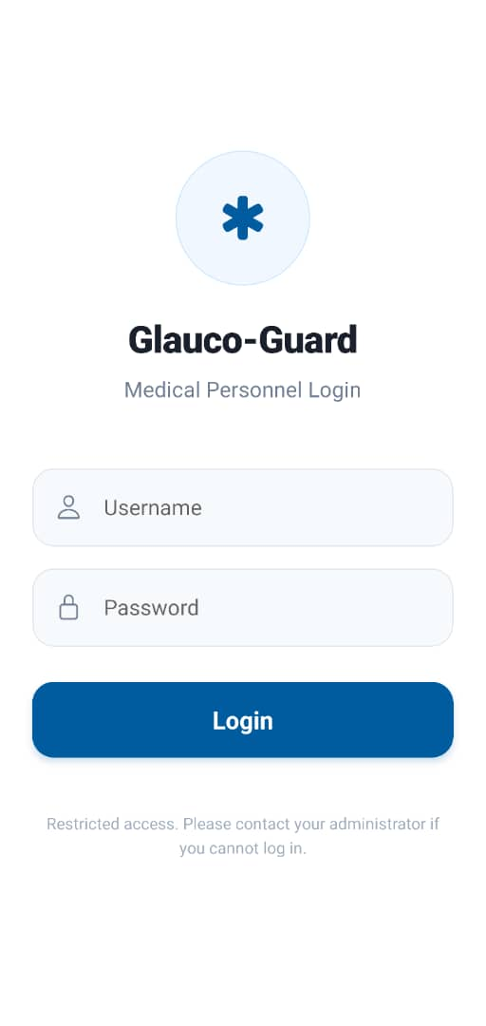
Figure 4.6: Login and Authentication Screen
This planned screen will allow doctors and specialists to securely authenticate before accessing clinical records on the administrator portal.
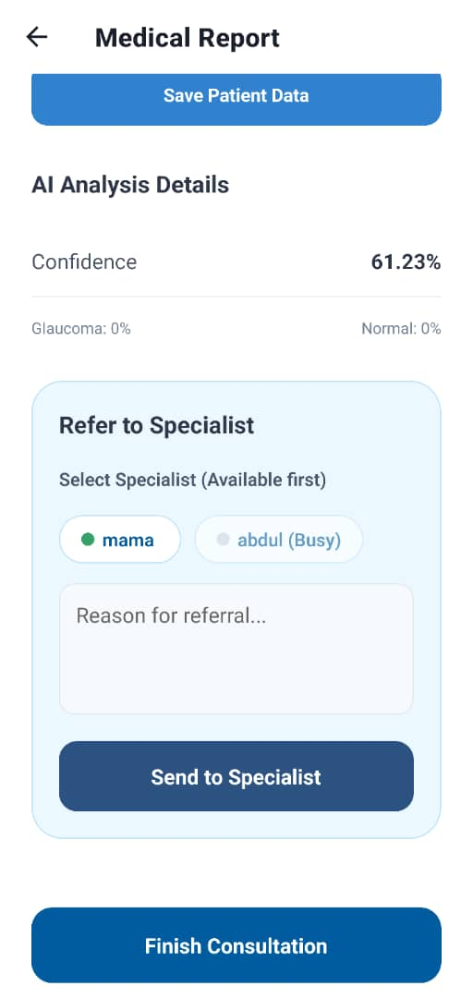
Figure 4.7: Specialist Selection and Referral Screen
This planned screen will allow a referring doctor to select an available specialist and attach referral notes to a diagnosed case.
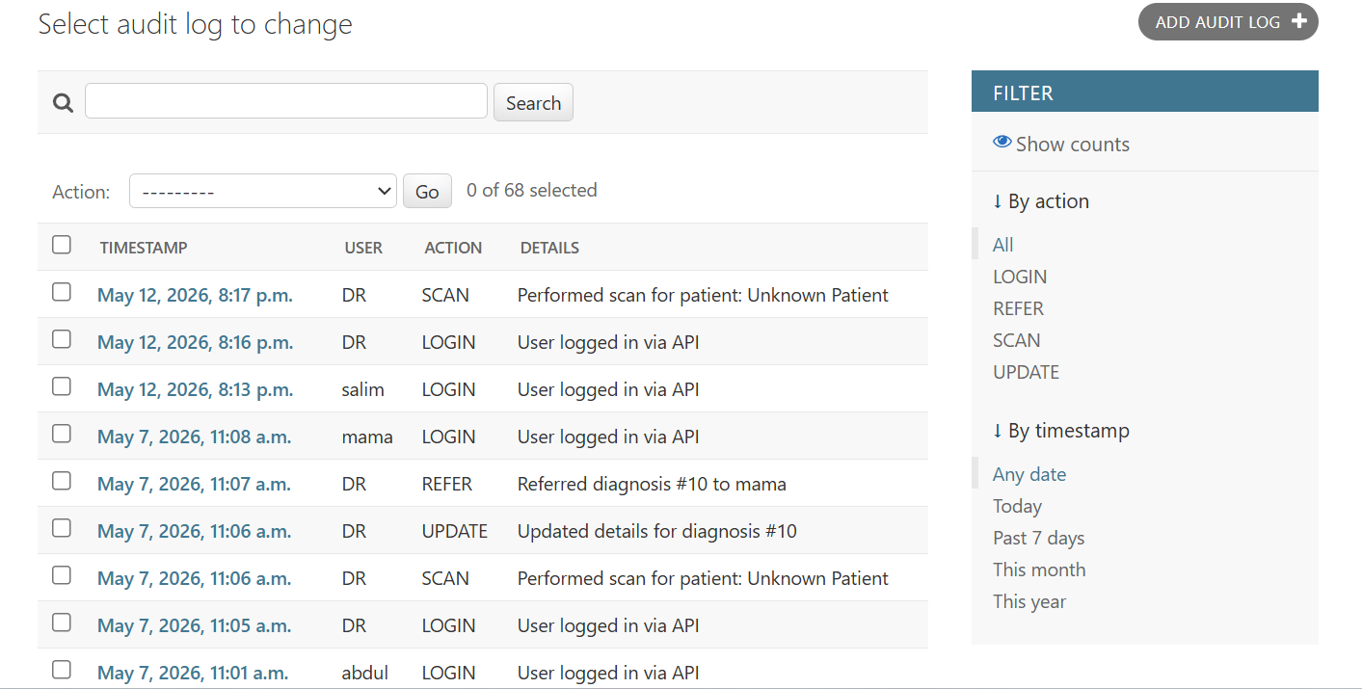
Figure 4.8: Audit Log and Case History Screen
This planned screen will present a timestamped audit trail of login, scan, referral, and update actions for accountability and compliance purposes.

4.6 Conclusion
In this chapter we have reported on the practical implementation of the Glauco-Guard AI, starting from the backend AI inference service, through the mobile user interface and deployment infrastructure, to the testing and evaluation activities that have been performed. These activities have confirmed that the single-engine system is working correctly, providing AI-based predictions with appropriate safeguards, and is generally usable by its target audience. Chapter Five summarizes the results, discusses the limitations, provides recommendations, and draws the conclusion from these findings.

CHAPTER FIVE
SUMMARY, CONCLUSION AND RECOMMENDATION

5.1 Summary
The project is a single AI-engine, mobile accessible system developed to automate the early detection of glaucoma from retinal fundus images. The system is designed and proven to deliver the following benefits:
● Glaucoma screening is now simple and accessible thanks to a mobile application.
● One well-validated Vision Transformer (ViT-B/16) engine classifies fundus images at a speed far in excess of manual clinical assessment.
● Bad quality or irrelevant images are automatically rejected by the system, decreasing the chance of unreliable results.
● Low-confidence predictions will be marked as “Unsure,” which will trigger a repeat scan rather than a misdiagnosis.
● Clinical administrators can access diagnostic records and download clinical reports in pdf format using a web-based dashboard.
● Quick and easy access to patient past diagnostic history and reports.
● It is easier to maintain, test and extend the platform as clinical needs grow over time because it is built around one engine rather than several.
● The mobile app and the backend are deployed separately with Docker. Therefore, there is no need to take down the entire running system for future updates.
● AI-generated diagnostic data is standardized and not subject to manual interpretation, facilitating decisions made by clinicians and administrators.

5.2 Conclusion
The project has been successful in demonstrating the possibility of a one AI-engine, mobile-accessible glaucoma detection system, all built on open-source technologies. The proposed system is a scalable and readily accessible screening aid that can be used for the early detection of glaucoma in underserved communities by combining a transfer-learned Vision Transformer (ViT-B/16) with a robust API backend, intelligent image validation, and an intuitive mobile interface.
While the current system has limitations, in particular moderate glaucoma recall and no formal clinical validation, it provides a robust technical base for future iterations. The recommendations in this chapter offer a clear roadmap for the evolution of this single-engine prototype into a clinically deployable tool.
Ultimately, the work points to the transformative potential of AI in democratizing healthcare. AI-powered glaucoma screening, based on a single well-understood engine and with ongoing development, collaboration with ophthalmologists and rigorous clinical evaluation, could help preserve the sight of people who would otherwise never have access to a specialist examination.

5.3 Recommendation
Based on the limitations presented and overall trends observed in the literature, the following recommendations are made for future work:
● GPU acceleration and larger epochs: Retraining the model with GPU acceleration, a larger epoch budget (e.g. 30-50 epochs) and a learning-rate schedule will likely improve both accuracy and more importantly glaucoma recall.
● State-of-the-Art Augmentation and Regularization: Techniques such as MixUp, CutMix and test-time augmentation could further improve model generalization and robustness to variation in image quality.
● Explainability with Grad-CAM Integration: The integration of Gradient-weighted Class Activation Mapping (Grad-CAM) allows the generation of visual heat maps over fundus images, highlighting for clinicians the most influential regions of an image for a given prediction.
● Multi-Class Staging: Moving from a binary classification task (Glaucoma/Normal) to a more granular scheme (e.g. Normal / Suspect / Mild / Moderate / Severe) would make the system output more clinically actionable.
● Multimodal Data Integration: Future versions may include OCT data in addition to fundus images, integrating structural and functional retinal information for improved diagnostic precision.
● On-Device Inference: Deploying the TorchScript model directly on the mobile device using PyTorch Mobile would eliminate the need for a live network connection and allow the tool to work offline, which is particularly important in rural Ghana.
● Clinical Validation Study: A formal prospective clinical study should be done in collaboration with teaching hospitals affiliated with UENR where the system’s predictions would be compared with the clinicians diagnosis on real patient data.
● Production-Ready Backend: For wider deployment, the system should be migrated to PostgreSQL and deployed behind a scalable, cloud-based infrastructure, such as AWS, Google Cloud, or a local server farm.

REFERENCES
Davis, F. D. (1989). Perceived usefulness, perceived ease of use, and user acceptance of information technology. MIS Quarterly, 13(3), 319–340.
Diaz-Pinto, A., Morales, S., Naranjo, V., Köhler, T., Mossi, J. M., & Navea, A. (2019). CNNs for automatic glaucoma assessment using fundus images: an extensive validation. BioMedical Engineering OnLine, 18(1), 1–19.
Elangovan, P., & Nath, M. K. (2022). Ensemble of deep convolutional networks for glaucoma detection using stacking ensemble learning. Biomedical Signal Processing and Control, 81, 104357.
He, K., Zhang, X., Ren, S., & Sun, J. (2016). Deep residual learning for image recognition. In Proceedings of the IEEE Conference on Computer Vision and Pattern Recognition (CVPR) (pp. 770–778).
Islam, S., et al. (2025). Novel deep learning model for glaucoma detection using fusion of fundus and optical coherence tomography images. Sensors, 25(14), 4337.
Joshi, S., Partibane, B., Hatamleh, W. A., Tarazi, H., Yadav, C. S., & Krah, D. (2022). Glaucoma detection using image processing and supervised learning for classification. Journal of Healthcare Engineering, 2022, Article 2988262.
Khonde, T. W., Puri, C., Hajbe, J. R., & Talvekar, S. V. (2026). AI-powered retinal disease classifier using fundus images. IEEE.
Norouzifard, M., Samaeili, A., & Turuwhenua, J. (2025). Glaucoma detection for automated referral system: using OCT data and fine-tuning LLM models.
Park, K., Kim, J., & Lee, J. (2020). Visual field prediction using recurrent neural network. Scientific Reports, 9(1), 8385.
Saha, S., Vignarajan, J., & Frost, S. (2023). A fast and fully automated system for glaucoma detection using colour fundus photographs. Scientific Reports, 13(1), 1–11.
Shoukat, A., Akbar, S., Hassan, S. A., Iqbal, S., Mehmood, A., & Ilyas, Q. M. (2023). Automatic diagnosis of glaucoma from retinal images using deep learning approach. Diagnostics, 13(10), 1738.
Tajbakhsh, N., Shin, J. Y., Gurudu, S. R., Hurst, R. T., Kendall, C. B., Gotway, M. B., & Liang, J. (2016). Convolutional neural networks for medical image analysis: Full training or fine tuning? IEEE Transactions on Medical Imaging, 35(5), 1299–1312.
Ucgul, A. Y., & Aktas, Z. (2025). Revolutionizing glaucoma care: Harnessing artificial intelligence for precise diagnosis and management.
Veena, H. N., Muruganandham, A., & Kumaran, T. S. (2022). A novel optic disc and optic cup segmentation technique to diagnose glaucoma using deep learning CNN over retinal fundus images. Journal of King Saud University – Computer and Information Sciences, 34(8), 6187–6198.
Velpula, V. K., & Sharma, L. D. (2023). Automatic glaucoma detection from fundus images using deep convolutional neural networks and exploring network behaviour using visualisation techniques. SN Computer Science, 4, 487.
World Health Organisation. (2023). Blindness and vision impairment. WHO Fact Sheet.
Zedan, M. J., Zulkifley, M. A., Ibrahim, A. A., Moubark, A. M., Kamari, N. A. M., & Abdani, S. R. (2023). Automated glaucoma screening and diagnosis based on retinal fundus images using deep learning approaches: A comprehensive review. Diagnostics, 13(13), 2180.
Zhu, Y., Salowe, R., & O'Brien, J. M. (2024). Advancing glaucoma care: Integrating artificial intelligence in diagnosis, management, and progression detection.

