Question 4-Written Question

Run “strace -c” and “time” on your bash script from Q1 and your C/C++ program from Q3 and compare the results. Include the output of the above commands in your report, and explain why the results are different.

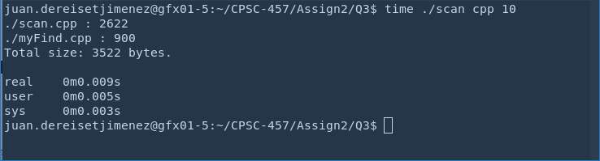
Results of time from scan.cpp

Results of time command for scan.sh

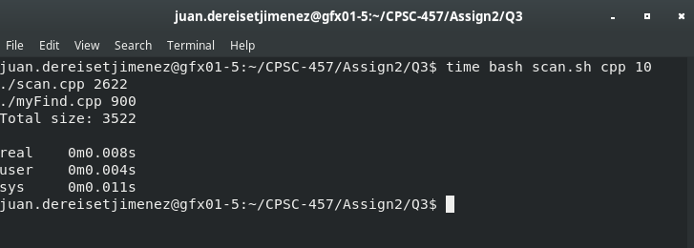

Results of strace -c command for scan.cpp

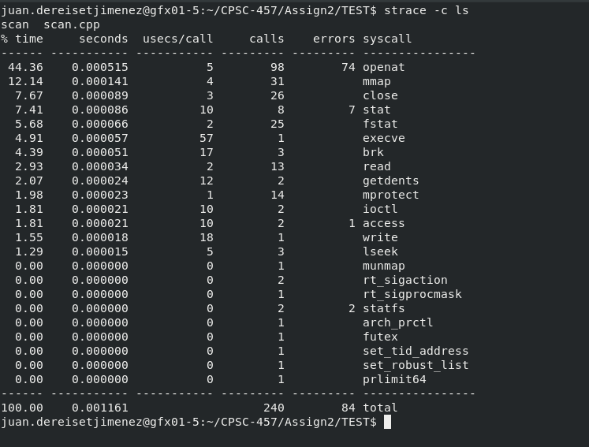

Results of strace -c command for scan.sh

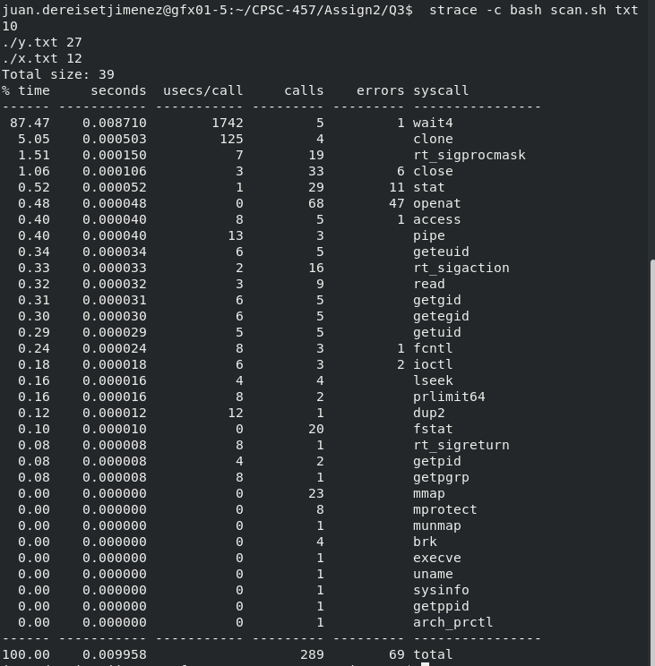

Results Explanation:

The c++ program, scan.cpp, is faster than the bash script, scan.sh. The reason for this performance difference is due to the fewer system calls that the c++ program made in comparison to the bash script. As we can see the bash files makes 289 calls while cpp only makes 240. Therefore we know that scan.cpp is faster than scan.sh. The C program, however utilizes both user mode and kernel mode, and spends less time in kernel mode.

