Institutional Operations Report
SYNTHETIC TEST DATA

Table of Contents

1. Executive Summary
This synthetic report exercises common institutional document structures. KHZ local documentation

1.1 Scope
The fixture contains styles, tables, images, headers, footers, lists, comments, tracked changes, and fields. Inserted synthetic tracked-change text.
- Operational continuity
- Evidence-based verification
- Create backup
- Validate backup

2. Metrics
Department | Cases | Average Time | Status
Operations | 124 | 3.4 | On target
Finance | 87 | 2.1 | On target
Quality | 33 | 5.0 | Review
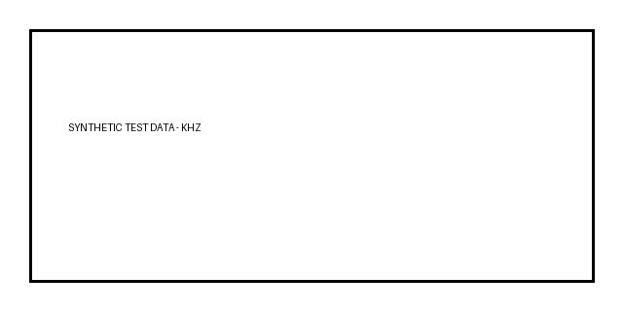
Figure 1. Synthetic fixture image

3. Review
Review note target sentence for comment testing.

