ASLWrite Google Chrome Extension Guide

Table of Contents

Summary 2

Handshapes 3

Diacritics 4

Movement Marks 4

Body Positions 4

Extramanual Marks 5

Symbol Modifiers 6

Height 6

Rotation 7

Mirror 8

Modifiers Summary 8

Symbol Spacers 9

Examples 10

YOU 10

I/ME 10

GO AHEAD 11

ADDRESS 11

FAMILY 12

REMEMBER 12

Appendix: Extended Dictionary 13

# Summary

ASLWrite Viewer Google Chrome extension can be downloaded here:

Main Facebook Page: <https://www.facebook.com/groups/434728996688075>

Dictionary Facebook Page: <https://www.facebook.com/groups/ASLwords/>

Written ASL words and sentences are formed by modifying and combining symbols with the following structure:

[Symbol] [Mirror] [Rotation] [Height] [Spacer]

Every combination must begin with a Symbol and end with a Spacer. The Symbol can be a Handshape, Diacritic, Movement Mark, Body Position, or Extramanual Mark. Height, Rotation, and Mirror modifiers are optional and can be used in any order.

See the following sections for more information.

Current project completion status: **45% Complete** (43/97 symbols)

# Handshapes

All symbols are case-sensitive.

|  |  |  |  |  |  |
| --- | --- | --- | --- | --- | --- |
| **1** | **Coming Soon** | **Coming Soon** | **Coming Soon** | **5** | **Coming Soon** |
| **%** | **Coming Soon** | **C** | **Coming Soon** | **x** | **k** |
| **f** | **h** | **Coming Soon** | **Coming Soon** | **Coming Soon** | **Coming Soon** |
| **b** | **B** | **s** | **a** | **A** | **y** |
| **o** | **c** | **g** | **Coming Soon** | **Coming Soon** | **Coming Soon** |
| **Coming Soon** | **Coming Soon** | **l (lowercase L)** | **Coming Soon** | **Coming Soon** | **i** |
| **d** | **e** | **m** | **n** | **Coming Soon** | **Coming Soon** |
| **Coming Soon** |  |  |  |  |  |

# Diacritics

All symbols are case-sensitive.

|  |  |  |  |  |
| --- | --- | --- | --- | --- |
| **.** | **:** | **@c** | **@o** | **@w** |
| **@s** | **@p** | **Coming Soon** | **Coming Soon** |  |

# Movement Marks

All symbols are case-sensitive.

|  |  |  |  |  |  |
| --- | --- | --- | --- | --- | --- |
| **!** | **!:** | **Coming Soon** | **!z** | **!t** | **Coming Soon** |
| **Coming Soon** | **Coming Soon** | **Coming Soon** | **Coming Soon** | **Coming Soon** | **Coming Soon** |
| **Coming Soon** | **Coming Soon** | **Coming Soon** | **Coming Soon** | **!c** | **Coming Soon** |

# Body Positions

All symbols are case-sensitive.

|  |  |  |  |  |
| --- | --- | --- | --- | --- |
| **Coming Soon** | **Coming Soon** | **Coming Soon** | **[** | **[a** |
| **Coming Soon** | **Coming Soon** | **}** | **}~** | **Coming Soon** |
| **}]** | **Coming Soon** | **Coming Soon** |  |  |

# 

# Extramanual Marks

All symbols are case-sensitive.

|  |  |  |  |  |
| --- | --- | --- | --- | --- |
| **Coming Soon** | **Coming Soon** | **Coming Soon** | **Coming Soon** | **Coming Soon** |
| **Coming Soon** | **Coming Soon** | **Coming Soon** | **#p** | **Coming Soon** |
| **Coming Soon** | **Coming Soon** | **#o** | **Coming Soon** | **Coming Soon** |
| **Coming Soon** | **Coming Soon** | **Coming Soon** | **Coming Soon** | **Coming Soon** |

# Symbol Modifiers

## Height

Four height offsets are available. They can be combined or repeated for additional offset. The symbols are:

|  |  |
| --- | --- |
| Large Upwards Offset (3x Small offset) | **‘** |
| Small Upwards Offset | **;** |
| Small Downwards Offset | **.** |
| Large Downwards Offset (3x Small offset) | **,** |

Example: The ‘a’ symbol has been offset to 13 different heights using various combinations of offsets:

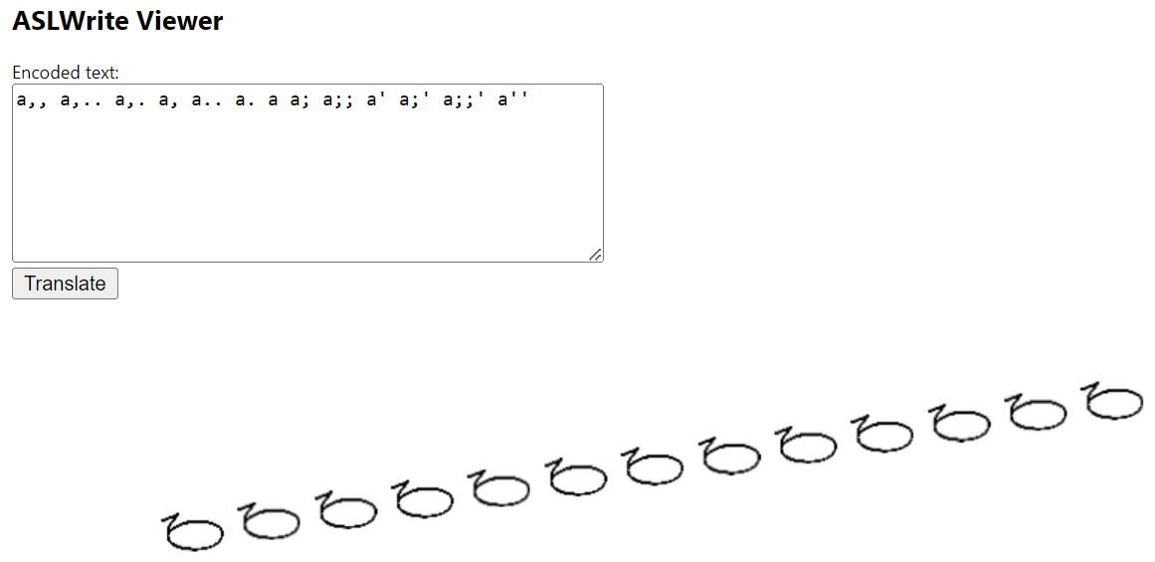

## Rotation

Eight rotation angles are available. They are:

|  |  |
| --- | --- |
| 0 Degrees | (leave blank) |
| 45 Degrees | **1** |
| 90 Degrees | **2** |
| 135 Degrees | **3** |
| 180 Degrees | **4** |
| 225 Degrees | **5** |
| 270 Degrees | **6** |
| 315 Degrees | **7** |

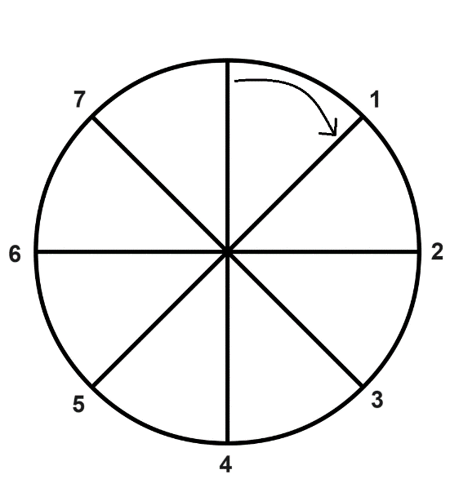

Example: The ‘a’ handshape has been rotated to all 8 rotation possibilities

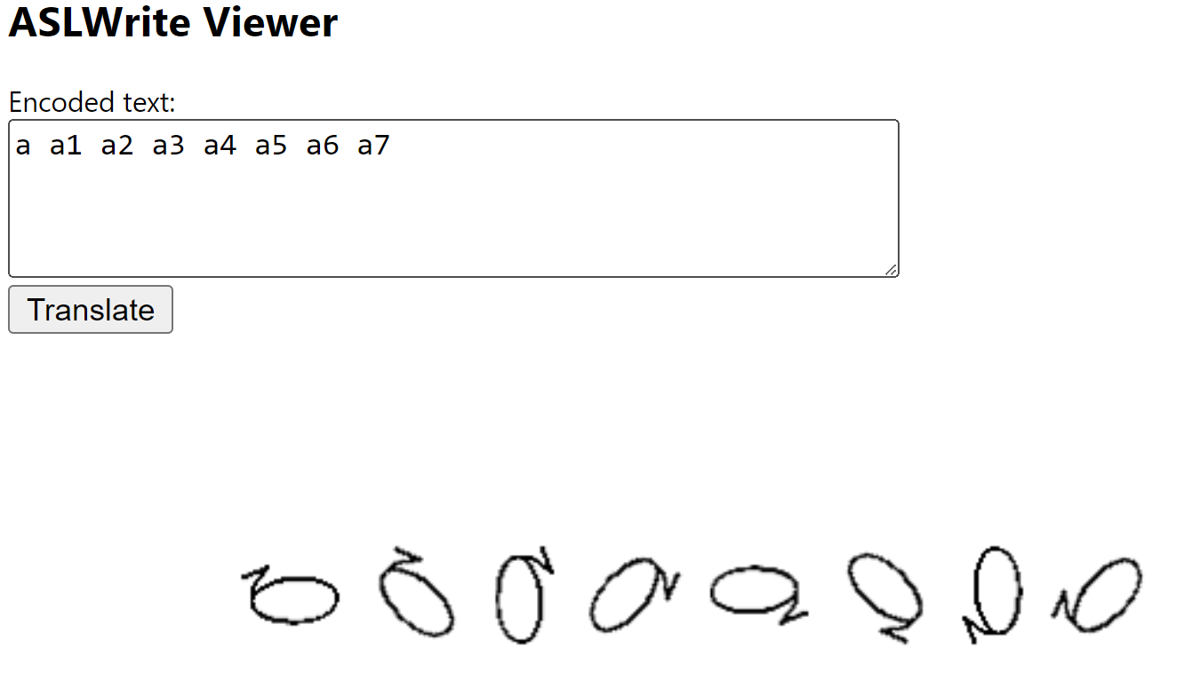

## Mirror

Any symbol can be flipped horizontally by adding **/** (forward slash)

Example: The ‘a’ handshape has been displayed normally and mirrored

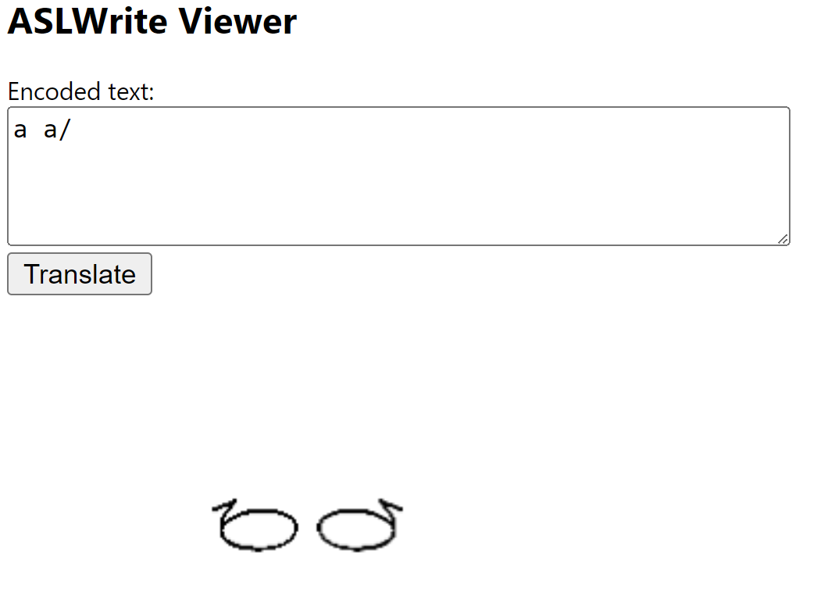

## Modifiers Summary

All these modifiers can be combined to achieve the desired symbol positioning.

Example: The ‘a’ handshape has been displayed normally, then mirrored, rotated, and offset

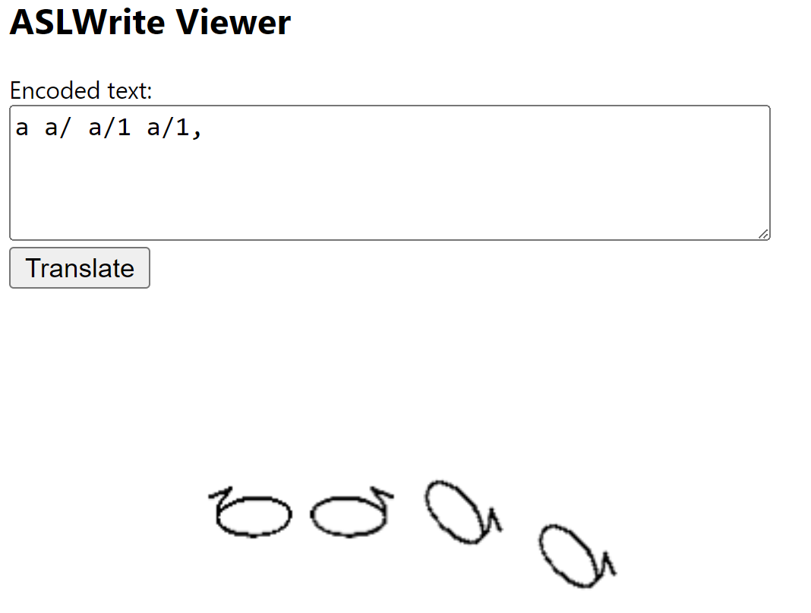

# Symbol Spacers

Symbol spacers can be thought of as moving the horizontal “cursor” that decides where the next symbol should be drawn. There are five spacers available. They can be combined or repeated for a variety of spacing combinations. They are:

|  |  |
| --- | --- |
| Align cursor with left edge of current symbol | **|** |
| Align cursor with middle of current symbol | **-** (dash) |
| Align cursor with right edge of current symbol | **=** |
| Move cursor by “small space” (doesn’t depend on last symbol width) | (space) |
| Move cursor by “large space” (3x small space, doesn’t depend on last symbol width) | **_** (underscore) |

Example: The ‘a’ and ‘b’ handshapes are drawn at 6 different spacing offsets. Note that because the left, middle, and right align spacing options depend on the symbol they are attached to, ‘a-b’ will give a different alignment than ‘b-a’.

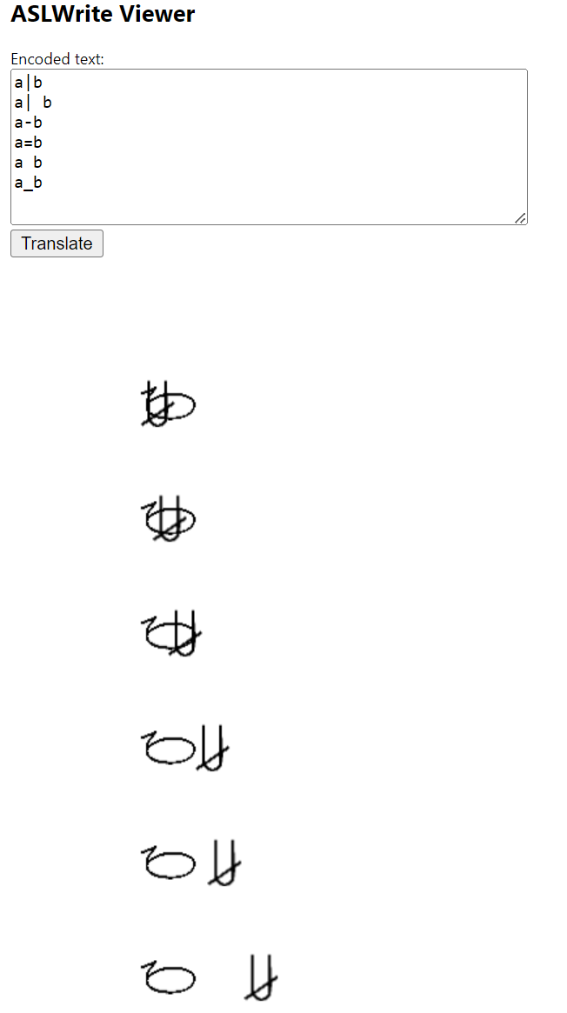

# Examples

Each word can be created in a variety of ways, I’ve only provided some possibilities. Color coding is only used for ease of understanding. Correct formation of words takes practice and may need some experimentation to get the desired appearance.

## YOU

**Encoded Text: 1=!;**

1. Handshape ‘1’ is used. Spacer is right align ( = ).
2. Movement symbol ‘!’ is given a small upwards offset ( ; ).

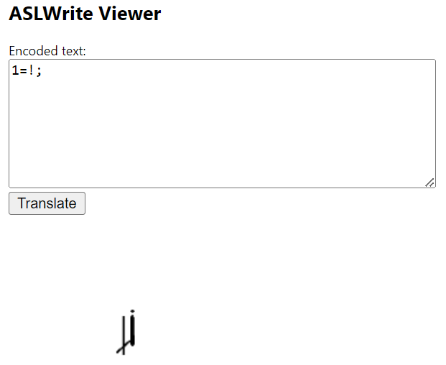

## I/ME

**Encoded Text: 14=!4.**

1. Handshape ‘1’ is rotated 180 degrees ( 4 ). Spacer is right align ( = ).
2. Movement symbol ‘!’ is rotated 180 degrees ( 4 ) given a small downwards offset ( . ).

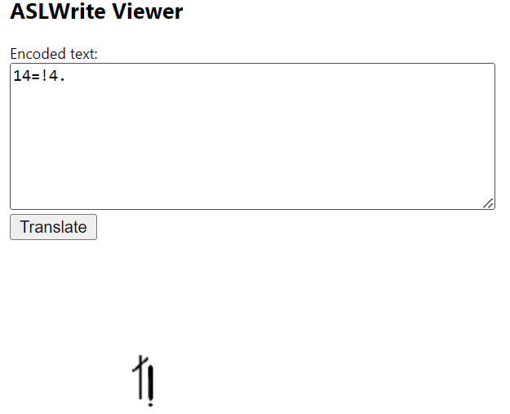

## GO AHEAD

**Encoded Text: C/.=!;=C.**

1. Handshape ‘C’ is mirrored ( / ) and given a small downwards offset ( . ). Spacer is right align ( = ).
2. Movement symbol ‘!’ is given a small upwards offset ( ; ).
3. Handshape ‘C’ is given a small downwards offset ( . ).

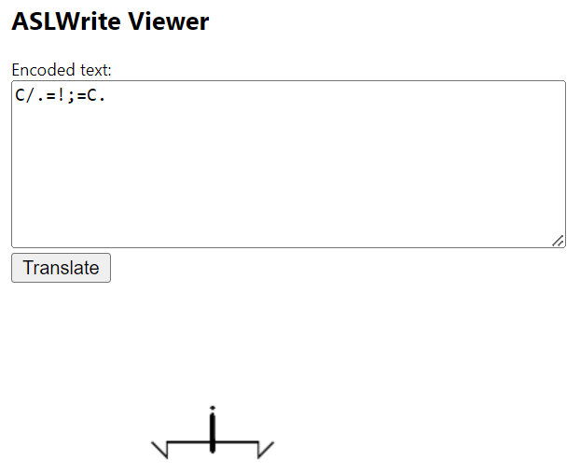

## ADDRESS

**Encoded Text: ['| A6/= !z= A2**

1. Shoulder body position ( [ ) is moved up to large upwards offset ( ‘ ). Spacer is set to left align ( | ) and a small space ( ).
2. ‘A’ hand shape is rotated by 270 degrees ( 6 ), then mirrored ( / ). Spacer is set to right align ( = ) and a small space ( ).
3. Double movement symbol (!z ) is used. Spacer is set to right align ( = ) and a small space ( ).
4. ‘A’ hand shape is rotated by 90 degrees ( 2 ).

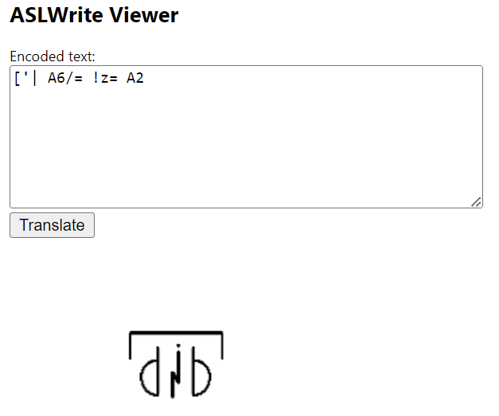

## FAMILY

**Encoded Text: !c=5/.|o/'=o'|5.=!c/**

1. Curved movement symbol ( !c ) is used. Spacer is right align ( = ).
2. ‘5’ handshape is mirrored ( / ) and given a small downwards offset ( . ). Spacer is left align ( | ).
3. ‘O’ handshape is mirrored ( / ) and given a large upwards offset ( ‘ ). Spacer is right align ( = ).
4. ‘O’ handshape is given a large upwards offset ( ‘ ). Spacer is left align ( | ).
5. ‘5’ handshape is given a small downwards offset ( . ). Spacer is right align.
6. Curved movement symbol ( !c ) is mirrored ( / ).

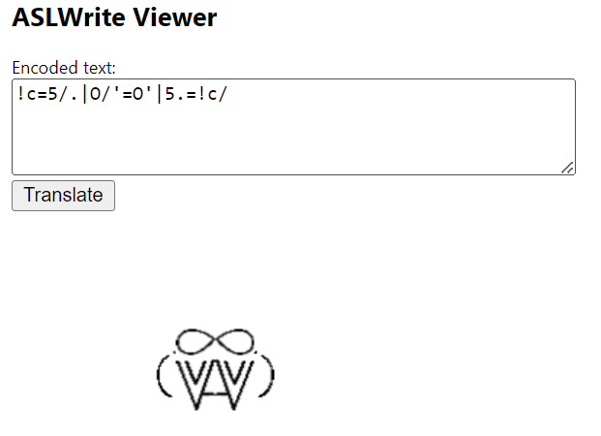

## REMEMBER

**Encoded Text: }-A'|!2,.-A7/- :;;2-A1**

1. Head body position ( } ) is used with middle align spacer ( - ).
2. ‘A’ handshape is given large upwards offset ( ‘ ). Spacer is left align ( | ).
3. Movement symbol ( ! ) is rotated by 90 degrees ( 2 ), then given a large downwards offset ( , ) and a small downwards offset ( . ). Spacer is middle align ( - ).
4. ‘A’ handshape is rotated 315 degrees ( 7 ) and mirrored ( / ). Spacer is left align with a small space.
5. Double dot diacritic ( : ) is given two small upwards offsets ( ; ), then rotated by 90 degrees ( 2 ). Spacer is middle align.
6. ‘A’ handshape is rotated by 45 degrees.

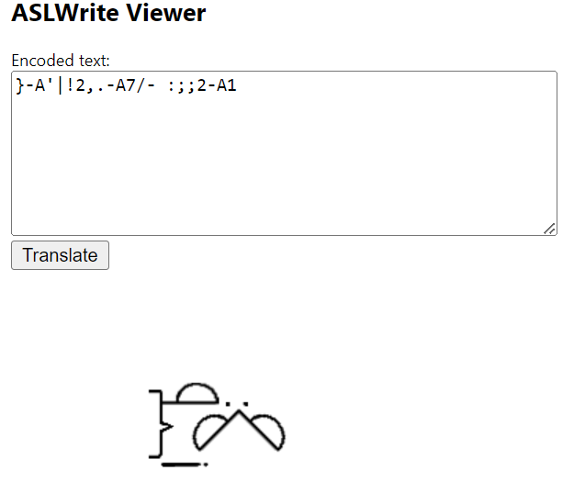

# Appendix: Extended Dictionary

|  |  |
| --- | --- |
| ABBREVIATE | 52'-!2- s6/..|s2,..-!6-56/' |
| ACT | %/2;|!:2. !:6.|%6; |
| ADDRESS | ['| A6/= !z= A2 |
| APPEAR | 5/2;-!t;-1,7 |
| ASK | }]. 1-!2,-x/ |
| BUT | 17-!t/6'-11-1/7-!t2'-1/1 |
| CLOTHES | @c2-['|52=!:4.=5/6=@c6 |
| COLLAPSE | @c1-%/1'=!t4;=%7'- @c7 |
| CONTINUE | A/=!z;-A |
| DEAF | 1,-.; ..=} |
| DIE | B'|!2,| @o. B'|!2,| @o. |
| FAMILY | !c=5/.|o/'=o'|5.=!c/ |
| FOLLOW | }] !2,|A2; A2; |
| FOOD | :2..| }=o, |
| FIRST | 1;|@o. |
| GIVE | o,-!; |
| GO AHEAD | C/.=!;=C. |
| GROW | c/| !t. o2,|5/;; |
| HELLO | }.-!c2'-b1 |
| HELP | B2.-A2; !t |
| I/ME | 14=!4. |
| IMPACT | 1=.;; s;; |
| IMPROVE | [a| !c6/=B/7; |
| IN | c./-!t4;=o6' |
| KNOW | :2;=}~=C |
| LIVE | ['| A6/= != A2 |
| MAKE | s2.| :2;|s'6/=@c7;; |
| MAN | }=5'=!c4. |
| MEET | 1|!,2=!/,6-1/ |
| MY/MINE | [;|_B/6-. |
| NAME | h/-:2;;-h' |
| NOT | }~/4-!2,| A. |
| PAH | #p=#o !c/7'|1|@o,. !c1'-1/|@o,. |
| PLAN | B|_@p2|!2,-B|!:2,|_@p2 |
| PROGRESS | C/.-@o;|C' |
| RED | }~4'/-@s5-x, |
| REMEMBER | }-A'|!2,.-!2,.-A7/- :;;2-A1 OR }-A'|!2,.-A7/- :;;2-A1 |
| RULES | B-:|:;; C/; |
| RUN/OPERATE | B/1-!:1'-B7/ |
| SPREAD | !7-5/'-o3.=o/5.-5'-!1 |
| STORY | o/-!:6,-52/ 56-!:2,-o |
| STUDY | B2=@w5;-55/' |
| SUPPORT | s'=!t7=s/ |
| THANK-YOU | }~'4/|B/1.- !3, |
| THEIR | B'|!6-!2 |
| THOSE/THEM | 1|!c2' OR !c1;|17 OR 11-!c3; |
| TIME | [a- :2-x6;; |
| TOMORROW | }'|!c2;|A3, |
| TREE | [a,-5=@s |
| UNDERSTAND | }~,=!. s..|1;; |
| WAIT | @w'|5 @w'|5/ |
| WANT | %/.|5'=!4 5/'|%. |
| WHERE | 1=@s. |
| WISH | [;| %;6/-!4, |
| WOMAN | }'=5;=!c4, |
| WORK | s1/.-:3|s7; |
| YEAR | s1/.-@o3|s7; |
| YOU | 1=!; |