1产品简介/Product Brief
全自动蛋液蛋壳分离机，由分离机配置相应蛋品梳理装置组成。蛋液蛋壳分离机先将输送 至分离工位的蛋敲破，然后通过特种刀片将蛋壳拨开，从而使蛋液流出，再经接蛋液托盘和 导流槽，将蛋液输送至相应的分离器内，通过分离器进一步将蛋清和蛋黄分离(分离器说明 见分离器说明书)。
The automatic egg shell separator consists of a separator and corresponding egg conveying devices.The egg liquid eggshell separator first breaks the eggs transported to the separation station,then uses a special blade to pry open the eggshell,allowing the egg liquid to flow out. Then,through the egg liquid tray and guide groove,the egg liquid is transported to the
corresponding separator,and further separates the egg white and egg yolk through the separator(see the separator manual for instructions).

设备壳体采用304不锈钢制作，便于清洗。整体结构紧凑，占地面积小，产量适中。适合中小 型食品厂，糕点房等单位使用。
The equipment shell is made of stainless steel(304),so convenienting to clean.
The overall structure is compact,small install area,and the output is moderate.
Suitable for small and medium food factory,pastry shop and other units.
2 产品技术参数/Product Specifcations
产品名称/Name: 全自动蛋液蛋壳分离机
Automatic EggBreaker machine
额定电压/Voltage:AC90V~260V 额定频率/Frequency:50/60Hz
额定功率/Power:300W
气源/ASUP:0.6Mpa 10L/min
产品型号/Model:EB-I-2.7K
最佳分离速度/Speed:2700eggs pcs hour
产品外形尺寸/Overall size:1750*1150*1050mm 重量/Weight:110~130Kg
安置场地尺寸/Install area size:2000*1500*1050mm 产品型号/Model:EB-II-5.4K
最佳分离速度/Speed:5400eggs pcs hour
产品外形尺寸/Overall size:1750*1150*1050mm 重量/Weight:120~140Kg
安置场地尺寸/Install area size:2000*1500*1050mm
产品型号/Model:EB-III-8.1K
最佳分离速度/Speed:8100 eggs pcs hour
产品外形尺寸/Overall size:1750*1150*1050mm 重量/Weight:140~160Kg
安置场地尺寸/Install arca size:2000*1500*1050mm
产品型号/Model:EB-IV-10.8K
最佳分离速度/Speed:10800eggspcs hour
产品外形尺寸/Overall size:1750*1150*1050mm 重量/Weight:150~170Kg
安置场地尺寸/Install arca size:2000*1500*1050mm

3 产品工作环境/Product Work Condition
1 ) 工 作 环 境/work condition: 温 度+ 1 0 °~+ 6 5 °相 对 湿 度9 0 %以 下 。
Temperature 10~+65°relatively moisture below 90%.
2 ) 贮 存 环 境 /stock condition: 温度 - 25°~+65°相对湿度90%以下。 Temperature -25~+65°relatively moisture below 90%.

4 整机示意图/Product Layout

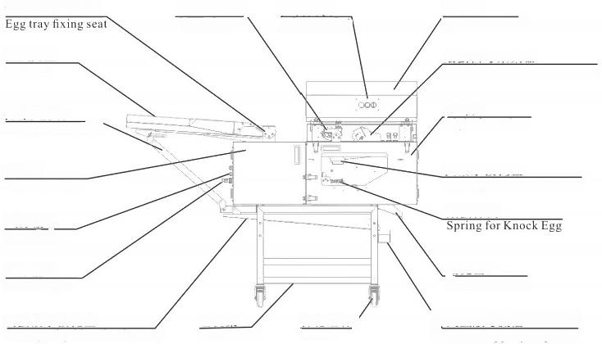
大托盘安装座

盛蛋托盘 Egg tray

托盘支撑杆
Egg tray supporter

左前门
Left front door
气源输入 Gas input
电源输入
Power input
残蛋液承接托盘
Lost egg liquid collection tray
上罩壳
Uper cover shell
敲蛋信号采集器
Signal collector ofknock egg

右前门
Right front door

蛋液承接托盘
Egg liquid collection tray
敲蛋弹簧

蛋壳出口
Eggshell outlet

砖蛋液彼导 ua uider
控制面板
control panel\

主机架
Main frame
蛋品固定器 Egg ixator
脚轮组件
casters
常规蛋壳蛋液分离机
Conventional eggshell and egg liquid separator

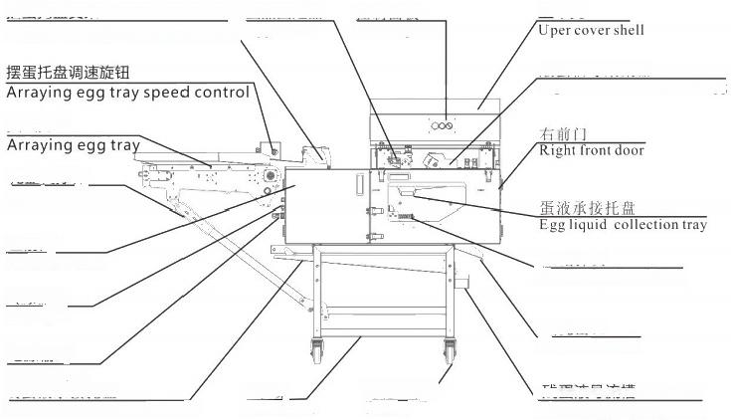
蛋品固定器
摆r 托n gg try fixing seatEgg fixator

摆蛋托盘

托盘支撑杆
Egg tray supporter

左前门
Left front door
气源输入 Gas input
电源输入
Power input
残蛋液承接托盘
Lost egg liquid collection tray
上罩壳

敲蛋信号采集器
Signal collector of knock egg

敲蛋弹簧
Spring for Knock Egg

蛋壳出口
Eggshell outlet

Se eg nquid guider
控制面板
control panel

脚轮组件
casters
主机架
Main frame
摆蛋托盘式蛋壳蛋液分离机
Arraying egg tray type eggshell and egg liquid separator

5 产品组装说明/Product lostall Method
拆箱取出部件名称如下：托盘，电源线和脚轮及附件(可能会有翻斗分离器参考分离器说明书)。 Unpack and remove the components with the following names:tray,power cord,casters,and accessories(there may be a tipping bucket separator,please refer to the separator manual).
按照上图的相应位置进行组装，顺序如下：
Plcase refer to above layout pic to install the machinc,steps as fllow:
1)将脚轮安装到支撑腿侧面，然后用扳手锁紧，并锁止刹车脚轮。
Install the casters on the side of the support legs,then lock them with a wrench and lock the brake casters.
2)如果所选用设备为常规蛋液蛋壳分离机，鸡蛋托盘安装如下图。先将托盘固定螺钉和鸡蛋托盘支 撑杆自由端固定螺钉取出，然后将鸡蛋托盘整体靠近主机，在对应位置将支撑杆和主机通过螺栓连 接。该螺栓不可旋转太紧，然后将托盘按照下图旋转方向拉起，将托盘固定耳放置在托盘固定耳安 装座上，并用螺钉固定。注意固定耳的方向如图一所示为正确方向。完成后进入下一步调整挡蛋杆， 调整挡蛋杆完成后需将托盘支撑杆两端的螺栓拧紧。
If the selected equipment is a conventional egg-shell separator,the installation of the egg tray is shown below.First remove the fixing screws of the tray and the free end of the support rod
of the egg tray,then bring the entire egg tray close to the main machine and connect the
support rod and the main machine with bolts at the corresponding position.The bolt should
not be tightened too tightly,and then pull up the tray according to the rotation direction shown below.Place the fixing ears of the tray on the mounting base of the fixing ears and secure them with screws.Note that the direction of the fixing ears is shown in Figure l as the correct
direction.After completing this step,proceed to the next step of adjusting the egg-stopping
rod.After adjusting the egg-stopping rod,tighten the bolts on both ends of the tray support rod.

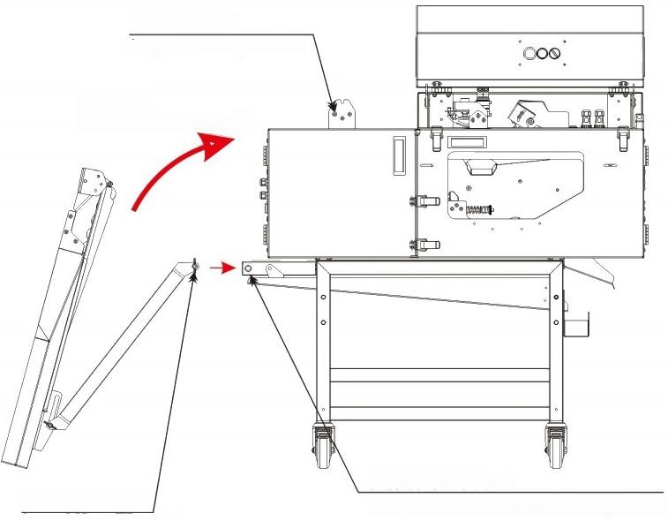
托盘固定螺钉
Tray retaining screws

旋转方向
Direction of rotation

支撑杆螺钉安装孔
支撑杆固定螺钉
Support rod screw
Support rod screw mounting holes

3)如果所选设备为摆蛋式托盘蛋壳蛋液分离机，安装方法如下图所示。将摆蛋式托盘末端拉手拉起， 支撑杆会跟随运动至其末端定位卡会自动卡在横梁上，摆蛋大托盘会在限位柱的位置停止翻转。此 时若支撑杆末端定位卡没有卡在横梁上，需人工干预将其卡在横梁上，然后在支撑杆和托盘连接处 的可调连接板处于松弛状态，需在尽可能上提托盘，同时下压支撑杆，从而去除支撑杆与托盘支撑 的活动间隙，此时将可调连接板上的螺栓拧紧。 (翻转时需注意侧壁的线管和气管没有被阻挡)
If the selected equipment is a swing egg tray eggshell liquid separator,the installation method is shown in the following figure.Pull up the handle at the end of the egg laying tray,and the
support rod will follow the movement until its end positioning card automatically gets stuck on the crossbeam.The egg laying tray will stop flipping at the position of the limit column.
If the positioning card at the end of the support rod is not stuck on the crossbeam at this time, manual intervention is needed to clamp it on the crossbeam.Then,the adjustable connecting plate at the connection between the support rod and the tray is in a relaxed state.It is
necessary to lift the tray as much as possible and press down on the support rod to remove the active gap between the support rod and the tray support.At this time,tighten the bolts on the adjustable connecting plate.(When flipping,it is important to note that the tubing and trachea on the sidewalls are not obstructed)
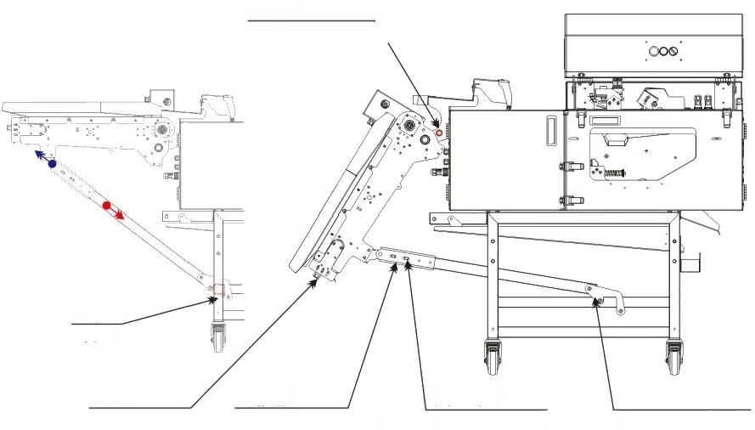
限位柱
Limiting column

连接板
Connecting plate
横梁 Beam

把手
Handle
定位卡
Positioning card
固定螺母
Retaining nut

4)在气源输入位置连接相应的气源管(φ8mm,0.6Mpa,10L/min) 并确保气源已打开。
Connect the corresponding air source pipe(diameter 8mm,0.6Mpa,101/min)at the input position of the air source and ensure that the air source is turned on.
5)将电源线快速插头插入电源输入位置，另一端为防漏电保护插头(输入为AC90V—260V), 将其插 接供电口(必须有接地线)即可。
根据具体要求可能会配置不同国家标准的转换插头，若果配有相应的转化插头，需将转换插头先插 接在防漏电保护插头上，再插接供电口(必须有接地线)。
完成以上操作后需检查漏电保护插头上绿色的指示灯是否点亮。
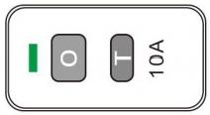
如果亮起，按下T键，指示灯会熄灭，再次按下O 键指示灯会点亮； 如果没有熄灭，反复操作后无果，请联系厂家。
再设备没有完成检查工作前，先将按下T键确保电路断开。

Insert the quick plug of the power cord into the power input position,and the other end is the leakage
protection plug.The input voltage is AC90V-260V,and plug it in the power supply port(Must have the ground wire).
According to specific requirements,different national standard conversion plugs may be configured.If equipped with corresponding conversion plugs,the conversion plugs need to be plugged in the leakage protection plug and then plug into the power supply portt(Must have the ground wire).
After completing the above operations,it is necessary to check whether the green indicator light on the leakage protection plug is light.
If it lights up,press the Tkey,the indicator light will go out,and press the Okey again to light up the indicator light.
Ifit does not turn off and repeated operations have no effects.Please contact the manufacturer. Before the equipment completes the inspection work,press the Tkey to ensure that the circuit is disconnected.
6)检查接蛋液盒是否安装正确，若果安装存在脱钩现象需将其取下进行再次安装。安装方法如下： 向上轻轻托起接蛋液盒，向左侧滑动，即可取下，安装时需将接蛋液盒两侧的缺口位置对照相应 的螺柱并向上托举，然后向右侧滑动，让侧边上的挂钩，挂在相应的螺柱上即可。(如下图所示)
Check if the egg box is installed correctly.If there is any detachment during installation, remove it and reinstall it.The installation method is as follows:
Gently lift the egg receiving box upwards and slide it to the left to remove it.
When installing,compare the gap positions on both sides of the egg receiving box with the corresponding onesLift the bolt upwards and slide it to the right,so that the hook on the side can be hung on the corresponding bolt.(As shown in the following figure)

拆卸方向 Detach

安装方向 Install

托起 Lift
7)取两枚蛋(常用蛋)放置在靠近大托盘出口的蛋杯内，如图所示，然后将校准板放置在两枚蛋表 面，观察挡蛋杆的高低，确保挡蛋杆自由状态下，挡蛋杆下表面与校准板上表面贴合，若果位置不 合适可将挡蛋杆两侧固定板固定螺钉松开进行上下调整，调整过程中挡蛋杆尽量靠近大托盘出口。
Take two eggs(commonly used eggs)and place them in the egg cup near the outlet of the egg tray,as shown in the figure.Then,place the calibration plate on the two egg top.
observe the height of the egg blocking rod to ensure that the lower surface of the egg blocking rod is in a free state and adheres to the upper surface of the calibration plate.If the position is not correct It is appropriate to loosen the fixing screws on both sides of the egg guard and
adjust it up and down.During the adjustment process,the egg guard should be as close to the outlet of the large tray as possible.Take two eggs(commonly used eggs)and place them in
the egg cup near the outlet of the large tray,as shown in the figure.Then,place the calibration plate on the two egg tablesFace,observe the height of the egg blocking rod to ensure that the lower surface of the egg blocking rod is in a free state and adheres to the upper surface of the calibration plate.If the position is not correctIt is appropriate to loosen the fixing screws on
both sides of the egg guard and adjust it up and down.During the adjustment process,the egg guard should be as close to the outlet of the large tray as possible.
8)摆蛋式敲蛋机的挡蛋杆和普通敲蛋机挡蛋杆安装方法不同，如下图所示，校准方法相同。请参考 上一条说明。
The installation method of the egg blocking rod of the egg laying machine is different from that of a regular egg knocking machine,as shown in the following figure.The calibration
method is the same,please refer to the previous explanation.

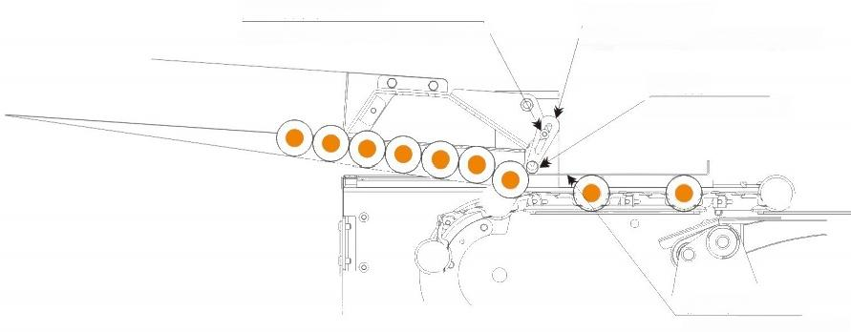
挡蛋杆固定板
Egg blocking rod fixing plate
挡蛋杆
Egg blocking rod

校准板
Calibration board
挡蛋杆固定螺钉
Egg blocking rod fixing screw

常规蛋壳蛋液分离机
Conventional eggshell and egg liquid separator

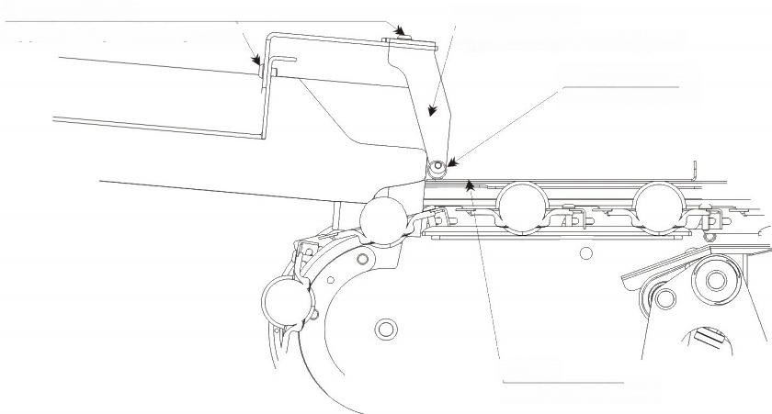
挡蛋杆固定螺钉
Egg blocking rod fixing screw

挡蛋杆ocking rod

校准板
Calibration board
挡蛋杆固定板
Egg blocking rod fixing plate

摆蛋托盘式蛋壳蛋液分离机
Arraying egg tray type eggshell and egg liquid separator

6,产品试机操作说明/Product trial operation instructions
1)确保主机内无异物后将漏电保护插头上的o键按下接通电源，指示灯点亮。同时设备控制面板处 绿灯点亮，如果控制面板绿灯没有点亮，需检查急停开关是否处于断电状态(急停按钮被按下), 需顺时针旋转急停按钮，将其解锁电源接通。如果此操作无果，请联系厂家。
After ensuring that there are no foreign objects inside the host,press the o button on the leakage protection plug to turn on the power,and the indicator light will light up.
At the same time,at the device control panel the green light is on.If the green light on the
control panel is not light,check if the emergency stop switch is in a power-off state (the
emergency stop button is pressed),Rotate the emergency stop button clockwise to unlock and power on.If this operation is unsuccessful,please contact the manufacturer.

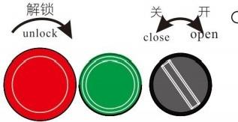

2)旋转启动旋钮主机开始工作，内部破蛋的零部件开始发出具有节奏的卡塔卡塔声响。反向旋转旋 钮，设备停止工作，但指示灯依然点亮。 (如果是摆蛋到托盘式蛋壳蛋液分离机，摆蛋托盘会自动 转动，没有转动的话需要将调速旋钮顺时针旋转，开启转动。注：顺时针旋转增大速度，逆时针旋 转降低速度)
The main engine started working by rotating the start knob,and the internal broken parts
began to emit rhythmic katakata sounds.Rotate the knob in reverse,the device stops working, but the indicator light remains on.(If it is a tray type egg shell and egg liquid separator,the
egg tray will automatically rotate.If it does not rotate,you need to turn the speed controlknob clockwise to turn it on.Note:clockwise rotation increases speed,counterclockwise rotation
decreases speed)
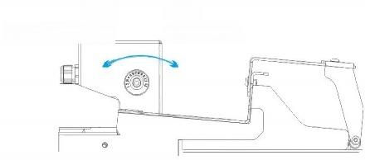
降速 Speed reduce
提速
Speed up

3)先在鸡蛋托盘的导流筒内分别放置4-10枚蛋。再放置第一枚蛋的时候，需用手再挡蛋杆前阻挡鸡 蛋，其目的是防止鸡蛋撞破并确保蛋品是横放的状态，然后依次放入多枚鸡蛋并确保导流筒内鸡蛋 横放滚落的状态。(如图所示)
常规机托盘内鸡蛋为自由滚落的方式，蛋品自行落入对应蛋杯中，蛋品在进入流蛋筒时容易堆积， 需人工干预，以确保蛋品排列进入流蛋筒。
摆蛋式蛋壳蛋液分离机托盘内靠托辊向前推动的方式将蛋品输送至蛋杯中。如果托盘内蛋品供应不 足或托辊运送速度过快会出现蛋品非横向进入流蛋筒，从而造成蛋品进入蛋杯时容易挤破。需将托 辊调速旋钮逆时针转动，降速或暂停运送。如果托盘内蛋品供应过多或托辊运送速度过慢会出现蛋 品在进入导流筒时堆积，需人工干预。确保蛋品横向进入导流筒。

First,place 4-10eggs in the draft tube of the egg tray.When placing the first egg,use your
hand to block the egg rod in front of it to prevent the egg from breaking and ensure that the
eggs are placed horizontally.Then,place multiple eggs in sequence and ensure that the eggs in the draft tube are placed horizontally and roll down.(As shown in the figure)The eggs in
the conventional machine tray fall freely and fall into the corresponding egg cups.The eggs
tend to accumulate when entering the egg flow tube,requiring manual intervention to ensure that the eggs are arranged and fed into the egg flow tube.The egg-type egg shell and egg liquid separator uses a roller to push the eggs forward into the egg cup.If the supply of eggs in the
tray is insufficient or the roller is moving too fast,the eggs may not enter the flow tube
horizontally,causing them to break when entering the egg cup.The speed controlknob of the roller needs to be turned counterclockwise to slow down or pause the delivery.If there is too much supply of eggs in the tray or the roller is moving too slowly,the eggs may accumulate
when entering the flow tube,requiring manualintervention.Ensure that the eggs enter the flow tube horizontally.

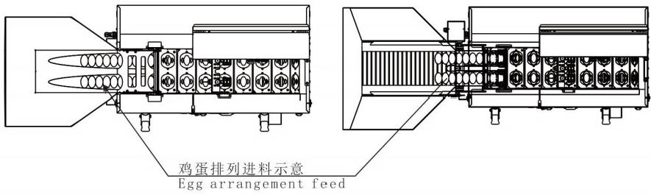
4)完成上述操作后，在蛋壳出口处，蛋液承接托盘出口以及残蛋液导流槽出口处分别放置相应的收 集容器。
After completing the above operations,corresponding collection containers are placed at the outlet of the eggshell,the outlet of the egg liquid receiving tray,and the outlet of the residual egg liquid flow channel.
5)旋转开关旋钮，设备将自动工作，注意观察挡蛋杆位置是否有蛋被挤破，或者有蛋被卡在挡蛋杆 无法滚落，如果偶尔出现上述情况为正常，需人工处理，如果连续出现上述情况，请确认是否正确 调整挡蛋杆。在通过调整挡蛋杆无法避免上述情况，请联系厂家。
Rotate the switch knob,and the equipment will automatically work.Pay attention to whether there are eggs squeezed or stuck in the position of the egg blocking rod that cannot roll off.
If the above situation occasionally occurs,it is normal and manual handling is required.If the above situation continues,please confirm whether the egg blocking rod is adjusted correctly. If the above situation cannot be avoided by adjusting the egg shift lever,please contact the
manufacturer.
6)设备运转后，需观察蛋品固定器位置鸡蛋的分离情况。
正常情况下鸡蛋运转至蛋品固定器下方，气缸会挤压固定柱，将鸡蛋固定，不能上下跳动，并开始 蛋壳蛋液分离工作，蛋壳会呈现出完整的两个半壳，蛋液会在落入蛋液承接托盘内并流出。
如果在蛋品在运送至固定器下方时，蛋品被挤破，说明蛋品固定片过低，则需要将固定片抬高。
如果在蛋品在运送至固定器下方，破壳的时候出现，蛋品跳起，说明蛋品固定片过高，无法固定蛋 品，需将固定片降低。
调整方法如下：关闭气源，逆时针转动调整螺钉，固定片降低，顺时针转动螺钉，固定片抬高。 调整幅度需根据所用蛋品的大小决定。
若果通过微调无法解决上述问题，则需要调整蛋品固定器整体的高低，蛋品固定器两侧通过安装片 与主机固定，可将固定螺钉松开后，整体上提或下压可大幅度调整固定片的高低。(结构如下图)

After the equipment is running,it is necessary to observe the separation ofeggs at the position of the egg holder.Under normal circumstances,when the egg runs below the egg stabilizer,
the cylinder will compress the fixing column to fix the egg without jumping up and down,
and the egg shell and egg liquid separation work will begin.The egg shell will present two
complete half shells,and the egg liquid will fall into the egg liquid receiving tray and flow out. If the egg is squeezed under the stabilizer during transportation,it indicates that the egg fixing plate is too low and needs to be raised.
If the egg breaks during transportation to the bottom of the fixator,causing the egg tojump,it indicates that the egg fixing plate is too high to fix the egg and needs to be lowered.
The adjustment method is as follows:turn off the air source,turn the adjustment screw
counterclockwise to lower the fixing plate,turn the screw clockwise to raise the fixing plate. The adjustment range needs to be determined based on the size of the egg used.If the above
problem cannot be solved through fine-tuning,it is necessary to adjust the overall height of
the egg holder.The two sides of the egg holder are fixed to the host through mounting plates. After loosening the fixing screws,the overall height of the fixing plate can be greatly adjusted by lifting or pressing it up or down.(Structure as shown in the figure below)
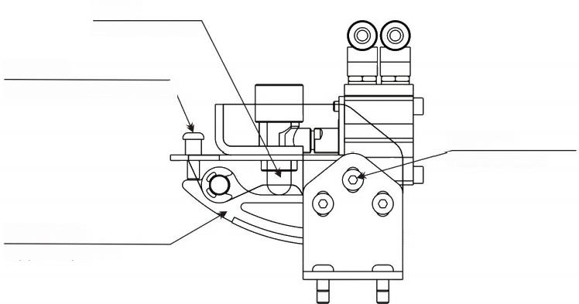
浮动柱
Piston column
微调螺钉
Fine adjustment screw

固定螺钉
Fixed screws

蛋品固定板
Egg fixing plate
7)设备正常工作情况下，观察开蛋情况是否理想。如果通过调整蛋品固定器仍然无法避免蛋品被挤 破或蛋品跳跃的现象，需要调整敲蛋信号采集器的位置，该采集器正面有两颗螺钉，松动两颗螺钉 后，信号采集器固定架可进行旋转调整，向右旋转信号会提前响应，可解决蛋品跳跃的现象，向左 旋转信号会延迟响应，可解决蛋品被挤破的现象。以上操作仅仅是微调信号采集的响应时机。(如 图示)
Under normal operation of the equipment,observe whether the egg opening situation is ideal. If the egg is still unable to avoid being squeezed orjumping by adjusting the egg holder,it is
necessary to adjust the position of the egg knocking signal collector.There are two screws on the front of the collector.After loosening the two screws,the signal collector holder can rotate and adjust.Turning the signal to the right will respond in advance,which can solve the
problem of eggjumping.Turning the signal to the left will delay the response,which can solve the problem ofegg being squeezed.The above operations are only for fine-tuning the response timing of signal acquisition.(As shown in the diagram)
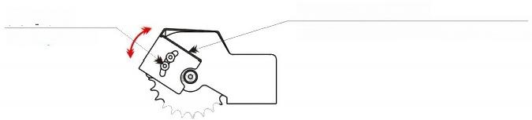
信号采集器固定架
固定螺钉
Fixing screw
Signal collector mounting bracket

7产品清洁与维护/Product elean and maintenance
1)清洗前需拔下插头，确保切断电源。
Make sure cut down the electricity and unplug before clean process.
2)打开主机上罩壳固定搭扣，将其掀起并折叠，放置在防脱块上。
Open the fixing buckle of the cover on the main unit,lifting it up and folding it,and then put it on the preventing slipping blocks
3)打开主机右前门，取出接蛋液托盒，单独清洗，并擦拭干燥。
Open the right front door and take out the egg liquid tray to rinsing,and then wiping it with dry towel.
4)可以用喷枪冲洗主机内的蛋杯，破蛋开壳部件等，也可逐一用湿毛巾擦拭。擦拭和冲洗一部分后 可以接通电源，让其转动，待转动后再将电源切断(请务必切断电源)。继续擦拭和清洗其他部
件，直至清洗完毕后，将其擦拭干燥。(摆蛋托辊即蓝色塑料部位不可用高压水枪冲洗)
You can use the spray gun to rinsing the egg tray in the main engine and the parts of breaking the egg shell,or wiping them with a wet towel.After wiping and washing some of the parts, you can turn on the powe,making machine running to reveal the parts unwashed.And then
turn off the power,to continue wiping other parts until the cleaning is finished.(Make sure the power is cut off before wiping parts.)
5)请勿向开关，电源以及后罩壳扣合缝隙内冲水。
Do not rinse the switch,power supply and the gap of the rear cover
6)定期向塑料轴承(开刀轴承每天涂抹)工件内涂抹凡士林或类似润滑脂。涂抹时需切断电源进行 操 作 。
Regularly apply Vaseline or similar lubricating grease to the plastic bearings(cutting
bearings applied daily)inside the workpiece.When applying,cut off the power supply for operation.

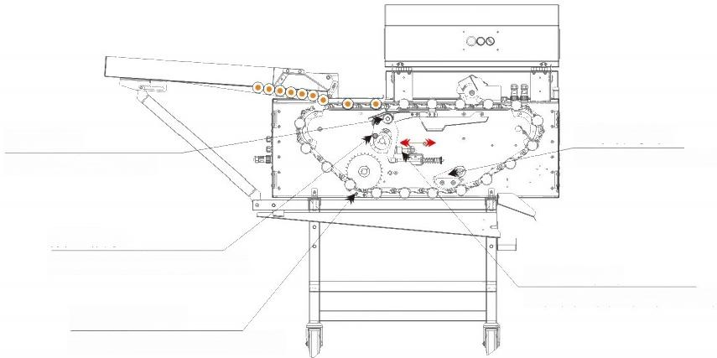
开刀轴承
Cutting bearings

抬刀轴承
Bearing of lifting knife

防链条跳齿器
Anti chain jumping gear
刀架缓冲器
Holder buffer of Knife
链条张紧块
Chain tensioner

7)定期检查蛋杯链条张紧情况，链条在使用过程中会出现延长现象，需定期将链条张紧防止链条跳 齿现象发生。
Regularly check the tension of the egg cup chain.The chain may experience elongation during use,and it is necessary to regularly tighten the chain to prevent tooth jumping.

8)定期检查抬刀轴承情况(如上图所示)。在刀片闭合的情况下用手拨动抬刀轴承，若果能拨动说明 运转正常，若果无法拨动或拨动存在阻力，则需将刀架缓冲器向刀架方向调整，使得抬刀轴承能轻
松转动，调整幅度不可过大，否则会影响刀片上升的高度，从而影响敲蛋效果。
调整方法：将缓冲器螺母松开缓冲器顺时针旋转，靠近刀架，逆时针旋转远离刀架。
Regularly inspect the condition of the knife lifting bearing(as shown in the above figure).
When the blade is closed,manually move the lifting bearing.Ifit can be moved,it indicates
normal operation.Ifit cannot be moved or there is resistance during movement,the buffer of the tool holder needs to be adjusted towards the direction of the tool holder,so that the lifting bearing can rotate easily.The adjustment range should not be too large,otherwise it will
affect the height of the blade and affect the knocking effect.Adjustment method:Loosen the buffer nut and rotate the buffer clockwise,close to the tool holder,and counterclockwise
away from the tool holder.
9)定期检查敲蛋弹簧情况(如上图所示)。该弹簧为易损件，挡敲蛋力度较弱的情况下可适当调整 弹簧后端的螺母，顺时针旋转可增大敲蛋力度，在调整该螺母时需注意刀架被拉动后弹簧固定螺母 和定位套内是否有间隙，最大调整量取决于该间隙的大小，当调整后没有间隙需更换弹簧，不可过 度调整，过度调整螺母造成容易造成敲蛋刀组件损坏。
Regularly check the condition of the egg knocking spring(as shown in the above figure).
This spring is a vulnerable component.If the knocking force is weak,the nut at the back of the spring can be adjusted appropriately.Turning it clockwise can increase the knocking force.
When adjusting the nut,attention should be paid to whether there is a gap between the spring fixing nut and the positioning sleeve after the tool holder is pulled.The maximum adjustment amount depends on the size of the gap.When there is no gap after adjustment,the spring
needs to be replaced and excessive adjustment is not allowed.Excessive adjustment of the nut can easily cause damage to the egg knocking knife component.

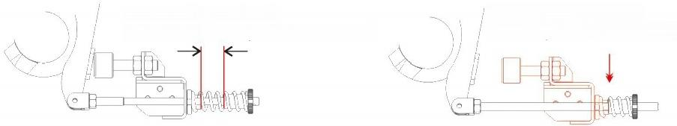
已经没有有可压缩距离
必须保证有可压缩距离
Must ensure compressible distance
No compressible distance

8产品故障检查/Product malfunction inspection
1)如发现漏电故障后需检查接地线是否确保接地。
If leakage fault is found,it is necessary to check whether the grounding line is grounded.
2)蛋品未敲破现象原因如下：
一、敲蛋弹簧力度较小适当调整螺母。 (顺时针将其力度加大，反之则减小)
二、敲蛋弹簧失去弹性或断裂，需更换弹簧。
三、蛋品定位器，未固定蛋品。
首先需检查气源情况，是否未供气。
其次检查气缸导柱是否动作。
如果气缸没有动作，气源没有问题，可能是继电器、电磁阀或传感器
损坏，需更换电磁阀、继电器或传感器。在判断以上部件前前需检查电源转换器是否损坏，如果电 源转换指示灯(绿色)未点亮，说明电源转换器损坏需更换电源转换器。
如果气缸动作正常需检查蛋品固定器固定片是否上下浮动正常(正常情况是断气的状态下固定片可 轻松上下浮动),若阻力较大说明其关联的浮动柱孔内存在异物，须将浮动柱取出将浮动柱表面及 浮动柱孔用干毛净擦拭。
四、刀片位置过低，可适当将刀片提高。
五、刀架固定轴承磨损，间隙较大，需更换轴承。

The reasons for the phenomenon of eggs not being broken are as follows:
1、Adjust the nut appropriately when the force of the egg tapping spring is small. (Increase the force clockwise,otherwise decrease it)
2、The egg knocking spring loses elasticity or breaks,and the spring needs to be replaced.
3、Egg locator,unfixed egg.
Firstly,it is necessary to check the condition of the gas source to see if there is no gas supply.
Next,check if the cylinder guide pillar is moving.
If the cylinder does not move and there is no problem with the air supply,it may be due to damage to the relay,solenoid valve,or sensor,which needs to be replaced. Before determining the above components,it is necessary to check if the power
converter is damaged.If the power converter indicator light(green)is not lit,it indicates that the power converter is damaged and needs to be replaced.
If the cylinder operates normally,it is necessary to check whether the fixed piece of the egg stabilizer is floating up and down normally(under normal circumstances,the fixed piece can easily float up and down when the air is cut off).
If the resistance is high,it indicates that there are foreign objects in the associated
floating column hole.The floating column must be removed and the surface and holes of the floating column should be wiped with a dry cloth.
4、The blade position is too low,and the blade can be raised appropriately.
5、The fixed bearing of the knife holder is worn and has a large gap,and the bearing needs to be replaced.

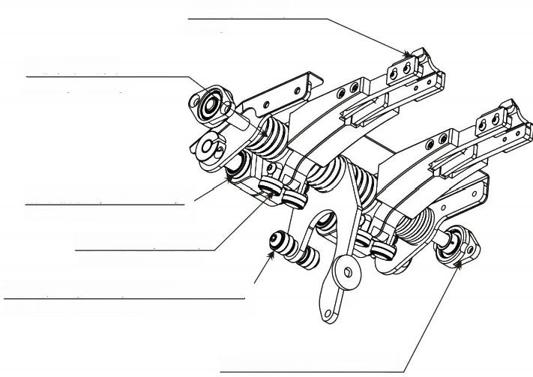
刀片(分左右)
Knife
刀柄复位弹簧 Sliding bearing

过动 BearinM⁰1-12)
开壳轴承(61801)
Open shell bearing

抬刀e钟 1 6 1earingofknife older

刀架固定轴承 (SKFL001) Knife holder fixed bearing

3)设备无法正常工作时，需首先确认设备机械部分是否正常。
首先判断传动凸轮部分是否出现严重磨损，如果磨损严重需更换传动凸轮。
其次判断开刀轴承是否出现严重磨损，若果磨损严重需更换刀柄。
再次判断刀架轴是否出现断裂，如果断裂需更换刀架。
最后需打开后盖，判断传动齿轮是否出现滑齿现象，以及黑色驱动器指示灯是否出现红灯报警。 出现上述故障需拍照或视频发送厂家进行判断。
When the device cannot function properly,it is necessary to first confirm whether the mechanical part of the device is normal.
Firstly,determine if there is severe wear on the transmission cam.If the wear is severe,
replace the transmission cam.Secondly,determine whether there is severe wear on the
cutting bearing.If the wear is severe,replace the tool handle.Check again if the tool holder shaft is broken.If it is,replace the tool holder.
Finally,it is necessary to open the back cover and check if there is any slipping of the
transmission gear,as well as whether the black driver indicator light shows a red light alarm. The above faults need to be photographed or video sent to the manufacturer for judgment.
驱动器指示灯报故障
下表为指示灯正常工作时，在驱动器不同状态下的显示方式，可对照下表确认驱动器的当前工作状态。

停机 | 正常：绿灯常亮，红灯常灭
 | 故障：红灯、绿灯交替闪烁指示故障代码
运行 | 正常：绿灯闪烁、红灯常灭
 | 限流：绿灯闪烁、红灯闪烁
 | 刹车：绿灯常亮、红灯快速闪烁

9电器原理图/Electrical principle

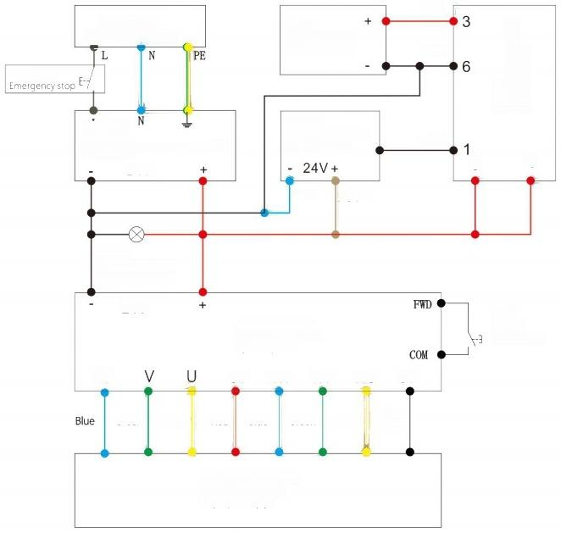
继电器
Intermediate relay
RJ25-CL-D24
Red
漏电保护器
leakage protector
急停按钮

传感器
开关电源
Switching Mode Power Suppl SE-450-24
24V
Blue Brown

指示灯
Indicateor light YW1P-1BUQ4G
24V
直流电机驱动器
DC motor driver
C20-400LR
W 5V HW HV HU OV

Green Yellow Red Blue Green Yellow

Z6BLD200-24GU-30S
DC GEAR MOTOR
直流减速电动机
电磁阀
Solenoid valve 4V210-08-24V
Proximity sensor TL-Q5MC1-Z
开关
Switch
YW1S-2E10
Black
Black
Black
8
4

环保清单一全自动蛋清蛋黄分离机
类别 | 部件名称 | 有害物质
 |  | 铅  (Pb) | 汞  (Hg) | 镉  (Cd) | 六价铬  (Cr(VI)) | 多溴联苯  (PBB) | 多溴二苯醚汞  (PBDE)
五金 | 主体 | O | O | O | O | O | O
 | 外壳 | O | O | O | O | O | O
 | 接蛋液托盘 | O | O | O | O | O | O
 | 蛋液导流槽 | O | O | C | O | O | O
 | 蛋清蛋黄分离器 | O |  |  | O | O | O
 | 托盘 | O |  |  | O | ○ | O
 | 螺钉 | O |  |  | O | O | O
电器 | 开关 | O |  |  | O | × | ×
 | 电源线 | O |  |  | O | O | O
橡胶 | 密封条 | O |  |  | O | O | O
 | 密封圈 | O |  | ○ | O | O | O
包装 | 包装箱 | O |  | O | O | O | O
 | 名牌 | O |  | O | O | O | O
 | 说明书 | O | O | O | O | O | O
 | 塑料袋 | O | O | O | O | O | O
本表格依据SJ/T11364的规定编制。
b:表示该有毒有害物质在该部件所有均匀材料中的含量均在GB/T26572规定的限量要求以下。 区：表示该有毒有害物质至少在该部件的某一项均质材料中的含量超出GB/T26572规定的限量要求。

