Killing Rate (γ) vs. Degradation by Living R (φ_max): Is the Relation Linear?
Model: Ma et al. (2024) two-strain model with the paper's SI parameters · one dose · 22 × 21 × 2 = 924 simulations plus 11 iso-lines found by root-finding · same engine and endpoint definitions as the main parameter sweep report.

Open issues to solve next
- γ is extended beyond the paper's range (1.1–1.4 in the paper, 1.1–3.1 here; group choice, same as the killing vs. protection test).
- Iso-lines are followed beyond the paper's φ_max range. The paper uses 0–5; the lines are traced up to φ_max = 40 so their shape can be seen.
- The linearity is empirical. No formula was derived for it; it holds for this model over these ranges.
- Plain model only. No extinction floor; at high γ and dose both strains fall far below one cell before regrowing.
- All other parameters at base. With the inhibitor at i = 10 the effective degradation is 0.31 × φ_max.

Base parameters & variation range
Table 1. Variation levels.
Quantity | Meaning | Base | Range | Values | Source
γ (y-axis) | killing rate: maximum lysis coefficient | 1.38 | 1.1–3.1 | 22 | SI range 1.1–1.4, extended
φ_max (x-axis) | antibiotic degradation by living R | 1 | 0–5 | 21 | SI range
a0 | antibiotic dose | 2.15 | 2.15 and 10 | 2 | base dose and a strongly killing dose

Decoupling of the parameters
- Full factorial: every γ is combined with every φ_max, for each dose. Each axis has 21 evenly spaced values (plus the base value for γ).
- Only two parameters move. α, β_min, c, κ_b, d_a and everything else stay at base.

Sweep setup:
- φ_max does not enter the equation for the R/S ratio. It acts only by shortening the time the antibiotic stays, so there is no closed-form neutral line as there was for protection.
- Iso-line: for each γ, the φ_max that holds one endpoint at a fixed level, found by root-finding on the simulation. It answers “how much more degradation offsets more killing?”.
- Endpoints held fixed: peak S loss at 50%, 90%, 99%, 99.99% and at its base-point value; final resistant fraction at its base-point value.
- Linearity is judged by the R² of a straight-line fit of φ_max against γ along each iso-line, and by the largest deviation from that line.

1. The γ × φ_max Plane
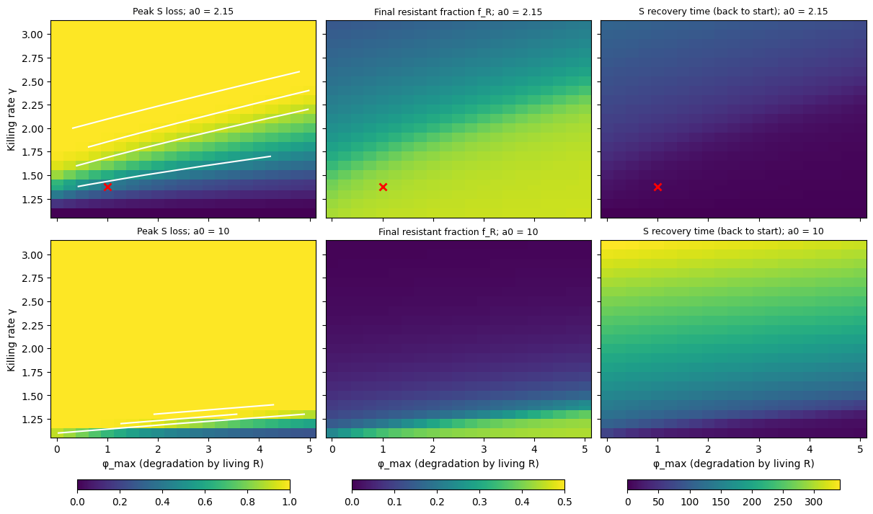
Figure 1. Peak S loss, final resistant fraction and S recovery time on the γ × φ_max plane. White lines: iso-lines of peak S loss (50%, 90%, 99%, 99.99%). Red cross: base point. Top: base dose. Bottom: a0 = 10.
- All 924 runs settle with both strains present (plain model).
- γ has the longer reach at the base dose. There γ takes peak S loss from 0% to 100% at every φ_max, while φ_max (0–5) moves it by at most 61 points (at γ = 1.6). At a0 = 10 the loss never drops below 26%, and γ (9–74 points) and φ_max (up to 65 points) have comparable reach.
- More degradation means less S loss, a higher final resistant fraction and a faster recovery, at every γ.
- The iso-lines run as straight, tilted bands across the plane.

2. Iso-Lines: φ_max Needed to Offset γ
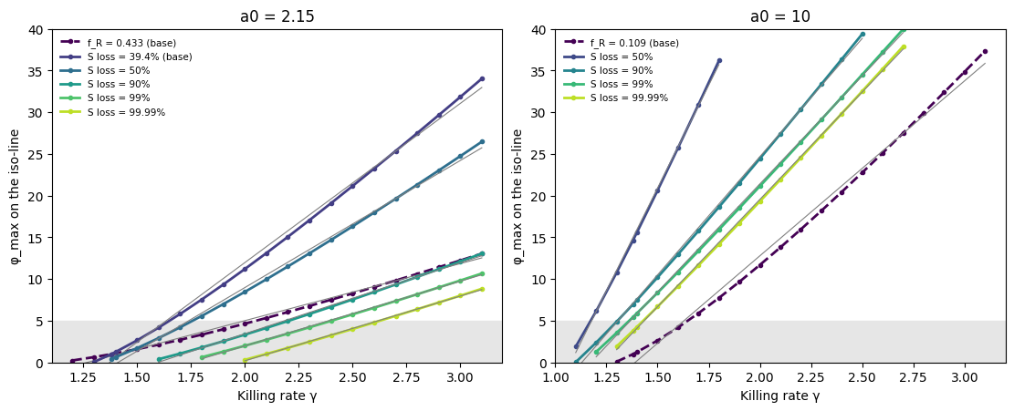
Figure 2. φ_max on each iso-line against γ. Solid: peak S loss levels. Dashed: final resistant fraction at its base value. Thin grey: straight-line fits. Shaded: the paper's φ_max range (0–5).
Table 2. Straight-line fits of φ_max against γ along each iso-line. Deviation = largest distance from the fitted line, as a share of the range. Slope ratio = slope at the high-γ end / slope at the low-γ end. Last column: width of the γ band the line covers inside φ_max 0–5.
Dose a0 | Iso-line | Points | γ range | Slope | R² | Deviation | Slope ratio | γ band in SI range
2.15 | f_R = 0.433 (base) | 21 | 1.2–3.1 | 6.8 | 0.9939 | 5.5% | 2.05 | 0.91
2.15 | S loss = 39.4% (base) | 20 | 1.3–3.1 | 19.1 | 0.9961 | 4.2% | 1.85 | 0.35
2.15 | S loss = 50% | 19 | 1.38–3.1 | 15.2 | 0.9968 | 3.4% | 1.71 | 0.42
2.15 | S loss = 90% | 16 | 1.6–3.1 | 8.5 | 0.9983 | 2.8% | 1.38 | 0.66
2.15 | S loss = 99% | 14 | 1.8–3.1 | 7.8 | 0.9991 | 1.9% | 1.24 | 0.70
2.15 | S loss = 99.99% | 12 | 2–3.1 | 7.8 | 0.9995 | 1.4% | 1.17 | 0.67
10 | f_R = 0.109 (base) | 20 | 1.3–3.1 | 21.0 | 0.9936 | 5.3% | 2.20 | 0.35
10 | S loss = 50% | 9 | 1.1–1.8 | 49.3 | 0.9989 | 2.1% | 1.24 | 0.07
10 | S loss = 90% | 16 | 1.1–2.5 | 28.4 | 0.9991 | 2.2% | 1.28 | 0.20
10 | S loss = 99% | 17 | 1.2–2.7 | 25.9 | 0.9995 | 1.5% | 1.19 | 0.22
10 | S loss = 99.99% | 16 | 1.3–2.7 | 25.7 | 0.9997 | 1.1% | 1.15 | 0.21

- Close to linear, with a slope that rises along each line. A straight line stays within 1–6% of the range on all eleven lines (R² = 0.994–0.9997).
- Every line bends upward: the slope at the high-γ end is 1.2 to 2.2 times the slope at the low-γ end. Only the high-loss lines (99% and above) are close to straight.
- The slope is steep. At the base dose each +0.1 in γ needs on average +0.8 (99% loss line) to +1.9 (39% loss line) more φ_max. At a0 = 10 it needs +2.6 to +4.9.
- Degradation offsets only a narrow band of killing rates. Inside the paper's φ_max range an iso-line covers a γ band of 0.35–0.91 at the base dose and 0.07–0.35 at a0 = 10.
- The final resistant fraction behaves the same way: the φ_max that keeps it at its base value is a near-straight line in γ (R² = 0.994).

3. Effect of φ_max at a Fixed γ
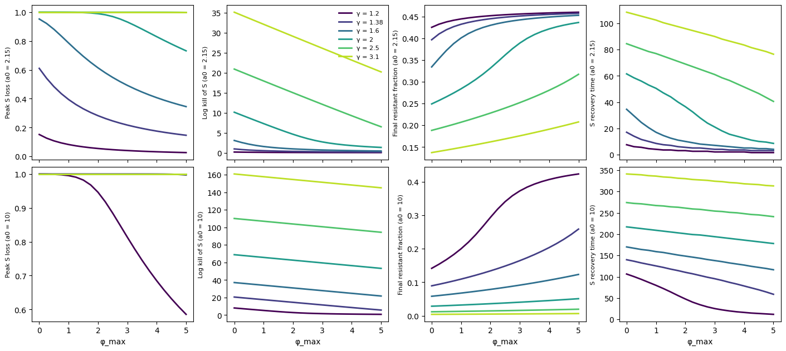
Figure 3. Peak S loss, log kill of S, final resistant fraction and S recovery time against φ_max, one line per γ. Top: base dose. Bottom: a0 = 10.
Table 3. R² of straight-line fits at fixed γ. Log kill = ln(starting density / lowest density).
Dose a0 | γ | Log kill of S at φ_max = 0 | Log kill vs φ_max | Log kill vs 1/(1 + φ_max) | Final f_R vs φ_max | Recovery time vs φ_max
2.15 | 1.2 | 0.2 | 0.809 | 0.999 | 0.826 | 0.815
2.15 | 1.38 | 0.9 | 0.816 | 0.998 | 0.795 | 0.782
2.15 | 1.6 | 3.1 | 0.797 | 0.998 | 0.794 | 0.787
2.15 | 2 | 10.1 | 0.932 | 0.917 | 0.978 | 0.974
2.15 | 2.5 | 20.9 | 1.000 | 0.796 | 0.987 | 0.995
2.15 | 3.1 | 35.1 | 1.000 | 0.791 | 0.997 | 1.000
10 | 1.2 | 8.1 | 0.882 | 0.951 | 0.951 | 0.929
10 | 1.38 | 20.6 | 1.000 | 0.791 | 0.972 | 0.997
10 | 1.6 | 37.1 | 1.000 | 0.788 | 0.990 | 1.000
10 | 2 | 68.9 | 1.000 | 0.788 | 0.994 | 1.000
10 | 2.5 | 110.2 | 1.000 | 0.788 | 0.996 | 0.999
10 | 3.1 | 160.9 | 1.000 | 0.788 | 0.996 | 0.999

- Strong killing: linear. When the crash is deep (log kill above about 20), the log kill of S falls in a straight line with φ_max (R² = 1.000), and so does the recovery time.
- Weak killing: not linear. The log kill follows 1/(1 + φ_max) more closely (R² = 0.998 at the base dose for γ ≤ 1.6), so the first unit of φ_max matters most.
- Peak S loss as a fraction saturates at 100% and is never a good linear measure; log kill is.

4. Conclusions
- γ and φ_max are close to linearly related: the degradation needed to offset more killing rises as a near-straight line in γ (R² ≥ 0.994), bending upward.
- The exchange rate is unfavourable: +0.1 in γ costs +0.8 to +4.9 in φ_max, against a φ_max range of only 0–5.
- So φ_max shifts outcomes only inside a narrow band of γ; at the base dose γ has the longer reach.
- At fixed γ, the crash depth is linear in φ_max under strong killing and follows 1/(1 + φ_max) under weak killing.
- Compared with private protection (previous test): protection trades off inversely with γ during treatment; degradation trades off almost linearly.
- Next: derive the iso-line slope analytically, repeat with κ_b and d_a, and add the extinction floor.

