Killing Rate vs. Protection: Is the Relation Linear?
Model: Ma et al. (2024) two-strain model with the paper's SI parameters · one dose · 22 × 22 × 3 × 2 = 2,904 simulations · same engine and endpoint definitions as the main parameter sweep report.

Open issues to solve next
- γ is extended beyond the paper's range. The paper uses 1.1–1.4; this test uses 1.1–3.1 (group choice) so the shape of the relation can be seen. Inside 1.1–1.4 the neutral line moves by only 0.01 in p and looks straight.
- “Killing rate” and “protection” are our reading of the question (definitions below). Other readings are possible, for example protection through antibiotic degradation (φ_max, κ_b).
- Plain model only. No extinction floor; at high γ and dose both strains fall far below one cell before regrowing.
- c, the inhibitor dose and all other parameters are at base. Test 3 uses α = 0.95 only.

Base parameters & variation range
Table 1. Variation levels. p is set through β_min: p = (1 − β_min)(1 − c·ι).
Quantity | Meaning | Base | Range | Values | Source
γ (y-axis) | killing rate: maximum lysis coefficient | 1.38 | 1.1–3.1 | 22 | SI range 1.1–1.4, extended
p = 1 − β (x-axis) | protection: fraction of lysis R avoids | 0.031 | 0–0.30 | 22 | largest p at base c is 0.307
α | growth of R relative to S | 0.95 | 0.85, 0.90, 0.95 | 3 | inside SI range
a0 | antibiotic dose | 2.15 | 2.15 and 100 | 2 | base dose and top of SI range

Decoupling of the parameters
- Full factorial: every γ is combined with every p, for each α and dose. Each axis has 21 evenly spaced values plus the base value.
- Only private protection changes along the x-axis. p is varied through β_min; c is fixed, so R's antibiotic degradation (φ) is the same in every run.

Sweep setup:
- Per-capita lysis rate of S = γ · H(a) · g(s). Per-capita lysis rate of R = (1 − p) · γ · H(a) · g(s).
- Subtracting the per-capita growth rates of the two strains gives an exact identity: d ln(R/S)/dt = g(s) · [γ · H(a) · p − (1 − α)]. R gains at any moment when γ · H · p > 1 − α.
- Neutral line: for each γ, the protection p* at which R neither gains nor loses share, found by root-finding on the simulation (not read off the grid).
- Two read-outs: after full regrowth (steady state), and during treatment (a0 = 100, t = 100).
- Linearity is judged by the R² of a straight-line fit and by the largest deviation from that line.

1. Lysis Rate of R vs. Protection
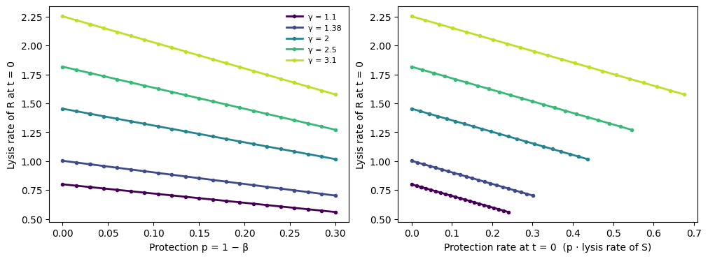
Figure 1. Lysis rate of R at the start of treatment against protection (left) and against the protection rate, p × lysis rate of S (right). α = 0.95, base dose.
- Exactly linear for every γ (R² = 1). Slope = −γ · H(a0) · g(s0), for example −1.00 at γ = 1.38 and −2.25 at γ = 3.1.
- Against the protection rate the slope is −1 for every γ: lysis of R = lysis of S − protection rate.
- This is how the model is built, not a finding.

2. Neutral Line Between Killing Rate and Protection
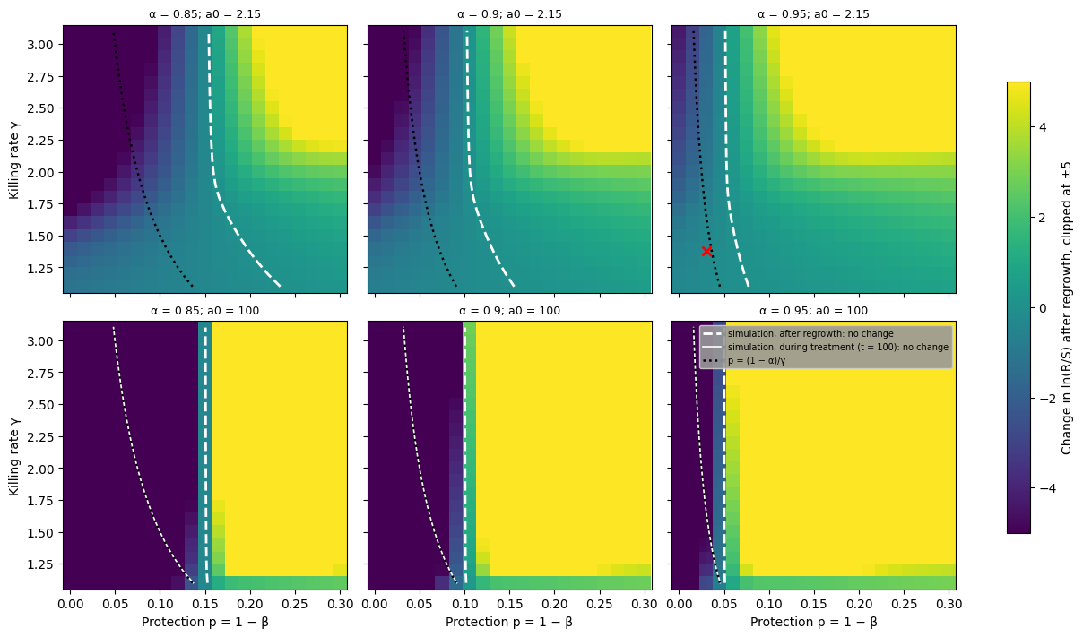
Figure 2. Change in ln(R/S) after regrowth on the γ × p plane (above 0 = R gained). White dashed: no change after regrowth. Black dotted: p = (1 − α)/γ. Thin white (bottom row): no change during treatment. Red cross: base point.
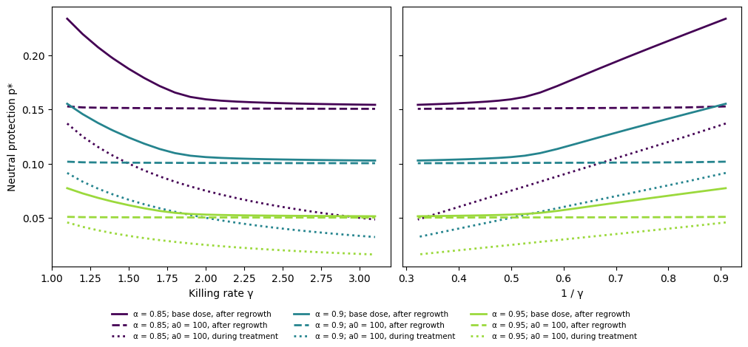
Figure 3. Neutral protection p* against γ (left) and against 1/γ (right).
Table 2. Straight-line fits of the neutral protection p*. Deviation = largest distance from the fitted line, as a share of the range of p*.
Dose, read-out | α | p* at γ = 1.1 | p* at γ = 3.1 | R² vs γ | Deviation vs γ | R² vs 1/γ | Largest |p* − (1 − α)/γ|
100, during treatment | 0.85 | 0.137 | 0.048 | 0.93 | 20% | 1.0000 | 0.0007
100, during treatment | 0.9 | 0.091 | 0.032 | 0.93 | 20% | 1.0000 | 0.0005
100, during treatment | 0.95 | 0.046 | 0.016 | 0.93 | 21% | 1.0000 | 0.0003
100, after regrowth | 0.85 | 0.153 | 0.151 | 0.74 | 46% | 0.9028 | 0.1022
100, after regrowth | 0.9 | 0.102 | 0.100 | 0.76 | 44% | 0.9163 | 0.0682
100, after regrowth | 0.95 | 0.051 | 0.050 | 0.77 | 43% | 0.9267 | 0.0341
2.15, after regrowth | 0.85 | 0.234 | 0.154 | 0.73 | 37% | 0.9236 | 0.1060
2.15, after regrowth | 0.9 | 0.155 | 0.103 | 0.72 | 38% | 0.9173 | 0.0706
2.15, after regrowth | 0.95 | 0.077 | 0.051 | 0.71 | 39% | 0.9112 | 0.0353

2.1 During treatment
- The relation is inverse, not linear: p* = (1 − α)/γ. The simulation is within 0.0007 of it.
- A straight line against 1/γ (R² = 1.0000); a curve against γ (R² = 0.93, up to 21% of the range off a straight line).
- Doubling the killing rate halves the protection R needs to keep its share.

2.2 After regrowth
- The killing rate almost stops mattering. At a0 = 100, p* stays at 0.050–0.051 from γ = 1.1 to 3.1 (α = 0.95).
- At the base dose p* bends from 0.077 (γ = 1.1) to 0.051 (γ = 3.1), then flattens.
- In every read-out p* is close to proportional to the cost of resistance, 1 − α (within 1.5%).
Table 3. Neutral protection after regrowth: simulation vs. the exact formula p* = (1 − α)/(1 − ΔlnS/G), α = 0.95. G = total growth ∫g dt; ΔlnS = ln(final S / starting S).
Dose a0 | γ | p* (simulation) | p* (formula) | Total growth G | ΔlnS | (1 − α)/γ
2.15 | 1.1 | 0.0774 | 0.0774 | 6 | 2.28 | 0.0455
2.15 | 1.38 | 0.0655 | 0.0655 | 10 | 2.27 | 0.0362
2.15 | 2 | 0.0530 | 0.0530 | 42 | 2.33 | 0.0250
2.15 | 3.1 | 0.0514 | 0.0514 | 85 | 2.37 | 0.0161
100 | 1.1 | 0.0509 | 0.0509 | 122 | 2.13 | 0.0455
100 | 1.38 | 0.0505 | 0.0505 | 232 | 2.33 | 0.0362
100 | 2 | 0.0503 | 0.0503 | 357 | 2.36 | 0.0250
100 | 3.1 | 0.0502 | 0.0502 | 563 | 2.37 | 0.0161

- Formula and simulation agree to 3 × 10⁻⁷. G and ΔlnS are taken from the same run, so this is a consistency relation that explains the result, not a prediction.
- Why: over a full kill-and-regrow cycle, total lysis equals total growth minus the small net gain ΔlnS. When killing is strong, G is far larger than ΔlnS, so p* → 1 − α whatever γ is.

3. Killing Actually Suffered vs. Protection
- Peak death rate: fastest net per-capita decline during the run.
- Log kill: ln(starting density / lowest density), the depth of the crash.
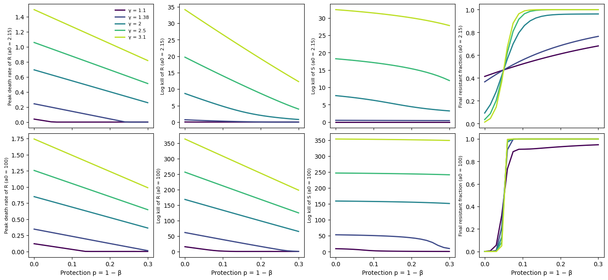
Figure 4. Peak death rate of R, log kill of R, log kill of S and final resistant fraction against protection, one line per γ (α = 0.95). Top: base dose. Bottom: a0 = 100.
Table 4. R² of a straight-line fit against protection, by γ (α = 0.95). n/a = S is not killed at all.
Dose a0 | γ | Lysis rate of R (t = 0) | Peak death rate of R | Log kill of R | Log kill of S | Final f_R
2.15 | 1.1 | 1.000 | 0.395 | 0.295 | n/a | 0.992
2.15 | 1.2 | 1.000 | 0.750 | 0.648 | 1.000 | 0.988
2.15 | 1.38 | 1.000 | 0.980 | 0.904 | 0.995 | 0.973
2.15 | 1.6 | 1.000 | 1.000 | 0.951 | 0.977 | 0.920
2.15 | 2 | 1.000 | 1.000 | 0.960 | 0.995 | 0.714
2.15 | 2.5 | 1.000 | 1.000 | 0.999 | 0.948 | 0.640
2.15 | 3.1 | 1.000 | 1.000 | 1.000 | 0.972 | 0.600
100 | 1.1 | 1.000 | 0.773 | 0.651 | 0.811 | 0.580
100 | 1.2 | 1.000 | 0.940 | 0.869 | 0.940 | 0.524
100 | 1.38 | 1.000 | 1.000 | 0.996 | 0.754 | 0.525
100 | 1.6 | 1.000 | 1.000 | 1.000 | 0.879 | 0.518
100 | 2 | 1.000 | 1.000 | 1.000 | 0.950 | 0.511
100 | 2.5 | 1.000 | 1.000 | 1.000 | 0.970 | 0.507
100 | 3.1 | 1.000 | 1.000 | 1.000 | 0.978 | 0.504

- Linear when killing is strong. Peak death rate of R: R² ≥ 0.99 in 17 of 22 γ levels at the base dose and 20 of 22 at a0 = 100. Log kill of R: 9 of 22 and 19 of 22.
- Not linear under weaker killing: γ ≤ 1.4 (peak death rate) and γ ≤ 2.2 (log kill) at the base dose, γ ≤ 1.3 at a0 = 100. There the lines hit zero once R is protected enough to stop declining.
- Killing of S falls as R's protection rises, and not linearly. More surviving R cells remove the antibiotic sooner. From p = 0 to 0.30 the log kill of S falls by 5–58% at the base dose; at a0 = 100 it falls up to ten-fold for γ ≤ 1.4 and by less than 5% for γ ≥ 2.0. R² ≥ 0.99 in 5 of 22 levels at the base dose and none at a0 = 100.
- Final resistant fraction is not linear in protection when killing is strong (γ ≥ 1.6, or a0 = 100): it is a steep S-shaped switch around p*. At the base dose with γ = 1.1–1.4 it rises smoothly (R² = 0.97–0.99).

3.1 Killing of R vs. killing of S
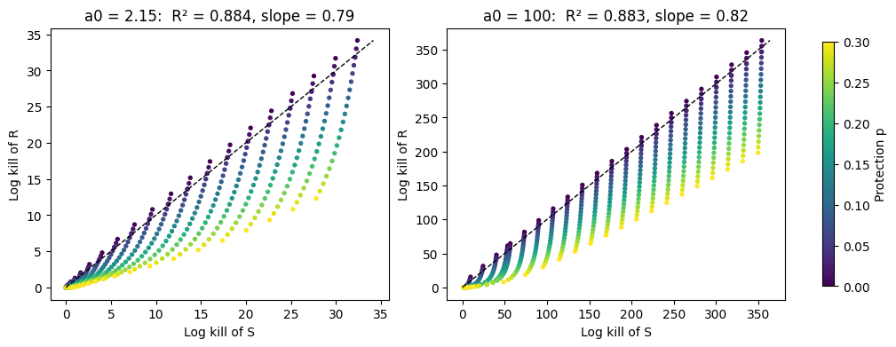
Figure 5. Log kill of R against log kill of S, one dot per run (all γ and p, α = 0.95). Dashed: equal killing.
Table 5. Straight-line fits of log kill of R against log kill of S.
Dose a0 | Runs | n | R² | Slope
2.15 | all runs | 484 | 0.884 | 0.79
2.15 | p = 0 | 22 | 1.000 | 1.05
2.15 | p = 0.30 | 22 | 0.989 | 0.43
100 | all runs | 484 | 0.883 | 0.82
100 | p = 0 | 22 | 1.000 | 1.01
100 | p = 0.30 | 22 | 0.985 | 0.58

- Without protection the log kill of R runs parallel to that of S (slope 1.01–1.05, R² = 1.000) but is larger, by 0.03–1.8 ln units at the base dose and 6–10 at a0 = 100, because of R's growth cost.
- Protection lowers the slope: 0.43 (base dose) and 0.58 (a0 = 100) at p = 0.30.
- Over all runs the two are strongly but not perfectly linearly related (R² = 0.88): each value of p has its own line.

4. Conclusions
- Rates: lysis of R is exactly linear in protection, by construction.
- Trade-off during treatment: killing rate and neutral protection are inversely related, p* = (1 − α)/γ. Linear in 1/γ, not in γ.
- Trade-off after regrowth: p* ≈ 1 − α, nearly independent of the killing rate when killing is strong.
- Killing suffered: for R, linear in protection only when killing is strong; for S it falls with R's protection but not linearly.
- Composition: under strong killing the final resistant fraction switches sharply around p*, so it is not linear in protection.
- Next: repeat with protection through antibiotic degradation (φ_max, κ_b), and with the extinction floor.

