Parameter Sweep Report: All Parameters and Dose × Trait Sweep
Model: Ma et al. (2024) model with the paper's Supplementary Information (SI) parameters · one dose · four parameter-group grids (223,167 simulations), a dose × trait sweep (164,934) and a fine grid in the low-degradation corner (9,261) · one engine, one grid rule and one set of endpoint definitions for all.

Open issues to solve next
- Viability of S is our own definition, not the paper's. S is “viable” if its final density is at least 50% of the final S density of the base community grown without drug (2.335; cut-off ≈ 1.17). The paper defines no viability for S; it only uses total-population suppression thresholds (final density below 1 or below 0.1). The reference is fixed for every run, so in parameter sets that support less biomass even without drug (low ξ), “not viable” can reflect the parameter set and not the treatment. Options: a per-run drug-free control, the starting density, or “not extinct”.
- The extinction floor is a rule added on top of the model. One cell = 4.4 × 10⁻⁹, assuming 10⁹ cells at saturation.
- The d_a range (0–0.1) is the group's choice. The paper does not randomize d_a.
- Dose-grid resolution. Neighbouring antibiotic doses differ by a factor of 1.26, wider than many of the selective dose windows in Section 4.
- One dose only. Repeated dosing is out of scope for now.
- Two strains. Shannon diversity carries the same information as the resistant fraction until more species are added.

Base parameters & variation range
Table 1. Base values and sweep ranges. SI = the paper's randomized range. Values = number of values on the sweep axis.
Parameter | Meaning | Base | Range | Values | Source
α | growth of R relative to S | 0.95 | 0.75–1 | 21 | SI
β_min | R's private protection (1 = none) | 0.9 | 0–1 | 21 | SI
c | inhibitor efficacy inside R | 0.7 | 0–1 | 21 | SI
γ | maximum lysis | 1.38 | 1.1–1.4 | 22 | SI
h_a | antibiotic Hill coefficient | 3 | 1–5 | 21 | SI
a0 | antibiotic dose | 2.15 | 1–100 (log) | 22 | SI dose range
i | inhibitor dose | 10 | 0.1–10 (log) | 21 | SI dose range
h_i | inhibitor Hill coefficient | 2 | 1–5 | 21 | SI
d_b | enzyme inactivation by inhibitor | 1 | 1–10 | 21 | SI
κ_b | degradation by free enzyme | 0.35 | 0–1 | 21 | SI
d_a | basal antibiotic decay | 0.02 | 0–0.1 | 21 | group choice
φ_max | degradation by living R | 1 | 0–5 | 21 | SI
ξ | nutrient recycling from lysed cells | 0.8 | 0–1 | 21 | SI

Decoupling of the parameters
- Grid rule: 21 evenly spaced values over the range (log-spaced for the two doses), plus the base value when it is not on the grid (γ, a0).
- Full factorial within each group: every combination is simulated, so each parameter's effect can be read with the others held at any value.
- Across groups: parameters not on a grid stay at base. All four grids contain the same base point and give the same result there (final f_R = 0.433).
- One-at-a-time sweep (41 values per parameter) puts all 13 parameters on one comparable scale (Figure 4).

Sweep setup:
- Four grids: α × β_min × c (9,261 runs); γ × h_a × a0 (10,164); i × h_i × d_b (9,261); κ_b × d_a × φ_max × ξ (194,481).
- Base dose a0 = 2.15, i = 10 (the paper's Fig. 2C). Start with S = R = 0.2, nutrient = 4.
- Each run continues until steady state (up to t = 2,400). Minima are located exactly, not from sampled time points.
- The model code passes 34 of 34 verification checks, including reproduction of the paper's Fig. 2C, 2D and 3A.
- Heat maps below show one plane per group with the other parameters of that group at base; the red cross marks the base point.
- The red cross is not in the centre of every panel because the paper's base values are not in the middle of its ranges (for example i = 10 is the top of 0.1–10, d_b = 1 the bottom of 1–10, φ_max = 1 in 0–5). Section 5 adds a fine grid for the low φ_max, κ_b corner.

1. Endpoint Analysis

1.1 Diversity Analysis
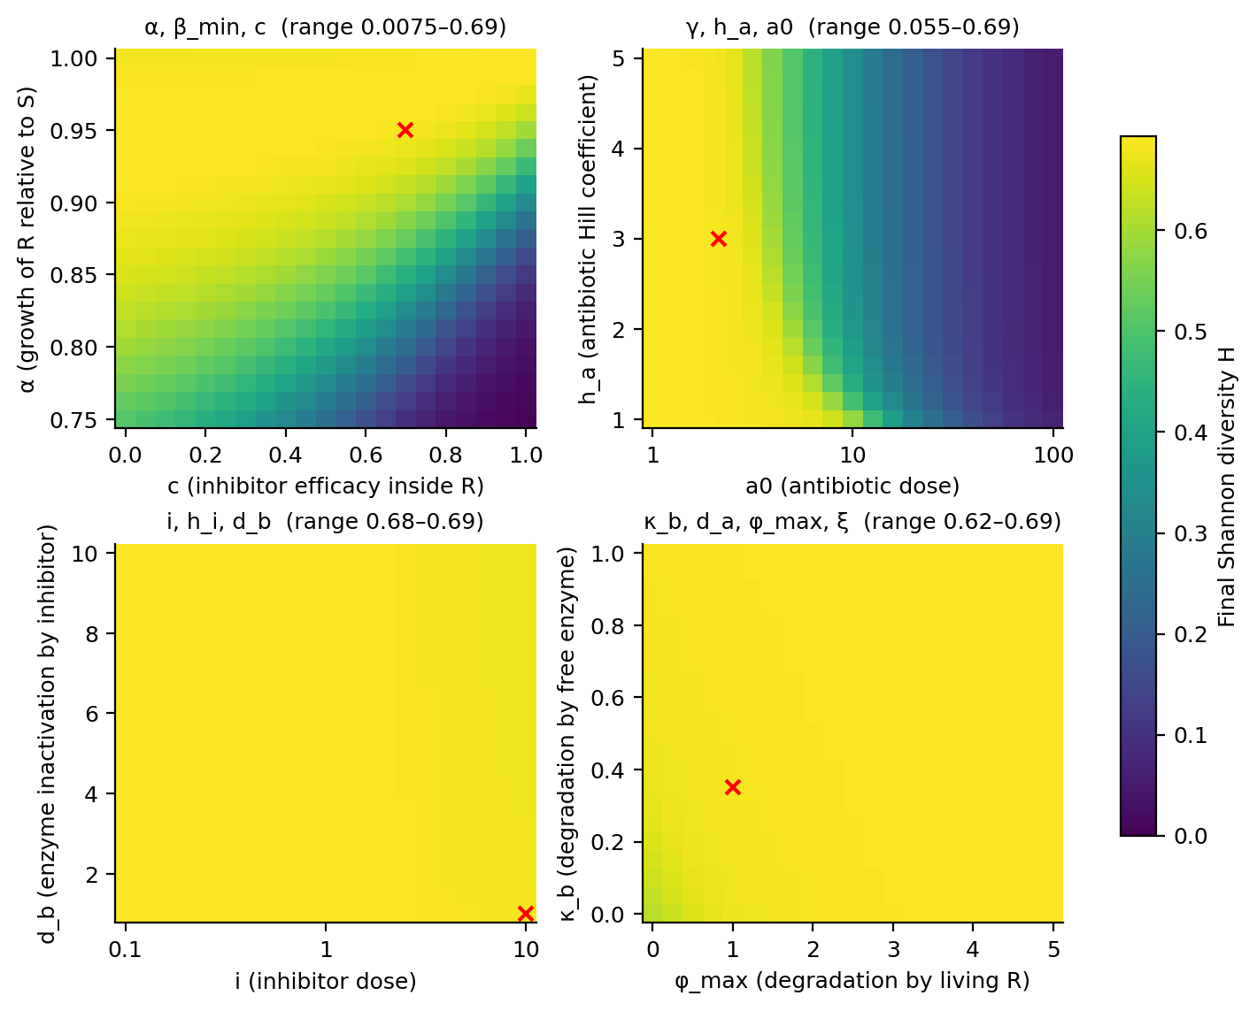
Figure 1. Shannon diversity at steady state, one plane per parameter group. Title = range within the plane.
Trivial in our case since there are only 2 species:
- H is close to its maximum (ln 2 ≈ 0.69) in most runs: one dose moves the S/R split only modestly from 50/50.
- Mean H: 0.56 (α, β_min, c), 0.46 (γ, h_a, a0), 0.69 (i, h_i, d_b), 0.69 (κ_b, d_a, φ_max, ξ).
- H falls only where one strain is strongly favoured: low α with high c (S wins), or high antibiotic dose (S wins after regrowth).
- Low H cannot tell “R gone” from “S gone”. Always read H together with f_R.

1.2 Time to reach steady state
- SS = both populations' per-capita rates stay below 10⁻³ for the last 10% of the run (happens once nutrient runs out).
Table 2. Time to steady state by sweep (model time units). “Did not settle” = antibiotic never clears, so the community never regrows.
Sweep | Runs | Median (IQR) | Min | Max | Needed t > 150 | Did not settle
α, β_min, c | 9,261 | 11.5 (9.0–17.0) | 6.0 | 40 | 0 | 0
γ, h_a, a0 | 10,164 | 77.5 (15.0–171.0) | 6.0 | 299 | 3,568 | 0
i, h_i, d_b | 9,261 | 12.0 (9.0–18.0) | 8.5 | 22 | 0 | 0
κ_b, d_a, φ_max, ξ | 194,481 | 10.0 (8.5–12.0) | 7.5 | 1138 | 462 | 353

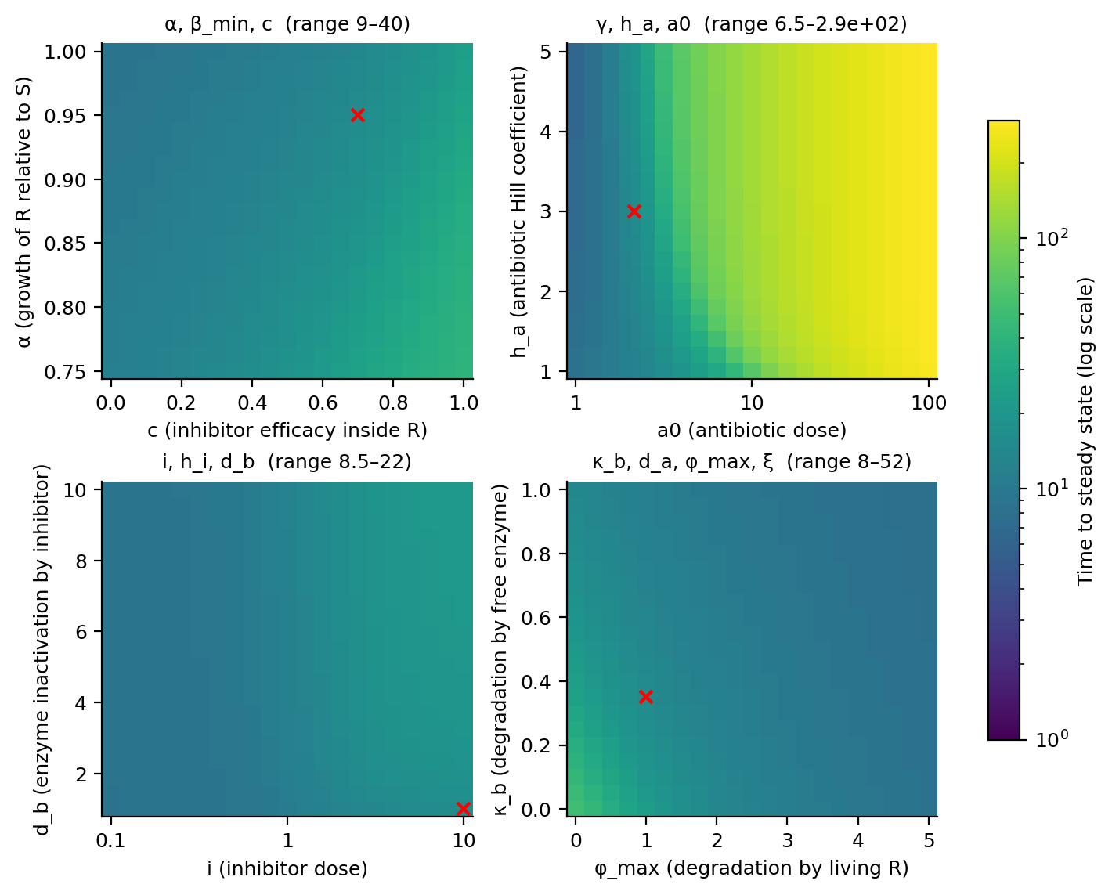
Figure 2. Time to steady state.
- At the base dose, runs settle fast (median 10–12) in three of the four grids.
- Antibiotic dose dominates: in the γ × h_a × a0 grid 35% of runs need more than t = 150, because populations regrow from very low densities.
- 353 runs in the degradation grid never settle: 350 have d_a = 0, κ_b ≤ 0.3 and φ_max ≤ 0.75, so the antibiotic is never cleared.

1.3 Final resistant fraction at steady state
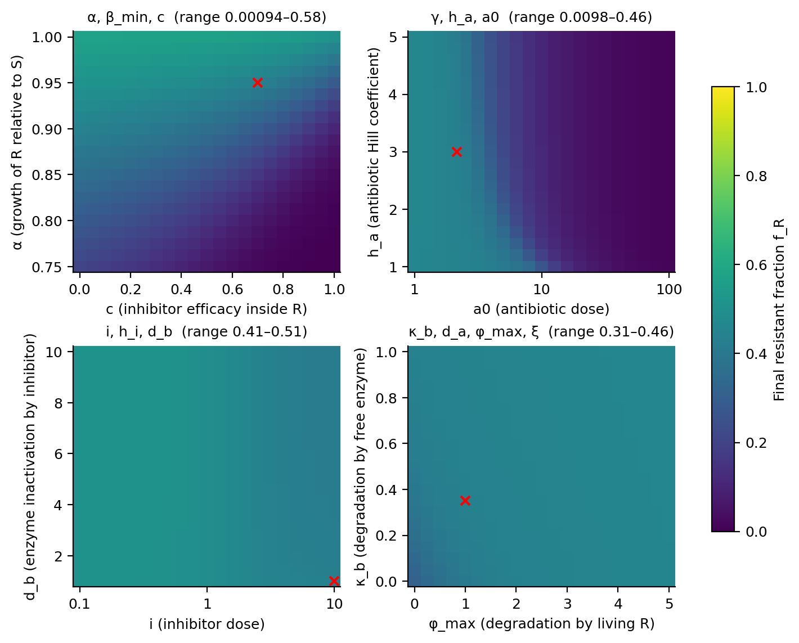
Figure 3. Final resistant fraction f_R = n_R / (n_S + n_R).
- α, β_min, c: f_R from 9 × 10⁻⁴ to 0.84; R ends as the majority in 54.0% of runs. Higher c, lower α and higher β_min all push toward S.
- γ, h_a, a0: f_R from 0.009 to 0.47; higher dose lowers f_R. R never ends as the majority.
- i, h_i, d_b: f_R only 0.41–0.51. The inhibitor parameters barely move composition at this dose.
- κ_b, d_a, φ_max, ξ: f_R 0.31–0.46 in the plane shown; these parameters change the depth of the crash, not who wins.
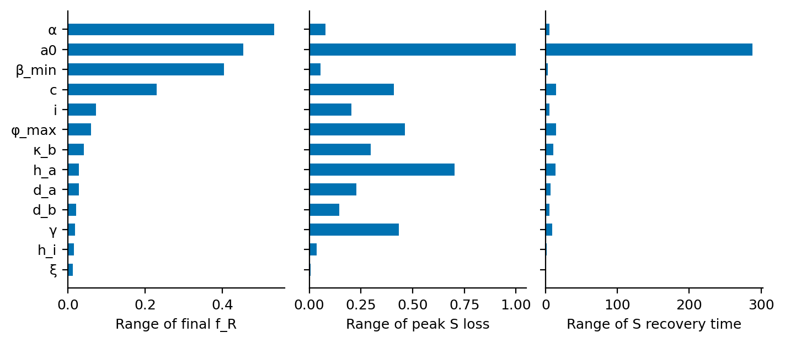
Figure 4. One-at-a-time sweep: how far each parameter alone moves three endpoints (largest minus smallest value over its range).
- Final f_R is set by α (range 0.53), a0 (0.45), β_min (0.40) and c (0.23). Every other parameter moves it by less than 0.08 when varied alone at the base dose.
- Peak S loss is set by a different group: a0, h_a, φ_max, γ and c.

2. Extinction Threshold

2.1 Proposed threshold
- R is extinct (cleared) if f_R < 10⁻⁹ at steady state; R is suppressed if 10⁻⁹ ≤ f_R < 10⁻⁶.
- Extinction floor (new): a strain is removed for good once its density falls below one cell (4.4 × 10⁻⁹). Every run is reported with and without this rule.

2.2 Rationale
- ODE populations never reach exactly zero, so a cutoff is required.
- A saturated culture holds roughly 10⁹ cells/mL, so f_R < 10⁻⁹ ≈ fewer than one R cell per mL.
- The f_R cutoff alone is not enough: in the plain model a strain can fall far below one cell during the crash and still regrow. The floor stops this regrowth, which is what makes eradication possible at all.
- Assumption: 10⁹ cells at saturation. Rescale if the experimental carrying capacity differs.

2.3 Results
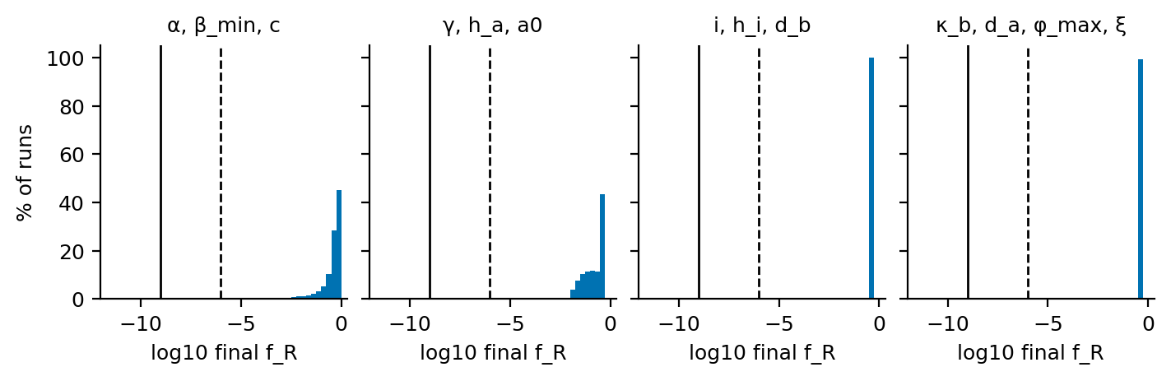
Figure 5. Distribution of final f_R (log scale). Solid line = 10⁻⁹ (extinct), dashed = 10⁻⁶ (suppressed).
Table 3. Lowest and highest final f_R, runs below each f_R threshold (plain model), and runs where a strain crosses the one-cell floor.
Sweep | Min f_R | Max f_R | < 10⁻² | < 10⁻⁶ | < 10⁻⁹ | R below one cell | S below one cell
α, β_min, c | 9.1e-04 | 0.84 | 245 | 0 | 0 | 0 | 0
γ, h_a, a0 | 9.0e-03 | 0.47 | 51 | 0 | 0 | 2,647 | 2,475
i, h_i, d_b | 4.1e-01 | 0.51 | 0 | 0 | 0 | 0 | 0
κ_b, d_a, φ_max, ξ | 5.1e-17 | 0.46 | 8 | 4 | 3 | 353 | 350

- At the base dose, changing α, β_min, c or the inhibitor parameters never brings R near any threshold.
- Only the antibiotic dose pushes strains below one cell: 2,647 runs lose R, and 2,475 of those lose S as well.
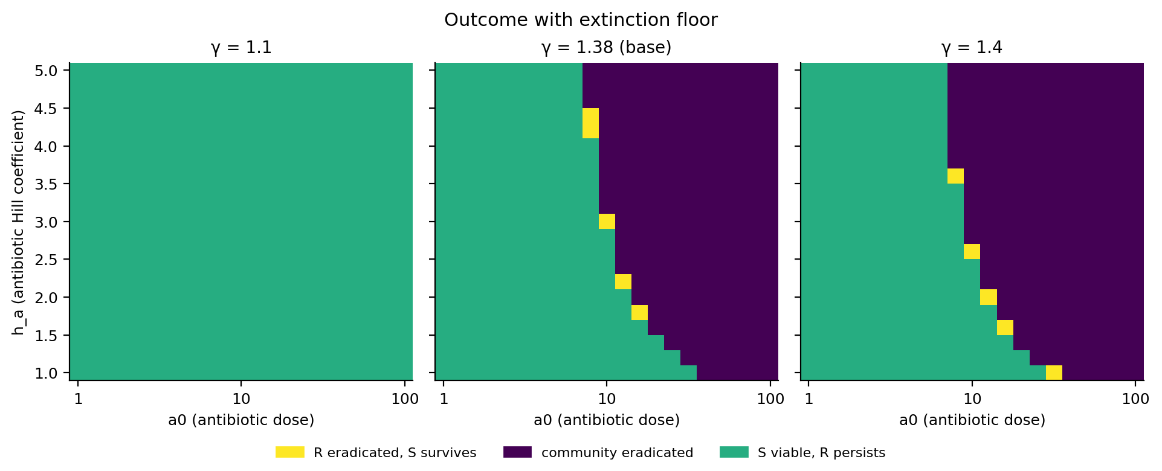
Figure 6. Outcome with the extinction floor on the dose × h_a plane, for the lowest, base and highest γ.
- With the floor: 24.4% of the γ × h_a × a0 grid ends with the whole community eradicated; only 172 runs (1.7%) eradicate R and keep S.
- The goal region is a thin band one grid dose wide: S and R are killed almost together.
- A single dose at base traits rarely removes R without removing S. Section 4 tests whether other strains or doses do better.

3. S Survival, Recovery and Population Loss
- S viable: S at SS ≥ 50% of S in the drug-free base run (see Open issues).
- Recovery time (changed): time for S to regain its starting density; 0 if S never dips. The old definition (90% of final level) also counted ordinary growth.
- Peak loss: largest fractional drop below the starting density.

3.1 Does S survive at a viable density?
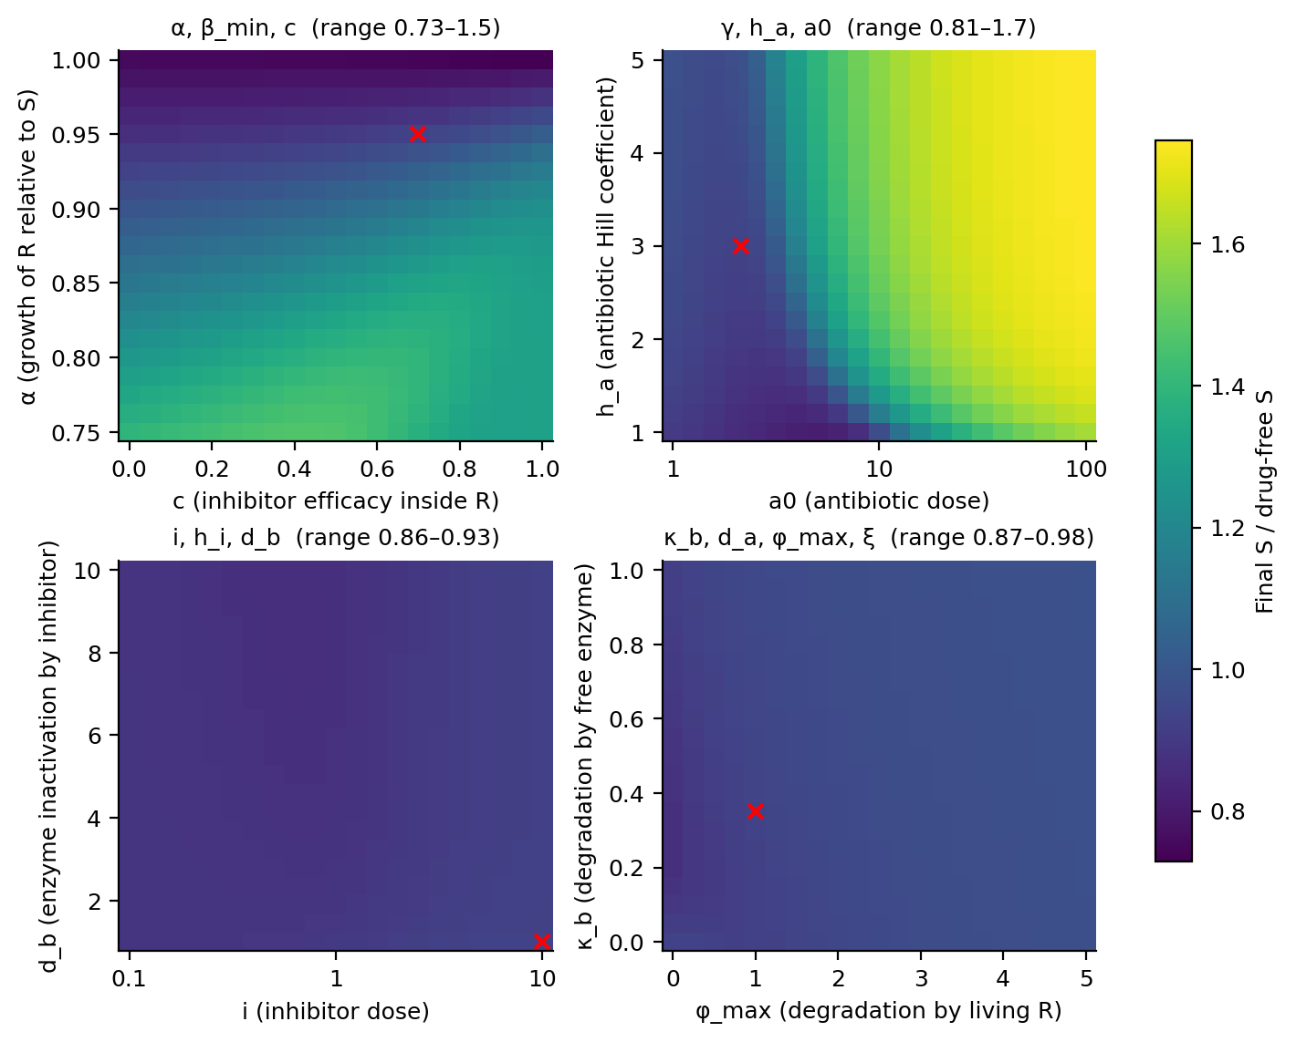
Figure 7. Final S relative to the drug-free base run. Viability cut-off = 0.5.
- S is viable in 81.6% (α, β_min, c), 100% (γ, h_a, a0, plain model), 100% (i, h_i, d_b) and 96.9% (κ_b, d_a, φ_max, ξ) of runs.
- α, β_min, c: S is not viable only where R keeps strong protection (β_min ≤ 0.55) and the inhibitor is imperfect (c ≤ 0.9).
- Degradation grid: the 5,588 “S not viable” runs are mostly low-ξ runs (median ξ = 0.1), where lysed biomass is not recycled. This is the fixed-reference issue.
- S can end at up to 1.8× its drug-free level when R is pushed down, because it takes R's share of nutrient.

3.2 Time to recovery for S
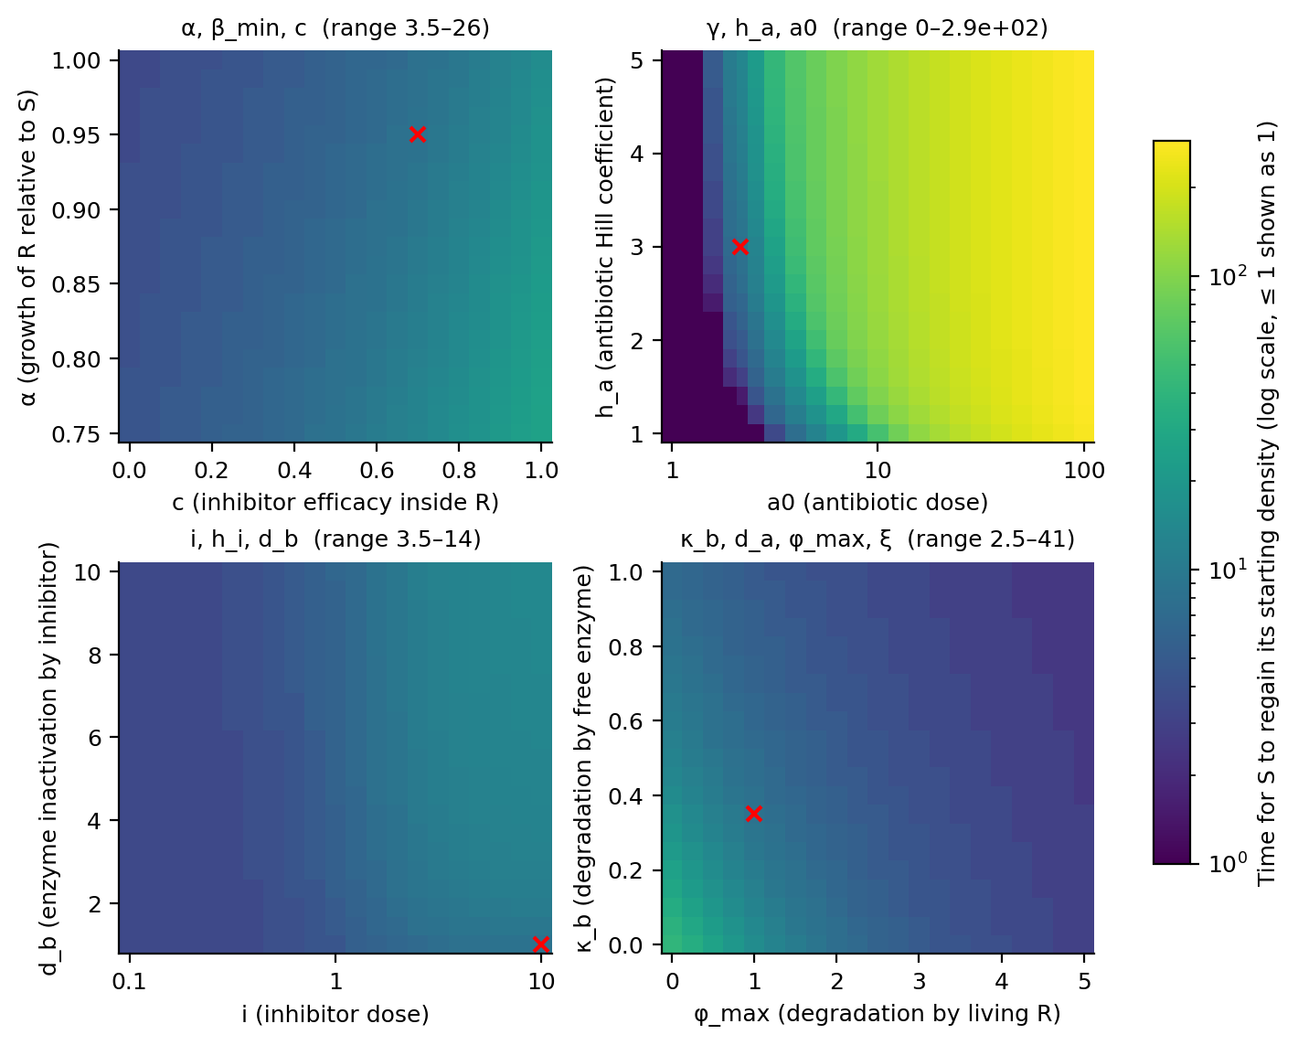
Figure 8. Time for S to regain its starting density.
- At the base dose S is back at its starting density by t ≈ 4–6 (medians), 8.5 at the base point.
- Dose dominates: up to t ≈ 290 at a0 = 100 in the plain model. With the floor these runs do not recover at all.

3.3 Peak population loss during treatment
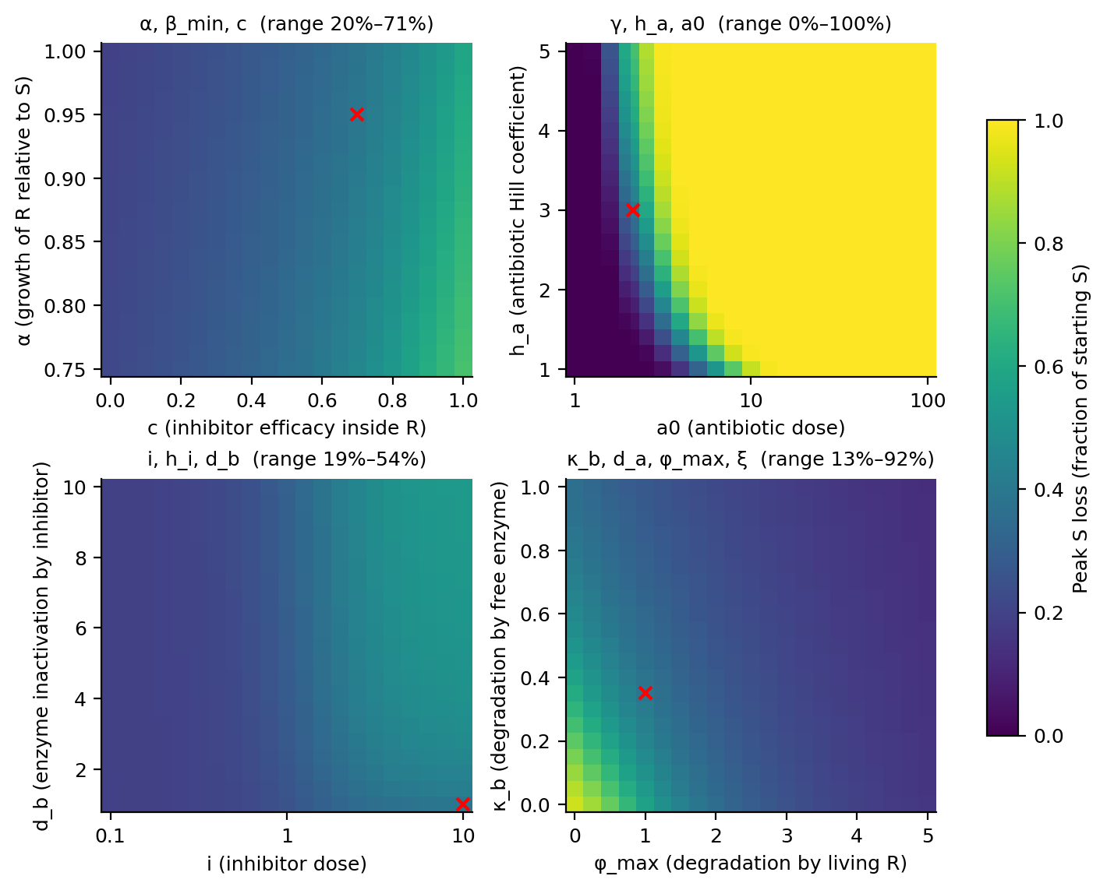
Figure 9. Peak S loss as a fraction of starting S.
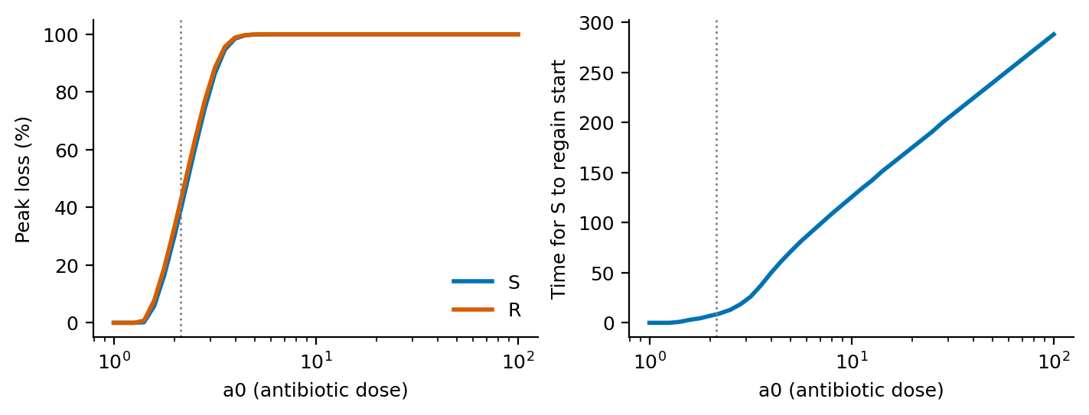
Figure 10. Peak loss and S recovery time vs. antibiotic dose (base parameters, plain model). Dotted line = base dose.
- No loss for a0 ≤ 1.26; 39% at the base dose (2.15); 95% at a0 ≈ 3.5; over 99.9% from a0 ≈ 5.6.
- At base parameters R falls below one cell from a0 ≈ 9.6 and S from a0 ≈ 10.0.
- S and R lose almost the same fraction at every dose, which is why selective removal is hard.

3.4 Diversity at the crash vs. at steady state
Table 4. Survival, loss, recovery and diversity by sweep. Loss and recovery: median (min–max). H: medians.
Sweep | S viable | Peak S loss | Recovery time | Lowest H | Final H | R gains
α, β_min, c | 81.6% | 30% (15–71%) | 5.5 (2.5–26) | 0.60 | 0.62 | 54.0%
γ, h_a, a0 | 100.0% | 99% (0–100%) | 69.8 (0.0–293) | 0.53 | 0.53 | 0.0%
i, h_i, d_b | 100.0% | 29% (19–55%) | 6.0 (3.5–14) | 0.69 | 0.69 | 43.7%
κ_b, d_a, φ_max, ξ | 96.9% | 20% (11–100%) | 4.0 (2.0–1002) | 0.69 | 0.69 | 0.0%

- Diversity changes little between the crash and steady state: the crash hits both strains alike.
- R increases its share in 54% (α, β_min, c) and 44% (i, h_i, d_b) of runs, and in none of the runs of the other two grids.

4. Dose × Trait Sweep
- Question: for which resistant strains is there any dose that removes R and keeps S?
- Dose plane: 22 antibiotic × 21 inhibitor doses = 462 doses per strain, with the extinction floor.
- Single-trait design: α, β_min, c each varied alone on its 21-value axis (29,106 runs). Joint design: 6 × 7 × 7 = 294 strains (135,828 runs).
- Goal doses: number of the 462 doses with “R eradicated, S survives”.
- Window ratio: (lowest antibiotic dose that eradicates S) / (lowest that eradicates R). Above 1 = a selective window exists; 1.2 = the dose may be up to 20% too high before S is lost too.

4.1 One trait at a time
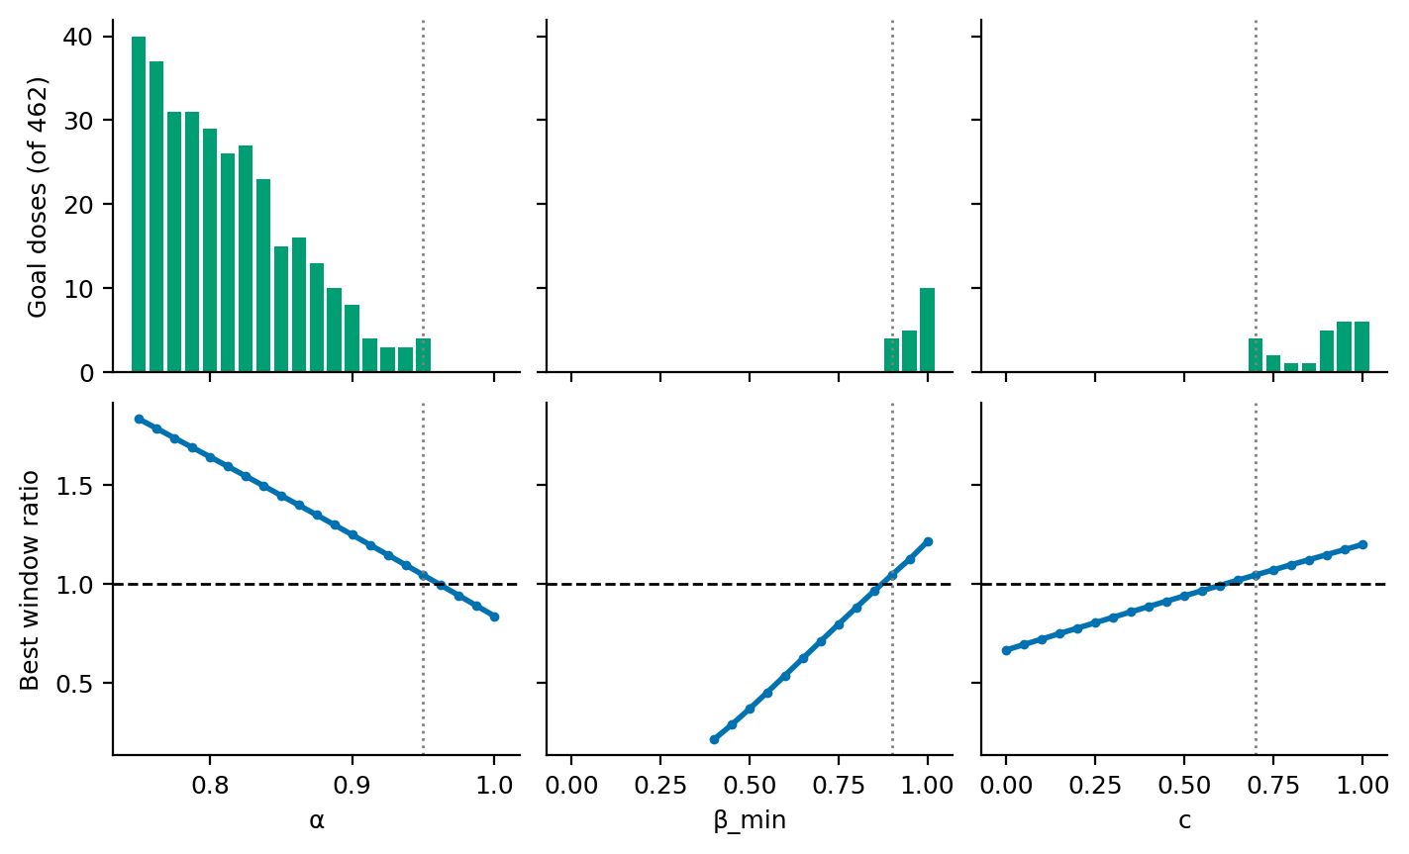
Figure 11. Goal doses (top) and best window ratio over all inhibitor doses (bottom). Dashed = ratio 1; dotted = base value.
- α matters most. From α = 0.95 to 0.75 the window widens from 1.04 to 1.83 and goal doses rise from 4 to 40. No window at α ≥ 0.9625.
- β_min: a window needs β_min ≥ 0.9 on the grid (little private protection); widest 1.21 at β_min = 1.
- c: a window needs c ≥ 0.65 on the grid; widest 1.20 at c = 1.
- The base strain sits just inside the window (ratio 1.04): the dose must be within 4% of the R-eradicating dose.

4.2 Dose maps
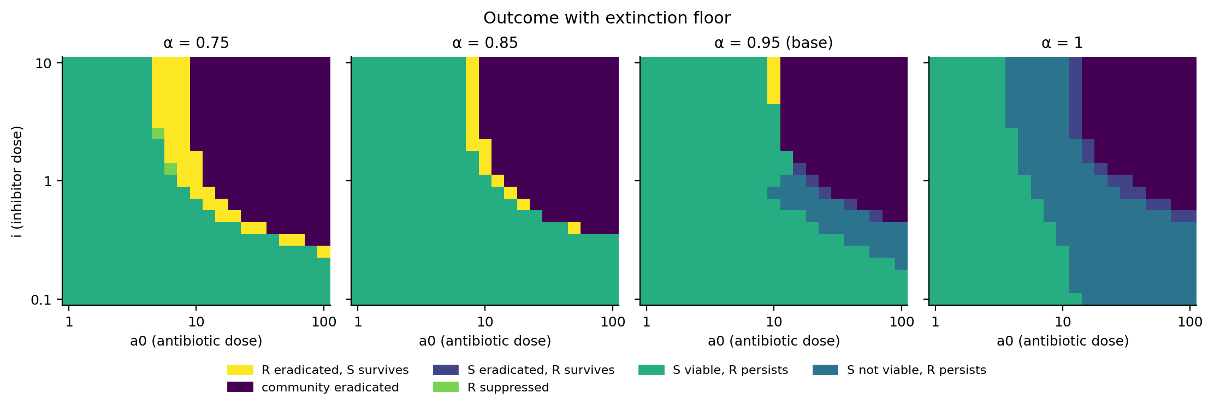
Figure 12. Outcome on the dose plane for four values of α (β_min, c at base).
- The goal region (yellow) lies along the edge between “R persists” and “community eradicated”, and widens as R becomes more costly.
- Without a cost (α = 1) the edge turns into “S eradicated, R survives”: treatment selects for R.
- More inhibitor helps: in 25 of the 26 strains with a window it is widest at the highest inhibitor dose (i = 10). The exception is β_min = 1, where the inhibitor has no private protection to act on.

4.3 All three traits together
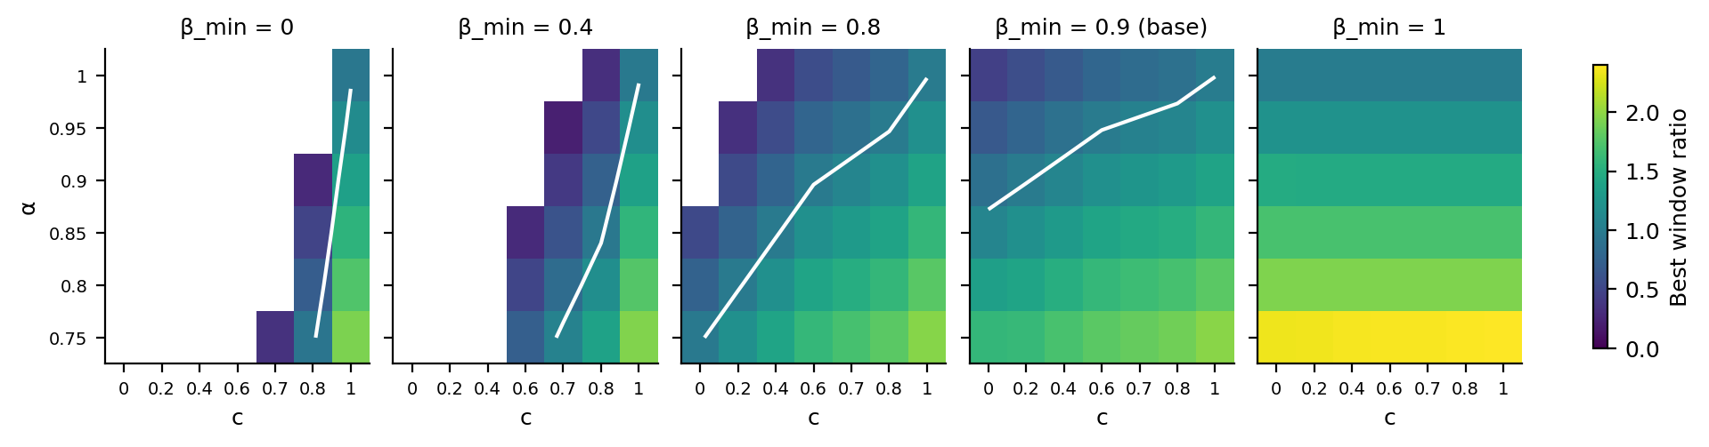
Figure 13. Best window ratio for the 294 strains of the joint design. White line = ratio 1. Blank = R is never eradicated in the dose range.
Table 5. Joint design: strains with a selective window, by value of each trait. “≥” = open-ended window: S survives every dose up to a0 = 100, so the ratio is a lower bound.
Trait value | Strains | With a window | Widest ratio | Most goal doses
α = 0.75 | 49 | 30 | ≥ 2.39 | 53
α = 0.8 | 49 | 26 | 1.94 | 47
α = 0.85 | 49 | 23 | 1.70 | 34
α = 0.9 | 49 | 19 | 1.46 | 26
α = 0.95 | 49 | 15 | 1.21 | 14
α = 1 | 49 | 0 | 1.00 | 0
β_min = 0 | 42 | 5 | 1.93 | 15
β_min = 0.2 | 42 | 6 | 1.94 | 18
β_min = 0.4 | 42 | 8 | 1.95 | 19
β_min = 0.6 | 42 | 11 | 1.96 | 23
β_min = 0.8 | 42 | 19 | 1.96 | 32
β_min = 0.9 | 42 | 29 | 1.97 | 42
β_min = 1 | 42 | 35 | ≥ 2.39 | 53
c = 0 | 42 | 8 | ≥ 2.34 | 53
c = 0.2 | 42 | 9 | ≥ 2.35 | 52
c = 0.4 | 42 | 11 | ≥ 2.36 | 52
c = 0.6 | 42 | 13 | ≥ 2.37 | 52
c = 0.7 | 42 | 17 | ≥ 2.38 | 53
c = 0.8 | 42 | 20 | ≥ 2.38 | 52
c = 1 | 42 | 35 | ≥ 2.39 | 52

- 113 of 294 strains have a window; 112 have at least one goal dose on the grid. Widest fully measured ratio: 2.2 (α = 0.75, β_min = 1); at the lowest inhibitor doses the same strains have an open-ended window of at least 2.4.
- With strong private protection (β_min ≤ 0.4) a window needs c ≥ 0.7, and c = 1 unless α ≤ 0.8.
Table 6. Joint design: outcomes over all 135,828 runs (with extinction floor).
Outcome | Runs | % of runs
S not viable, R persists | 55,834 | 41.1%
S viable, R persists | 54,935 | 40.4%
community eradicated | 19,551 | 14.4%
S eradicated, R survives | 3,101 | 2.3%
R eradicated, S survives | 2,302 | 1.7%
R suppressed | 105 | 0.1%

- Missing the window is costly both ways: 14.4% of runs eradicate the whole community; 2.3% eradicate S and leave R.

4.4 The paper's criterion is a close guide to the window
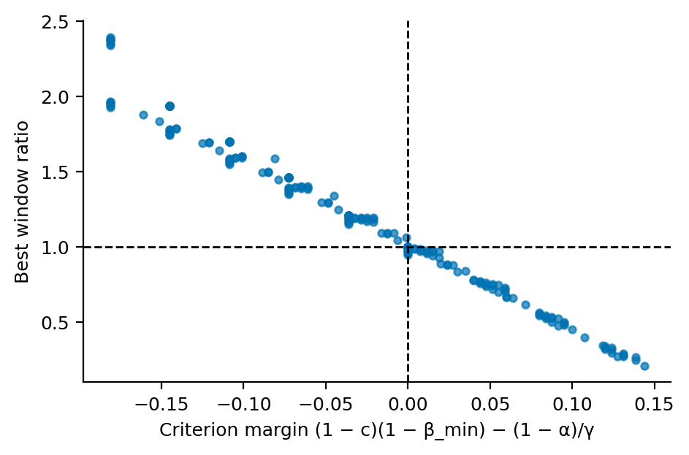
Figure 14. Best window ratio vs. the margin of the paper's simplified criterion (Eq. 2), one dot per strain.
- On this grid a window exists whenever (1 − c)(1 − β_min) < (1 − α)/γ, and only then: all 294 strains agree.
- The window ratio falls steadily as the margin rises (Spearman −0.995).
- The agreement is empirical and the grid is coarse. A fine check next to the boundary finds strains just on the R-favoured side (margin up to +0.002) that still have a very narrow window (ratio ≤ 1.01).
- The criterion, measured on a strain alone, is a close guide to whether that strain can be removed selectively.

5. Fine Grid in the Low-Degradation Corner
- Why: the base values of φ_max (1 in 0–5) and κ_b (0.35 in 0–1) sit low in the paper's ranges, so the standard grid has only 5 × 8 values between zero and the base point.
- Fine grid: φ_max 0–1 × κ_b 0–0.35 × d_a 0–0.1, 21 values each (9,261 runs) at the base dose; ξ and all other parameters at base. The base point is the top-right corner of the plane; the red cross marks it in the base panel (d_a = 0.02).
- A higher inhibitor dose was not added: the inhibitor effect is already at 99% of its maximum at i = 10.

5.1 Final resistant fraction and peak loss
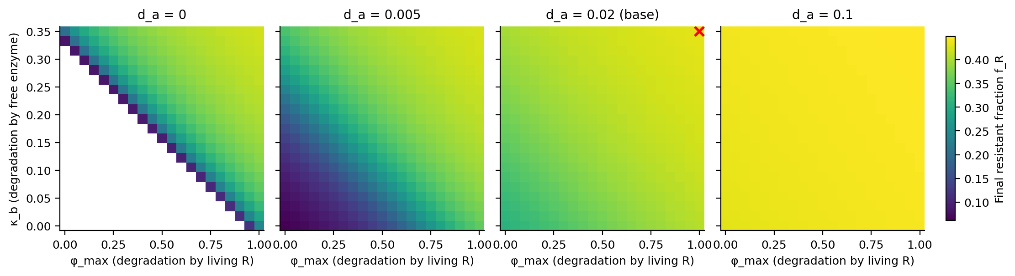
Figure 15. Final resistant fraction on the fine grid for four values of basal decay d_a. Blank = collapsed (antibiotic never cleared).
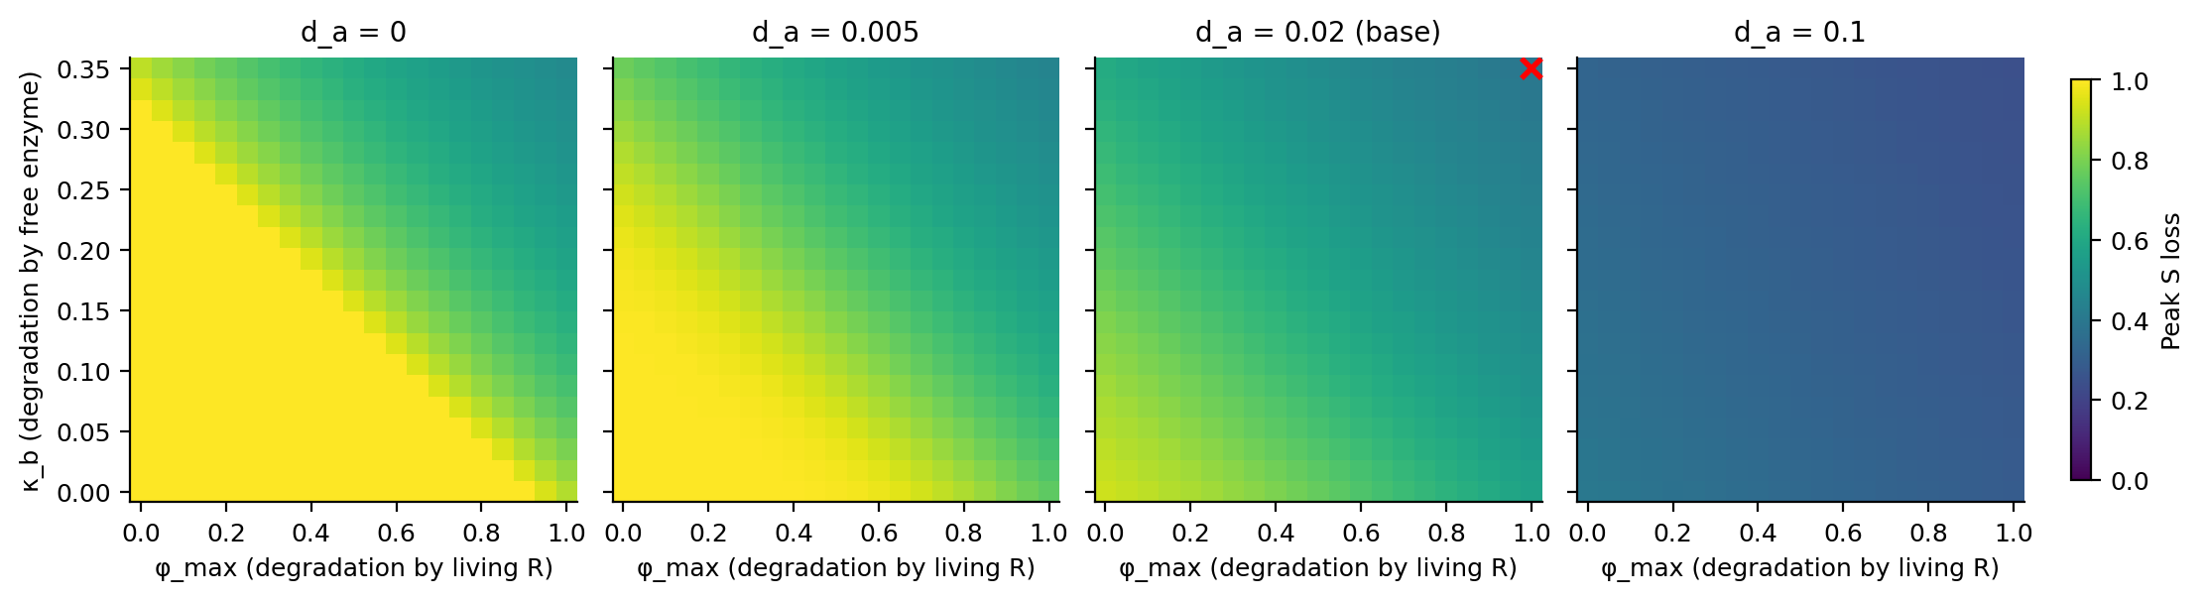
Figure 16. Peak S loss on the fine grid.
Table 7. Fine grid by basal decay d_a (441 runs per value). Ranges are over the runs that settle.
d_a | Runs | Collapsed | Final f_R | Peak S loss | Longest S recovery
0 | 441 | 190 | 0.08–0.42 | 47–95% | 140
0.005 | 441 | 0 | 0.06–0.42 | 45–100% | 163
0.01 | 441 | 0 | 0.19–0.43 | 43–99% | 82
0.02 | 441 | 0 | 0.31–0.43 | 39–92% | 41
0.05 | 441 | 0 | 0.40–0.44 | 32–64% | 16
0.1 | 441 | 0 | 0.43–0.45 | 25–40% | 8

- Same ranges as the standard grid in this corner, with eleven times the resolution (441 instead of 40 points per plane): the fine grid confirms the earlier result and resolves its shape.
- The corner only matters when basal decay is slow. At d_a = 0.1 the plane is flat (f_R 0.43–0.45); at d_a = 0.005 f_R spans 0.06–0.42 and peak S loss 45–100%.
- Slow drug removal lowers R's share but deepens the crash. At the base traits R loses share whenever cells grow; a longer exposure means a deeper crash and more regrowth, and S takes longer to recover (up to t = 163).
- No run meets the goal: neither strain falls below one cell in any run that settles.

5.2 The two enzyme routes are nearly interchangeable
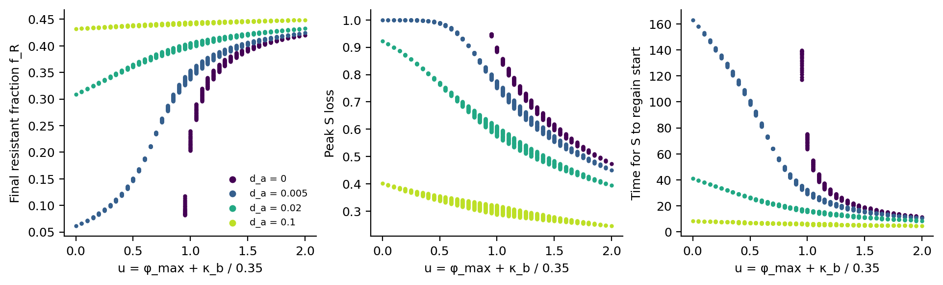
Figure 17. Endpoints vs. combined enzyme removal u = φ_max + κ_b / 0.35 (base point: u = 2), one dot per run.
- For d_a > 0, final f_R is almost a function of u alone (rank correlation 0.976–0.998; runs with equal u differ by at most 0.016).
- Going from κ_b = 0 to 0.35 does the same as going from φ_max = 0 to 1.
- Collapse has a sharp boundary: with d_a = 0 the community collapses when u ≤ 0.90 and survives when u ≥ 0.95 (190 of 441 runs). With any d_a > 0 on this grid, no run collapses.

6. Conclusions
- Who wins is set by α, β_min, c and the doses; the other eight parameters move final f_R by less than 0.08 each.
- How deep the crash goes is set by the dose, h_a, γ and how fast the antibiotic is removed (φ_max, κ_b, d_a).
- At the base dose no trait change eradicates R. Eradication needs a higher antibiotic dose, which kills S almost as fast.
- A selective dose window exists for 113 of 294 strains, is a factor of 2.2 at its widest measured, and is 4% wide for the base strain.
- Costly resistance (low α), weak private protection (high β_min), an effective inhibitor (high c) and a high inhibitor dose all widen the window.
- The paper's criterion is a close guide to which strains have a window (all 294 on the grid; exceptions only within +0.002 of its boundary).
- Slow antibiotic removal (low φ_max, κ_b and d_a) lowers R's share to 0.06 but never removes R, and costs S a deeper, longer crash.
- Next: settle the viability definition, refine the dose grid near the window, then repeated dosing and more species.

