**Part 1 Lecture cues**

1. **Listen to audio clip 1 and answer the following questions.**
2. Why do speakers use lecture cues?

Speakers use lecture cues to aid listeners’ understanding.

1. What types of lecture cues do you know from this talk?

Structure cues, transition cues, concluding cues and organization cues.

1. **There are different types of transition cues. Transition cues help listeners figure out how information is connected and also tell the essential information from the unessential one. Read the following table for more transition cues and expressions a lecturer may use. You may need to fill in more expressions if there isn’t any examples given below.**

|  |  |
| --- | --- |
| **Cues for giving examples:** | **Cues for giving additional information:** |
| Let me give you an example…  Such as…  For instance…  A good example of… is … | In addition…  Moreover…  Another point…  Not only… but also… |
| **Cues for contrasting:** | **Cues for listing:** |
| But…  However…  While…  On the other hand…  In contrast to this… | Next…  Another….  A final…  First…/the first… |
| **Cues for giving definition:** | **Cues for sequencing:** |
| … refers to …  … means …  The definition of … is … | First/Second/Third, …  Then, …  Next, …  Finally, …  At first/At the beginning, … |
| **Cues for referring to sources:** | **Cues for focusing on details:** |
| According to …  As …  … by/in … shows … | Here are some details about …  To prove that, …  The reason is …  Let’s focus on … |
| **Recycling cues:**  *Speakers sometimes build redundancy recycling the main points, in other words, saying the same thing more than once. There are 3 ways to recycle information*. | |
| **Repeating cues:** | **Paraphrasing cues:** |
| Let me say that again...  Let me repeat that... | In other words...  Put another way...  Now let me put that a different way...  Now let me put that another way...  To put that another way... |
| **Summarizing cues:** |  |
| So...  So, to sum up...  Thus...  Therefore...  To recap...  In conclusion...  We've seen then...  In short... | In brief...  Summing up...  To sum up...  To summarize..  You might be interested to know...  By the way...  Incidentally...  You don't need to write this down... |
| **Digression cues:**  *Even good lecturers, however, move away from the main topic from time to time.* | |
| You might be interested to know...  By the way...  Incidentally...  You don't need to write this down... | |
| **Resumption cues:** A speaker may need to signal that they are back from the digression by using the following expressions. | |
| Getting back to what I was discussing earlier...  To get back to the point...  Anyway...  Anyhow... | |

1. **Read the transcript of the lecture excerpt, and fill in the form in the following.**

*Today we’re going to look at the levels of biological organization that exist in nature…. There are ten levels of biological organization, and we’re going to discuss them in order of largest to smallest…. Before we begin, I just want to say that this is an incredibly exciting time to be studying biology, as we are starting to understand more and more about how all these levels are connected. . . The more we learn about life, the more we can appreciate how miraculous it really is…. I myself just became a grandmother five months ago, so I am very in awe of that miraculousness right now…. The first level is the biosphere… let me write that on the board for you … the biosphere is all the environments on Earth that have life in them…. In the biosphere we find land masses… bodies of water such as oceans, lakes, and rivers… and the atmosphere up to several kilometers…. The next level is the ecosystems. .*

|  |  |  |
| --- | --- | --- |
| Cue type | Expressions used | Add another example you know |
| Topic cue | *“Today we’re going to look at…”* | *My topic of today is…* |
| Digression cue | “*Before we begin, I just want to say …*” | *By the way...*  *Incidentally...* |
| Cue for giving examples | *“… such as …”* | *For example, …*  *For instance, …* |
| Cue for listing | *“The first level is …”*  *“The next level is …”* | *Another …*  *A final …* |
| Cue for focusing on details | *“ let me write that on the board for you”* | *Let’s focus on …* |

1. **Listen to audio clip 2 of a beginning of a lecture. When you are listening, please note down the lecture cues you heard. Then put them into different categories of lecture cues.**

|  |  |
| --- | --- |
| Topic cues | The title of this little talk is … |
| Structure cues | Let me just indicate the structure of the talk. |
| Cues for listing | Firstly/Secondly/Thirdly … |
| Summarizing cues | So … |
| Cues for sequencing | Then/Finally … |

**Part 2: Taking notes**

1. **Search online for at least 3 types of note-taking systems. List the advantage and disadvantage of each of them.**

|  |  |  |
| --- | --- | --- |
|  | **Advantages** | **Disadvantages** |
| **Linear note-taking system** | usually very clear, especially when there is a clear structure to the lecture | not as interesting or visual as pattern notes |
| **Pattern note-taking system** | quick and easy to make  visual  easy to add information | briefer than linear notes |
| **Cornell note-taking system** | specifically designed for making notes in a lecture  ensure a more active engagement | take some time to learn |

1. **Listen to audio clip 3 for the shorthand types people use to take a fast note. Figure out the types, and note down all the examples the speaker give.**

|  |  |
| --- | --- |
| **Type** | **Examples** |
| **use beginning of the words** | **politics-pol**  **government-gov**  **subject-subj**  **information-info**  **introduction-intro** |
| **use beginning of the words with the final letter** | **government-govt/gov’t**  **international-interl/inter’l** |
| **omit vowels** | **problem-prblm**  **school-schl**  **background-bkgd** |
| **abbreviate -ing** | **checking-ckg/ckng/ck’g** |
| **abbreviate specific words from the lecture** | **acid rain-AR**  **sulphur-S**  **nitrogen-N**  **pollution-pol**  **factories-facs** |

1. **Match the symbols and numbers (1-16) to their meanings (a-p).**

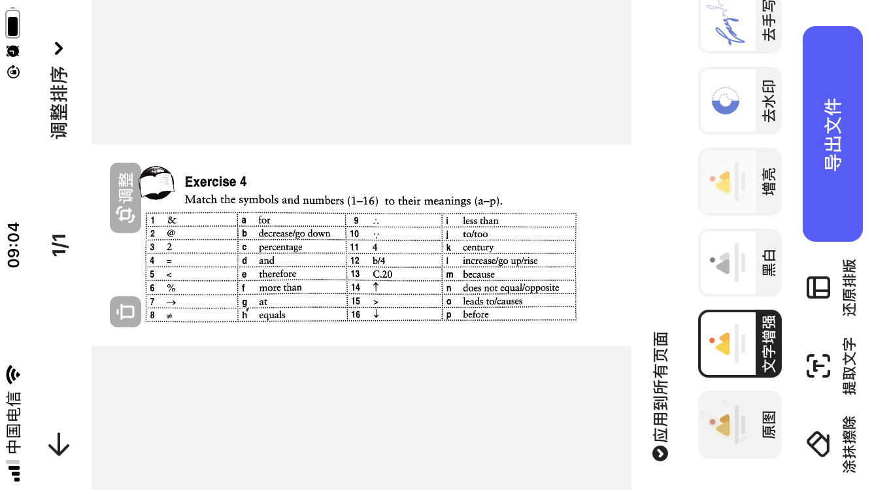

|  |  |  |  |
| --- | --- | --- | --- |
| 1.___d___ | 2.___g___ | 3.____j____ | 4.____h___ |
| 5.___i___ | 6.___c___ | 7.____o____ | 8.____n___ |
| 9.___e___ | 10.__m____ | 11.___a____ | 12.___p____ |
| 13.__k____ | 14.__l____ | 15.___f____ | 16.___b____ |

1. **Match the meaning with the abbreviations.**

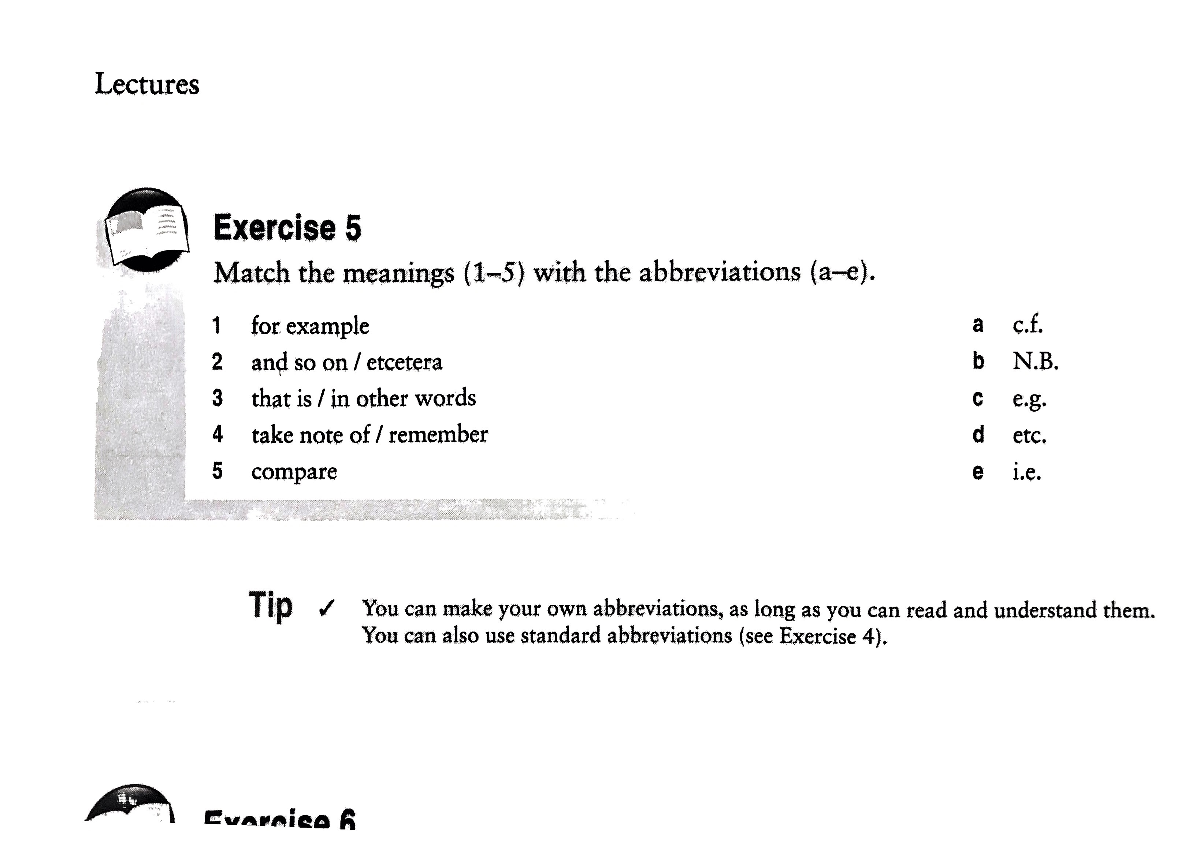

|  |  |  |  |  |
| --- | --- | --- | --- | --- |
| 1 | 2 | 3 | 4 | 5 |
| c | d | e | b | a |

1. **Match the abbreviations with the words in the box.**

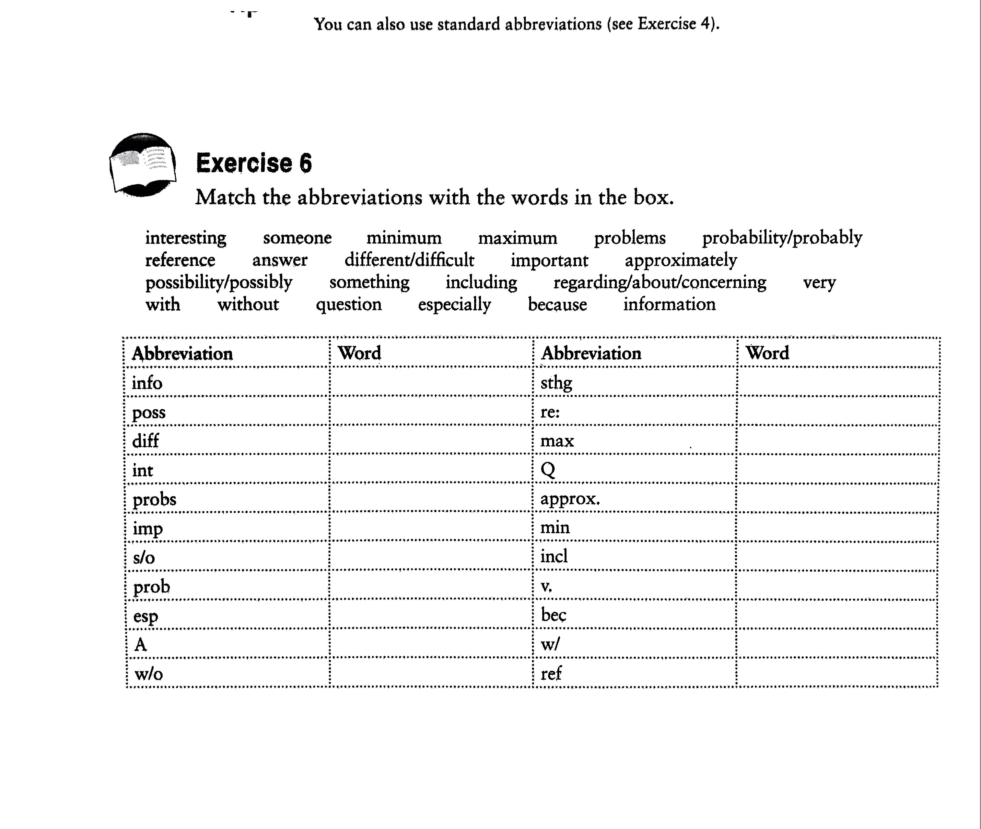

|  |  |  |  |
| --- | --- | --- | --- |
| **Abbreviation** | **Word** | **Abbreviation** | **Word** |
| info | information | sthg | something |
| poss | possible/possibly | re: | reply |
| diff | different/difficult | max | maximum |
| int | interesting | Q | question |
| probs | problems | approx. | approximately |
| imp | important | min | minimum |
| s/o | someone | incl | including |
| prob | probably/problem | v. | very |
| esp | especially | bec | because |
| A | answer | w/ | with |
| w/o | without | ref | reference |

**Part 3: Lecture understanding**

**1.Lecture: Doing market research**

1. **Listen to the audio clip 4 and answer:**
2. What macro-structure does this speaker generally follow？

Introduction-Body-Conclusion.

Body structure: Topical order.

1. Listen and complete the list of methods that the speaker mentioned.
2. Computer assisted telephone interviewing (CATI)
3. Telephone interviewing
4. Personal interviewing
5. Postal quertionnaires
6. **Watch the extract (clip 5), and take notes in your note book on any implications the lecturer mentions for the market research methods.**

|  |
| --- |
| 1. **Computer assisted telephone interviewing (CATI)**   data entry occurs at the same time as asking questions  analyze automatically   1. **Telephone interviewing**   low respond rates   1. **Postal quertionnaires**   concentrated  most accurate   1. **Personal interviewing**   high respond rates  bias influence |

**2.Lecture: Social learning**

**In this lecture, the speaker is looking at the hypothesis suggesting that animals learn from each other, for example, learning which foods to eat or avoid and which animals are their natural predators. Please listen and answer the following questions.**

1. Listen to clip 6. The lecturer is talking about the research method of the study. Please 1). identify the organization in this lecture excerpt. 2.)tell how many parts there are in this description of research method.

1) Process organization.

2) Three.

1. Did you hear any type of lecture cues in this extract? Write it down and name it.

|  |  |
| --- | --- |
| Cue for listing | First of all …  and then …  One of which … the other …  is one … .The other … |
| Cue for giving examples | for example … |
| Summarizing cue | So … |

1. Listen to part 2 of the extract. Make notes on the results and the conclusion the speaker draws form the results. (clip 7)

|  |
| --- |
| **Results:**  **Pre-test:** monkeys show no avoidance of snakes at all  **Post-test:** opportunity to watch an observer acting frightened, very little time near the snakes  **3-month-follow-up:** as strong as post-test  **Conclusion:**  Naive monkeys can learn the snakes are dangerous just by watching another monkey. |