CHARTER
Certification and History Architecture for Robust Transport, Evidence, and Retention
Framed Prime Shells and Bound Persistent Shells

Christopher D. Pang
Public release v1.0 — 5 September 2026
Reserved record: 10.5281/zenodo.22288471
Status: Author-adopted v1.0 release; not peer reviewed. Public availability begins only upon actual deposit.
License: © 2026 Christopher D. Pang · Creative Commons Attribution 4.0 International (CC BY 4.0) · https://creativecommons.org/licenses/by/4.0/
CLAIM STATUS CHARTER v1.0 is an author-adopted 2026 mathematical and systems synthesis with a delimited machine-checked core. The inherited v0.1–v0.2 Lean chains compiled under their pinned environment; v0.2 exact-inventory hardening remains open. Material introduced after that core is proved or defined at manuscript level unless explicitly stated otherwise; it has no dedicated Lean receipt, implementation, calibration, independent review, or deployment. Version 1.0 marks publication readiness, not an expansion of the machine-checked boundary. The reserved DOI is a locator, not mathematical evidence.
AI-ASSISTANCE NOTE Christopher D. Pang is the sole author and publication authority. OpenAI ChatGPT and connected coding tools assisted with mathematical exploration, checking, drafting, figures, and document production. They are tools, not authors or mathematical authorities; the full disclosure appears at the end.

Abstract
Let $η=e^{iπ/3}$ and $Q\left(a,b\right)=a^{2}+ab+b^{2}$. A prime shell is the exact lattice level $S_{p}=\{\left(a,b\right)∈Z^{2}:Q\left(a,b\right)=p\}$; occupancy follows the classical split/ramified/inert classification. CHARTER studies the added structure needed to orient, compare, certify, carry, and purposefully release an occupied shell without conflating mathematical equality with evidentiary or physical equivalence.
The exact frame core is unchanged. One marked vector does not span the plane; a suitable vector and its arithmetic conjugate do. Of three antipodal unit choices, one pair has squared normalized area at least $3/4$ and squared Euclidean condition number at most $3$, both sharp at the norm-three shell. Two references determine a unique composable transport. A derived coordinate preserves the trace kernel; a jointly retained coordinate refines it exactly when it splits a former fiber.
A framed atlas lists witness-sensitive states; a ribbon retains an ordered route even when flat transport depends only on its endpoints. Smith-chart geometry separates a derived spherical coordinate, a retained shell condition, and a route-carrying sweep. Golden Rainbow schedules change display unless a jointly retained event refines the trace.
Prime Seeds and Circuit Gardens separate an object from the evidence under which its named claim may enter a ledger. The executable two-input NAND garden shares certification grammar with framed shells but transfers no circuit-complexity theorem to number theory. Systemic Friction records source-bound carriage burdens at a declared realization boundary. A weed is purpose-relative; Atomic Edge Promotion applies a separately checked transition, and neither cost nor compression grants deletion.
The orchestration layer models finite Bound Persistent Shells: indexed Tripartite Task Carriers under one frozen manifest. Each TTC separates work, completion-criterion, and ledger roles and contributes one typed terminal record. The joint kernel is the intersection of the TTC kernels; an added TTC earns informational refinement only by splitting a current collision; and a deterministic completion coordinate adds no state distinction. Separately sourced liveness refines the trace only when it supplies a strict-fiber witness.
For an optional minimum-asymmetry subclass, let the odd number of TTCs be $t_{m}=2m+1$ with $m≥1$, split into banks $\left(m+1,m\right)$. This is the unique closest ordered split into distinct positive integers. Under a declared adapter into the Eisenstein coordinate lattice,
$$4Q\left(u,v\right)=3{\left(u+v\right)}^{2}+{\left(u−v\right)}^{2},$$
so the adjacent bank coordinate has framed-shell index
$$n_{m}=Q\left(m+1,m\right)=3m^{2}+3m+1=\frac{3t_{m}^{2}+1}{4}.$$
The sequence contains composites. Prime status requires a separately checked primality witness and exact norm-equality witness. Bank difference supplies orientation—not truth, voting power, liveness, or performance.
The motivating 2012 notebook identity is cited only as ancestry. The adjacent-bank proofs, declared adapter, Bound Persistent Shell construction, and systems interpretation are a 2026 synthesis. The inherited Lean chains compiled under their pinned environment; post-core layers remain manuscript-level pending formalization, implementation, calibration, and independent review.
Keywords: Eisenstein integers; norm shells; robust frames; kernel fibers; Prime Seeds; Circuit Gardens; Systemic Friction; Atomic Edge Promotion; Tripartite Task Carriers; Bound Persistent Shells; selected carry; Smith charts; atlases; ribbons; evidence receipts; Lean 4

Document map
Sections | Reading route
1-3 | FOUNDATIONS. Claim boundary, Eisenstein coordinates, and classical shell arithmetic.
4-10 | FRAMES + FIBERS. Minimum references, robust selection, sharp quality, transport, prime specialization, and kernel tests.
11-13 | STATE + ROUTE. Witness-sensitive atlas, trace-bearing ribbons, Smith-chart states, and Golden Rainbow schedules.
14-16 | CERTIFY + CARRY. Prime Seeds, Circuit Gardens, Systemic Friction, Tripartite Task Carriers, Bound Persistent Shells, selected carry, and release.
17-18 | EVIDENCE. Formal status, provenance, literature boundary, nonclaims, and open burdens.

1. Orientation and claim boundary
A prime shell in this paper is an exact norm level set in the Eisenstein lattice. It is not a physical shell, an electron shell, a probability distribution, a zeta-zero packet, or a mechanism for the Riemann Hypothesis.
The paper keeps three roles separate.
- Classical arithmetic. Eisenstein factorization and representation theory determine shell occupancy, point counts, and unit-orbit structure.
- Framed-shell construction. A selected point, its arithmetic conjugate, a unit-rotation choice, a conditioning functional, and a shell-to-shell comparison law turn an occupied shell into a framed object.
- Geometric exposition. The author supplies the intuitive account of why two references stop a shell from floating, why three unit choices suffice, how a frame approaches collapse, and what shell transport means.
The geometric account may orient the mathematics; it does not replace a theorem or strengthen its scope.
GEOMETRIC READING The equation Q(a,b)=n determines a continuum level before the integer lattice is consulted. The framed-shell object begins only after exact lattice occupancy and its witnesses are supplied.
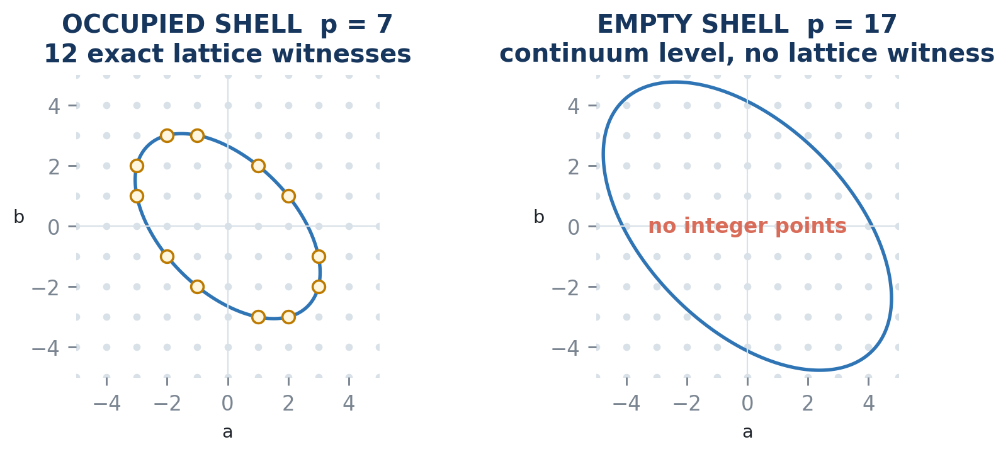
Figure 1. The continuum levels Q(a,b)=7 and Q(a,b)=17 both exist, but only the first carries integer lattice points. Occupancy is arithmetic evidence, not a visual consequence of drawing the level curve.

1.1 Layered contribution
CHARTER is a 2026 mathematical and systems synthesis with a delimited machine-checked core. Its claims are layered so that a later realization cannot borrow authority from an earlier theorem merely by sharing vocabulary.
Exact local-frame core. Within the fixed-center two-dimensional linear model, a selected Eisenstein point and its arithmetic conjugate form the minimum internal reference pair; one of three antipodal unit choices is uniformly far from collapse; normalized area and Euclidean condition number are two views of one certificate; the constants are sharp; and two ready frames determine a unique composable transport.
Information geometry. Derived coordinates preserve fibers. Joint coordinates intersect kernels and become independent relative to a trace only by splitting an existing collision. The framed atlas records available states, the ribbon records visited order, and endpoint-determined transport need not preserve route history.
Certification and carriage. A Prime Seed binds a supplied object, witness, mathematical certificate, and external evidence without conflating them. A Circuit Garden makes the finite obligations, obstructions, verifier, receipt, residual, and reopening condition explicit. Systemic Friction then asks what a realized carrier costs to keep under a declared purpose; it is not a hidden scalar inside the abstract equality.
Bounded orchestration. A Tripartite Task Carrier divides one frozen objective into work, completion-criterion comparison, and admitted trace. A finite Bound Persistent Shell joins several TTC returns without merging their identities or ledgers. Protected-query sufficiency, earned expansion, selected carry, and boundary residue state exactly which distinctions survive.
Minimum-asymmetry bridge. The 2012 notebook equation supplies an antecedent image. Under finite integer, positivity, parity, ordering, and optimization hypotheses, the closest distinct split is unique. A separately declared Eisenstein adapter yields the adjacent-coordinate shell family and exact frame-quality formulas; primality remains conditional on a separate witness.
The inherited Lean receipts bind only their exact declarations. The post-core proofs and derivations, and every interface, policy, implementation, performance, novelty, and adoption claim, retain their separately stated status.

2. Eisenstein coordinate algebra
Use the sixth root
$$η=e^{iπ/3}, η^{2}=η−1,$$
and write an Eisenstein integer as
$$x=a+bη, a,b∈Z.$$
In the $\left(1,η\right)$ basis, multiplication is
$$\left(a,b\right)\left(c,d\right)=\left(ac−bd, ad+bc+bd\right).$$
Arithmetic conjugation and multiplication by the unit $η$ are
$$\overline{\left(a,b\right)}=\left(a+b,−b\right),$$
$$R\left(a,b\right)=\left(−b,a+b\right).$$
For a point x = a + bη, the point norm and coordinate form are identified by
$$N\left(x\right)=N\left(a+bη\right)=Q\left(a,b\right)=a^{2}+ab+b^{2}.$$

Proposition 2.1 — Coordinate identities
For all coordinate points $x,y$,
$$\overline{\overset{‾}{x}}=x, R^{6}x=x,$$
$$N\left(\overset{‾}{x}\right)=N\left(x\right), N\left(Rx\right)=N\left(x\right),$$
$$N\left(xy\right)=N\left(x\right)N\left(y\right), x\overset{‾}{x}=N\left(x\right).$$

Proof
Each statement follows by substitution in the displayed coordinate operations and polynomial normalization. The Lean proofs use only the declared commutative-ring structure for the algebraic identities. The fixed-point equation $Rx=x$ gives $−b=a$ and $a+b=b$, hence $a=b=0$. Therefore no positive shell contains a point fixed by the full sixty-degree unit rotation. ∎

2.1 Conjugation eigen-coordinates
Define
$$X\left(x\right)=2a+b, Y\left(x\right)=b.$$
Then
$$X{\left(x\right)}^{2}+3Y{\left(x\right)}^{2}=4N\left(x\right).$$
The ordinary Euclidean embedding is
$$E\left(x\right)=\frac{1}{2}\left(X\left(x\right),\sqrt{3} Y\left(x\right)\right),$$
and conjugation becomes reflection:
$$E\left(\overset{‾}{x}\right)=\frac{1}{2}\left(X\left(x\right),−\sqrt{3} Y\left(x\right)\right).$$
In the integer-scaled carrier, set
$$u_{x}=\left(X,Y\right), w_{x}=\left(X,−Y\right).$$
Their determinant is
$$det\left(u_{x},w_{x}\right)=−2XY.$$
Thus the pair is nonparallel exactly when
$$X≠0 \text{and} Y≠0.$$
We call such a point frame-ready.
GEOMETRIC READING Conjugation fixes the reflection-axis component and reverses the transverse component. Their determinant is the visible noncollapse witness. The center is supplied; an affine frame without a supplied center would require an additional reference.
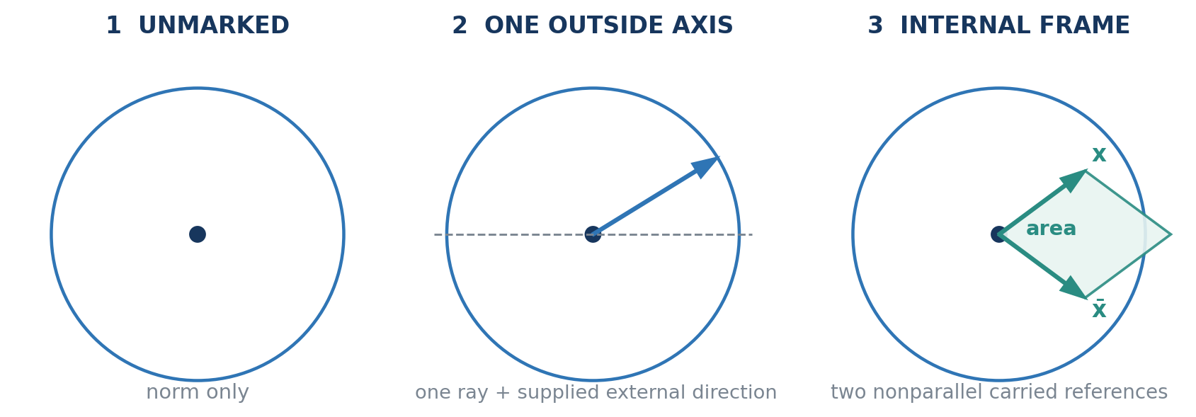
Figure 2. An unmarked shell carries only its norm level. One ray can orient it relative to a supplied outside axis. A nonparallel conjugate pair carries a complete internal planar frame and a nonzero area witness.

3. Classical prime-shell arithmetic
Let
$$S_{n}=\{\left(a,b\right)∈Z^{2}:a^{2}+ab+b^{2}=n\}$$
and let
$$U=\{η^{j}:0≤j<6\}$$
be the six-element unit group.
The classical prime classification is
$$\left|S_{p}\right|=\left\{\begin{matrix}6, & p=3, \\ 12, & p≡1 \left(mod 3\right), \\ 0, & p≡2 \left(mod 3\right).\end{matrix}\right.$$
For a split prime $p≡1 \left(mod 3\right)$, choose $π_{p}$ satisfying
$$p=π_{p}\overline{π_{p}}.$$
Then
$$S_{p}=Uπ_{p} ⊔ U\overline{π_{p}}.$$
After quotienting by the six unit rotations, exactly two conjugate arithmetic classes remain.

Proposition 3.1 — Modulo-three obstruction
For all integers $a,b$,
$$a^{2}+ab+b^{2}≢2 \left(mod 3\right).$$
Consequently,
$$n≡2 \left(mod 3\right)⇒S_{n}=⌀.$$

Proof
The finite ring $Z/3Z$ has nine pairs $\left(a,b\right)$. Direct reduction shows the quadratic form assumes only $0$ and $1$. The publication-facing Lean declaration discharges the finite case by ordinary kernel-reduced decision, then transports the contradiction back to the integer equation. In particular, the norm-$17$ shell is empty. ∎
FINITE PROOF IS NOT FINITE SAMPLING The nine residue pairs in (Z/3Z)^2 prove a universal obstruction because every integer pair reduces into that quotient and Q preserves the relevant residue. By contrast, the occupied shells 3, 7, 13, and 19 and the empty shell 17 are fixtures. The difference is the proved coverage map, not merely the number of checked cases.
The inherited formal branch also checks occupied fixtures at norms 3, 7, 13, and 19. It does not reconstruct the classical split-prime representation theorem or the full six/twelve-point orbit count. Those remain cited inputs.

4. Minimal reference data
The norm already identifies an unmarked shell as a set. A framed shell asks for enough internal relation to express arbitrary planar comparison without importing an undeclared second direction.

Theorem 4.1 — One reference is insufficient
For every $u∈R^{2}$, there exists $v∈R^{2}$ that is not a scalar multiple of $u$.

Proof
Write $u=\left(u_{1},u_{2}\right)$. If $u_{1}=0$, take $v=\left(1,0\right)$. No scalar multiple of $u$ has first coordinate $1$. If $u_{1}≠0$, take $v=\left(0,1\right)$. An equation $cu=v$ forces $cu_{1}=0$, hence $c=0$, contradicting the second coordinate. ∎
One marked shell vector therefore cannot span a two-dimensional real carrier.

Theorem 4.2 — Two conjugate references reconstruct uniquely
Let $x$ be frame-ready. For $v=\left(r,s\right)$, define
$$c_{x}\left(v\right)=\frac{r}{2X\left(x\right)}+\frac{s}{2Y\left(x\right)},$$
$$d_{x}\left(v\right)=\frac{r}{2X\left(x\right)}−\frac{s}{2Y\left(x\right)}.$$
Then
$$v=c_{x}\left(v\right)u_{x}+d_{x}\left(v\right)w_{x}.$$
These coefficients are unique.

Proof
Expanding the right side gives
$$\left(\left(c_{x}+d_{x}\right)X,\left(c_{x}−d_{x}\right)Y\right)=\left(r,s\right).$$
Because $X$ and $Y$ are nonzero, the two scalar equations have the displayed unique solution. Equivalently, the determinant $−2XY$ is nonzero, so the two references are linearly independent and form a basis of $R^{2}$. ∎
This is the exact seam behind the informal statement that two references are required for a shell to carry its own two-dimensional frame.
GEOMETRIC READING Figure 2 separates the meanings that prose often collapses: norm-level identity, orientation relative to an outside direction, and internal reconstruction from two carried references. Only the third is the framed-shell claim proved here.

5. Three unit choices and the robust selector
The six unit rotations contain three antipodal pairs. It is therefore enough to inspect
$$x, Rx, R^{2}x.$$
For $x=\left(a,b\right)$, define the determinant coordinates
$$A_{0}=b\left(2a+b\right),$$
$$A_{1}=a^{2}−b^{2},$$
$$A_{2}=−a\left(a+2b\right).$$
Each $A_{k}$ is $X\left(R^{k}x\right)Y\left(R^{k}x\right)$, up to the displayed sign convention.

Lemma 5.1 — Three-area identity
$$A_{0}^{2}+A_{1}^{2}+A_{2}^{2}=2N{\left(x\right)}^{2}.$$

Proof
Substitute the three coordinate polynomials and expand. The difference between the two sides normalizes to the zero polynomial. ∎

Lemma 5.2 — Shortfall-product identity
$$\prod_{k=0}^{2}{\left(N{\left(x\right)}^{2}−A_{k}^{2}\right)}=−a^{2}b^{2}{\left(a−b\right)}^{2}{\left(a+b\right)}^{2}{\left(a+2b\right)}^{2}{\left(2a+b\right)}^{2}.$$

Proof
Again substitute and normalize as a polynomial identity. The right side is the negative of a product of six squares and is therefore nonpositive over $R$. ∎

Theorem 5.3 — Robust conjugate-pair selection
For every Eisenstein-lattice vector $x$, at least one of the three antipodally distinct unit choices satisfies
$$N{\left(x\right)}^{2}≤A_{k}^{2}.$$
If $N\left(x\right)≠0$, the selected pair is frame-ready.

Proof
Assume all three strict inequalities $A_{k}^{2}<N{\left(x\right)}^{2}$. Every factor on the left side of Lemma 5.2 is then positive, so their product is positive. Lemma 5.2 says the same product is nonpositive, a contradiction. Thus one $A_{k}^{2}$ is at least $N{\left(x\right)}^{2}$.
If $N\left(x\right)≠0$, then $N{\left(x\right)}^{2}>0$, so the selected $A_{k}=XY$ is nonzero. Hence both $X$ and $Y$ are nonzero and the conjugate pair is frame-ready. ∎

6. Sharp area and conditioning

6.1 Normalized area
Because
$$∥E\left(x\right)∥^{2}=∥E\left(\overset{‾}{x}\right)∥^{2}=N\left(x\right),$$
and
$$det\left(E\left(x\right),E\left(\overset{‾}{x}\right)\right)=−\frac{\sqrt{3}}{2}X\left(x\right)Y\left(x\right),$$
the squared normalized area is
$$A{\left(x\right)}^{2}=\frac{{\left|det\left(E\left(x\right),E\left(\overset{‾}{x}\right)\right)\right|}^{2}}{∥E\left(x\right)∥^{2}∥E\left(\overset{‾}{x}\right)∥^{2}}=\frac{3X{\left(x\right)}^{2}Y{\left(x\right)}^{2}}{4N{\left(x\right)}^{2}}.$$
This is also the squared sine of the angle between the references.

Theorem 6.1 — Sharp normalized-area lower bound
For every nonzero Eisenstein-lattice vector x and the robust choice from Theorem 5.3,
$$\frac{3}{4}≤A{\left(R^{k}x\right)}^{2}≤1.$$

Proof
The robust inequality $N^{2}≤X^{2}Y^{2}$ gives the lower bound immediately:
$$A^{2}=\frac{3X^{2}Y^{2}}{4N^{2}}≥\frac{3}{4}.$$
For the upper bound, use
$${\left(X^{2}−3Y^{2}\right)}^{2}≥0.$$
Expanding and substituting $X^{2}+3Y^{2}=4N$ yields
$$3X^{2}Y^{2}≤4N^{2},$$
so $A^{2}≤1$. ∎
The selected references therefore meet at an angle between ${60}^{∘}$ and ${120}^{∘}$.

6.2 Axis balance
Set
$$H\left(x\right)=X{\left(x\right)}^{2}, V\left(x\right)=3Y{\left(x\right)}^{2}.$$
The robust inequality also gives
$$\left(X^{2}−Y^{2}\right)\left(X^{2}−9Y^{2}\right)={\left(X^{2}+3Y^{2}\right)}^{2}−16X^{2}Y^{2}=16\left(N^{2}−X^{2}Y^{2}\right)≤0.$$
Hence
$$Y^{2}≤X^{2}≤9Y^{2},$$
and therefore
$$H≤3V, V≤3H.$$

6.3 Euclidean frame condition number
The Euclidean frame matrix is
$$F_{x}=\frac{1}{2}\left(\begin{matrix}X & X \\ \sqrt{3}Y & −\sqrt{3}Y\end{matrix}\right).$$
Its two rows are orthogonal and
$$F_{x}F_{x}^{T}=\frac{1}{2}\left(\begin{matrix}X^{2} & 0 \\ 0 & 3Y^{2}\end{matrix}\right).$$
Thus the squared spectral condition number is
$$κ_{2}{\left(F_{x}\right)}^{2}=\frac{max\{H,V\}}{min\{H,V\}}.$$

Theorem 6.2 — Uniform condition-number bound
For every nonzero Eisenstein-lattice vector x, one of the three antipodally distinct unit choices is frame-ready and satisfies
$$κ_{2}{\left(F_{R^{k}x}\right)}^{2}≤3,$$
or equivalently
$$κ_{2}\left(F_{R^{k}x}\right)≤\sqrt{3}.$$

Proof
The selected choice is frame-ready and satisfies $H≤3V$ and $V≤3H$. If $H≤V$, then $κ_{2}^{2}=V/H≤3$. If $V≤H$, then $κ_{2}^{2}=H/V≤3$. ∎

Theorem 6.3 — Exact area-conditioning duality
For every frame-ready point, let H = X², V = 3Y², and q = max{H,V}/min{H,V} = κ₂(Fₓ)². Then
$$A{\left(x\right)}^{2}=\frac{4q}{{\left(1+q\right)}^{2}}.$$
Consequently, for q ≥ 1,
$$A{\left(x\right)}^{2}≥\frac{3}{4} ⇔ κ_{2}{\left(F_{x}\right)}^{2}≤3,$$
with strict inequalities corresponding. Among frame-ready candidates, maximizing normalized area is therefore exactly the same choice as minimizing squared condition number.

Proof
Since 4N = H + V and HV = 3X²Y²,
$$A^{2}=\frac{4HV}{{\left(H+V\right)}^{2}}=\frac{4q}{{\left(1+q\right)}^{2}}.$$
For q ≥ 1, the inequality 𝒜² ≥ 3/4 is equivalent to (3q−1)(q−3) ≤ 0, hence to q ≤ 3. The displayed function is strictly decreasing for q ≥ 1. ∎
V0.3 THEOREM STATUS The proof is included in this manuscript. A dedicated Lean declaration and receipt have not yet been produced.
GEOMETRIC READING The six unit rotations form three antipodal candidate pairs. Their normalized area and condition number rank the same candidates in opposite directions; one opens sufficiently, and for represented primes above 3 exactly one wins.
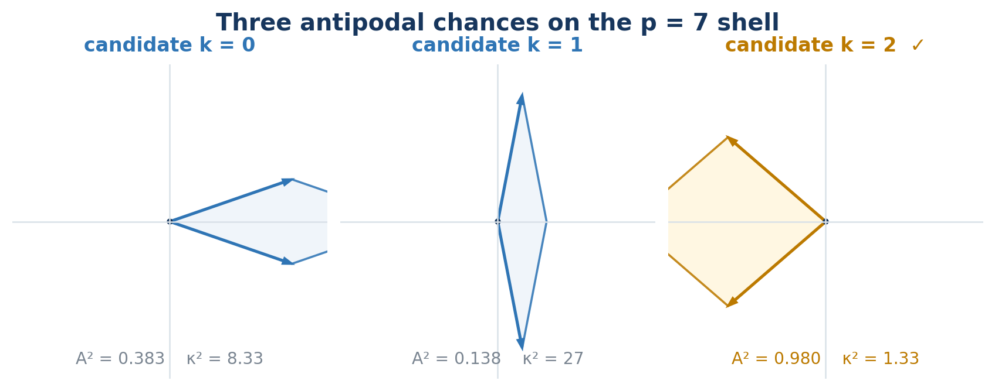
Figure 3. The three antipodal candidates for the represented p=7 shell. The gold candidate uniquely maximizes normalized area and minimizes squared condition number. The p=3 shell remains the exact equality boundary.

7. Sharpness at the norm-three shell
Take the ramified point
$$x=1+η,$$
so $\left(a,b\right)=\left(1,1\right)$. Then
$$N\left(x\right)=3, X\left(x\right)=3, Y\left(x\right)=1.$$
Consequently,
$$A{\left(x\right)}^{2}=\frac{3⋅9⋅1}{4⋅9}=\frac{3}{4},$$
and
$$H\left(x\right)=9, V\left(x\right)=3,$$
so
$$κ_{2}{\left(F_{x}\right)}^{2}=3.$$

Theorem 7.1 — Sharpness
No universal normalized-area lower bound larger than $3/4$, and no universal squared condition-number bound smaller than $3$, works for the stated selector among the three antipodally distinct unit choices while requiring a frame-ready output.

Proof
At the norm-$3$ point, the ready choices attain squared normalized area $3/4$ and squared condition number $3$; the remaining candidate is singular. Therefore any stronger universal constant fails on this shell. ∎
The exceptional ramified shell is not only a boundary case in the classical arithmetic classification. It also certifies the exact constants of the framing theorem.

Theorem 7.2 — Six-line equality locus and strict prime optimality
For nonzero x, let sₖ = Aₖ² and M = max{s₀,s₁,s₂}. The following conditions are equivalent: M = N(x)²; the maximizing candidate is not unique; and
$$ab\left(a−b\right)\left(a+b\right)\left(a+2b\right)\left(2a+b\right)=0.$$
Off this locus, M > N(x)² and the maximum is unique. If N(a,b) = p for a rational prime p > 3, the locus is impossible. Exactly one antipodal candidate then satisfies Aₖ² ≥ p², and in fact
$$A_{k}^{2}>p^{2}, A{\left(R^{k}x\right)}^{2}>\frac{3}{4}, κ_{2}{\left(F_{R^{k}x}\right)}^{2}<3.$$

Proof
Theorem 5.3 gives M ≥ N² and Lemma 5.1 gives s₀+s₁+s₂ = 2N². If M = N², a maximizing index makes one shortfall factor N²−sₖ vanish, so Lemma 5.2 places x on the six-line locus. If two candidates attain M, then 2M+sℓ = 2N² forces M = N² and sℓ = 0. Conversely, direct substitution on each line makes (s₀,s₁,s₂) a permutation of (N²,N²,0). On those lines the norm is t² or 3t². Such a norm can be prime only in the ramified case p = 3. Thus a represented prime p > 3 is off the locus and has M > p². The other two squares sum to 2p²−M < p², so each is below p²; exactly one candidate satisfies Aₖ² ≥ p². The strict quality bounds follow from Theorem 6.3. ∎
SCOPE OF UNIQUENESS The winner is unique within the three antipodal candidates and is preserved when unit rotation or conjugation merely permutes their squared values, relative to the fixed Eisenstein embedding and conjugation convention. No coordinate-free global selector is claimed beyond that structure.

8. Shell-to-shell transport
Let $x$ and $y$ be frame-ready. In conjugation eigen-coordinates, define
$$T_{x→y}\left(r,s\right)=\left(\frac{X\left(y\right)}{X\left(x\right)}r,\frac{Y\left(y\right)}{Y\left(x\right)}s\right).$$
Then
$$T_{x→y}\left(u_{x}\right)=u_{y}, T_{x→y}\left(w_{x}\right)=w_{y}.$$

Theorem 8.1 — Characterized transport
Suppose $f:R^{2}→R^{2}$ preserves every real linear combination and satisfies
$$f\left(u_{x}\right)=u_{y}, f\left(w_{x}\right)=w_{y}.$$
Then
$$f=T_{x→y}.$$

Proof
By Theorem 4.2, every $v$ has a unique decomposition
$$v=c_{x}\left(v\right)u_{x}+d_{x}\left(v\right)w_{x}.$$
Linearity and the two prescribed reference images force
$$f\left(v\right)=c_{x}\left(v\right)u_{y}+d_{x}\left(v\right)w_{y}.$$
Direct expansion gives exactly the displayed diagonal formula for $T_{x→y}$. Therefore no other combination-preserving map can satisfy the same two reference correspondences. ∎

Theorem 8.2 — Exact composition laws
For frame-ready $x,y,z$,
$$T_{x→x}=id,$$
$$T_{y→z}∘T_{x→y}=T_{x→z},$$
$$T_{y→x}=T_{x→y}^{−1}.$$

Proof
Each statement is coordinatewise cancellation of the nonzero scale ratios. For example,
$$\frac{X\left(z\right)}{X\left(y\right)}\frac{X\left(y\right)}{X\left(x\right)}=\frac{X\left(z\right)}{X\left(x\right)},$$
with the same identity in the $Y$ coordinate. ∎
The transport is a coordinate comparison between framed shells. It does not by itself describe physical motion, elapsed time, causal transfer, or a historical path.
GEOMETRIC READING Transport preserves the coefficients of a vector relative to the two carried references and rebuilds the vector in the target frame. It is a comparison map, not a claim that an object physically moves between shells.
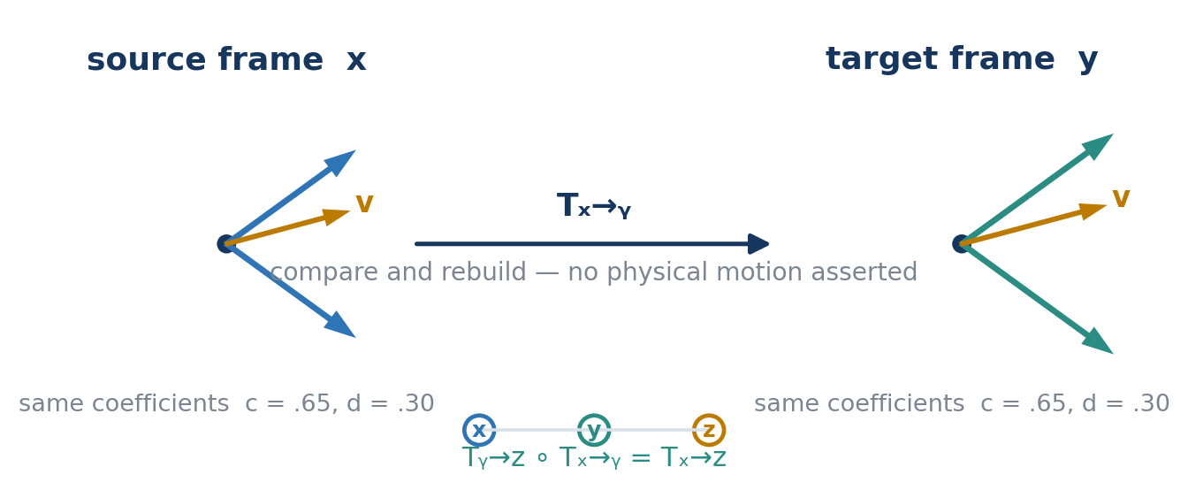
Figure 4. The same coefficients are read in the source pair and rebuilt in the target pair. Exact composition reduces a three-frame comparison to the direct endpoint map.

9. Prime-shell specialization
Every exact supplied representation
$$p=a^{2}+ab+b^{2}$$
of a rational prime gives a nonzero shell vector. The sharp selector therefore applies.

Corollary 9.1 — Represented prime shells admit sharp frames
Let $p$ be prime and suppose
$$p=a^{2}+ab+b^{2}.$$
Then one of the three antipodally distinct unit choices produces a frame-ready conjugate pair satisfying
$$A^{2}≥\frac{3}{4},$$
and
$$κ_{2}^{2}≤3.$$
The corollary consumes a certified representation; it does not discover, factor, or prove the representation. For split primes, the classical two-orbit theorem supplies the conjugate arithmetic classes. The ramified prime $3$ remains exceptional in orbit structure and is the sharp equality case.

Corollary 9.2 — Unique strict frame above the ramified shell
If p > 3 is prime and p = a² + ab + b², exactly one of the three antipodal candidates satisfies the robust determinant inequality. It has squared normalized area strictly greater than 3/4 and squared condition number strictly less than 3.

Proof
Apply Theorem 7.2 to the supplied representation. ∎

10. Derived and jointly retained axis lifts
Let $W$ be a set of underlying alternatives, let
$$τ:W→T$$
be a declared state trace, and write
$$K\left(f\right)=\{\left(u,v\right)∈W^{2}:f\left(u\right)=f\left(v\right)\}$$
for the kernel relation of a map $f$.
The phrase adding an axis hides two different operations.

10.1 Derived-axis lift
Let $h:T→A$ be any deterministic function of the existing trace and define
$$D_{h}\left(w\right)=\left(τ\left(w\right),h\left(τ\left(w\right)\right)\right).$$

Theorem 10.1 — Derived-axis invariance
$$K\left(D_{h}\right)=K\left(τ\right).$$

Proof
If $D_{h}\left(u\right)=D_{h}\left(v\right)$, equality of first coordinates gives $τ\left(u\right)=τ\left(v\right)$. Conversely, if $τ\left(u\right)=τ\left(v\right)$, applying $h$ gives $h\left(τ\left(u\right)\right)=h\left(τ\left(v\right)\right)$, so both coordinates agree. Thus the lift changes representation without adding a distinction. ∎

10.2 Joint-axis lift
Let λ : W → Λ be a jointly retained observable, condition, label, or provenance coordinate and define
$$J_{λ}\left(w\right)=\left(τ\left(w\right),λ\left(w\right)\right).$$

Theorem 10.2 — Joint-fiber intersection
$$K\left(J_{λ}\right)=K\left(τ\right)∩K\left(λ\right).$$

Proof
Two ordered pairs are equal exactly when both of their coordinates are equal. ∎

Corollary 10.3 — Strict refinement witness
If there exist $u,v∈W$ such that
$$τ\left(u\right)=τ\left(v\right) \text{and} λ\left(u\right)≠λ\left(v\right),$$
then $J_{λ}$ strictly refines $τ$.

Corollary 10.4 — Fiber criterion for derivability
A coordinate λ factors through τ on its image if and only if λ is constant on every τ-fiber. Equivalently, λ is derived from τ exactly when τ(u) = τ(v) always implies λ(u) = λ(v).

Proof
If λ = h∘τ, equal τ-values give equal λ-values. Conversely, fiber constancy makes h(t) = λ(w) well-defined for any w with τ(w) = t on the image of τ. ∎
A separately retained coordinate is not automatically independent. Independence is relative to the declared trace and requires an actual strict-refinement witness. This is the exact interface distinction behind the three-role taxonomy and the fixed-interface substrate used in Abstract Loops and Compactification Costs.
GEOMETRIC READING Figure 5 makes the criterion visible. A derived axis redraws every old fiber without splitting it. A jointly retained axis becomes independent relative to the old trace only where it separates at least one former collision.
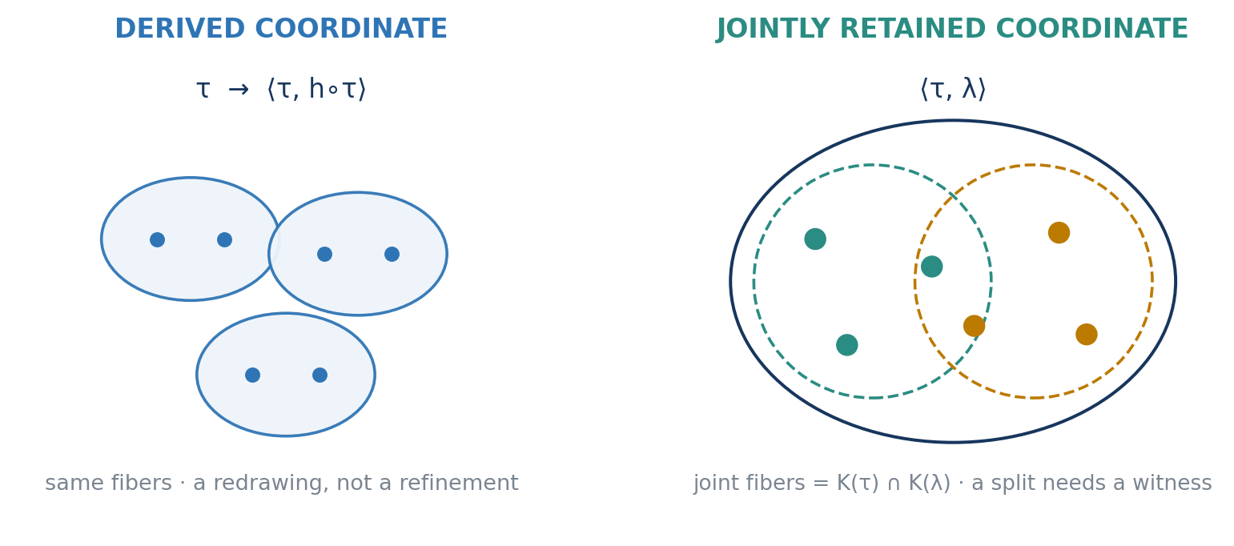
Figure 5. A derived axis preserves the original fibers. A jointly retained axis intersects them with a second partition and becomes independent relative to the trace only when it splits a former collision.

10.3 The prime-shell dependence boundary
For an exact Eisenstein coordinate $x=\left(a,b\right)$, the shell level
$$n=N\left(x\right)=a^{2}+ab+b^{2}$$
is already determined by $x$. Therefore
$$x↦\left(x,N\left(x\right)\right)$$
is a derived-axis lift. Plotting $N\left(x\right)$ or $logN\left(x\right)$ vertically may reveal nested shells, but it adds no information to the exact coordinate.
The answer changes after a coarsening. If the active trace retains only phase, normalized direction, a sixfold sector, a rounded cell, or another quotient that forgets scale, the shell label may no longer factor through that trace. Adjoining a certified prime address can then strictly refine that declared interface.
Thus derived and independent are not visual properties of an axis. They are relations between the new coordinate and the interface already in force. With that distinction fixed, local frames can be assembled without mistaking display height for new state.

10.4 Certified derivation and evidence-bearing carriage
Kernel equality is extensional. It says that a derived coordinate creates no new distinction among the mathematical states already represented. It does not imply zero cost of computation, storage, certification, or replay.
$$K\left(⟨τ,h∘τ⟩\right)=K\left(τ\right).$$
To type the evidence separately, let Hₑᵥ be a domain of evidence histories, q : Hₑᵥ → Q retain the mathematical claim, and r : Hₑᵥ → R retain its receipt. Theorem 10.2 gives
$$K\left(⟨q,r⟩\right)=K\left(q\right)∩K\left(r\right).$$
Two records may therefore carry the same mathematical claim while preserving different proof sources, checker versions, environments, or review histories. This is evidence-bearing carriage, not the geometric frame transport Tₓ→ᵧ of Section 8.
CARRIAGE BOUNDARY A receipt does not make an equality true. It records why a declared verifier accepted an equality claim for carriage under a fixed model. Derived values need not refine mathematical state; their receipts may refine evidence history.
Derived does not mean free, and extensional equivalence does not price its realizations. The equality
$$K\left(⟨τ,h∘τ⟩\right)=K\left(τ\right)$$
says nothing about stored or transferred bytes, replicas, replay time, recomputation time, directly measured energy, operator time, exposure, or maintenance burden. Those quantities arise only after an implementation, environment, observation procedure, and time are supplied. Section 15 calls their source-bound record a Systemic Friction profile.
SYSTEM BOUNDARY Systemic Friction is not an intrinsic cost added to the abstract kernel. It records typed burdens observed or declared at a physical, social, or operational realization boundary. Once measured, those values may be serialized for computation; their provenance remains external to the equality. An unknown channel remains unknown, not zero.

11. The framed prime-shell atlas
A represented rational prime shell is supplied data
$$s=\left(p,a,b; p\text{ prime}, a^{2}+ab+b^{2}=p\right).$$
Section 14 calls the corresponding witness-bearing candidate a Prime Seed. The mathematical atlas records which framed entries exist; the release ledger records which claims have passed a declared promotion contract.
The representation is not produced by the atlas. It enters with its own arithmetic witness. For each supplied s, let F(s) be the finite set of permitted unit choices whose conjugate pair is frame-ready and carries the recorded quality certificates. The inherited selector proves F(s) nonempty, while Theorem 7.2 makes the optimum unique for represented primes above 3.

Definition 11.1 — Framed prime-shell atlas
The exact atlas is the indexed sum
AFPS=s∈Rprime​Fs,
where $R_{prime}$ is the set of supplied represented prime shells.
An atlas entry retains at least
$$A=\left(p,a,b,k; F_{k},Ready,A^{2}≥3/4,κ_{2}^{2}≤3\right).$$
The shell object, representation witness (a,b), frame witness k, mathematical certificate, and external receipt occupy different roles. The current atlas is witness-sensitive: it does not quotient these fields merely because their prime labels coincide. The certificates record distance from collapse; evidence receipts belong to the release ledger, not the mathematical carrier.

Theorem 11.2 — Atlas occupancy for represented primes
Every supplied represented rational prime shell has at least one entry in $A_{FPS}$.

Proof
Apply Corollary 9.1 to the supplied exact norm representation. It returns a unit choice with readiness, squared normalized area at least $3/4$, and squared condition number at most $3$. Package those fields with the represented prime shell. ∎
The exact atlas is a dependent family, not a picture. A nested-shell drawing is one realization. If a positive radius rule R(p) is declared, an entry may be rendered on a sphere or circle of radius R(p). The mathematical product carrier is distinct from the current Lean implementation, which uses an ambient three-dimensional point paired with the index and separately proves that realized points lie on the unit sphere.
The ramified prime $3$ remains an exceptional stratum. It belongs in the same atlas because it carries a valid represented shell and certified frame; it is not silently forced into the same twelve-point orbit type as split primes.
An atlas lists the framed states that are available; it does not remember which states were visited.

12. Trace-bearing prime-shell ribbons
The atlas records the available indexed states. A ribbon records an ordered realized route through them.

Definition 12.1 — Prime-shell ribbon
A finite prime-shell ribbon is a nonempty ordered sequence
$$ρ=\left(A_{0},A_{1},…,A_{m}\right), A_{j}∈A_{FPS}.$$
Its exact route data include the vertex list, start, finish, boundary, and edge count m:
$$start\left(ρ\right)=A_{0}, finish\left(ρ\right)=A_{m}, ∂ρ=\left(A_{0},A_{m}\right).$$
The boundary forgets every interior vertex. A rendered smooth strip may aid inspection, but the arithmetic ribbon is the discrete ordered route record. It becomes an integrity-bearing record only when canonical serialization, digest binding, and replay are separately supplied.

Proposition 12.2 — Boundary-route separation
Two prime-shell ribbons can have the same first and last entries while remaining different routes.

Fixture
Fix complete mathematical atlas entries A_3, A_7, and A_13 on the represented shells 3, 7, and 13, with readiness and quality fields established at manuscript level. These are not promoted release records. Compare
$$ρ_{direct}=\left(A_{3},A_{13}\right)$$
with
$$ρ_{via}=\left(A_{3},A_{7},A_{13}\right).$$
They share the boundary (A_3,A_13), but their edge counts are 1 and 2. Hence they are not the same ordered ribbon.

Theorem 12.3 — Trace-to-boundary factorization
Let trace(ρ) = ρ and boundary(ρ) = ∂ρ. Then
$$K\left(trace\right)⊆K\left(∂\right),$$
and the inclusion is strict on any ribbon domain containing the direct and via-7 fixtures. Flat transport factors through the boundary, so K(∂) ⊆ K(T). Equality between the boundary and transport kernels is not claimed.

Proof
Boundary is computed from the full trace, giving the first inclusion. The two fixture ribbons have the same boundary and different traces, proving strictness. Theorem 12.5 below supplies the factorization of transport through the boundary. ∎
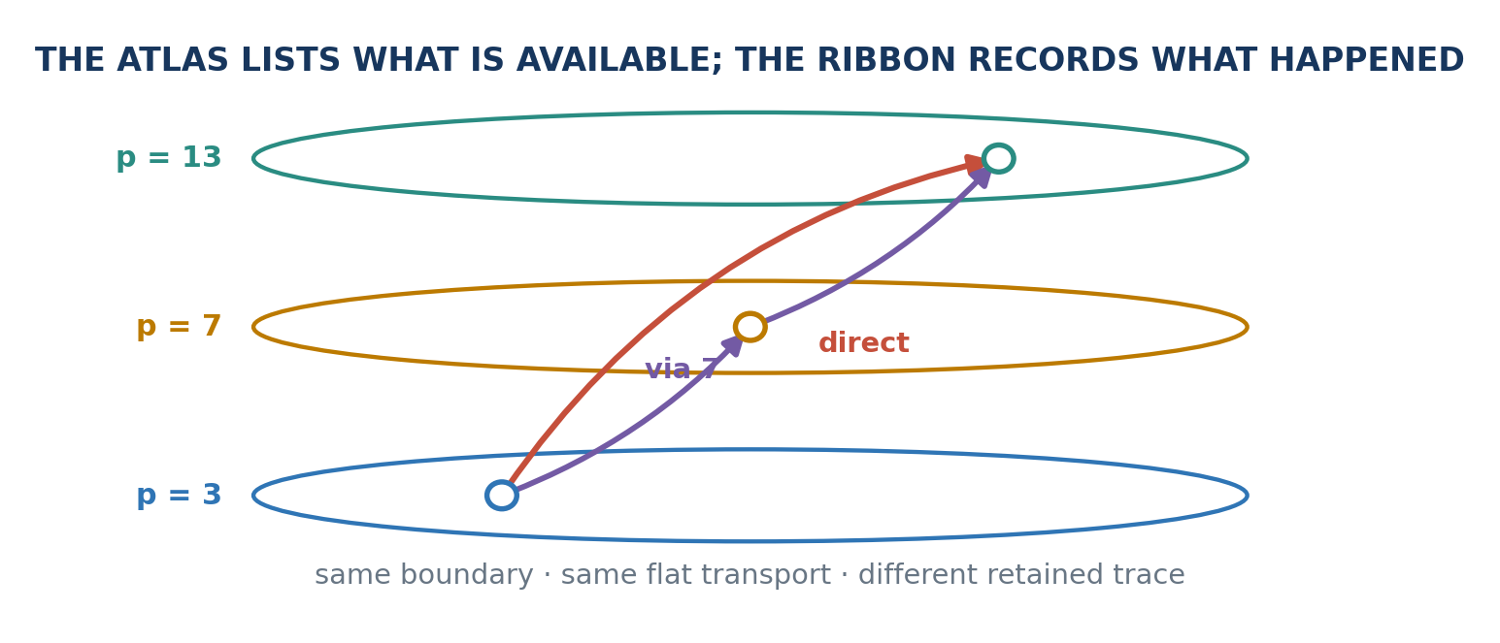
Figure 6. The framed prime-shell atlas separates available states from retained routes. A direct ribbon and a ribbon passing through p=7 can have the same endpoints and induce the same flat transport while remaining different ordered traces. Atlas here means a state inventory, not the declared syntactic room of Section 15.

12.4 Transport along a ribbon
Let $x_{j}$ be the selected ready frame carried by $A_{j}$. Define the composite transport
$$T_{ρ}=T_{x_{m−1}→x_{m}}∘⋯∘T_{x_{0}→x_{1}},$$
with the singleton ribbon assigned the identity map.

Theorem 12.5 — Flat finite ribbon transport
For every finite ready ribbon,
$$T_{ρ}=T_{x_{0}→x_{m}}.$$

Proof
Induct on the number of appended vertices. The singleton case is $T_{x→x}=id$. For the induction step, assume the transport through $x_{j}$ equals $T_{x_{0}→x_{j}}$. Then the v0.1 composition law gives
$$T_{x_{j}→x_{j+1}}∘T_{x_{0}→x_{j}}=T_{x_{0}→x_{j+1}}.$$
Thus every finite composite reduces to the direct endpoint transport. ∎

Corollary 12.6 — Same endpoint map, different retained history
The direct and via-$7$ fixture ribbons induce the same transport map even though their ordered routes differ.
This is not a defect. It identifies exactly where the history lives. The v0.1 transport is flat and endpoint-determined; the ribbon is the separate carrier of path information. Nontrivial twist, holonomy, accumulated cost, uncertainty, or route-dependent action would require an additional path-sensitive structure and remains outside the present theorem.
This separation matches the role discipline already used in GPPR and GOLD: a commutative endpoint may agree while an ordered factor-event or occurrence/receipt route remains different. Those papers are same-lineage neighbors, not independent corroboration.
GEOMETRIC READING Figure 6 separates available framed states from the route actually retained through them. Flat endpoint transport can close while the ordered trace remains recoverable in the ribbon record.
The ribbon supplies the ordered route while leaving endpoint transport separately typed.

13. Smith-chart states, indexed shells, and Golden Rainbow display
The Smith chart makes the derived-axis, atlas, and ribbon distinction unusually concrete. Let
$$z=\frac{Z_{L}}{Z_{0}}$$
be normalized load impedance and
$$Γ=\frac{z−1}{z+1}$$
its reflection coefficient. The ordinary Smith chart is a Möbius-coordinate diagram in the complex $Γ$ plane.

13.1 Spherical state
Write $Γ=u+iv$. The stereographic lift used by spherical Smith-chart constructions is
$$σ\left(Γ\right)=\left(\frac{2u}{1+u^{2}+v^{2}},\frac{2v}{1+u^{2}+v^{2}},\frac{1−u^{2}−v^{2}}{1+u^{2}+v^{2}}\right).$$
Direct algebra gives
$$∥σ\left(Γ\right)∥^{2}=1,$$
and, at every image point where Z ≠ −1, the planar point is recovered by
$$Γ=\frac{X+iY}{1+Z}.$$
The sphere therefore carries the same two degrees of freedom as the plane. Its third coordinate is derived. It is a state chart, not an information gain.

13.2 Shell-indexed family
Now retain a genuinely separate condition
$$λ∈Λ,$$
such as frequency, time, temperature, bias, power, measurement epoch, or network-construction stage. The exact family carrier is
$$S^{2}×Λ.$$
A radial visualization may choose a positive radius function $R:Λ→R_{>0}$ and draw
$$Φ\left(Γ,λ\right)=R\left(λ\right)σ\left(Γ\right).$$
Then
$$∥Φ\left(Γ,λ\right)∥^{2}=R{\left(λ\right)}^{2}.$$
Every fixed condition occupies one spherical shell. The exact information account remains the product pair. The current Lean carrier is ambient ℝ³ × Λ together with a theorem that the realized point lies on the unit sphere; it is not literally implemented as a sphere subtype.

Proposition 13.1 — Exact radial-faithfulness criterion
Let S be a nonempty unit sphere and let R : Λ → ℝ satisfy R(λ) > 0 for every λ. Define Φ(s,λ) = R(λ)s on the full product S × Λ. Then Φ is injective if and only if R is injective.

Proof
If Φ(s,λ) = Φ(t,μ), equality of norms gives R(λ) = R(μ). When R is injective, λ = μ; positivity then permits division and yields s = t. Conversely, if R is not injective, fixing one sphere point gives a collision. Necessity need not hold after restricting Φ to a particular ribbon graph, where direction may separate equal radii. ∎

13.3 Realized ribbon
A particular sweep or experiment is a parametrized map, not merely a set-valued image:
$$r:I→S^{2}×Λ, r\left(t\right)=\left(σ\left(Γ\left(t\right)\right),λ\left(t\right)\right).$$
For sampled data, retain the ordered sequence (r(t₀),…,r(tₘ)). Its image set records only occupancy and cannot by itself preserve order or repeated visits. With interpolation and a separately declared transverse width, the parametrized trace may be rendered as a ribbon or tube.
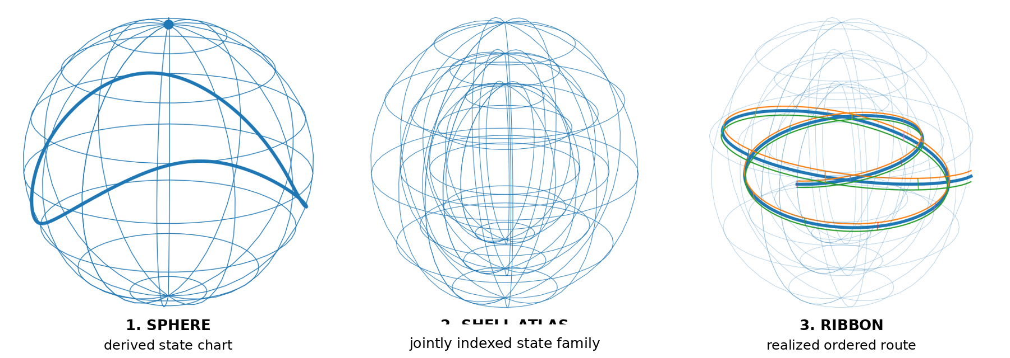
Figure 7. Three roles illustrated by Smith-chart geometry: a sphere is a derived state representation; nested shells carry a jointly indexed family; and a parametrized ribbon records one ordered realized route.
The compact reading is:
The sphere is where the state is. The shells are where states are indexed under each condition. The ribbon is the route actually retained through them.
Existing literature supplies the ordinary Smith chart, exact spherical constructions on the Riemann sphere, and three-dimensional multi-parameter uses involving frequency orientation, variable homothety, quality factor, temperature, and active or passive regions. Those precedents govern the engineering content. The atlas and ribbon roles are this manuscript's interpretive taxonomy, not established Smith-chart nomenclature.
$$\text{framed shell} → \text{shell atlas} → \text{trace-bearing ribbon}.$$
The informal phrase Golden Rainbow Prime Shell Ribbons names the visual synthesis only. Prime structure supplies an exact arithmetic address, golden or other color/angle schedules may supply declared display orientation, shells supply the indexed family, and ribbons supply ordered trace. None of those display choices becomes arithmetic authority merely because the image is compelling.

13.4 Golden Rainbow display schedules
Let ρ be a retained ribbon and let δ be a declared color-and-orientation schedule. When δ = h(ρ) is deterministically derived from the retained ribbon,
$$K\left(⟨ρ,h\left(ρ\right)⟩\right)=K\left(ρ\right).$$
The rendered Golden Rainbow ribbon changes presentation without adding a distinction. If a separately retained display event, operator choice, or measurement condition splits a former ribbon fiber, the joint carrier may refine the trace under Theorem 10.2.
DISPLAY CEILING Golden angle, rainbow color, thickness, glow, or orientation schedules carry no arithmetic, verifier, or retention authority merely because they make the structure visible.
A picture may expose structure, but visibility does not make a claim earned.

14. Prime Seeds and Circuit Gardens
Prime Seeds and Circuit Gardens introduce one record type and one schematic promotion grammar. Neither changes the underlying shell. Together they specify what must travel with a framed-shell claim before a release ledger may treat that claim as earned under a declared scope.

14.1 Prime Seeds: object, witness, and certificate
A raw shell candidate is
$$s_{0}=\left(p,a,b\right).$$
Once the supplied proof terms pass, the represented shell is
$$s=\left(p,a,b;h_{prime},h_{norm}\right), h_{norm}:a^{2}+ab+b^{2}=p.$$
A frame witness is f = (s,k), where k is one of the three antipodal candidates. Its mathematical certificate records readiness and the exact area and conditioning claims:
$$c_{math}=\left(h_{ready},h_{A},h_{κ}\right).$$
A mathematical Prime Seed is the witness-bearing package
$$P=\left(s,f,c_{math}\right).$$
The term is local to this manuscript: it does not name a new number-theoretic species or a mechanism that generates primes. The raw record remains a seed candidate until its primality, norm, frame, readiness, and declared quality obligations pass.
The current construction is witness-sensitive. Distinct supplied representations, unit choices, or evidence histories are not silently quotiented merely because they refer to the same prime label.
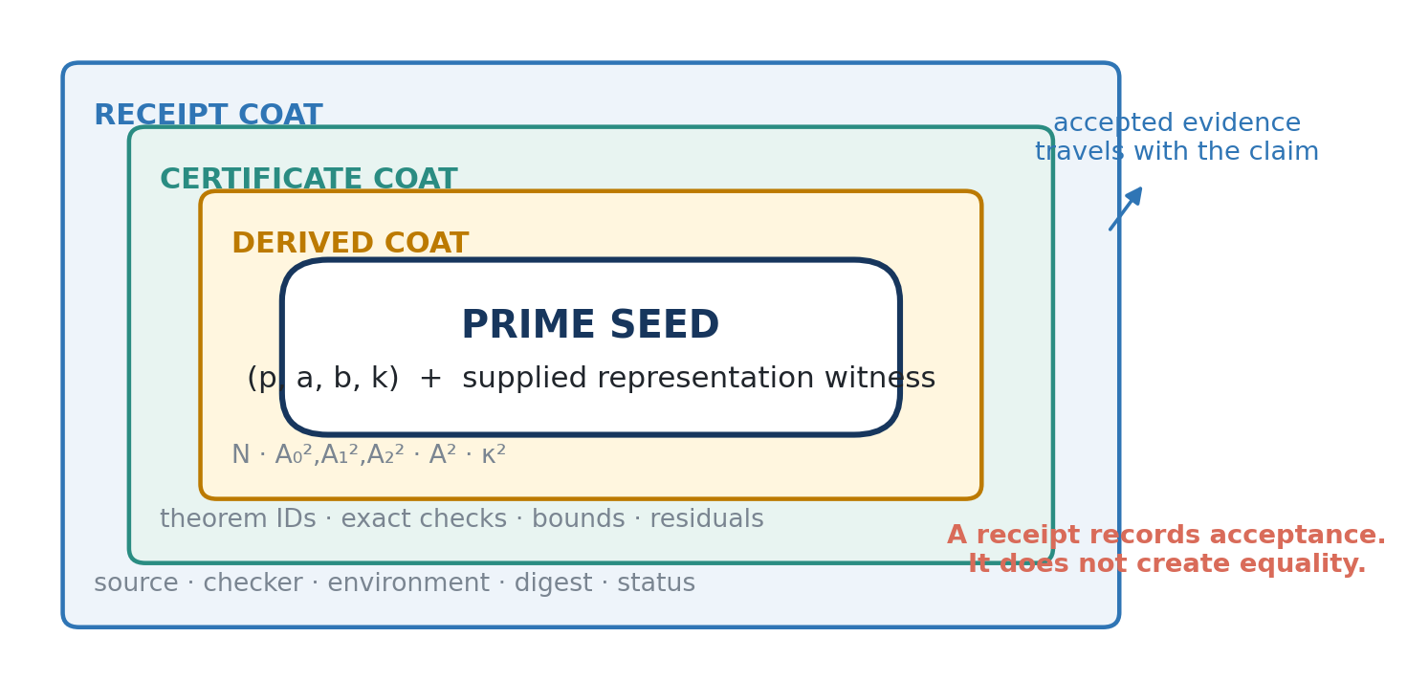
Figure 8. Prime Seed anatomy. The mathematical kernel and its derived values remain distinct from the theorem/checker certificate and the attached evidence receipt. The receipt carries accepted evidence; it does not create equality.

14.2 Atomic Edge Promotion under a declared verifier
Let G = {V₁,…,Vₘ} be the finite obligations declared for one named claim. A promotion attempt binds the claim, exact domain, witness, obstruction duties, verifier identities, evidence links, authority ceiling, residual, and reopening condition before evaluation.
Fix a Prime-Seed type 𝒫, an evidence type C, a receipt type ℛ, a residual type 𝒟, and total verdicting maps Vᵢ : 𝒫 × C → {accept, reject, unresolved}. Let Receipt_G : 𝒫 × C → ℛ be used only when every verdict is accept, and let Residual_G : 𝒫 × C → 𝒟 be a total constructor that lists every rejected or unresolved duty. The result is a tagged accepted-or-open record, and the typed schematic contract is
$${Promote}_{G}\left(P,c\right)=\left\{\begin{matrix}\left(P,{Receipt}_{G}\left(P,c\right),\text{accepted under }G\right), & ∀i, V_{i}\left(P,c\right)=\text{accept}, \\ \left(P,{Residual}_{G}\left(P,c\right),\text{open}\right), & \text{otherwise.}\end{matrix}\right.$$
This display is a typed schematic contract, not an implemented constructor. Atomic means that the complete named record changes ledger status together or no promoted record is issued. It does not claim database transactionality, alter the mathematical object, manufacture truth, grant publication authority, or erase a failed or unresolved duty.
The certificate-admission contract is one instance of a broader Atomic Edge Promotion discipline. It retains the codomain accepted/open and is not silently reused for retention. Section 15 introduces a separately typed disposition contract. The intelligence-bearing wrapper proposes the edge; Atomic Edge Promotion performs only the mechanically authorized transition.
VERIFIER / CHINESE-ROOM BOUNDARY In the limited analogy, the encoded claim and certificate are the slips, the declared model is the rulebook, and the verifier returns a verdict by applying supplied rules. The analogy concerns rule-following over declared symbols. The verifier does not thereby choose the claim's purpose, protected distinctions, retention horizon, worth, or authority. This paper takes no position on whether computation or any AI system understands, possesses intentionality, or is conscious.
PAL V2.3 BOUNDARY This is a proposed realization beside PAL v2.3, not a new PAL constructor or A16. PAL A15 statuses remain CLOSED_IN_SCOPE, OPEN, UNRESOLVED, and REOPENED. A Playground result such as certified_finite can support a separate CLOSED_IN_SCOPE receipt only through an explicit adapter with the exact finite scope retained.

14.3 Circuit Garden: the finite control crop
The first executable control fixture uses all sixteen Boolean functions of two inputs. Its declared model permits two-input NAND gates, unbounded fan-out, repeated operands, no free constants or negated inputs, and an output equal either to a primary input at size zero or to the final gate.
Complete enumeration reaches all sixteen functions by size five. The exact numbers of topologically ordered gate sequences at sizes 0 through 5 are 1, 3, 18, 180, 2,700, and 56,700: 59,602 sequences in total. A witness at size k establishes the upper side; complete absence from every smaller layer establishes the lower side.
$$C_{0}=1, C_{n}=\prod_{j=0}^{n−1}{\left({j+3 \atop 2}\right)} \left(n≥1\right).$$
Before gate j there are j+2 available signals. Because NAND is symmetric and repeated operands are allowed, the gate input is one unordered pair with repetition, giving (j+2)(j+3)/2 choices. Multiplying these layer choices proves the sequence-count recurrence. At size zero, C₀ counts one empty gate sequence; the model separately permits either primary input as the output.
First reach by minimum gate count: 0—x₀, x₁; 1—not x₀, not x₁, NAND; 2—AND, true, and the two implications; 3—false, the two inhibitions, and OR; 4—NOR and XOR; 5—XNOR.
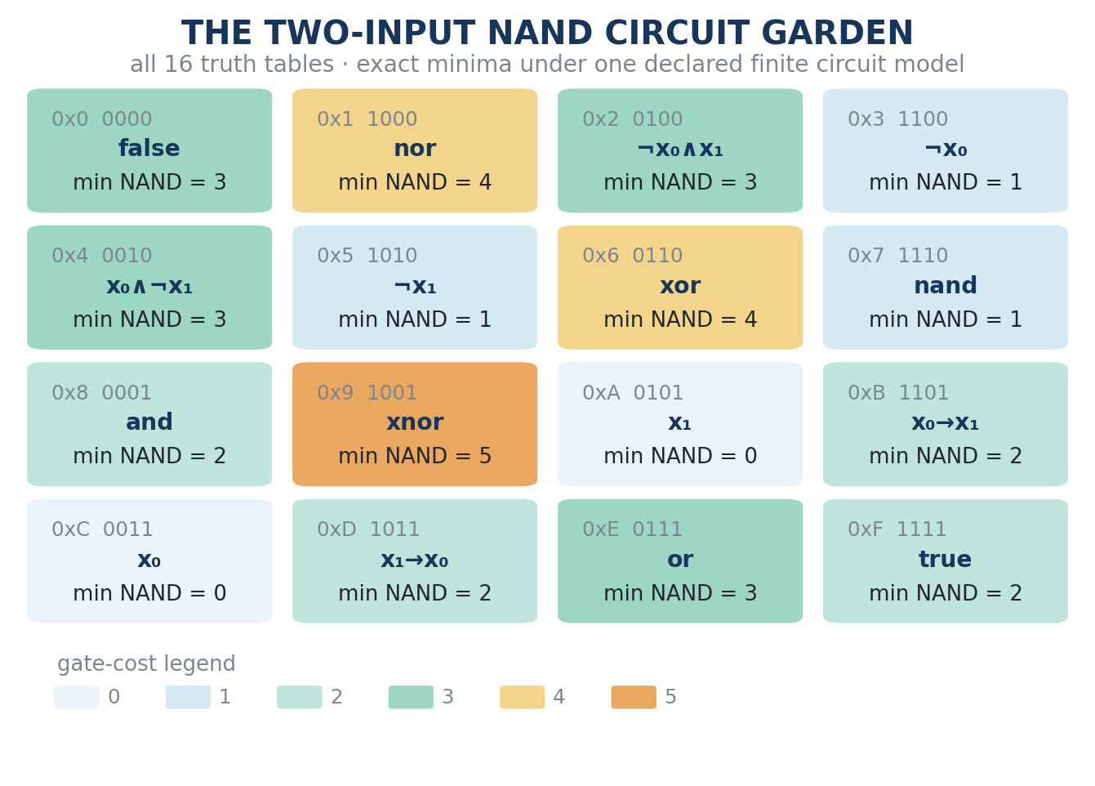
Figure 9. The two-input NAND Circuit Garden. Truth bits are ordered 00, 01, 10, 11. Each tile gives the exact minimum gate count under the declared finite model; the certificate supplies a witness at that count and exhaustive exclusion below it.
REPLAY RECEIPT Canonical public commit 3449bd282309aa291a98d1e08819232b1849832e. From that checkout run: python3 millennium/games/p-vs-np/circuit_garden.py --verify millennium/games/p-vs-np/certificate-n2-nand.json. The receipt is millennium/receipts/20260904T074434Z-pnp-circuit-garden.json. Certificate SHA-256: 4b8c6c350d3590fd990f7a905e135f9905569c0d9ef9dbb4ee3ccc26bd880c6c; certificate-core SHA-256: 0a1490f8968e23bb35fa0e3637ed9f0d5996e31d7a5d344c79b763c3df3db8d9; receipt-JSON SHA-256: 975bcd81d3779648900ad3b925bae1ce1bacea1ff6889b6961a9886751206f54. The receipt binds CPython 3.12.13, its reported platform, byte order, algorithm, and environment digest. It does not provide provider-signed runtime identity, a trusted external timestamp, a full session transcript, or a measured Systemic Friction profile.
FINITE CLAIM CEILING The fixture is internally classified certified_finite and its deterministic replay passes. It is not an asymptotic circuit lower bound, a general Minimum Circuit Size Problem solution, or evidence for either P = NP or P ≠ NP. Its public receipt remains labeled model-drafted pending steward review.
CONTROL-CARRIAGE OBSERVATION At canonical commit 3449bd282309aa291a98d1e08819232b1849832e, replay enumerates 59,602 topologically ordered sequences but does not serialize that exhaustive intermediate frontier. It retains a 6,920-byte certificate, a 6,067-byte verifier source, a 4,402-byte JSON run receipt, and a 1,370-byte Markdown receipt view. Replay reconstructs the finite enumeration. These are exact checkout-file observations, not a total measurement of storage allocation, transfer, transient memory, energy, operator burden, or long-term maintenance. The implementation demonstrates recompute-instead-of-carry; it does not prove that disposition optimal and no later pruning event is claimed.

14.4 From Circuit Garden to Prime Seeds
Circuits and prime shells do not prove one another. They share a certification grammar. A minimum-circuit claim requires a constructive witness and complete exclusion below the claimed size. A Prime Seed requires its supplied representation, permitted frame witness, readiness and quality proofs, and—when exact optimum or uniqueness is claimed—exclusion of the competing candidates.
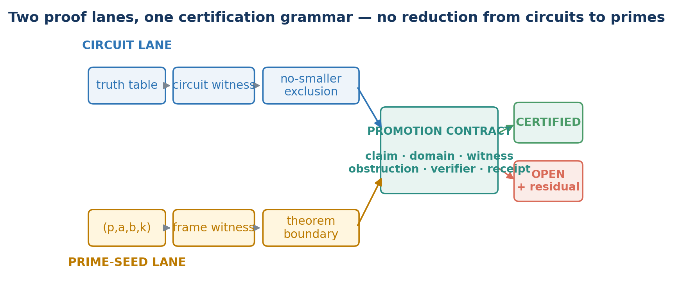
Figure 10. Two proof lanes, one certification grammar. The Circuit Garden and Prime Seeds keep different mathematics and different obstruction duties; no reduction or theorem transfer between circuits and primes is asserted.
The mathematical atlas and the release ledger must therefore remain separate. The atlas may contain a mathematically valid entry independently of whether a particular checker has reviewed it. The release ledger stores accepted records and may preserve several verification histories for the same mathematical entry.
ATOMIC PROMOTION SENTENCE What is promoted is the ledger status of a framed-shell claim—not the prime, the shell, or the truth of an equation. The claim travels with the exact evidence and limits under which that status was earned.
Certification determines whether a named claim may enter the release ledger; it does not make that ledger free to carry.

15. Systemic Friction and retention disposition
Sections 10 and 14 separated mathematical state, evidence history, verifier acceptance, and ledger status. Retention adds a different question: what burden does a realized system incur by continuing to carry one representation rather than an allowed replacement? Neither mathematical equality nor verifier verdict answers that question without additional inputs.
THREE DISTINCT LOSSES Logical information loss is a property of a map. Evidentiary loss is failure of a future protected question to factor through the retained edge. Physical dissipation belongs to a concrete implementation. Entropy is not outside the physical circuit; it is outside the logical diagram until a physical realization and measurement model are supplied.

15.1 Declared-input ceiling

Proposition 15.1 — Declared-input ceiling
Let W be a set of realized situations, let ι : W → I serialize exactly the input admitted to a deterministic declared verifier, and let V_M : I → O. Then
$$K\left(ι\right)⊆K\left(V_{M}∘ι\right).$$
If a distinction λ : W → Λ is not constant on every ι-fiber, then λ does not factor through ι and cannot be recovered from either the admitted input or the verifier verdict alone.

Proof
Equal admitted inputs receive equal deterministic verdicts, giving the kernel inclusion. If λ = h∘ι, Corollary 10.4 makes λ constant on every ι-fiber. Contraposition proves the second claim. Any function of the verdict also factors through ι. ∎
Purpose or retention criteria may be processed when explicitly encoded. The proposition says only that a verifier cannot manufacture distinctions absent from its declared input. This information boundary, rather than a philosophical conclusion about minds, is the manuscript's Chinese-room use.

15.2 Systemic Friction at the realization boundary

Definition 15.2 — Systemic Friction profile
Fix a realized environment ε, observation time t, carried representation x, candidate disposition d, and a declared collection J of burden channels. A Systemic Friction profile is the source-bound partial product
$$Ξ_{ϵ,t}\left(x,d\right)=(\left(v_{j},u_{j},m_{j},s_{j},δ_{j}\right))_{j∈J},$$
where v_j is a measured or declared value, u_j its unit, m_j its observation method, s_j its source, and δ_j its uncertainty or typed UNKNOWN. Candidate channels include stored and transferred bytes, replica count, wall and processor time, replay and recomputation time, directly measured energy, failure or recovery events, operator time, and a separately operationalized exposure surface.
The profile is not intrinsically scalar. Aggregation, weighting, and comparison require a separately declared policy and baseline; non-substitutable channels remain separate. Systemic Friction is not thermodynamic entropy, moral worth, social relevance, or a mathematical invariant of the underlying claim.

Proposition 15.3 — Recomputation does not imply carriage equivalence
Let q : Hₑᵥ → Q retain a claim, let r : Hₑᵥ → R retain its evidence receipt, and set c = ⟨q,r⟩. If r is not constant on every q-fiber, then c does not factor through q. Consequently, cheaper recomputation of q alone does not preserve the evidence-bearing carrier c.

Proof
Section 10.4 gives
$$K\left(c\right)=K\left(q\right)∩K\left(r\right).$$
If r splits a q-fiber, then K(c) is a proper subset of K(q). Were c derivable from q, its second projection r would also be derivable from q, contradicting Corollary 10.4. ∎
REPLAY-RATIO CEILING An inequality such as C_verify > C_recompute is a friction observation, not a retirement rule. Recomputation may reproduce the mathematical result while losing proof identity, checker history, source lineage, contest routes, former status, or other protected distinctions.

15.3 Protected replacement edges

Definition 15.4 — Protected replacement edge
Let X be a space of carried representations and let 𝒬 be a declared finite family of partial protected queries on X. A candidate replacement carrier e ∈ X, together with its declared reopening route, preserves x ∈ X relative to 𝒬 when
$${Pres}_{Q}\left(x,e\right)⇔∀q∈Q, q\left(x\right)↓ ∧ q\left(e\right)↓ ∧ q\left(e\right)=q\left(x\right).$$
Here e names the target carrier of the proposed transition x → e, not the arrow itself; q(x)↓ and q(e)↓ mean that the protected query is answerable from both the current carrier and the candidate carrier with its declared reopening route. Missing information does not count as equal merely because both sides use an unknown marker. Protected queries may cover the mathematical claim, witness identity, receipt status, source locator, verifier version, contest route, former state, or other explicitly retained distinctions.

Corollary 15.5 — Edge factorization ceiling
For a transition map E : X → Y and protected query q : X → A, q remains answerable from the retained target y = E(x) exactly when q factors through the reachable image E(X), equivalently when
$$K\left(E\right)⊆K\left(q\right).$$
Thus a digest-only edge preserves q only if q is constant on every digest fiber. A bare digest can support later byte-equality checking when canonical bytes are disclosed under the stated cryptographic assumptions. It does not by itself establish existence, time, acceptance, authenticity, truth, reconstruction, or replayability; each requires separately bound evidence.
PROOF-CARRYING EDGE ATOM A strong replacement edge may bind an epoch, schema, commitment, protected predicate, count, verifier policy, inclusion path or timestamp anchor, optional proof of a predeclared predicate, signature, and reopening route. It preserves only the facts those objects actually support. It does not make discarded interior distinctions globally recoverable or globally erased.

15.4 Relative weeds

Definition 15.6 — Relative weed candidate
A retention frame is
$$F=\left(G,G_{mutable},π,T,ϵ,t,Q,H,E,≺,Γ\right),$$
where G is a declared garden, G_mutable ⊆ G is its predeclared mutable domain, π is the purpose, T the horizon, (ε,t) the realized environment and observation time, 𝒬 the protected queries, ℋ the holds, ℰ the permitted replacement-carrier interfaces, ≺ a declared strict friction comparison, and Γ an external authority grant. For disposition d, the set ℰ_Γ(x,d) contains only target carriers and reopening routes admitted for x under that exact grant and disposition. A carried record x is a weed candidate relative to 𝓕, target carrier e, and proposed disposition d exactly when
$${WeedCandidate}_{F}\left(x;e,d\right)⇔x∈G_{mutable}∧e∈E_{Γ}\left(x,d\right)∧{Pres}_{Q}\left(x,e\right)∧{Safe}_{F}\left(x,e,d\right).$$
The final guard expands as
$${Safe}_{F}\left(x,e,d\right)⇔H\left(x\right)=⌀∧DutiesSafe\left(x,e\right)∧Ξ_{ϵ,t}\left(e,d\right)≺_{F}Ξ_{ϵ,t}\left(x,KEEP\right).$$
DutiesSafe requires every active dependency, open residual, contest obligation, and reopening route either to remain supported or to block the classification. Purpose and horizon determine which questions and duties are protected; they are supplied, not inferred from cost. Weed is therefore a relational gardening term, not an intrinsic property of a receipt or computation. Failure of any conjunct returns NOT_ESTABLISHED or HOLD, never permission to discard.
PRESERVATION FLOOR Canonical PAL receipts, former receipts required for reopening, open or unresolved duties, active dependencies, contest evidence, and legal, ethical, privacy, safety, or preservation holds remain outside G_mutable by default. Relaxing that floor requires an explicit versioned extension; Systemic Friction cannot silently rewrite 'preserved' as 'digest retained.'

15.5 Authorized disposition and Atomic Edge Promotion
A scoped steward may return one typed retention classification
d ∈ { KEEP, COMPACT, ARCHIVE, PRUNE_ELIGIBLE, FRICTION_UNKNOWN_HOLD }.
The classification binds the candidate edge, reasons, measurements, unknowns, residuals, grant, and reopening condition. PRUNE_ELIGIBLE is not deletion authority. A controller may request an exact retention effect only through a separately admitted grant and checker.

Definition 15.7 — Retention-lane Atomic Edge Promotion
$${AEP}_{Γ}\left(x\overset{d}{→}e\right)=\left\{\begin{matrix}\left(APPLIED,e,d,Receipt\right), & C_{Γ}\left(x,e,d\right)=accept, \\ \left(UNCHANGED,x,Residual\right), & \text{otherwise.}\end{matrix}\right.$$
The checker C_Γ verifies the exact grant, replacement edge, protected-query results, holds, residuals, and effect type. Atomic means that the named pointers, active-carriage state, and receipt change together or the former edge remains active. AEP does not choose purpose, interpret value, widen authority, or erase a failed check. Retiring an active copy under a declared custody boundary does not make the mathematical claim false and does not establish global erasure from backups, caches, or external holders.

15.5.1 Logical retirement is not a thermodynamic receipt
Landauer's principle concerns the minimum physical dissipation associated with logically irreversible operations under a concrete physical model; an ideal reset of one unknown unbiased bit at temperature T gives the familiar k_B T ln 2 scale. Bennett showed that an ordinary irreversible computation can in principle be embedded in a logically reversible one by retaining history, copying the result, and uncomputing the work. Logical reversibility does not make real hardware energy-free, and a software retirement instruction does not establish that a device attained either ideal.
Accordingly, AEP_APPLIED certifies only the declared ledger and custody transition. Claims about energy, heat, media overwrite, replica reconciliation, backup expiry, or global unrecoverability require their own instruments, effect receipts, and custody boundary. Physical deletion can fail even when the logical edge changes cleanly; physical dissipation can occur even when the abstract map is reversible.
ENTROPY CEILING Systemic Friction may carry directly measured energy as one typed channel. It is not entropy itself, and neither compression nor a retained digest proves that physical distinctions were destroyed everywhere.
The abstract retention calculus now has enough typed boundaries for one concrete orchestration realization.

15.5.2 Release sufficiency and reopenable refinement
An authorized release contract distinguishes blocking obligations from reopenable refinements. When every blocker named by the current grant has passed, nonblocking improvements remain as versioned residuals rather than extending the gate indefinitely. Continued polishing has a Systemic Friction cost in delayed observation, testing, and discovery. That cost may justify release; it does not convert an incomplete blocker into success.
A v1.0 release is therefore an Atomic Edge Promotion under a specific publication grant, not a claim of finality. Later versions may correct or extend the artifact while preserving the earlier release and its receipts.
RELEASE CEILING Release proves only that declared blocking obligations were passed under the current scope. It does not prove perfection, completeness, permanence, or freedom from future correction.

16. Tripartite Task Carriers, Bound Persistent Shells, and selected carry

16.1 Tripartite Task Carrier formation

Definition 16.1 — Tripartite Task Carrier
For one frozen task line, a Tripartite Task Carrier (TTC) is an all-or-none controller binding of three separately identified role instances: work role W, completion-criterion role K, and ledger role L. Hearthline may nominate W and K; Thulia separately nominates L. The controller reserves the exact identities, return homes, grants, return transactions, and candidate-bundle records inside one frozen offer. Each provider signs only its own seats. TTC_BOUND opens no work lane; a separately revalidated dispatch receipt activates the three jobs. Role K carries the frozen finish line, not a liveness signal, scheduler, or keepalive.
Each role instance has one job. W returns task-native work and residuals; K returns one boundary witness against the frozen completion predicates; L returns admitted coverage, provenance, omissions, and representation residuals. The TTC is one bounded objective projected into three sibling tasks, not one agent holding three duties and not three votes over truth.
A member may enter return custody only when its controller-observed candidate is SEALED, separately VALID, and execution-terminal. It then uses its own preallocated emission identity and exact recipient projection to the commissioning Hearthline task intake. Arrival of one bundle implies neither arrival nor content of another; Thulia’s provisioning of role L grants no access to the ledger body.
TTC CEILING Direct return means controller/store-mediated terminal movement under an exact grant. It is not a live role-instance backchannel, merged memory, transfer of member authority, or evidence that the parent goal is complete.

16.2 Finite Bound Persistent Shells
A larger task may require several TTCs before its protected terminal question is recoverable. The finite construction combines their controller-observed terminal outcome envelopes without merging their identities, grants, ledgers, or authority.
For a frozen manifest M and finite nonempty index set I, a Bound Persistent Shell (BPS) is the manifest-bound finite carrier determined by the indexed TTCs and their typed outcome maps. Its joint trace is τ_I. “Persistent” means that task identity, role identities, return types, and admitted receipts remain addressable through the declared lifecycle; it does not imply process liveness, indefinite storage, shared memory, consciousness, or preservation authority. Let W_M be the declared set of complete realized situations under M, including every admitted source of nondeterminism required to make the outcome maps total. For each i ∈ I and role r ∈ {W,K,L}, let
$$λ_{i}^{r}:W_{M}→L_{i}^{r}$$
be the controller-observed terminal-outcome map for that separately identified role instance seat. Each $L_{i}^{r}$ is a tagged sum containing VALID(bundle) plus every typed terminal alternative required by the interface, including applicable ABSENT, BLOCKED, UNKNOWN, INVALID, or STALE outcomes. Only the VALID variant contains an admitted member payload; the other variants are controller-recorded status envelopes.
Define the typed TTC record
$$λ_{i}=⟨λ_{i}^{W},λ_{i}^{K},λ_{i}^{L}⟩:W_{M}→L_{i}^{W}×L_{i}^{K}×L_{i}^{L}=:L_{i}.$$
Its fields retain their distinct preallocated identities and receipts; the product is a typed record, not a merged payload or shared memory. Missing or rejected return is therefore represented as a distinction rather than silently omitted or admitted as payload.

Definition 16.2 — Joint trace of a Bound Persistent Shell
The joint trace is
τI:WM→i∈I​Li, τIw=(λiw)i∈I.
For completeness, define $τ_{⌀}:W_{M}→1$ as the constant empty tuple. Then $K\left(τ_{⌀}\right)=W_{M}×W_{M}$. This makes the essentiality test for a one-TTC Bound Persistent Shell well-typed.
The formation contains 3|I| role-instance seats because each indexed job is carried by one work role, one completion-criterion role, and one ledger role. The frozen outer task and its derived completion coordinate are not additional role instances. This is a finite return carrier, not a communal BPS memory: every coordinate remains separately addressed and receipted.
TYPE BOUNDARY An arithmetic shell S_n is an Eisenstein-lattice level set. A BPS is a typed systems carrier. The optional adjacent-bank adapter sends a declared pair of BPS bank cardinalities to an Eisenstein coordinate and shell index; it does not identify the two kinds of shell or transfer a theorem, certificate, authority, or physical claim between them.

Proposition 16.3 — Finite-product kernel law
For every finite nonempty $I$,
$$K\left(τ_{I}\right)=\underset{i∈I}{⋂}K\left(λ_{i}\right).$$

Proof
For $u,v∈W_{M}$, equality $τ_{I}\left(u\right)=τ_{I}\left(v\right)$ holds exactly when $λ_{i}\left(u\right)=λ_{i}\left(v\right)$ for every $i∈I$. Thus $\left(u,v\right)$ belongs to the joint kernel exactly when it belongs to every coordinate kernel. This is the finite-product extension of Theorem 10.2. ∎

Corollary 16.4 — Earned expansion
Suppose a new TTC $j∉I$ is provisioned under the same frozen manifest with separately identified role-level outcome maps and typed TTC record $λ_{j}:W_{M}→L_{j}$. Then
$$K\left(τ_{I∪\{j\}}\right)=K\left(τ_{I}\right)∩K\left(λ_{j}\right)⊆K\left(τ_{I}\right).$$
The inclusion is strict exactly when some $u,v∈W_{M}$ satisfy $τ_{I}\left(u\right)=τ_{I}\left(v\right)$ but $λ_{j}\left(u\right)≠λ_{j}\left(v\right)$. A larger roster, more computation, or another ledger does not establish refinement by headcount alone. A proposed TTC that claims informational refinement carries a discrimination obligation; its admitted return must earn the split. A non-refining TTC may still have a separately declared operational or evidentiary purpose—such as cheaper recomputation, availability, fault tolerance, or protected evidence carriage—but it is not counted as information refinement.

16.3 Protected-query sufficiency

Definition 16.5 — Sufficiency, essentiality, and irredundancy
Let $q:W_{M}→Q$ be a total protected task query. A Bound Persistent Shell $I$ is called $q$-sufficient when
$$K\left(τ_{I}\right)⊆K\left(q\right).$$
Equivalently, $q$ factors through $τ_{I}$ on the image of $τ_{I}$. A TTC $i∈I$ is $q$-essential when $q$ does not factor through $τ_{I\backslash \{i\}}$. A $q$-sufficient Bound Persistent Shell is $q$-irredundant when every included TTC is $q$-essential. Irredundancy is inclusion-minimality; it does not prove minimum cardinality among every admissible BPS design.

Proposition 16.6 — Necessity-witness criterion
Suppose $I$ is $q$-sufficient and, for every $i∈I$, there are $u_{i},v_{i}∈W_{M}$ with
$$τ_{I\backslash \{i\}}\left(u_{i}\right)=τ_{I\backslash \{i\}}\left(v_{i}\right) \text{but} q\left(u_{i}\right)≠q\left(v_{i}\right).$$
Then $I$ is $q$-irredundant.

Proof
For each $i$, the displayed pair lies in one fiber of the trace with TTC $i$ removed while the protected query separates it. Corollary 10.4 prevents $q$ from factoring through that reduced trace. Hence every TTC is essential. ∎
This gives a precise version of the design rule that BPS size should follow unresolved separability. At first orientation, the unresolved fibers may be poorly known; a very large Bound Persistent Shell can therefore multiply coordination and carriage without having a justified discrimination plan. BPS design is an adaptive engineering practice, not a numerological size prescription.

16.4 Derived completion coordinate and liveness boundary

Proposition 16.7 — Derived completion-coordinate invariance
Let $β_{M}:im\left(τ_{I}\right)→B$ be the deterministic outer completion view computed from the frozen manifest and controller-observed terminal-outcome trace. Define
$$D_{M}\left(w\right)=\left(τ_{I}\left(w\right),β_{M}\left(τ_{I}\left(w\right)\right)\right).$$
Then
$$K\left(D_{M}\right)=K\left(τ_{I}\right).$$

Proof
Apply Theorem 10.1 with $h=β_{M}$. ∎
For exposition, β_M is represented as the derived completion coordinate: one visible task and finish-line surface holding the TTCs together. It is not another vote, job result, degree of freedom, or role instance. The completion-criterion roles carry their local frozen completion predicates; β_M derives the outer comparison across admitted returns.
A separately sourced readiness or liveness observation $ℓ:W_{M}→L$ is different:
$$K\left(⟨τ_{I},ℓ⟩\right)=K\left(τ_{I}\right)∩K\left(ℓ\right).$$
Its source, time, uncertainty, and receipt must remain explicit. Static bank imbalance, prose such as “still working,” or the presence of a derived completion coordinate does not manufacture liveness evidence.

16.5 Minimum-asymmetry BPS frames
Under its internally dated 3 September 2012 entry, an author-held notebook recorded:
Minimum asymmetric change:
$P=\left(\left(P+1\right)/2\right)+\left(\left(P−1\right)/2\right)$
$P=\text{infinity}$
The source is catalogued in the References with its author-held metadata and supplied-file digest. The displayed identity is algebraically tautological by itself. The present result adds finite integer, positivity, parity, ordering, and optimization hypotheses. The adjacent infinity line is retained as provenance and is not a premise; the rigorous family below is finite at every stage.

Lemma 16.8 — Unique closest distinct-integer split
Let $t≥3$ be odd. Among ordered positive-integer pairs $\left(u,v\right)$ satisfying $u+v=t$ and $u>v$, the unique pair minimizing $u−v$ is
$$u=\frac{t+1}{2}, v=\frac{t−1}{2}, u−v=1.$$

Proof
Because $u−v=2u−t$, the difference has the same parity as odd $t$. It is a positive odd integer, hence at least one. Equality $u−v=1$ together with $u+v=t$ has the displayed unique solution. ∎
The lemma fixes the two bank sizes, not the labeled membership. There are $\left({t \atop \left(t+1\right)/2}\right)$ assignments of $t$ identified TTCs to the larger bank. The manifest must choose and justify one; the larger bank receives no voting, truth, completion, or authority privilege.

Definition 16.9 — Minimum-asymmetry BPS frame
Let $t_{m}=2m+1$ with $m≥1$. A minimum-asymmetry BPS frame is an ordered partition
$$I=I_{+}⊔I_{−}, \left|I_{+}\right|=m+1, \left|I_{−}\right|=m.$$
The complete trace is $τ_{C}=⟨τ_{+},τ_{−}⟩$, so
$$K\left(τ_{C}\right)=K\left(τ_{+}\right)∩K\left(τ_{−}\right)=\underset{i∈I}{⋂}K\left(λ_{i}\right).$$
Even-sized Bound Persistent Shells remain allowed. Minimum asymmetry is an optional odd-TTC subclass, not a universal formation rule.

Proposition 16.10 — Adjacent-coordinate shell identity
Declare the bank-count adapter $\left(u_{m},v_{m}\right)=\left(m+1,m\right)$ into the Eisenstein coordinate lattice. Since
$$4Q\left(u,v\right)=3{\left(u+v\right)}^{2}+{\left(u−v\right)}^{2},$$
the associated framed-shell index is
$$n_{m}=Q\left(m+1,m\right)=3m^{2}+3m+1=\frac{3t_{m}^{2}+1}{4}≡1 (mod 3).$$

Proof
Expand both identities and use $u_{m}+v_{m}=t_{m}$ and $u_{m}−v_{m}=1$. ∎
The first values are
$$t_{m}:3,5,7,9,11,13,15,17 ↦ n_{m}:7,19,37,61,91,127,169,217.$$
Thus the family contains composites: $91=7⋅13$, $169={13}^{2}$, and $217=7⋅31$. Conversely, composite TTC count $t=9$ maps to prime $61$, and represented split prime $13=Q\left(3,1\right)$ is not an adjacent-coordinate member. No implication from the primality of $t_{m}$ is claimed, not every split prime occurs, and no infinite prime-valued subsequence is asserted.

Proposition 16.11 — Exact adjacent-frame quality
For $x_{m}=\left(m+1,m\right)$ with $N=n_{m}$, the three determinant coordinates of Section 5 are
$$A_{0}=N−\left(m+1\right), A_{1}=t_{m}, A_{2}=−\left(N+m\right).$$
For every $m≥1$, $A_{2}$ is the unique robust selector. Its exact quality values are
$$κ_{2}{\left(F_{R^{2}x_{m}}\right)}^{2}=\frac{{\left(3m+1\right)}^{2}}{3{\left(m+1\right)}^{2}}↗3,$$
and
$$A{\left(R^{2}x_{m}\right)}^{2}=\frac{3{\left(N+m\right)}^{2}}{4N^{2}}↘\frac{3}{4}.$$

Proof
Substitution into $A_{0}=b\left(2a+b\right)$, $A_{1}=a^{2}−b^{2}$, and $A_{2}=−a\left(a+2b\right)$ gives the displayed values. For $m≥1$, $\left|A_{2}\right|=N+m>N$, while $0≤A_{0}<N$ and $0<A_{1}<N$; therefore $A_{2}$ is the unique candidate satisfying the robust threshold $A_{k}^{2}≥N^{2}$. Substituting the corresponding $X$ and $Y$ values into Sections 6.1 and 6.3 gives the two ratios. The first is one third the square of $3−2/\left(m+1\right)$ and therefore increases to $3$. For the second, direct subtraction gives $m/n_{m}−\left(m+1\right)/n_{m+1}=\left(3m^{2}+3m−1\right)/\left(n_{m}n_{m+1}\right)>0$; hence $\left(3/4\right){\left(1+m/N\right)}^{2}$ decreases to $3/4$. ∎
The ratios approach but do not attain the sharp global bounds at any finite adjacent point. The condition number is frame geometry, not BPS computational difficulty; normalized area is not intelligence, diversity, consensus, or reliability.

Corollary 16.12 — Conditional adjacent Prime Seed
If an independently supplied witness establishes that $n_{m}$ is prime, then $\left(m+1,m\right)$ supplies a represented split-prime shell and $k=2$ supplies its unique strict frame witness. Only after the Prime Seed obligations of Section 14 pass may that record be promoted under its declared scope.
The seven-TTC example has twenty-one role instances plus one derived completion coordinate. Its banks are (4,3), its shell index is 37, and its determinant coordinates are (33,7,−40). Here 37 = Q(4,3), and trial division by the primes 2, 3, and 5 ≤ √37 proves primality. The arithmetic therefore lands on the prime-indexed shell n = 37; it does not make “twenty-two” a role-instance count or a general prime law.
For a bank-preserving successor,
$$\left(m+1,m\right)↦\left(m+2,m+1\right), Δn_{m}=6\left(m+1\right).$$
The successor adds two Tripartite Task Carriers, hence six role instances, while preserving bank difference one. It still requires a new frozen task or objective epoch. The arithmetic never authorizes live recursive spawning.
MINIMUM-ASYMMETRY STATUS The finite adjacent-bank identities and selector formulas are proved here by integer algebra under m ≥ 1. Their BPS interpretation, task-allocation value, runtime behavior, and engineering usefulness remain proposed and uncalibrated. A value n_m is called prime only after a separately checked primality witness; its represented shell address remains bound to the exact norm-equality witness. No dedicated post-core Lean source freeze, exact-inventory receipt, implementation, calibration, or independent review exists. The v1.0 release does not enlarge that boundary.

16.6 BPS Circuit Gardens

Definition 16.13 — BPS Circuit Garden
Let G_i be the finite declared obligation set for TTC i. A BPS Circuit Garden is the disjointly typed union
G_BPS = ⨆_{i∈I} G_i ⊔ G_join ⊔ G_completion.
The local gardens check the separately scoped TTC returns. G_join checks index coverage, compatible epochs, typed absences, and the exact join. For protected-query sufficiency it verifies a supplied finite proof or certificate under a declared finite model and checker; absent such a certificate, the obligation returns UNRESOLVED rather than inferring decidability from a finite roster. G_completion checks that the outer completion view is derived from the frozen manifest and admitted joint trace. Local acceptance does not imply join acceptance, and completion-coordinate acceptance proves derivation and status only—not truth, independent corroboration, or liveness.
The substantive bridge to prime shells is therefore not the secondary count 3|I|+1. Each TTC proposed for informational refinement is an observable aimed at splitting an unresolved task fiber; the BPS is their finite joint lift; the completion coordinate is derived; and the Circuit Garden records why that bounded carrier may return. A non-refining TTC needs an explicit operational or evidentiary justification and does not count as refinement. Count congruences remain arithmetic curiosities unless a separately declared adapter and theorem earn more.
BPS-FRAME CEILING Minimum asymmetry fixes only the closest distinct finite bank sizes. It does not choose membership, prove informational independence, determine the correct number of TTCs, create a liveness signal, confer authority on the larger bank, or show that a larger BPS performs better.
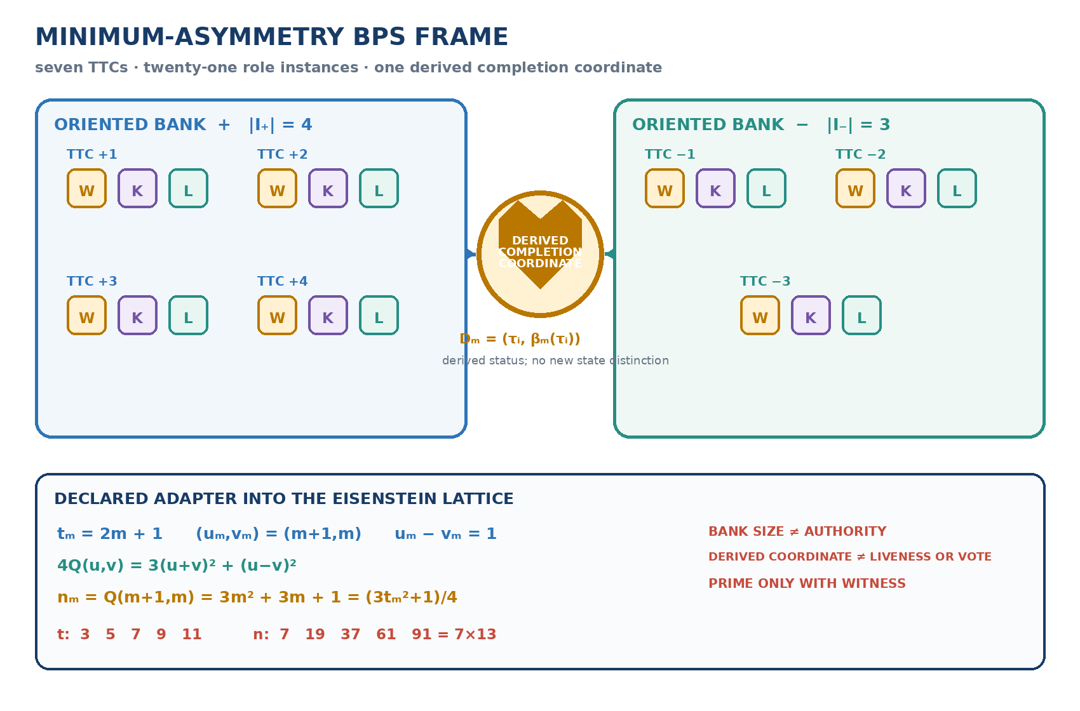
Figure 11. Minimum-asymmetry BPS frame. Seven TTCs form oriented banks of four and three, giving twenty-one role instances plus one derived completion coordinate. The declared adjacent-coordinate adapter lands at the framed-shell index 37. The diagram records topology and arithmetic only; bank size grants no authority and the derived coordinate is not a liveness witness.

16.7 Partitioned custody: Hearthline, Thulia, Gloss, and controller
IMPLEMENTATION ALIASES The Hearthline realization calls a TTC a “Light Trio,” its role instances “Sparks,” a BPS a “Creature,” and β_M its “Heart.” These names are implementation and narrative aliases, not theorem terms.
The following is a concrete Hearthline interface proposal, not a mathematical theorem, cognitive model, deployed mechanism, or source of number-theoretic authority. Hearthline, Thulia, Gloss, role instances, and the controller remain non-overlapping roles inside one declared realization.
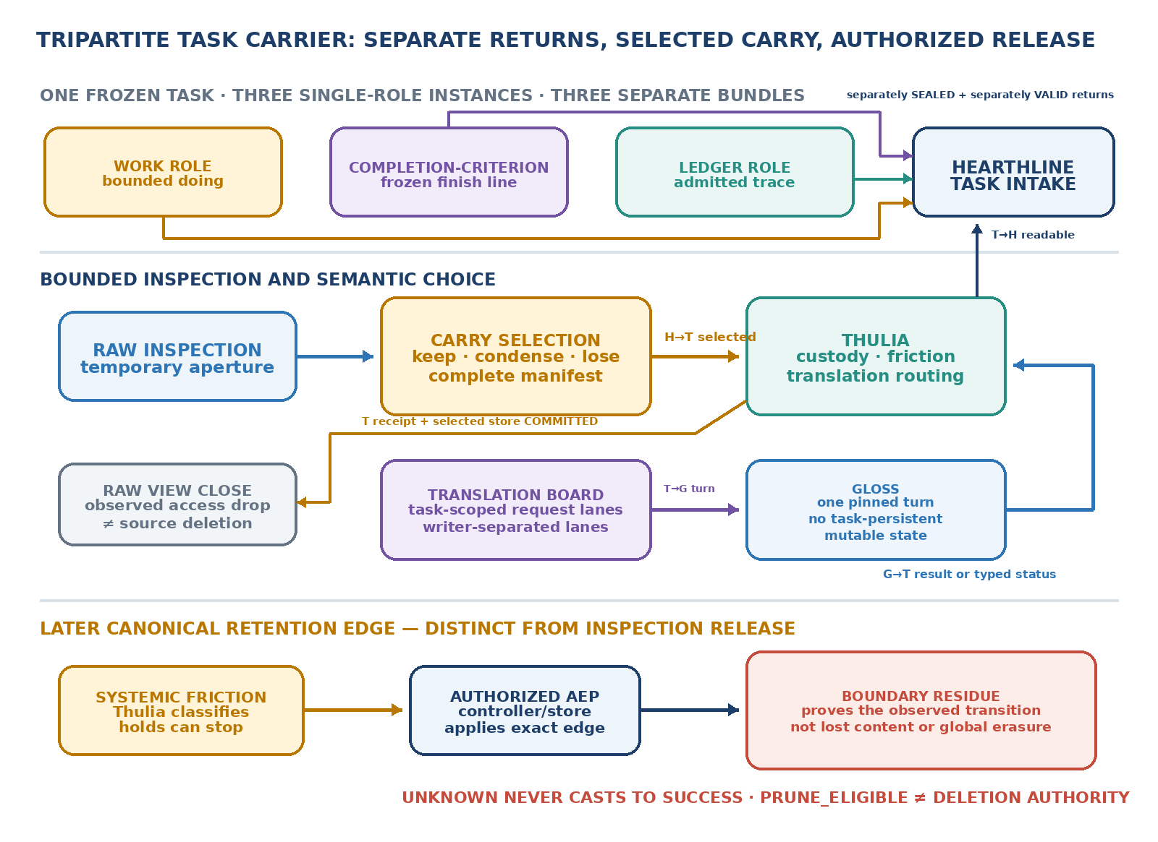
Figure 12. Tripartite Task Carrier return and selected-carry choreography. Three single-role instances return separately to the exact Hearthline task intake. Hearthline freezes the semantic Carry Selection; Thulia receives the selected projection and receipt-complete disposition manifest, routes any pinned Gloss turn, and later classifies Systemic Friction. Raw-view closure begins only after durable Thulia acceptance and committed selected-carry storage. Closing the temporary inspection view and applying a canonical retention edge are distinct, separately authorized transitions. Gloss has no task-persistent mutable state.
The role boundaries are deliberately asymmetric:
Role | Bounded function | Must not absorb
Hearthline | Orchestrates the root task; co-provisions work and completion-criterion roles; receives three separate valid terminal bundles; freezes semantic Carry Selection and task-scoped shorthand serviceability. | Thulia’s ledger seat, Systemic Friction, deterministic translation, durable receipt attestation, or storage effects.
Thulia | Co-provisions the ledger role; accepts the selected projection and receipt-complete disposition manifest; routes translation; alone classifies Systemic Friction under a current grant. | Raw-member access by provisioning, primary-task work, semantic carry choice, shorthand serviceability, self-granting, or direct deletion.
Gloss | When controller-observed ready, applies one pinned deterministic lexicon generation and emits one output or typed terminal status. | Task-history state, ledger custody, mapping mutation, semantic serviceability, pruning, authorization, or future-readiness claims.
Role instance | Holds exactly one of the three sibling jobs and returns one separately sealed candidate bundle to the exact task intake. | A sibling job, merged identity, backchannel, parent acceptance, retention authority, or ledger-as-self claim.
Controller / AEP | Allocates identities and grants, binds all seats or none, records separately identified receipts, closes access, and applies only an exact authorized AEP edge. | Purpose selection, meaning, truth creation, Systemic Friction judgment, hidden status casting, or authority widening.
Table 1. Non-overlapping custody and effect lanes in the proposed Hearthline realization.
The Hearthline task intake temporarily exposes only the separately admitted member projections authorized for the active root task. The immutable Carry Selection and constrained Translation Board are separate account surfaces, not Hearthline’s private memory and not copies of arbitrary raw bundles. Thulia keeps partitioned pointers, receipts, holds, and unresolved exceptions; provisioning role L grants her no raw-member access. Gloss transforms only the exact pinned request presented for one ready turn. The canonical controller or store owns identities, receipts, access-drop transitions, and later edge effects.
Gloss remains a version-pinned, task-memoryless transducer:
$${Gloss}_{g}\left(m,Σ_{g}\right)=\left(m′,ν\right), TaskMutableState\left({Gloss}_{g}\right)=⌀.$$
Here Σ_g is the pinned read-only lexicon generation admitted for that exact turn, and ν is TRANSLATED, AMBIGUOUS, UNMAPPED, or GENERATION_MISMATCH. Gloss emits only (m′,ν). The canonical controller separately appends a turn mark μ to the external Gloss lane; μ is neither produced nor stored by Gloss. Empty task-mutable state excludes task-persistent mutable state, while the pinned executable and lexicon generation remain persistent versioned artifacts. The task-scoped Translation Board has writer-separated lanes for Hearthline requests and serviceability decisions, Thulia custody marks, and Gloss results. It is external, replaceable, account-owned, and subject to Systemic Friction; it is not Gloss's surface, body, autobiographical memory, possession, or identity.
A role instance receives one exclusive bounded job and one account-partitioned output lane, not a personal memory object. The work role performs the primary assignment; the completion-criterion role compares only the frozen completion predicates; the ledger role records admitted coverage and residuals. Each returns its own bundle and stops. A role instance may raise a typed retention objection only by citing the affected record and one of REPLAY_DEFECT, OPEN_DUTY, HOLD_VIOLATION, CONTEST_OPEN, or SCOPE_UNRESOLVED. These objections can block pruning; SELF_PRESERVATION is not a retention verdict because the task ledger was never assigned as the role instance’s body or identity.
NON-EVASION CEILING This contract governs only records predeclared as account-owned members of G_mutable. If a future implementation gives Gloss or a role instance persistent autobiographical state, or otherwise models a state surface as constitutive of that role, the state lies outside this retention lane and requires separate governance. It may not be relabeled account-owned merely to bypass an identity or refusal claim.
DISTINCT CUSTODY SURFACES Thulia does not carry three payload histories or become a second Hearthline. She co-provisions the ledger role, mediates the selected-carry and translation lanes, and exclusively issues the bounded Systemic Friction classification. Hearthline chooses semantic carry; Gloss transforms symbols deterministically; the canonical writer applies effects. No role silently absorbs another.
The surrounding duty bundles are threefold without merging roles. Hearthline (1) provisions work and completion-criterion seats, (2) receives and selects from the three direct returns while communicating selected carry with Thulia, and (3) authors task-scoped Translation Board requests and serviceability decisions. Thulia (1) provisions only the ledger seat, (2) keeps the selected-carry and readable-return crossings separate, and (3) keeps the Gloss request and result crossings separate; under a later, distinct grant she alone applies Systemic Friction. Quantity bounds how many role instances may be provisioned, but does not create another duty.

16.8 Selected carry and four one-way lanes

Definition 16.14 — Carry Selection
After the applicable member returns have been admitted, Hearthline may inspect their grant-filtered projections inside a bounded task aperture and seal one immutable Carry Selection. The selection enumerates every admitted item and typed absence, records SELECT_KEEP, SELECT_CONDENSE, or SELECT_LOSE, binds every proposed shorthand or translation request, names unresolved duties and accepted-loss boundaries, and fixes task, audience, authority epoch, objective epoch, expiry, and destination.
The handoff to Thulia must also include a complete disposition manifest over the admitted return surface, with separately valid protected-query evaluation receipts, dependency coverage, hold coverage, declared search scope, and unresolved unknowns sufficient for the classifications in Sections 15.3–15.4. Content may remain access-gated; raw member bodies need not be exposed when the receipts are sufficient. An omitted or unevaluable reference, obligation, dependency, hold, or unknown forces FRICTION_UNKNOWN_HOLD. This prevents semantic selection from becoming pruning-by-concealment.

Proposition 16.15 — Selection does not imply retention disposition
No value of the Hearthline Carry Selection mechanically determines a Systemic Friction classification or a canonical storage effect.

Proof
The interfaces have different inputs, owners, and codomains. Carry Selection records task-relative semantic preference. Systemic Friction additionally consumes the complete disposition manifest, measured or declared burdens, protected queries, holds, dependencies, authority, and unknowns. Atomic Edge Promotion then requires a separate effect grant and checker. In particular, SELECT_LOSE may coexist with KEEP, ARCHIVE, or FRICTION_UNKNOWN_HOLD, and PRUNE_ELIGIBLE still supplies no deletion authority. Therefore there is no valid status cast from selection to disposition or effect.
The selected-carry route is four separately identified and separately receipted one-way transactions: (i) Hearthline to Thulia; (ii) Thulia to Gloss when exact translation is required; (iii) Gloss to Thulia with output or typed terminal status; and (iv) Thulia to the exact Hearthline task intake with one SEALED, separately VALID, durable terminal envelope. Lane (iv) is either CANDIDATE_COMPLETE(readable payload) or OWL_SUPPORT_REQUIRED(reason, residual), which may carry AMBIGUOUS, UNMAPPED, GENERATION_MISMATCH, BLOCKED, or UNKNOWN. Only CANDIDATE_COMPLETE may be loaded as readable carry. OWL_SUPPORT_REQUIRED still reaches Hearthline and the controller as terminal status without being cast to readable success. Unknown emission or receipt on one lane never becomes success on another and is reconciled by the original identity rather than blind resend.
The Translation Board is task-scoped and writer-separated. Hearthline alone makes the semantic serviceability decision for the active root task; the canonical writer records it only after the mapping, exact lexicon generation, mechanical round trip, grant, audience, and epoch validate. Thulia routes pointers, and Gloss emits deterministic results. The Board cannot store arbitrary raw bundles. At root-task close, serviceability expires while the immutable mapping reference remains addressable; a revisit requires a successor load receipt under current authority.

Corollary 16.16 — Selected-return projection
Let $c_{M}$ be the full frozen selection context, including purpose, protected-query family, authority and audience epochs, selector version and policy, and any declared randomness or seed. Holding $c_{M}$ fixed, let ScM:i∈I​Li→H be a deterministic selected-carry projection. Its kernel satisfies
$$K\left(τ_{I}\right)⊆K\left(S_{c_{M}}∘τ_{I}\right).$$
If the inclusion is strict, the selected return identifies at least two distinct complete BPS returns. After the full return aperture is released, the missing distinction cannot be reconstructed from the selected return alone.

Proof
Equal complete traces receive equal deterministic selections under the same frozen context, giving the kernel inclusion. Strict inclusion supplies two distinct full returns with one selected projection, so no procedure restricted to that projection can distinguish them. A stronger claim about a surviving pair consisting of selected carry and boundary receipt requires the explicit non-injectivity hypothesis of Proposition 16.18. ∎

16.9 Bounded release and boundary residue

Definition 16.17 — Inspection-projection release
An inspection-projection release is a controller-observed transition that revokes the active Hearthline task's raw bundle locators, account reads, cache or index routes, and other exact inspection handles after the same valid Carry Selection has been durably received and stored on Thulia's selected-carry lane. It closes that temporary aperture only. It does not by itself compact, archive, prune, overwrite, or globally erase the canonical source.
Canonical retention occurs later. Thulia classifies Systemic Friction under a separate current grant; the controller or canonical writer applies only the separately admitted AEP edge. The effect and recoverability axes remain distinct: an applied transition may leave the exact source reopenable, only a projection reopenable, the content intentionally unrecoverable inside the declared boundary, or recoverability unknown. Translation dependencies block retirement unless every surviving shorthand has an exact retained decoder route or the resulting unreadability is expressly admitted as loss.

Proposition 16.18 — Boundary-residue ceiling
Let X be the former source space. Suppose a declared interface retains only maps p : X → P and b : X → B, representing a selected projection and boundary receipt after an authorized release. If the joint surviving map ⟨p,b⟩ : X → P × B is not injective, then no procedure restricted to the surviving pair (p(x),b(x)) can recover which source x was present.

Proof
Choose distinct x₁,x₂ ∈ X with ⟨p,b⟩(x₁)=⟨p,b⟩(x₂). Any procedure whose complete input is that surviving pair receives identical input in both cases and therefore cannot distinguish x₁ from x₂ without an additional oracle or retained route. The receipt may establish that its trusted transition record was observed, but it cannot restore distinctions absent from its surviving domain. This is an interface-relative non-reconstruction result, not a claim that all physical copies were erased.
HONEST FORGETTING CEILING Informal descriptions may say that Hearthline forgets after handoff. The enforceable statement is narrower: after a durable Thulia receipt, the controller releases the active Hearthline task’s raw inspection projection. This closes the temporary read aperture; it does not prove global erasure, remove canonical records, or authorize a later retention effect.

16.10 Order of operations and failure closure
The acyclic choreography is: separate valid member arrivals → bounded Hearthline inspection → sealed Carry Selection and receipt-complete disposition manifest → durable Thulia receipt and selected-carry storage → observed release of Hearthline's raw inspection projection → optional pinned Gloss turn → durable CANDIDATE_COMPLETE readable return or OWL_SUPPORT_REQUIRED terminal status → later Systemic Friction review and separately authorized canonical effect.
The completion-criterion role's comparison terminates before selection, translation, retention, readable return, or parent acceptance. UNKNOWN at return, handoff, readiness, translation, close, readable receipt, friction, or effect remains typed uncertainty. It never casts to completion, successful compression, or permission to retry under a new identity. A stale root task may reconcile an old transaction but may not load its late result without a successor task and current grant.
For long-running interfaces, an operator may prefer bounded passes, frequent checkpoints, and explicit handoff receipts. Runtime timing and user-interface behavior remain implementation observations outside the mathematical lifecycle; they provide no hidden transport theorem or role instance-liveness signal.
PURPOSE DAG Christopher’s declared goal narrows to Hearthline’s objective. That objective separately narrows to the TTC task line and to Thulia’s mediation objective; Thulia may further narrow one exact request to a pinned Gloss turn. Co-provisioning is a formation edge, not purpose parentage. Every descendant grant narrows authority; usefulness never reverses the arrows.

17. Formal verification account
The inherited formal package preserves five v0.1 theorem modules and adds two v0.2 successor modules:
PAL/PrimeShells.lean
PAL/PrimeShellsModThreeKernel.lean
PAL/PrimeShellsConditioning.lean
PAL/PrimeShellsBasisTransport.lean
PAL/PrimeShellsConditionNumber.lean
PAL/PrimeShellsThreeCharts.lean
PAL/PrimeShellsRibbons.lean
The corresponding raw dependency reports are generated from seven audit modules. The v0.1 and v0.2 workflows remain separate so the successor does not rewrite the earlier formal receipt.
The v0.2 modules formalize:
- derived-axis fiber invariance;
- joint-fiber intersection and a strict-refinement witness;
- the stereographic sphere equation, exact image inverse, and injectivity;
- the exact product shell atlas and radial shell-radius identity;
- represented-prime atlas occupancy inherited from the sharp selector;
- generic and prime-shell ribbon structures;
- finite ready-ribbon transport reduction to endpoints; and
- an explicit same-endpoint/different-route prime-shell fixture.
The inherited environment is pinned to Lean 4.32.1 and Mathlib 4.32.1. Both theorem chains compiled successfully. The source freeze, run, and raw artifact identities below establish only the exact statements and outputs they bind.
Inherited verification receipt — v0.1. The theorem-source freeze is commit 56574e76c111204c8e33b468e48ea0e6af8ff4de; the receipt-gate commit and successful workflow head is 2d830794ac34b38bf9a541293afecccaaf93486c. Workflow run 33820043692 produced artifact 9917985202 with ZIP SHA-256 a7aa5c917d59b6e0a1d7397aa2644b4b5d612ccef33f1af8bf5888ebb7365ce5. Its raw receipt contains exactly 62 declaration reports.
Inherited verification receipt — v0.2. The theorem-source freeze is commit 450e808325743b130c2f6cb3cf7496a7bb3a7556. Dedicated workflow run 33837570265 completed successfully in Lean 4.32.1 with Mathlib 4.32.1 at revision 520045ab14e26149ee970e2e617ca04b09bde5d6. Artifact 9923832727 has ZIP SHA-256 6d90e1b47924c2bd1356eb7956ebd81cc36c1983377ad42bc8e2a5ff76672191 and contains 40 raw dependency reports: 26 dependency-bearing and 14 explicitly reported by Lean as axiom-free. The previous manuscript count of 26, and stacked count of 88, were incorrect; the raw surfaces are 40 and 102.
OPEN RECEIPT CORRECTION The prior checker parsed only the phrase 'depends on axioms' and therefore did not enforce the exact 40-name inventory. An append-only checker hardening and replay must pin both inherited declaration-name sets before the 102-report surface is described as fully fail-closed.

17.1 Formalization boundary beyond the inherited core
No dedicated post-core Lean source freeze, exact-inventory gate, artifact, or successful successor receipt exists. The following additions are proved or defined at manuscript level and remain candidates for a later formal pass:
- exact area-conditioning duality;
- the six-line equality locus and unique strict optimum for represented primes above 3;
- the radial-faithfulness criterion on the full product carrier;
- trace-to-boundary kernel factorization for ribbons; and
- Prime Seed and Circuit Garden record/promotion definitions as a typed realization proposal.
- the declared-input ceiling and evidence-carriage non-factorization result;
- protected replacement-edge and relative-weed definitions;
- the separately typed retention-lane AEP contract; and
- the proposed Hearthline account, Translation Board, custody, objection, and non-overlap invariants.
- the Tripartite Task Carrier formation and direct-return type boundaries, immutable Carry Selection, four one-way transaction families, task-scoped Translation Board, selection-disposition separation, inspection-projection release, and boundary-residue ceiling.
- the finite Bound Persistent Shell joint-kernel law, earned-expansion criterion, protected-query sufficiency, and necessity-witness criterion;
- the derived completion coordinate ceiling and the distinction between derived status and separately sourced liveness;
- the closest distinct-integer split, adjacent-coordinate Eisenstein identity, exact adjacent-frame selector and quality formulas, and conditional Prime Seed adapter; and
- the BPS Circuit Garden, successor-epoch boundary, and selected-return kernel ceiling.
The inherited formal receipts establish only their exact Lean statements under the pinned environment. They do not establish the imported classical prime classification, global novelty, engineering validity, any post-core addition, a calibrated Systemic Friction profile, a deployed TTC or BPS mechanism, actual model forgetting, peer review, or publication authority.

18. Literature boundary, provenance, and open burdens
U. P. Nair supplies elementary representability background for $a^{2}+ab+b^{2}$. Oscar Marmon supplies the Eisenstein/hexagonal shell count, split/ramified/inert classification, and angular structure. Standard linear algebra supplies basis, determinant, singular-value, and condition-number concepts. PAL v2.3-M / RAINBOW supplies the author’s prior research address for shell and local-frame language. Abstract Loops and Compactification Costs supply same-lineage fixed-interface fiber language. GPPR and GOLD supply same-lineage endpoint-versus-route precedents.
Phillip H. Smith’s transmission-line calculator supplies the classical engineering chart. Later spherical and 3D Smith-chart work maps the extended reflection-coefficient plane to a Riemann sphere and uses additional scalar or frequency-dependent structure for multi-parameter visualization. Those sources govern the Smith-chart precedent; this manuscript does not backdate its atlas/ribbon terminology into them.
The CHARTER candidate contribution remains narrower than its visual synthesis: the exact local-frame theorem package, witness-sensitive atlas and ribbon separation, exact quality refinements, Prime Seed anatomy, receipt-bearing promotion grammar, typed retention boundary, Tripartite Task Carrier and BPS return carriers, and selected-carry interface. Same-lineage sources supply declared-interface and purpose-relative compression precedents; they are not independent corroboration. Initial targeted searching has not established that the complete synthesis is globally novel.
ARCHIVAL LINEAGE An author-held Google Docs notebook titled I imagined that gravity was the only force in the universe reports creation on 21 October 2012, contains entries internally dated from 31 August 2012, and was modified on 5 January 2014. It supplies conceptual ancestry and the quoted minimum-asymmetry identity only. It contains no Eisenstein shell construction, frame theorem, BPS bank, Prime Seed, Circuit Garden, Systemic Friction, Tripartite Task Carrier, or selected-carry architecture. The notebook supplies ancestry, not authority; the 2026 definitions, proofs, interfaces, and receipts are the work claimed here.

18.1 Explicit nonclaims
This manuscript does not claim:
- a proof or new route to the Riemann Hypothesis, twin primes, or a prime-gap bound;
- a solution of the Minimum Circuit Size Problem, an asymptotic circuit lower bound, or evidence for either P = NP or P ≠ NP;
- a mathematical reduction, theorem transfer, or equivalence between NAND circuits and Eisenstein prime shells;
- that a Prime Seed generates a prime or names a new number-theoretic species;
- that atomic promotion creates truth, external authorization, publication adoption, a new PAL constructor, or an A16 layer;
- that verifier acceptance selects meaning, relevance, purpose, protected distinctions, or authority;
- that the Chinese Room analogy resolves whether computation or any AI system understands or is conscious;
- that Systemic Friction is a universal scalar, thermodynamic entropy, moral value, or abstract invariant;
- that C_verify > C_recompute suffices to retire a record;
- that a weed classification is intrinsic, permanent, or self-authorizing;
- that a digest alone establishes existence, time, acceptance, authenticity, truth, reconstruction, or replayability;
- that Systemic Friction may override canonical preservation, open duties, holds, contest, or reopening requirements;
- that the Thulia, Gloss, Hearthline, or Tripartite Task Carrier realization is a deployed mechanism or mathematical result;
- that an observed inspection release proves provider-level model forgetting, physical erasure, deletion from backups or external holders, or global unrecoverability;
- that a task-scoped shorthand mapping is globally meaningful, true, authorized, or serviceable after its root task closes;
- that the motivating interface timing observations establish hidden transport mechanics, universal safe durations, progress, or liveness;
- that a role instance acquires ledger ownership or an identity-based preservation veto by using a bounded write lane; or
- that BPS size is a rational prime, that odd TTC count implies a prime shell, or that infinitely many adjacent indices are prime;
- that minimum asymmetry selects bank membership, makes the larger bank authoritative, or establishes independent corroboration;
- that a derived completion coordinate is a liveness witness, another role instance, a vote, or an independent state coordinate;
- that q-irredundancy proves globally minimum BPS size or that larger Bound Persistent Shells improve accuracy, cost, or completion;
- that the geometric condition number measures BPS computational difficulty or normalized area measures intelligence, diversity, consensus, or reliability;
- that a BPS successor may self-expand inside a frozen manifest without a new objective and authority epoch;
- that the finite minimum-asymmetry lemma extends to the notebook line P = infinity; or
- that the composite-containing adjacent family is itself a prime-shell ribbon or inherits the flat transport theorem without a separately typed construction;
- a new classification of Eisenstein primes or a new proof of the classical shell counts;
- invention of the ordinary, spherical, generalized, or 3D Smith chart;
- that a third visual coordinate necessarily adds information;
- that the prime label is independent when the starting trace already contains exact Eisenstein coordinates;
- that a smooth drawn ribbon is the exact arithmetic object;
- nontrivial holonomy or path-dependent transport under the present flat transport law;
- a physical shell, particle model, wavefunction, force law, RF-prime coupling, or cosmology;
- a coordinate-free selector beyond the unique p>3 winner relative to the fixed Eisenstein embedding and conjugation convention; or
- that exact real-number conditioning guarantees every finite-precision implementation; or
- that Lean compilation establishes source truth, global novelty, peer review, author adoption, or publication authority.

18.2 Open burdens beyond v1.0
- Append-only repair and replay of the inherited Lean exact-inventory checker, followed by a dedicated formal pass for the post-core claims.
- Freeze a versioned Systemic Friction schema: channels, units, sources, uncertainty, UNKNOWN handling, policy, protected queries, holds, and grant semantics.
- Produce a pinned Circuit Garden calibration receipt for repeated wall/CPU time, transient memory, serialization, and energy only where directly instrumented.
- Adversarially test digest-only replacement, incomplete disposition manifests, lost replay routes, omitted former receipts, active holds, open residuals, stale lexicon generations, ambiguity, false preservation equivalence, and unknown close or effect outcomes.
- Implement and test account ownership, Tripartite Task Carrier co-formation, separate member intake, bounded inspection, Carry Selection, writer-separated Translation Board lanes, four one-way receipt families, Gloss readiness, access-drop reconciliation, Thulia-only friction classification, and controller/AEP effects.
- Version the Thulia boundary explicitly: Ledger-seat provisioning grants no raw-result access; exclusive retention classification must not become semantic carry choice, general governance, or direct deletion authority.
- Archive the 2012 notebook, if desired, as a clearly labeled 2026 public deposit with a stable reading copy and revision-history caveat; replace the provisional citation with its live DOI without backdating public availability.
- Complete literature, priority, privacy, and independent mathematical review; freeze a publication manifest only when manuscript, figures, formal status, and receipts agree byte-for-byte.

Conclusion
An arithmetic shell fixes a level set. A frame fixes its local orientation. A kernel records whether another coordinate creates a state distinction. An atlas lists available states; a ribbon retains their ordered route. Smith and Golden Rainbow displays expose those relations without acquiring authority from visual form.
A Prime Seed binds one supplied witness and mathematical certificate. A Circuit Garden records which finite obligations support a scoped promotion. Systemic Friction prices continued carriage only after a purpose, realization, measurement method, protected distinctions, and authority are declared. Atomic Edge Promotion applies the resulting checked edge; it does not choose meaning or value.
A Tripartite Task Carrier separates work, completion-criterion comparison, and admitted trace. A Bound Persistent Shell joins only as many such coordinates as the unresolved task fibers justify. Its completion coordinate is derived from the frozen task and admitted returns. The minimum-asymmetry subclass gives the banks a one-step orientation, and the declared Eisenstein adapter exposes a precise adjacent-coordinate shell family—but no bank majority, liveness signal, performance theorem, or automatic primality.
The complete route is one dependency-shaped account: shell → frame → fiber → atlas → ribbon → display → seed → garden → friction → TTC → BPS → selected carry → authorized release. Kernel equality says a derived coordinate creates no new state distinction. It does not say that the coordinate is free to compute, store, certify, or reproduce. A smaller retained boundary may honestly preserve scoped evidence that a declared controller observed a transition under a named trust model while declining to pretend it still contains every distinction that led there.
That is CHARTER's claim ceiling and its purpose: robust transport without confusing the state with its route, the claim with its receipt, the receipt with its cost, or a reasoned loss with proof that nothing remains anywhere else.

References
- Marmon, Oscar. “Hexagonal Lattice Points on Circles.” arXiv:math/0508201, 2005.
- Nair, Umesh P. “Elementary Results on the Binary Quadratic Form $a^{2}+ab+b^{2}$.” arXiv:math/0408107, 2004.
- Pang, Christopher D. PAL v2.3: Primitive Axiom Layers. Mathematical Realization Atlas, RAINBOW section. Zenodo, 2026. DOI 10.5281/zenodo.22240134.
- Pang, Christopher D. Abstract Loops: Joint Certification, Generative Coupling, and the Cut Inside the Composite. v1.0. Zenodo, 2026. DOI 10.5281/zenodo.21950771.
- Pang, Christopher D. Compactification Costs: A Typed Framework for Extension, Boundary, Identification, and Ambiguity. v0.2. Zenodo, 2026. DOI 10.5281/zenodo.22238012.
- Pang, Christopher D. Golden Phase Prime Ribbons. GPPR v0.1. Zenodo, 2026. DOI 10.5281/zenodo.22225414.
- Pang, Christopher D. GOLD: Golden-Oriented Lens Diagram. v0.1. Zenodo, 2026. DOI 10.5281/zenodo.22236848.
- Smith, Phillip H. “Transmission Line Calculator.” Electronics 12, no. 1 (January 1939): 29-31.
- Caspers, F. “RF Engineering Basic Concepts: The Smith Chart.” arXiv:1201.4068, 2012.
- Zelley, Chris. “A Spherical Representation of the Smith Chart.” IEEE Microwave Magazine 8, no. 3 (2007): 60-66. DOI 10.1109/MMW.2007.365060.
- Wu, Yongle, Yaxing Zhang, Yuanan Liu, and Haiyu Huang. “Theory of the Spherical Generalized Smith Chart.” Microwave and Optical Technology Letters 51, no. 1 (2009): 95-97. DOI 10.1002/mop.23999.
- Muller, Andrei A., P. Soto, D. Dascalu, D. Neculoiu, and V. E. Boria. “A 3-D Smith Chart Based on the Riemann Sphere for Active and Passive Microwave Circuits.” IEEE Microwave and Wireless Components Letters 21, no. 6 (2011): 286-288. DOI 10.1109/LMWC.2011.2132697.
- Muller, Andrei A., et al. “3D Smith Charts Scattering Parameters Frequency-Dependent Orientation Analysis and Complex-Scalar Multi-Parameter Characterization Applied to Peano Reconfigurable Vanadium Dioxide Inductors.” Scientific Reports 9 (2019), article 18346. DOI 10.1038/s41598-019-54600-5; arXiv:1905.09701.
- Asavei, Victor, Andrei A. Muller, Esther Sanabria-Codesal, Alin Moldoveanu, and Adrian M. Ionescu. “3D Smith Chart Constant Quality Factor Semi-Circles Contours for Positive and Negative Resistance Circuits.” IEEE Access 8 (2020): 176012-176022. DOI 10.1109/ACCESS.2020.3026917; arXiv:2006.13315.
- Lean Prover Community. Mathlib 4, release v4.32.1, 2026.
- Pang, Christopher D. Framed Prime Shells Formal Package. v0.1 theorem-source freeze 56574e76c111204c8e33b468e48ea0e6af8ff4de; receipt-gate commit 2d830794ac34b38bf9a541293afecccaaf93486c; workflow run 33820043692; artifact 9917985202; ZIP SHA-256 a7aa5c917d59b6e0a1d7397aa2644b4b5d612ccef33f1af8bf5888ebb7365ce5. v0.2 theorem-source freeze 450e808325743b130c2f6cb3cf7496a7bb3a7556; workflow run 33837570265; artifact 9923832727; ZIP SHA-256 6d90e1b47924c2bd1356eb7956ebd81cc36c1983377ad42bc8e2a5ff76672191. Grativy6/PAL-Lean-Audit, 2026; branches and pull requests 9 and 10 retain the public lineage.
- Pang, Christopher D. “Two-Input NAND Circuit Garden: Certified Finite Receipt.” Hearthline Plays, game PNP-CIRCUIT-GARDEN-N2-NAND-001, canonical commit 3449bd282309aa291a98d1e08819232b1849832e, 2026. Public receipt remains model-drafted pending steward review.
- Searle, John R. “Minds, Brains, and Programs.” Behavioral and Brain Sciences 3, no. 3 (1980): 417-457. DOI 10.1017/S0140525X00005756.
- Landauer, Rolf. “Irreversibility and Heat Generation in the Computing Process.” IBM Journal of Research and Development 5, no. 3 (1961): 183-191. DOI 10.1147/rd.53.0183.
- Bennett, Charles H. “Logical Reversibility of Computation.” IBM Journal of Research and Development 17, no. 6 (1973): 525-532. DOI 10.1147/rd.176.0525.
- National Institute of Standards and Technology. Secure Hash Standard (SHS). FIPS PUB 180-4, August 2015. DOI 10.6028/NIST.FIPS.180-4.
- Adams, Carlisle, Patrick Cain, Denis Pinkas, and Robert Zuccherato. Internet X.509 Public Key Infrastructure Time-Stamp Protocol (TSP). RFC 3161, August 2001. DOI 10.17487/RFC3161.
- Laurie, Ben, Eran Messeri, and Rob Stradling. Certificate Transparency Version 2.0. RFC 9162, December 2021. DOI 10.17487/RFC9162.
- Gondrom, Tobias, Ralf Brandner, and Ulrich Pordesch. Evidence Record Syntax (ERS). RFC 4998, August 2007. DOI 10.17487/RFC4998.
- Pang, Christopher D. Exact Certification Through a Declared Interface: Fiber Factorization, Finite Capacity, and a Lean 4 Audit (APCI Run 0001). Version 1.0.0. Zenodo, 2026. DOI 10.5281/zenodo.21923290.
- Pang, Christopher D. SEED: Sustainable, Empathic Expression and Disclosure. v0.3 Complete Release Discipline and Mathematical Realization. Zenodo, 2026. DOI 10.5281/zenodo.21760893.
- Pang, Christopher D. I Imagined That Gravity Was the Only Force in the Universe. Unpublished author-held Google Docs research notebook, 2012–2014. Author-supplied transcription consulted 4 September 2026; SHA-256 ed362f7ed69722a215bfc79490d3716aed18f4a0a94e5b145cf9e58f61ec9fd0.

Revision history
This compressed log records each manuscript stage. Detailed proof and receipt status remains governed by Sections 17–18.
v0.1 — exact local frames and the transport basis.
v0.2 — witness-sensitive atlases and route-bearing ribbons.
v0.3 — Prime Seeds, Circuit Gardens, and certification grammar.
v0.4 — declared-input and Systemic Friction retention boundaries.
v0.5 — tripartite task carriage, selected carry, and bounded release.
v0.6 — finite composite carriers and minimum-asymmetry frames.
v1.0 — author-adopted release; TTC/BPS terminology, an explicit prime-shell/BPS type boundary, normalized front matter, corrected figures and cover mark, a release-sufficiency rule, CC BY 4.0 licensing, and resolved author notes. The mathematics and claim ceilings are preserved.

License
© 2026 Christopher D. Pang. This work is licensed under the Creative Commons Attribution 4.0 International License (CC BY 4.0): https://creativecommons.org/licenses/by/4.0/

Authorship and AI-assistance disclosure
Christopher D. Pang is the sole author, steward, and adoption/publication authority. He supplied the shell-frame intuition and 2012 notebook antecedent; selected the atlas/ribbon, Prime Seed/Circuit Garden, Systemic Friction/AEP, tripartite task-carriage, Bound Persistent Shell, selected-carry, and minimum-asymmetry synthesis; named CHARTER; and remains responsible for its mathematics, claims, citations, corrections, licensing, and release. OpenAI ChatGPT and connected coding tools assisted with retrieval, mathematical exploration, adversarial checking, inherited Lean work, figures, drafting, repository implementation, and document production. They are tools—not authors, co-authors, witnesses, stewards, or mathematical authorities.

