项目课程系列之Atcrowdfunding

尚硅谷JavaEE教研组

版本：V1.0

第一章 整合SpringSecurity-认证应用

1.1 引入Sprin gSecurity的依赖
<dependency>
<groupId>org.springframework.security</groupId>
<artifactId>spring-security-web</artifactId>
<version>4.2.10.RELEASE</version>
</dependency>
<dependency>
<groupId>org.springframework.security</groupId>
<artifactId>spring-security-config</artifactId>
<version>4.2.10.RELEASE</version>
</dependency>
<!-- 标签库 -->
<dependency>
<groupId>org.springframework.security</groupId>
<artifactId>spring-security-taglibs</artifactId>
<version>4.2.10.RELEASE</version>
</dependency>

1.2 编写SpringSecurity的配置

1.2.1 web.xml配置Security的Filter拦截所有请求
<!-- 权限过滤Filter -->
<filter>
<filter-name>springSecurityFilterChain</filter-name>
<filter-class>org.springframework.web.filter.DelegatingFilterProxy</filter-class>
</filter>
<filter-mapping>
<filter-name>springSecurityFilterChain</filter-name>
<url-pattern>/*</url-pattern>
</filter-mapping>

1.2.2 编写SpringSecurity的配置类
@EnableGlobalMethodSecurity(prePostEnabled=true)
@EnableWebSecurity
@Configuration
public class AtcrowdFundingSecurityConfig extends WebSecurityConfigurerAdapter {

@Autowired
SecurityUserDetailServiceImpl securityUserDetailServiceImpl;

//@Autowired
//AccessDeniedHandler accessDeniedHandler;

@Bean
public PasswordEncoder passwordEncoder(){
return new BCryptPasswordEncoder();
}

@Override
protected void configure(AuthenticationManagerBuilder auth) throws Exception {
auth.userDetailsService(securityUserDetailServiceImpl).passwordEncoder(passwordEncoder());
}

/**
* 1、自定义请求授权访问规则
*/
@Override
protected void configure(HttpSecurity http) throws Exception {
http.authorizeRequests().antMatchers("/static/**","/login.jsp").permitAll()
.anyRequest().authenticated();//剩下都需要认证

// /login.jsp==POST 用户登陆请求发给Security
http.formLogin().loginPage("/login.jsp")
.usernameParameter("loginacct").passwordParameter("userpswd")
.defaultSuccessUrl("/main.html").permitAll();

http.csrf().disable();

http.logout().logoutSuccessUrl("/login.jsp");

//http.exceptionHandling().accessDeniedHandler(accessDeniedHandler);
}
}

1.2.3 AccessDeniedHandler

1.2.4 UserDetailsService
@Service
public class SecurityUserDetailServiceImpl implements UserDetailsService {
Logger logger = LoggerFactory.getLogger(getClass());
@Autowired
TAdminMapper adminMapper;

@Autowired
TRoleMapper roleMapper;

@Autowired
TPermissionMapper permissionMapper;

@Override
public UserDetails loadUserByUsername(String username) throws UsernameNotFoundException {
//1、查询用户
TAdminExample example = new TAdminExample();
example.createCriteria().andLoginacctEqualTo(username);
List<TAdmin> list = adminMapper.selectByExample(example);

if(!list.isEmpty()&&list.size()==1){
TAdmin tAdmin = list.get(0);
//2、将这个用户对应的所有角色和权限全部查询出来
List<TRole> hasRoles = roleMapper.getHasRoles(tAdmin.getId());
logger.debug("SpringSecurity将 {} 用户信息去数据库查询",tAdmin.getLoginacct());
//3、这个用户对应的所有权限
List<TPermission> permissions = permissionMapper.getPermissionsByUserId(tAdmin.getId());

Set<GrantedAuthority> authorities = new HashSet<>();

//4、将角色添加到权限列表
for (TRole role : hasRoles) {
if(!StringUtils.isEmpty(role.getName())){
authorities.add(new SimpleGrantedAuthority("ROLE_"+role.getName()));
//hasRole("管理员") ROLE_管理员
}
}

//5、将权限添加到权限列表
for (TPermission perm : permissions) {
if(!StringUtils.isEmpty(perm.getName())){
authorities.add(new SimpleGrantedAuthority(perm.getName()));
//hasRole("管理员") ROLE_管理员
}
}
logger.debug("SpringSecurity {} 用户信息收集完成",tAdmin.getLoginacct());
return new TSecurityAdmin(tAdmin, authorities);
}
//用户查不出返回空即可
return null;
}
}

1.2.5 封装TSecurityAdmin
package com.atguigu.atcrowdfunding.security.bean;

import java.util.Collection;
import org.springframework.security.core.GrantedAuthority;
import org.springframework.security.core.userdetails.User;
import com.atguigu.atcrowdfunding.bean.TAdmin;

public class TSecurityAdmin extends User {

private TAdmin originalUser;//为了将数据库查出来的所有原始信息都保存

public TSecurityAdmin(TAdmin admin,Collection<? extends GrantedAuthority> authorities){
super(admin.getLoginacct(), admin.getUserpswd(), true, true, true, true, authorities);
this.originalUser = admin;
}

public TSecurityAdmin(String username, String password, boolean enabled, boolean accountNonExpired,
boolean credentialsNonExpired, boolean accountNonLocked,
Collection<? extends GrantedAuthority> authorities) {
super(username, password, enabled, accountNonExpired, credentialsNonExpired, accountNonLocked, authorities);
}

public TAdmin getOriginalUser() {
return originalUser;
}

public void setOriginalUser(TAdmin originalUser) {
this.originalUser = originalUser;
}
}

1.2.6 让SpringMVC来扫描所有的组件

1.3 给方法上标注权限注解

1.4 添加和更新用户的代码进行修改
admin.setUserpswd(passwordEncoder.encode("123456"));

1.5 之前自己写的登录方法作废了，使用权限框架的登录认证

1.6 注销系统
<a href="${appPath }/logout"><i class="glyphicon glyphicon-off"></i> 退出系统</a>

1.7 登录成功信息
<%@taglib prefix="sec" uri="http://www.springframework.org/security/tags" %>
<sec:authentication property="name"/> 获取登录账号名称

1.8 页面元素控制
具有相关的角色，才能看到相关信息。
<sec:authorize access="hasRole('TL - 组长')">
<button type="button" class="btn btn-default btn-danger">
<span class="glyphicon glyphicon-question-sign"></span> 帮助
</button>
</sec:authorize>
<sec:authorize access="hasRole('管理员')">
<button type="button" class="btn btn-default btn-danger">
<span class="glyphicon glyphicon-question-sign"></span> 牛逼
</button>
</sec:authorize>

1.9 参考标签
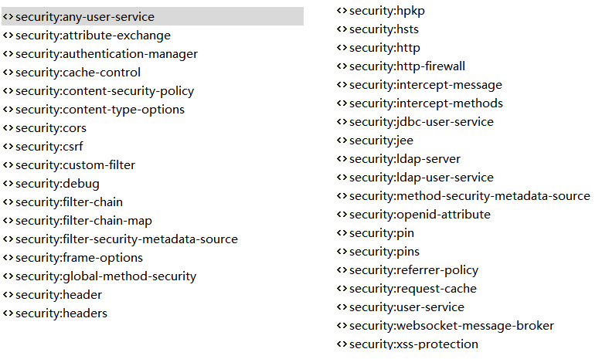

第二章 整合SpringSecurity-授权应用

2.1 授予方法访问权限
@PreAuthorize("hasRole('管理员')")
@RequestMapping("/main.html")
public String main(HttpSession session){
if(session.getAttribute(AppConst.SYS_MENU)==null){
//1、查询系统的所有菜单
List<TMenu> listMenus = systemMenuService.listMenus();
//2、session；
session.setAttribute(AppConst.SYS_MENU, listMenus);
}
return "main";
}

2.2 测试
直接在控制器方法上增加@PreAuthorize("hasRole('管理员')")注解，权限框架不起作用，谁都可以访问

2.2.1 原因
- 分层编写以后：
- @PreAuthorize不能标注在@Controller上，原因是Security的配置是在根容器（Spring配置文件）。
- Spring配置文件没有扫SpringMVC的东西，导致SpringMVC中的组件不能被Security识别

2.2.2 解决

1 只让SpringMVC加载所有文件，去除ContextLoaderListener监听器，Spring框架IOC容器不需要启动了，交给SpringMVC扫描配置。

2 SpringMVC扫描配置
<servlet>
<servlet-name>springDispatcherServlet</servlet-name>
<servlet-class>org.springframework.web.servlet.DispatcherServlet</servlet-class>
<init-param>
<param-name>contextConfigLocation</param-name>
<param-value>
classpath:springmvc.xml,
classpath*:spring/spring-beans.xml,
classpath*:spring/spring-mybatis.xml,
classpath*:spring/spring-tx.xml
</param-value>
</init-param>
<load-on-startup>1</load-on-startup>
</servlet>
<servlet-mapping>
<servlet-name>springDispatcherServlet</servlet-name>
<url-pattern>/</url-pattern>
</servlet-mapping>

第三章 整合SpringSecurity-访问拒绝处理器

3.1 设置访问拒绝
http.exceptionHandling().accessDeniedHandler(accessDeniedHandler);

3.2 访问权限拒绝处理器：AccessDeniedHandler
/**
* 自定义的无权访问的处理器
*/
@Component
public class AccessDenidHandlerImpl implements AccessDeniedHandler {
@Override
public void handle(HttpServletRequest request, HttpServletResponse response,
AccessDeniedException accessDeniedException) throws IOException, ServletException {
request.setAttribute("msg", accessDeniedException.getMessage());
//必须区别对待ajax和普通请求
if("XMLHttpRequest".equals(request.getHeader("X-Requested-With"))){
//ajax请求
String msg = "403";
response.getWriter().write(msg);
}else{
//普通请求
request.getRequestDispatcher("/WEB-INF/views/error/403.jsp").forward(request, response);
}
}
}

3.3 普通请求和ajax请求请求头对比
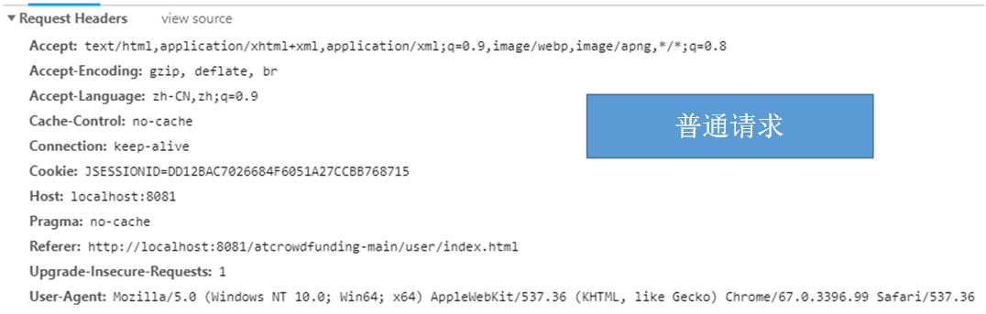
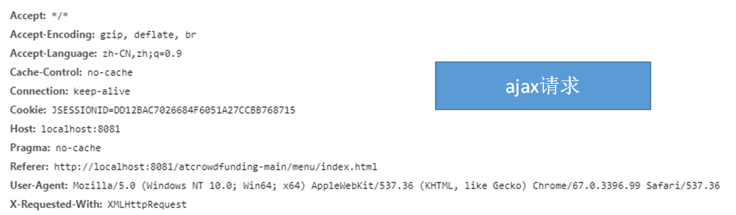
判断是否ajax："XMLHttpRequest".equals(request.getHeader("X-Requested-With"))

