Pandas & Matplotlib Assignment

PYBER

Trong Nguyen

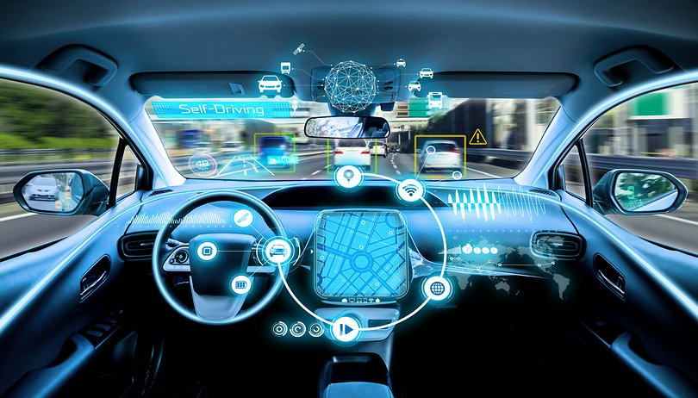

# Urban vs Rural

* From the data provided in 2016, it seems that our customers in urban areas will use the Pyber app a lot more than customers who live in rural areas. However, the people in rural areas that do use Pyber seem to spend on average more money than a customer who lives in an urban area. The most plausible explanation is that the distances in rural areas are farther apart, and customers living in urban are most likely using Pyber to go only a few blocks.

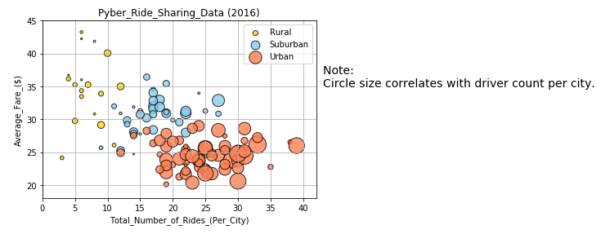

## More Drivers in Urban Area – Density, High Cost of Living

* The data clearly indicates that there is a higher percentage of drivers in urban area than there are in rural or suburban areas. The most plausible explanation for this is that there are more Pyber drivers living in urban areas that use this service. This could also indicate that our Pyber drivers might use the Pyber app to subsides their incomes due to the high cost of living in urban areas.

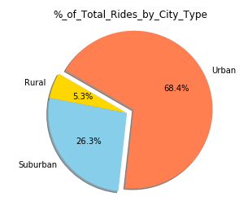

## More Rides in Urban Area

* It seems that our app is most popular in urban areas. Customers living in urban areas used Pyber in 2016 significantly more than customers living in rural areas. The most likely explanation for this is that a higher percentage of people living in urban areas do not own cars or do not drive on a regular basis.

