

WeatherPy

06-Python-APIs Home work

Trong Nguyen | SMUDAL201905DATA | 07/20/2019

# The Equator is Hot

Right off the bat, our Latitude vs. Temperature (Max Temp) plot shows that as one moves closer to the equator, the temperature tends to get hotter. It doesn’t matter if one approaches the equator from the Northern or the South hemisphere, the overall temperature will still continue to increase. If this plot was used for resort developers, it could be a helpful guide to see what type of tourist attractions (beach-like activities or snow-attractions) might be more successful.

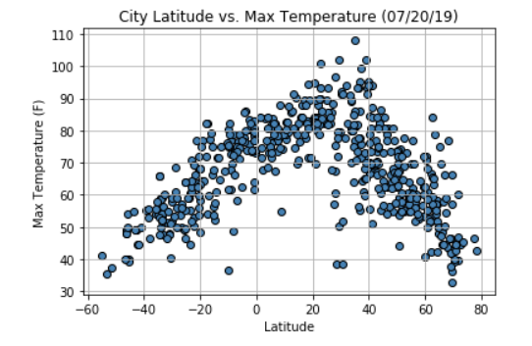

## Wind speed Below 10 mph

From the random cities generated, our analysis shows that wind speeds usually stay below 10 mph. This makes a lot of sense because if the wind speed was consistently high, then it would dramatically effect weather patterns across the globe. This data could be extremely help for NASA or companies that are looking to settle on other planets. One could compare the City Latitude vs. Wind Speed plot on earth with the City Latitude vs. Wind Speed plot on another planet to see if it’s worth settling on.

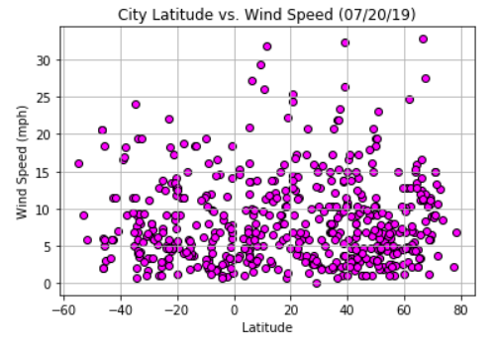

## cloudier in the Northern hempishers

Our analysis shows that there are slightly more clouds generated in the Northern hemispheres than there are in the Southern Hemisphere. We do not have enough data at this time to determine why this is, but it could be due to the tilt of the earth. However, this plot could be perfect for sports companies or the Olympic committee that want to plan for large events that take place outdoors.

