**sdohcc_Condition_FoodInsecurity_1**

**Additional Guidanc****e**

The FHIR Observation, Condition and Goal resources reference one another. Therefore, to support interoperability and analytics, similar approaches have been used in the structured representation of food insecurity observations, conditions and goals.

The diagram below shows the relationship between Observation, Condition and Goal.

An initial Observation (1) is evidence for a Condition (2) that is addressed by a Goal (3) that has an outcome of a later Observation (4).

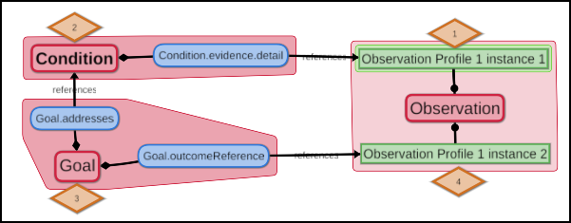

The sections that follow provide additional guidance on 1) specific elements of this profile and 2) efforts to align the profile with the following correlated Observation and Goal profiles:

* sdohcc_Observation_FoodInsecurity_1
* sdohcc_Goal_FoodInsecurity_1

**Condition.evidence**

To align this food insecurity condition with the food insecurity observation that supports it, this element is constrained to Condition.evidence.detail which, in turn, is constrained to reference only sdohcc_Observation_FoodInsecurity_1.

**Condition.code**

This element references sdohcc_ValueSet_FoodInsecurity_1. This value set contains the SNOMED CT codes listed below.

|  |  |
| --- | --- |
| Code | Display |
| 733423003 | Food insecurity (finding) |
| sdohcc-sctt-21000243108 | Mild food insecurity (finding) |
| sdohcc-sctt-31000243105 | Moderate food insecurity (finding) |
| sdohcc-sctt-41000243104 | Severe food insecurity (finding) |

1. This value set is also used for:

* Observation.code in sdohcc_Observation_FoodInsecurity_1

The consistent use of similar codes for a condition and an observation referenced as evidence for that condition will facilitate analytics and interoperability between Condition and Observation.

Example:

* sdohcc_Condition_FoodInsecurity_1 modeled with:
  + Condition code = Mild food insecurity

aligns with the observation that this condition references (via Condition.evidence.detail):

* sdohcc_Observation_FoodInsecurity_1 modeled with:
  + Observation code = Mild food insecurity
  + Observation value = Known present

1. The Food insecurity (finding) code in this value set is also used as the value for:

* Goal.target.measure in sdohcc_Goal_FoodInsecurity_1

The consistent use of similar codes for a condition and a goal that addresses that condition will facilitate analytics and interoperability between Condition and Goal.

Example:

* sdohcc_Condition_FoodInsecurity_1 modeled with:
  + Condition code = Food insecurity

aligns with the goal that address this condition (via Goal.addresses):

* sdohcc_Goal_FoodInsecurity_1 modeled with:
  + Goal description: Food security

and

* + Goal target measure = Food insecurity
  + Goal target detail = Known absent

**Condition.severity**

This element is prohibited.

In lieu of a value set of food insecurity codes with precoordinated severities, this profile could have allowed only “Condition.code = Food insecurity” and represented severity using Condition.severity. However, the FHIR Observation Resource does not provide a separate element for modifying the severity of Observation.code. Therefore, Observation.code for sdohcc_Observation_FoodInsecurity_1 uses a value set of food insecurity codes that have precoordinated severity. To enable consistency across the Observation and Condition profiles, Condition.code and Observation.code use the same value set and Condition.Severity is prohibited.

**Condition.onset**

This element is constrained to “Period”.Similar to the constraint for Observation.effective for sdohcc_Observation_FoodInsecurity_1, “Date” is not allowed for Condtition.onset.

Observation.effective is constrained to “Period” because, unlike some observations (e.g., a seizure, body weight, etc.) that occur at a point in time, the observation of “Food insecurity” is about a state that is present over an extended period of time (e.g., the past month, year, etc.). Similarly, Condition.onset constrains the onset of the condition of “Food insecurity” to occur over a period of time (e.g., the past month, year, etc.) as opposed to at a point in time.

**Condition.abatement**

This element is constrained to “Period” or “Date”.Although“Date” is not allowed for Condition.onset for the reasons stated above, “Date” is allowed for Condition.abatement because the condition of food insecurity could end at a specific point in time (e.g., the day a paycheck from a new job arrives or access to meals in a food program starts).