**SDOHCC_Goal_FoodInsecurity_1**

**Additional Guidance**

The FHIR Observation, Condition and Goal resources reference one another. Therefore, to support interoperability and analytics, similar approaches have been used in the structured representation of food insecurity observations, conditions and goals.

The diagram below shows the relationships between Observation, Condition and Goal.

An initial Observation (1) is evidence for a Condition (2) that is addressed by a Goal (3) that may have an outcome of a later Observation (4).

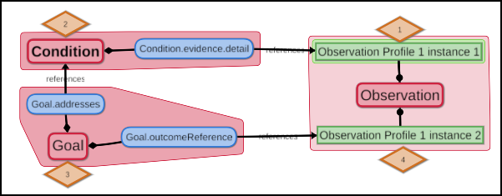

The sections that follow provide additional guidance on 1) rules to improve the integrity of data generated by this profile, 2) specific elements of this profile, and 3) efforts to align the profile with the following correlated Condition and Observation profiles:

* SDOHCC_Condition_FoodInsecurity_1
* SDOHCC_Observation_FoodInsecurity_1

**Goal.description**

This element references the SNOMED CT code below.

|  |  |
| --- | --- |
| Code | Display |
| sdohcc-sctt-91000243106 | Food security (finding) |

**Goal.target**

**Goal.target.measure**

This element references the SNOMED CT code below.

|  |  |
| --- | --- |
| Code | Display |
| 733423003 | Food insecurity (finding) |

Food insecurity (finding) is also a member of sdohcc_ValueSet_FoodInsecurity_1 which is used for:

* Observation.code in SDOHCC_Observation_FoodInsecurity_1
* Condition.code in SDOHCC_Condition_FoodInsecurity_1.

The consistent use of similar codes for a condition and a goal that addresses that condition will facilitate analytics and interoperability between Condition and Goal.

Example:

* SDOHCC_Condition_FoodInsecurity_1 modeled with:
  + Condition code = Food insecurity

aligns with the goal that address this condition (via Goal.addresses):

* SDOHCC_Goal_FoodInsecurity_1 modeled with:
  + Goal description: Food security

and

* + Goal target measure = Food insecurity
  + Goal target detail = Known absent

**Goal.target.detail**

This element references the SNOMED CT code below.

|  |  |
| --- | --- |
| Code | Display |
| 410516002 | Known absent (qualifier value) |

Known absent (qualifier value) is also a member of sdohcc_ValueSet_ContextValue_1 which is used for:

* Observation.value in SDOHCC_Observation_FoodInsecurity_1

The consistent use of similar codes for a goal and an observation referenced as an outcome for that goal will facilitate analytics and interoperability between Observation and Goal.

Example:

* SDOHCC_Goal_FoodInsecurity_1 modeled with:
  + Goal description: Food security

and

* + Goal target measure = Food insecurity
  + Goal target detail = Known absent

aligns with the observation that this goal references (via Goal.outcomeReference):

* SDOHCC_Observation_FoodInsecurity_1 modeled with:
  + Observation code = Food insecurity
  + Observation value = Known absent

The observation “Food insecurity = known absent” implies that all states of food insecurity (including mild, moderate and severe) are absent. This clearly establishes that the patient is not in a food insecure state (e.g., equates to “Food security = known present”) in support of Goal.achievementStatus = Achieved.

**Goal.addresses**

To align this food insecurity goal with the food insecurity condition that it addresses, this element references SDOHCC_Condition_FoodInsecurity_1.

Since a food security goal might also reference related service requests and additional conditions, this element also references ServiceRequest and US Core Condition. Overtime, these references may also be constrained to specific profiles in the SDOH CC IG (e.g., a BSer Service Request profile).

**Goal.outcomeReference**

To align this food insecurity goal with the food insecurity observation that it references as an outcome, this element is constrained to reference only SDOHCC_Observation_FoodInsecurity_1.

**Additional rules**

To improve data integrity, the following rules should be applied to this profile:

1. If Goal.description and/or Goal.target are changed, a new Goal instance MUST be created.

This rule is not specific to this food insecurity goal. For any goal, a change to these elements essentially results in a different goal.

1. Goal.statusDate MUST be updated if and ONLY if Goal.achievementStatus is updated.

The Goal resource does not clearly specify whether Goal.statusDate applies to Goal.achievementStatus or to Goal.lifecycleStatus. To unambiguously establish when a goal has been achieved, Goal.statusDate MUST be synchronized with Goal.achievementStatus.

1. An update to Goal.achievementStatus MUST be supported by an update to Goal.outcomeReference.

This rule is not specific to this food insecurity goal. Any goal should be required to update Goal.outcomeReference as evidence for a change in Goal.achievementStatus.