Creating MongoDB Indexes
Name: Zedekiah Heteroza
Student ID: 24-0521-842

Step 1: Database Setup
use mydatabase
db.createCollection("products")

db.products.insertMany([
{ name: "Laptop", category: "Electronics", price: 1200, tags: ["new", "featured"] },
{ name: "Smartphone", category: "Electronics", price: 800, tags: ["popular", "sale"] },
{ name: "T-shirt", category: "Clothing", price: 25, tags: ["new", "discount"] },
{ name: "Jeans", category: "Clothing", price: 75, tags: ["popular"] },
{ name: "Coffee Maker", category: "Appliances", price: 100, tags: ["new"] },
{ name: "Blender", category: "Appliances", price: 50, tags: ["sale"] },
{ name: "Tablet", category: "Electronics", price: 300, tags: ["featured"] },
{ name: "Dress", category: "Clothing", price: 60, tags: ["discount"] },
{ name: "Microwave", category: "Appliances", price: 150, tags: ["popular"] },
{ name: "Headphones", category: "Electronics", price: 120, tags: ["new", "sale"] }
])

Step 2: Query Performance Without Index
db.products.find({ category: "Electronics"}).explain("executionStats")
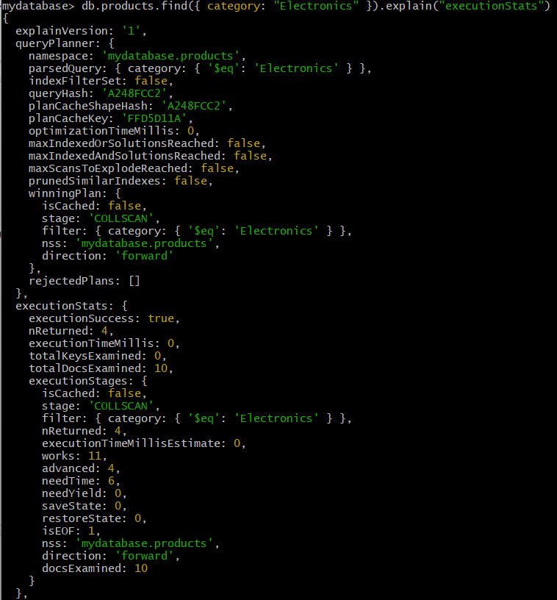
Before indexing, MongoDB performed a collection scan (COLLSCAN), meaning all documents were checked. This resulted in a zero-millisecond execution time and more documents examined.

Step 3: Single Field Index
db.products.createIndex({ category: 1 })

Step 4: Query With Single Index
db.products.find({ category: "Electronics" }).explain("executionStats")
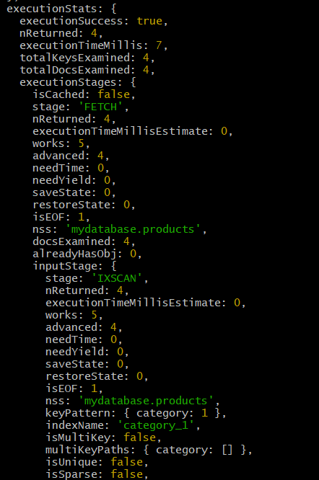
After creating the index, MongoDB used IXSCAN instead of COLLSCAN. The number of documents examined significantly decreased, and execution time remained at zero ms, showing improved performance.

Step 5: Compound Index
db.products.createIndex({ category: 1, price: 1 })

Step 6: Compound Query Performance
db.products.find({
category: "Electronics",
price: { $gt: 500 }
}).explain("executionStats")
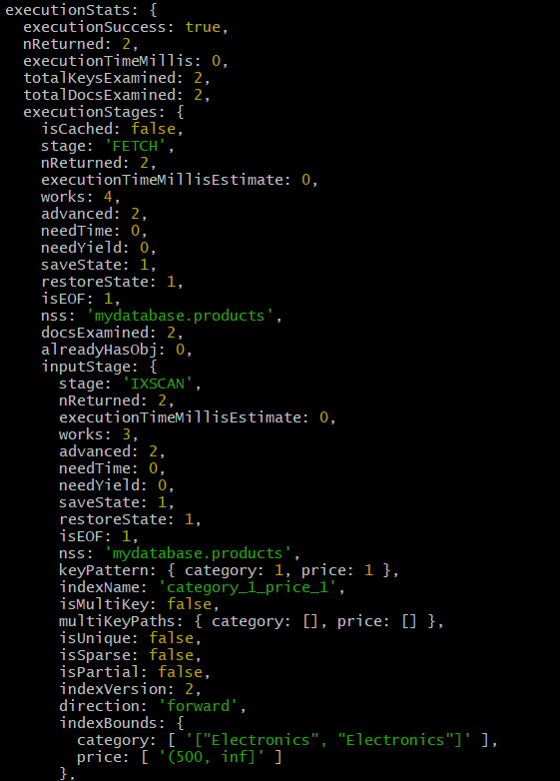
The compound index improved performance further by allowing MongoDB to filter using both category and price simultaneously, reducing scanned documents.

Step 7: Multi-Key Index (Array Field)
db.products.createIndex({ tags: 1 })

Step 8: Query Using Multi-Key Index
db.products.find({ tags: "new" }).explain("executionStats")
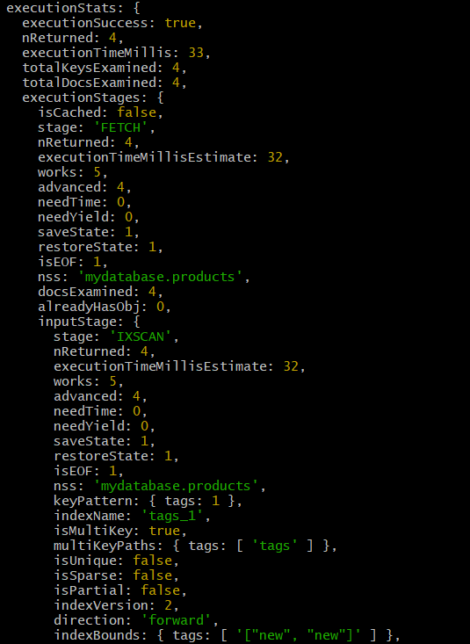
The multi-key index improved query performance for array searches by allowing direct lookup of array values instead of scanning all documents.

Step 9: List and Drop Indexes
db.products.getIndexes()
db.products.dropIndex("category_1")
db.products.dropIndexes()
