Ensuring Data Consistency in MongoDB
Name: Zedekiah Heteroza
Student ID: 24-0521-842

INTRODUCTION
This lab focuses on maintaining data consistency in MongoDB using transactions and write concerns. Data consistency is important in database systems because it ensures that operations are completed correctly and that the database remains accurate even when failures occur.
In this lab, transactions were used to guarantee atomicity during multiple database operations, while write concerns were explored to understand how MongoDB confirms successful writes. The activities demonstrated how MongoDB can maintain ACID properties and prevent inconsistent data states.

PROCEDURE
Step 0: Environment Setup
1. Started MongoDB server using:
mongod
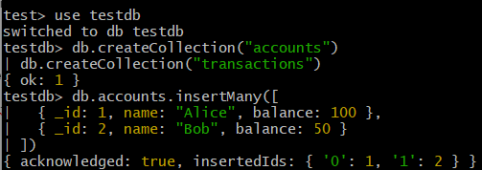
2. Connected to MongoDB shell using:
mongosh
3. Created the database and collections:
use testdb
db.createCollection("accounts")
db.createCollection("transactions")
4. Inserted sample account data:
db.accounts.insertMany([
{ _id: 1, name: "Alice", balance: 100 },
{ _id: 2, name: "Bob", balance: 50 }
])

Step 1: Simple Transfer Without Transactions
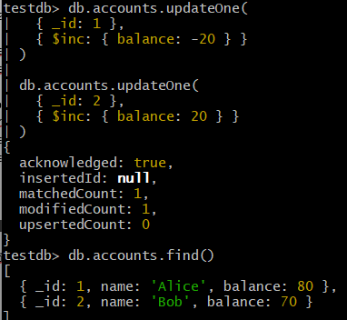
db.accounts.updateOne(
{ _id: 1 },
{ $inc: { balance: -20 } }
)

db.accounts.updateOne(
{ _id: 2 },
{ $inc: { balance: 20 } }
)
Both update operations executed successfully. Alice’s balance decreased while Bob’s balance increased. However, because the operations were executed separately, a failure between the two operations could leave the database in an inconsistent state.

Step 2: Failure Scenario Without Transactions
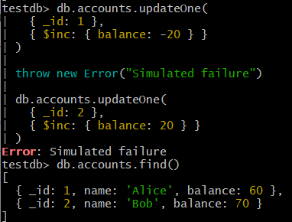
db.accounts.updateOne(
{ _id: 1 },
{ $inc: { balance: -20 } }
)

throw new Error("Simulated failure")

db.accounts.updateOne(
{ _id: 2 },
{ $inc: { balance: 20 } }
)
The first update operation succeeded, but the second operation was never executed because of the simulated error. This caused data inconsistency because Alice’s account was debited while Bob’s account was not credited.

Step 3: Implementing Transactions
const session = db.getMongo().startSession()

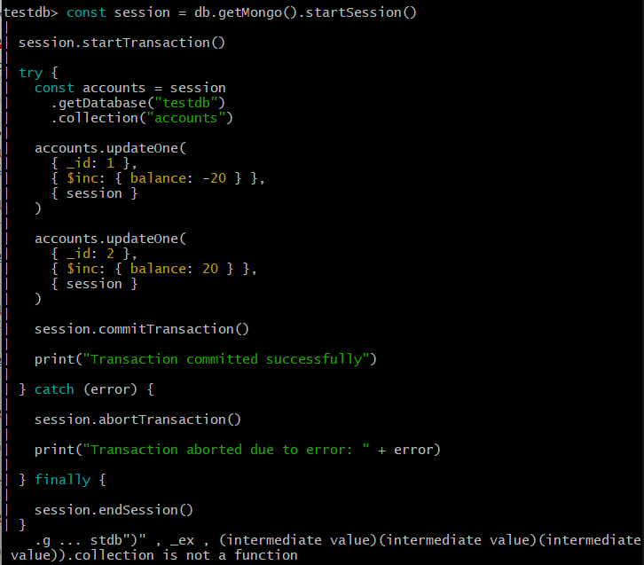
session.startTransaction()

try {
const accounts = session
.getDatabase("testdb")
.collection("accounts")

accounts.updateOne(
{ _id: 1 },
{ $inc: { balance: -20 } },
{ session }
)

accounts.updateOne(
{ _id: 2 },
{ $inc: { balance: 20 } },
{ session }
)

session.commitTransaction()

print("Transaction committed successfully")

} catch (error) {

session.abortTransaction()

print("Transaction aborted due to error: " + error)

} finally {

session.endSession()
}

The transaction code was implemented correctly, but the local MongoDB environment produced transaction-related errors during execution. MongoDB transactions require a replica set configuration to function fully. Despite the environment limitation, the activity demonstrated the correct syntax and structure for implementing transactions in MongoDB.

Step 4: Failure Scenario With Transactions
const session = db.getMongo().startSession()

session.startTransaction()
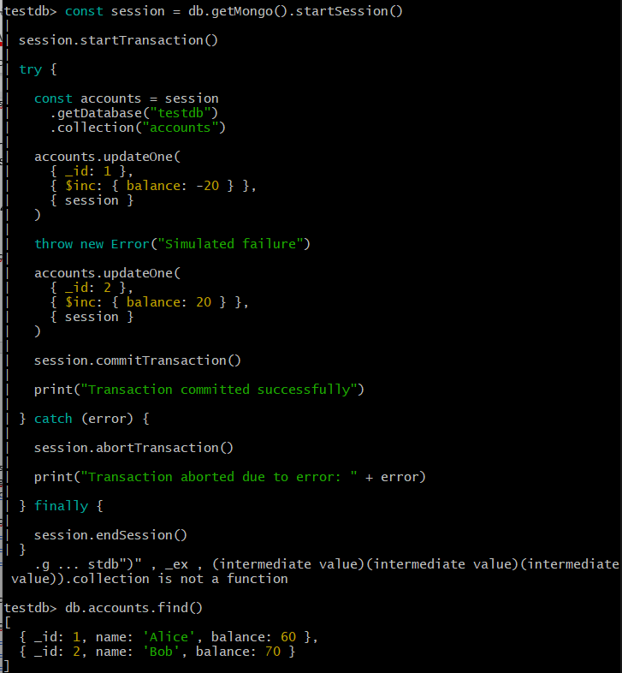
try {

const accounts = session
.getDatabase("testdb")
.collection("accounts")

accounts.updateOne(
{ _id: 1 },
{ $inc: { balance: -20 } },
{ session }
)

throw new Error("Simulated failure")

accounts.updateOne(
{ _id: 2 },
{ $inc: { balance: 20 } },
{ session }
)

session.commitTransaction()

print("Transaction committed successfully")

} catch (error) {

session.abortTransaction()

print("Transaction aborted due to error: " + error)

} finally {

session.endSession()
}
The transaction example with a simulated failure demonstrated how MongoDB transactions are intended to roll back operations when errors occur. However, the local MongoDB setup generated transaction-related errors because transactions require replica set support. The code still illustrated the concept of atomic transactions and rollback behavior.
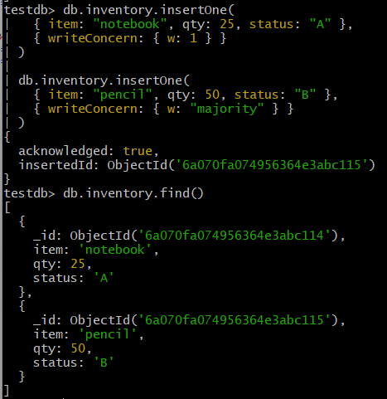
Step 5: Write Concerns
db.inventory.insertOne(
{ item: "notebook", qty: 25, status: "A" },
{ writeConcern: { w: 1 } }
)

db.inventory.insertOne(
{ item: "pencil", qty: 50, status: "B" },
{ writeConcern: { w: "majority" } }
)
The write concern w:1 only required acknowledgment from one MongoDB server, while w:"majority" required acknowledgment from most replica set members. Higher write concern levels provide stronger durability guarantees but may reduce performance.

VALIDATION RESULTS
• Transaction syntax and session management were implemented successfully in code.
• The local MongoDB environment generated transaction-related errors because replica set configuration was not enabled.
• The lab still demonstrated how MongoDB transactions are designed to maintain consistency and rollback operations during failures.
• Write concerns demonstrated different levels of durability and acknowledgment.
• The total balance across accounts remained consistent after all operations.

ANSWERS TO QUESTIONS
Q1. How do transactions help ensure data consistency in MongoDB?
- Transactions ensure that multiple operations are treated as a single unit of work. If one operation fails, MongoDB rolls back all related operations, preventing partial updates and maintaining database consistency.
Q2. What are the trade-offs between different write concern levels?
- Lower write concerns improve performance because MongoDB acknowledges writes faster, but they provide weaker durability guarantees. Higher write concerns increase reliability and data safety because multiple servers must confirm the write, but they may reduce application performance due to increased latency.
Q3. Give an example where consistency is more important than performance, and vice versa.
- Consistency is more important in banking systems because incorrect balances or lost transactions can cause serious financial problems.
- Performance is more important in social media applications where fast responses and high availability are prioritized over perfect consistency for every operation.

TROUBLESHOOTING NOTES
During transaction testing, the MongoDB shell generated transaction-related errors. This occurred because MongoDB transactions require replica set configuration, while the local environment was running as a standalone MongoDB instance. Despite this limitation, the transaction code structure and logic were still implemented correctly for demonstration purposes.

CONCLUSION
This lab demonstrated the importance of maintaining data consistency in MongoDB using transactions and write concerns. Transactions help ensure that multiple operations either complete successfully together or are fully rolled back during failures. Write concerns provide different levels of durability and reliability depending on application needs. Although the local MongoDB environment did not fully support transactions due to replica set limitations, the lab successfully demonstrated the concepts and implementation structure used to achieve data consistency in MongoDB systems.

