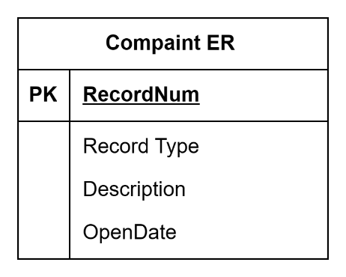

The "Complaint" entity is designed to store information about various complaints received by a system or organization. Each complaint is uniquely identified by its RecordNum, which serves as the primary key. This ensures that each complaint record is distinct within the table.

The RecordType attribute provides information about the type of complaint, helping to categorize and classify different kinds of issues. For example, it distinguishes between complaints related to construction, land use, or other categories.

The Description attribute allows for a more detailed explanation of the reported issue. It may include information provided by the person reporting the complaint.

The OpenDate attribute records the date when the complaint was opened, providing a timestamp for when the issue was reported.

In summary, the "Complaint" entity captures essential information about complaints, including unique identifiers, types, descriptions, and timestamps, to facilitate tracking and management of reported issues.

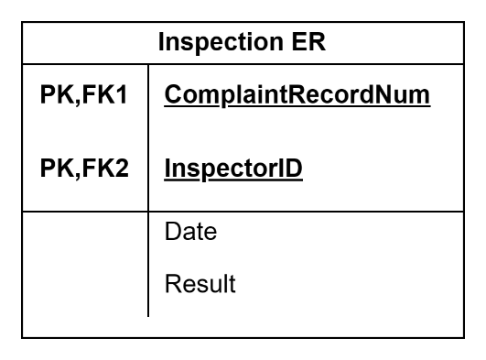

The "Inspection" entity is designed to store information related to inspections carried out in response to complaints. Each inspection is uniquely identified by its InspectionID, serving as the primary key for the table.

The ComplaintRecordNum attribute is a foreign key that establishes a relationship between the "Inspection" and "Complaint" entities. It links to the primary key RecordNum in the "Complaint" entity, indicating which complaint the inspection is associated with.

The InspectorID attribute is another foreign key, linking to the primary key InspectorID in the "Inspector" entity. This connection indicates which inspector conducted the inspection.

The Date attribute records the date when the inspection occurred, providing a timestamp for when the assessment took place.

The Result attribute captures the outcome or findings of the inspection, providing information about whether the reported issue was resolved, the level of compliance, or any other relevant details.

In summary, the "Inspection" entity facilitates the tracking and management of inspections, associating them with specific complaints, inspectors, and recording key details such as the inspection date and results.