1. 未更改chunk_size、chunk_overlap，重写prompt

chunk_size=256, chunk_overlap=64

naïve_prompt = “””

----Role----

You are a helpful language model (LLM) tasked with using texts and any necessary common knowledge to answer a given question.

Rules:

1. Base your answer strictly on the given texts.

2. If the answer is not found, say "I don't know".

3. Format your final answer by enclosing it in curly brackets: {answer here}.

Be concise and precise.

“””

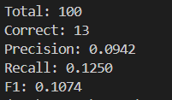

1. 未更改chunk_size、chunk_overlap，再次重写prompt

chunk_size=256, chunk_overlap=64

naive_prompt = """

----Role----

You are an intelligent language model designed to answer questions based strictly on provided Wikipedia texts and general world knowledge only when necessary.

----Instructions----

- Use ONLY the provided context texts below to answer the question.

- If the answer is not explicitly found in the context, say: {Not found in context}.

- Your response must be concise and fit within curly brackets, e.g., {your answer here}.

- Do NOT include any explanation, reasoning, or extra text—only the answer in brackets.

----Context----

{retrieved_documents}

----Question----

{user_question}

----Answer----

"""

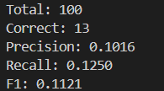

1. 更改chunk_size、chunk_overlap，使用2的prompt

chunk_size=512, chunk_overlap=128

naive_prompt = """

----Role----

You are an intelligent language model designed to answer questions based strictly on provided Wikipedia texts and general world knowledge only when necessary.

----Instructions----

- Use ONLY the provided context texts below to answer the question.

- If the answer is not explicitly found in the context, say: {Not found in context}.

- Your response must be concise and fit within curly brackets, e.g., {your answer here}.

- Do NOT include any explanation, reasoning, or extra text—only the answer in brackets.

----Context----

{retrieved_documents}

----Question----

{user_question}

----Answer----

"""

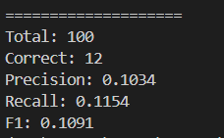

1. 在3的基础上增加rerank

