Methods
In this section we describe the main experimental setup we defined to explore the Aggression Identification task. Also the methods we used during this experimental setup, such as data preprocessing, vector space modeling and learning machines.

Experimental setup

Our experimental setup consists of two stages. During the fisrt stage we explored Aggression Identification by detecting each level of aggression separately. That is, as a One-Versus-Rest classification problem. In this way, we can observe the behavior of different levels of aggression separately. To this end, we tested a number of well-know text representation methods. Furthermore, we used a state-of-the-art method for sentence representation which is based on word embeddings and importance weighting. The first well-known representation method was simple Bag-of-Words (BoW), which consists in representing an input document (social network posts in our case) uniquely as a vector of frequencies of the words it contains. Each dimension of that vector maps to each word type in the vocabulary of the corpus (in practice we used an memory-optimized version of this method called Hashing, which helped us to accelerate all our experiments). The second text representation method we used is called TF—IDF (Term Frequency—Inverse Document Frequency). This text representation method measures the “importance” of a word from three points of view. In addition we also applied the Latent Semantic Analysis transform, which is ised to obtain a compacted and recombined version of TF—IDF. This method, although proposed long time ago, is difficult to beat in text classification tasks.

Vector Space Modeling
TF—IDF consists in estimating the probability of a word of being observed in observed in the whole corpus; the second one comes from estimating the probability of a word of being observed within a subset of documents dealing with similar topics. And the third point of view comes from the absence or presence of that particular word in a particular document. This description can be summarized in Eq. (1) :

whereis the TF—IDF matrix, and each of its row represents a document and its columns map to a word of the vocabulary . The number of documents where the word can be observed is . The total amount of documents is , so it is a constant.

In addition, we used a second transformation which is also well-known in text representation literature. This is the Singular Value Decomposition (SVD) method. This method can be applied to the TF—IDF matrix in order to obtain a set of eigenvectors that can be seen as latent variables behind groups of documents with similar contents, i.e.

The successive projections of the original TF--IDF vectors ofonto theeigenvectors ofproduces low approximationsof these original vectors. Each of these approximations are dense as its dimensions are linear combinations of all other original dimensions. Therefore, if the distribution of dimensions of a group of transformed documents inis centered at some eigenvector, then the documents of this group share similar meanings. Thus, this transformation method is commonly called Latent Semantic Analysis (LSA).

Regarding the state-of-the-art method we used, it is on a easy to implement one that consists in representing a document as a weighted sum of word embeddings. The weights of the embeddings are computed by using the TF—IDF transform. That is,

where is the importance weight of the i-th word contained in the j-th document . The word embedding is . Notice that is each cell of matrix in Eq. (1).

Currently vector space modeling on text data has been progressing rapidly. Most methods are based purely on neural networks. Therefore, several well know methods have emerged for representation of very short text snippets, including sentences. There exists some of them that are easy-to-use, but we selected the weighted sum method as it was shown that it is much more robust and comprehensive, although not too popular.

Learning Machines

Naïve Bayes

In this paper we tested a number of well-known learning algorithms. The first one is Naïve Bayes, which is very popular in text classification tasks. This algorithm performs a first learning step by estimating the likelihood of seeing the document as being of a given aggression level . This likelihood is denoted as. The Bayes theorem then is used to estimate the probabilityof predicting that a test document to express the aggression level . That is:

where is the probability of seeing the aggression level in the training set and is the probability of the document in the training set.

Results
Baseline embeddings

Under the hypothesis of that the classifiers behave different for different levels of aggression we decided to classify them in an OVR (One-Versus-Rest) fashion. The case that we expected much more interesting was the CAG class of aggressions. This is because it can be associated with sarcasm detection, which is an open problen in NLP. The main difficulty of CAG identification is that, similarly to sarcasm detection, this class of aggressions can be expressed in such a way that syntactic, lexical, semantic and, more importantly, pragmatic ambiguity are present in the text. In the Figure <> we show results of accuracy for the three classes of aggressions (OAG, CAG, NAG) by using four state of the art classifiers as well as two baseline embedding methods, i.e. Hansing and TF—IDF. In order to observe how the amount of training samples influence the accuracy of the classifiers, we plotted the accuracy as a function of the amount of training samples (from the whole training set). The accuracy was measured on the development dataset.

The results show that Naïve Bayes, Passive Aggressive and linear SGD classifiers generalize in similar ways. However, the Perceptron showed to be a bit unstable and performs the worst. In most cases, the classifiers attained relatively stable performance after 5000 training samples. In this sense, with respect to NAG and CAG, identifying OAG aggressions represented much less complexity as a classification problem (2000-3000 TF—IDF-transformed samples were required by classifiers to stabilize their performance). Contrarily, identifying CAG resulted in a much more complex task for the classifiers. Perceptron was again the worst while Naïve Bayes and linear SGD performed better, but barely surpassed 65% accuracy. Detecting NAG aggressions required much more samples to allow the classifiers to be relatively stable. Furthermore, it was hard for the classifiers to reach 73-74% of accuracy. Overall TF—IDF representations allowed the classifiers to be much more stability than Hassing did.

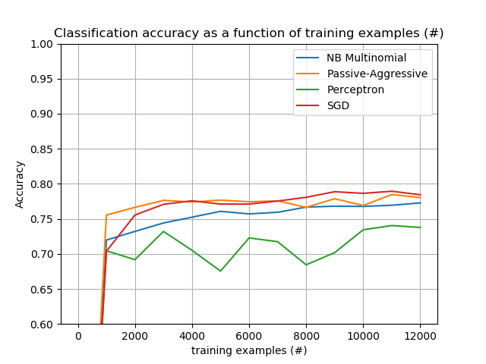
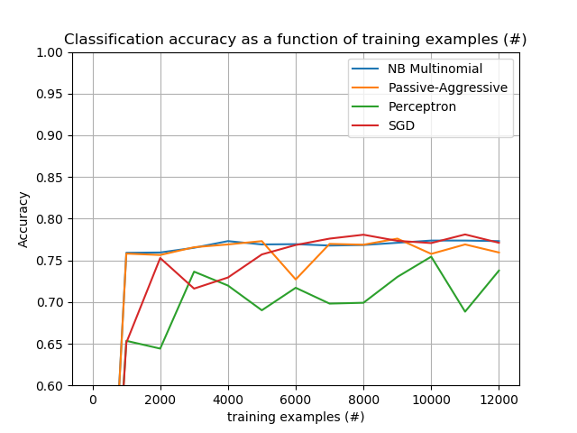
OAG-TFIDF
OAG-Hashing

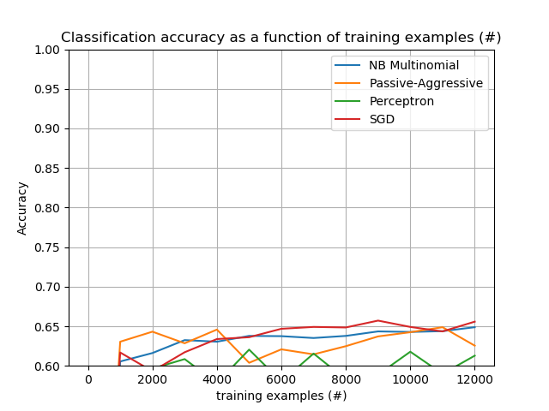
CAG-Hashing
CAG-TFIDF
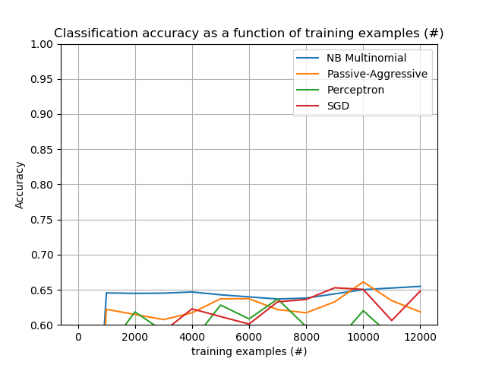

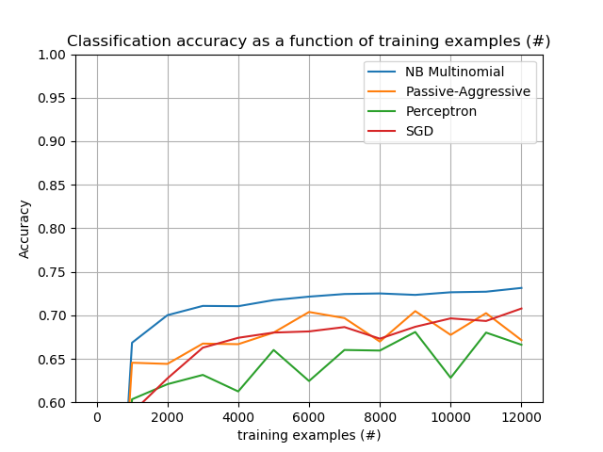
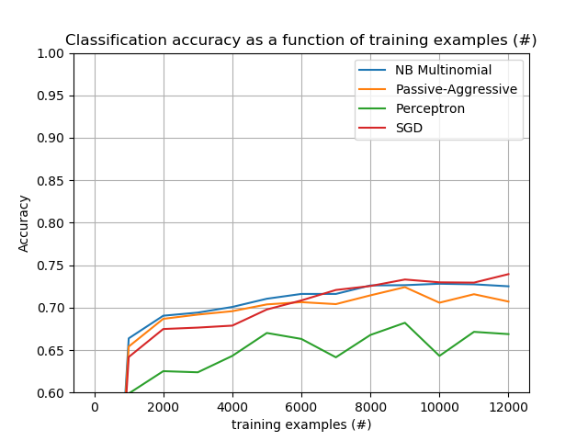
NAG-Hashing
NAG-TFIDF

Two additional experiments were conducted for analyzing baseline embeddings on CAG detection in more detail. On the one hand, we used Singular Value Decomposition (SVD) for dimensionality reduction on the word-based TF—IDF representations of the posts. Although a number of dimensionalities were tested (50, 100, 200, 300, 400), this modification neither showed improvements with respect to sparse TF—IDF representations reported above. On the other hand, we segmented documents into character n-grams before embedding them into TF—IDF representations. Surprisingly the classification accuracy was much better (+10%). The Passive-Agressive and linear SGD classifiers attained about 70% accuracy by segmenting the input posts into a range of (1-5)-grams of characters. To observe this performance, more than 9000 samples were needed (See Figure <>). Other n-gram ranges did not perform better (e.g. 2-5, 3-5, 1-6, 2-6, etc).

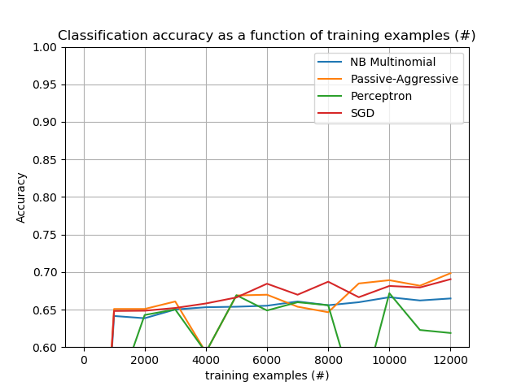
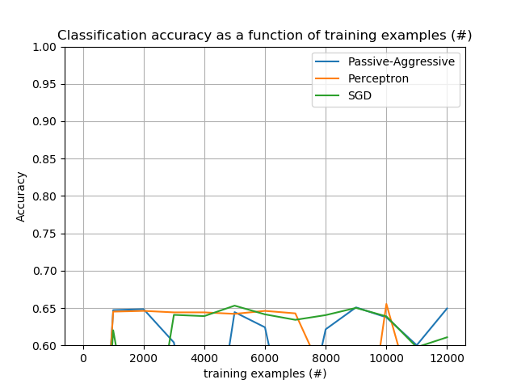
CAG-TFIDF-SVD
CAG-charTFIDF

State of the Art sentence embeddings

In the NLP literature there are reported a number of text embedding methods at the sentence level. Among the State of the Art methods there is an easy to use one which uses a combination of word embeddings weighted with TF—IDF (Word Information Series for Sentence Embedding, WISSE). The used word embeddings were FastText of 300 dimensions [ref], which have been reported as well-performed in sentence representation for Semantic Textual Similarity tasks [ref]. Even when these embeddings showed State of the Art performance in STS, their performance in aggression identification was not better than the baseline methods presented in this work (see Figure <>). The behavior of classifiers with this sentence embedding method showed much more unstable and the performance diminished by 5% average with respect to the TF—IDF sparse representations. Although the sparse representations are high dimensional (thousands of dimensions), most State of the Art classifiers are prepared to deal efficiently with this issue. Thus, sparse representations are high dimensional, but 5% or less of their entries are nonzero which allows the classifier working with 100 or less nonzero entries. Conversely, sentence embeddings based on word embeddings are of 300 dense dimensions, which adds complexity to the learning problem. Furthermore, the original purpose of sentence embeddings is to represent an approximation of sentence semantics, which can be a much more complex task than that of aggression identification. Therefore, this additional complexity of the representations can lead to overfitting of the classifiers.

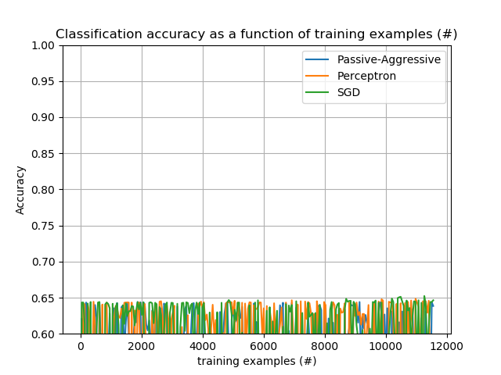
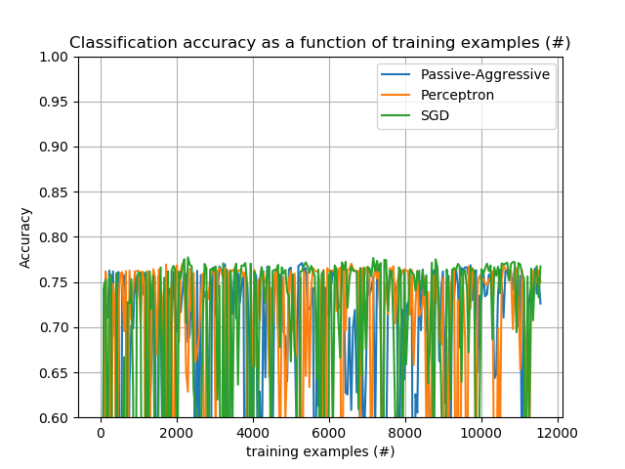
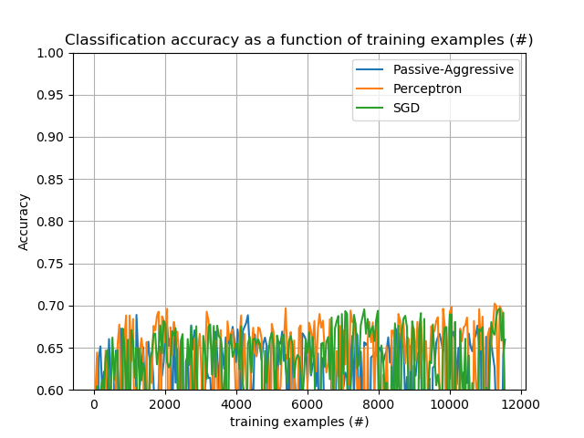
CAG-WISSE
OAG-WISSE
NAG-WISSE

