Sasan Ghoraishi
45 San Marino Irvine, CA 92614 Phone: 001- (949) 3331680 Email: sghoraishi@yahoo.com

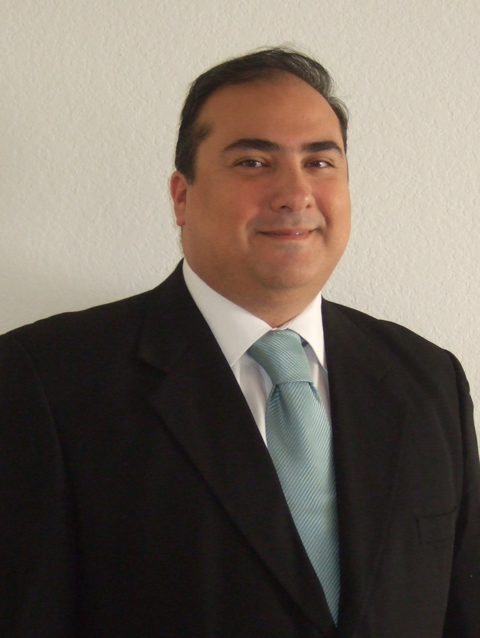

OBJECTIVE: To secure an ESL teaching position in Latin America

HIGHLIGHT OF QUALIFICATION:

- Fluent in Spanish
  - Twenty years experience in Management & Education including, private one-on-one English & Spanish conversation, leading group instruction, and bilingual tutoring.
- Experience living, working and traveling in many parts of the world.

EDUCATION:

Advanced TESOL Certificate (120 hours) October 2010
TESOL Training International
San Diego, CA U.S.A

Master of Science in International Business February 2000
Columbus University
New Orleans, LA U.S.A

Bachelors of Art in Spanish February 1993
University of Houston
Houston, TX U.S.A

RELATED EXPERIENCE:

Private English Teacher, Self Employed January 2010 - Present
Irvine, CA U.S.A

- Create personalized lesson plans.
- Focused on conversational English.
- Taught grammar and pronunciation.

Translation & Interpretation in English, Excel Interpreting, LLC January 2010 - Present
Sacramento, CA U.S.A

- Translate the documents from Spanish to English & English to Spanish.
- Interpret simultaneous from Spanish to English & English to Spanish.

Private & Tutor English Teacher, Self Employed May 2007 – October 2009
Houston, TX U.S.A

- Taught grammar, pronunciation, and conversation.
- Focused on new methodology, and lesson plans for adult students.
- Lesson plans for Beginners and Elementary students.

Assistant English Teacher, International Languages Institute March 2004 – December 2006
Houston, TX U.S.A

- Helped organize daily planning for class sessions.
- Graded homework assignments, papers, and tests.
- Encouraged conversation through creative games.

Bilingual Teaching Assistant , Rose Elementary School April 2000 – August 2003
Houston, TX U.S.A

- Special education for Elementary students to adopt the English language.
- Conversation with new students in Spanish before and after the lessons.
- Provided additional support to struggling students in English.

