Resumé – Leandri Crouse

Personal Details

Name: | Leandri Crouse |  |  | 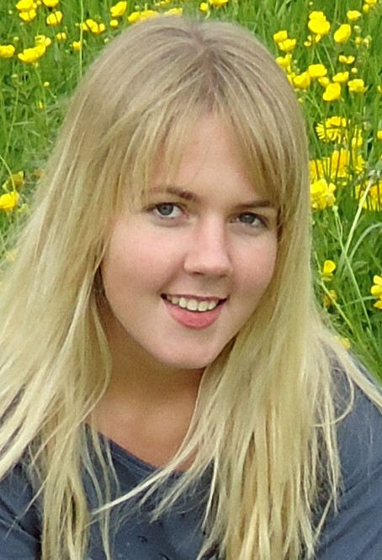
Address: | Allweg 4  6372 Ennetmoos  Nidwalden  Switzerland
Tel (home): | +41 41 610 0993
Tel (mobile): | +420 737 191 885
e-mail: | leacro92@gmail.com
Marital Status: | Unmarried
Health: | Excellent
Gender: | Female
Age | 18 years (DOB: 4 July 1992)
Nationality: | South African
Formal Education

Cornwall Hill College, South Africa (2010)  www.cornwall.co.za |  | Independent Examination Board – Grade 12  Main Subjects and (Symbol achieved):
 |  | English (A)  French (A)  Afrikaans (A) | Mathematics (B)  Accounting (C)  Physical Science (C)
ITTP TEFL Prague  (May 2011)  www.tefl-prague.com |  | International TEFL/TESOL Certification Course (Onsite)  Experience in advanced one-on-one teaching, elementary in-school teaching and small groups of pre-intermediate, intermediate and upper-intermediate teaching.
Relevant Experience

Swiss Schools | Attended German medium schools from April 2007 till December 2008 in Stans and Lucerne, Switzerland
Waitress | Part-time waitress experience in restaurant during 2009
Global Vision International (GVI)  www.gvi.co.uk | Volunteered as Grade 1 teacher for GVI community project in Estelí, Nicaragua for 3 months (January 2011 till March 2011)  Responsibilities included: lesson planning, setting long and short term goals, writing reports on the progress of the kids, teaching a group of between 6-30 children for five hours a day in Spanish. Attended 40 hours of Spanish classes during this period.
Languages, IT, and Other

Languages | English (First Language)  Afrikaans (fluent) , French (intermediate), German (fluent), and Spanish (elementary)
Computer Skills | Competent in Microsoft Software such as Windows, Word, Excel, and Power Point
Hobbies and Interests | Travelling, Music, and Reading
References | Available on request

