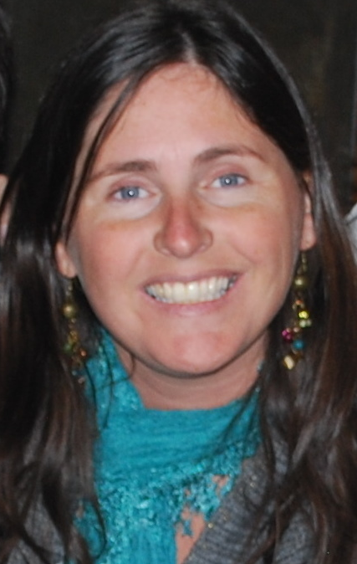
CURRICULUM VITAE
Cynthia Wilkinson

Personal Information

Date of Birth: August 11th, 1980
Nationality: Argentine
Marital Status: Single
Address: Av. Cristóbal Colón 5185, depto. 179, Las Condes
Mobile Number: 6261-0370
Email Address: cynwilkinson@gmail.com

Objetive: To contribute to a school that can use an enthusiastic young educator, who offers experience in the teaching of English to foreigners, as well as in the development of quality lesson plans, and who possesses excellent communication, organizational and motivational skills.

Relevant Working Experience

- CEP School of English – Fagnano 861, Río Grande, Tierra del Fuego, Argentina
February 2007 – January 2012
Coordinator of the Higher Levels (pre-intermediate through advanced)
Teacher of English in courses ranging age (children, teenagers, adults) and level (starter to advanced)
Preparation of International Examinations PET and FCE (University of Cambridge)

- Escuela Nº 21 “Provincias Unidas” – Pref. Naval 111, Río Grande, Tierra del Fuego, Argentina
October 2010 – January 2012
Teacher of English in 1st and 2nd form

- Southern Cross School – Ramal Tigre 2375, San Isidro, Bs. As., Argentina
2004 – 2007
Teacher of English in 3rd form

- Lincoln Hall International School – Olleros 2283, Belgrano, Cdad. Autónoma de Bs. As., Argentina
2000 - 2002
Teacher of English in 1st and 2nd form

Education and Training

Instituto Cultural Argentino Norteamericano Escuela Superior – 3 de Febrero 821, Belgrano, Argentina
Teacher Education College ICANAES
Degree: Teacher of English (gained December 2006)
Average; 9.29

Michael Ham Memorial College – Gaspar Campos 517, Vicente López, Buenos Aires, Argentina
1998-1993 Secondary School

Saint Catherine’s School – Carbajal 3250, Belgrano, Buenos Aires, Argentina
1992-1987 Primary School

Other Work Experience

Rifugio Franz Kostner al Vallon – 2550 mts Corvara, Bolzano, Italy
June – October 2004 / June – October 2003
Babysitter of a three-year old at a hut, placed in the Dolomites Mountains.

Buen Molino Kindergarten – Uruguay 2820, Beccar, Argentina
November – December 2004
Two-month substitute English teacher in Kinder 4

Pilgrims’ College – Ramal Tigre 1860, San Isidro, Argentina
March – May 2004
Auxiliary English teacher in 1st form

Cáritas Argentina – San Vicente, Virreyes, Argentina
March – December 1998
Volunteer work at a Buenos Aires emergency neighbourhood

International examinations sat for:

2005 Test of English for International Communication, Educational Testing Service
1998 Certificate of English International Business and Trade, University of Cambridge
C.E.I.B.T. in Business
1998 Advanced International General Certificate of Education, University of Cambridge
A.I.C.E. in: Literature, Comprehension, Essay Writing and Critical Appreciation.
1997 International General Certificate of Secondary Education, University of Cambridge
I.C.E. in: English as a First Language, Spanish as a First Language, Natural Economy, Literature, Mathematics, Child Development and Art.

Other Interests

- Taking photographs
4th Mention in 2005 Photograph Contest at Universidad CAECE, for the picture “The Boat and the Sea”
- Sailing
Participation in Interschool Regattas representing St Brendan’s College, Argentina

