CURRICULUM VITAE

NAME : Andriette Korb
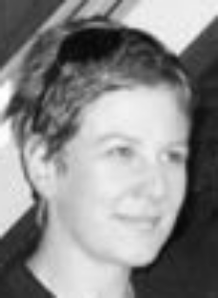
DATE OF BIRTH : 31 December 1973
ADDRESS : PO Box 12987
Leraatsfontein
1038
South Africa
TEL. NO. : 083 621 9429
013 691 1219

E-MAIL : andriette.korb@gmail.com

LANGUAGES : English ( Native Speaker)
Afrikaans ( Native Speaker )
German ( Elementary)

Dutch (Understand )

TEACHING AND RELATED EMPLOYMENT HISTORY

May 2010-Currently : Educational Advisor/ Facilitator
Marketing and facilitating courses in Learning-and Life skills for learners aged 10yr to 21yr. Providing follow up courses and constant assistance.
Courses cover: Reading skills, Writing Techniques, Study methods( eg OQLSC_R), Memorisation techniques, Planning, Problem solving, Communication skills.

South African Memory Institute
HQ Agri-Expo Building
11G Queen St
Durbanville
7550
021 979 2225

August 2003 – June 2005 : EFL Teacher/ Afrikaans Teacher
-Full-time and part-time English classes
-Placement testing
-Elementary level to Advanced level
-Careful and accurate weekly and lesson planning
-Lessons covering all Skills
-Regular testing of students
-Cambridge Exam preparation
-Wide variety of course books and materials used
-Creative and interactive lessons
-± 2000 hours classroom time
-Afrikaans lessons successfully based on TEFL

Language Teaching Centre
Pier House
13 Heerengracht
Cape Town
8000
021 4253585
( Mechtild Braxmaier)

EDUCATION

December 1991 : Matric with University exemption.
Hoogenhout High School
Bethal
Mpumalanga

January 1993-December 1993 : Entertainment Technology ( Theatre Crafts )
Pretoria Technikon
Vermeulen St. Campus
Pretoria

January 2003 : T.E.F.L. / T.E.S.O.L Certificate
One World Language School
37 Strand Street
Cape Town

Course content:
-Placement testing
-TOEFL, IELTS and Cambridge examinations
-Skills: Listening, Reading, Speaking, Pronunciation, Vocabulary and Writing
-The phonetic alphabet
-Lesson planning and presentation
-Materials, course books and teaching aids
-Teaching methodologies
-Teaching practice

