Estrategia Didáctica
Información personal
 | Listening: My friend Lara  Inicio  Se muestra a los/las estudiantes la imagen de la guía de estudio y se realiza un mapa conceptual con las ideas que van surgiendo. La idea es guiar a los/las estudiantes para que sus respuestas estén relacionadas con los temas a tratar en este modulo y los anteriores (people, friends, family, descriptions): Look at the picture, what do you think the audio is going to be about? etc.  Luego se explica a los/las estudiantes que escucharán dos audios. El primer audio corresponde a la historia de una niña llamada Lara y el segundo es sobre una persona que recibió un celular perdido: You are going to listen to two audios. The first one corresponds to a girl called Lara and the second one is about a person who received a lost mobile phone.  Desarrollo*  Se pregunta a los/las estudiantes que tipo de información y palabras creen que encontrarán en el audio: What type of words and information do you think you will find in the audio?  Se leen las preguntas y se trata de relacionar lo predicho con las preguntas sobre el audio: Now, read the qustions and try to think about the topic of the audio. What else can you predict?  Se reproduce el audio y se pide a los/las estudiantes responder las preguntas de la guía: Now listen and answer the questions.  Cierre  Se vuelve a escuchar el audio para que los/las estudiantes corroboren sus respuestas. Se invita a los/las estudiantes a comparar sus predicciones con sus respuestas: Listen again and check the answers. Where your predictions correct?  Finalmente, se revisan las respuestas de los/las estudiantes en forma oral.  * El mismo procedimiento se deberá realizar al presentar a los/las estudiantes el audio Who’s handed in Jacob’s mobile phone?. El objetivo de esta actividad es que los/las estudiantes identifiquen a la persona correcta siguiendo la descripción del audio. Posibles preguntas a realizar:  - Para presentar el audio:  Look at the pictures, what do you see? , What do you think the audio is about?  - Para lograr una major comprension del audio:  Can you describe the people in the pictures? How are these people different? Can you compare them?  - Antes de escuchar el audio se explica nuevamente a los/las estudiantes que el audio es sobre una persona que encontró un celular perdido. Luego, se puede preguntar: Who do you think found the phone? Para que los alumnos hagan sus predicciones.  - Transcripciones  My friend Lara  Let me describe my friend Lara Dang to you. She is fifteen years old and she studies English at Surry Hills. She was born in Vietnam. Lara is slim and very tall – about 180cm. I think she is the tallest of all my friends. She’s got black straight hair down to her waist and pretty brown eyes. She is very pretty, in fact; and boys are always asking her out. Lara has an open personality and is a lot of fun. She is caring and kind and loves animals. She also enjoys talking to people and sharing good moments with them.  Who’s handed in Jacob’s mobile phone?  Jacob lost his phone on the bus. Someone found it and gave it to the bus driver. Listen to the driver’s description and find the correct person  Oh, yes, the phone. It was a man, a man gave me the phone. He wasn’t a young man, he was an old man, about 50 I think. Let’s see…he had brown hair, his hair was short and er…he had dark skin, that’s right. Oh yes, and he was wearing glasses. He was wearing black glasses, I hope you find him!  - Guía de trabajo para el alumno  ---------------------------------------------------------------------------------------------------------------------------  - Listen and answer the following questions    - How old is Lara? _______________________________________________________________________  - Where is she from? _______________________________________________________________________  - Is she good looking? _______________________________________________________________________  - Is Lara an easy-going person? Why? _______________________________________________________________________  - What things does she like? _______________________________________________________________________  - Listen again and tick √ the pictures that best describe Lara  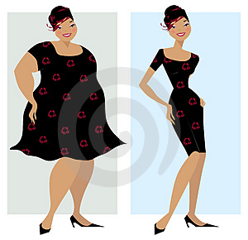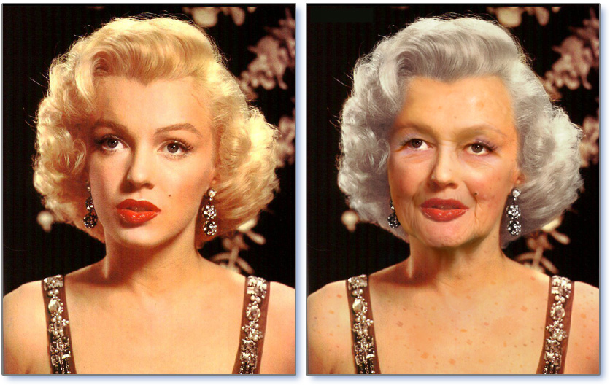  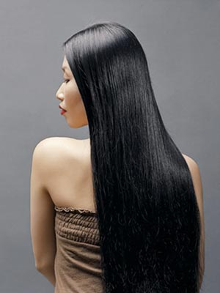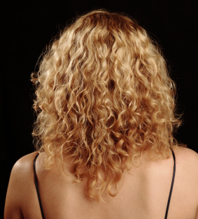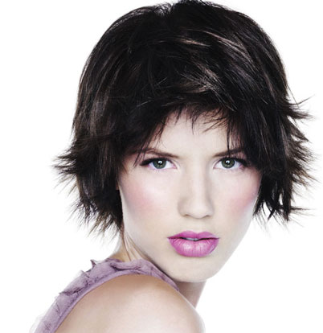  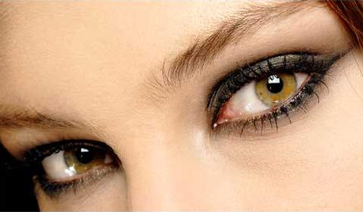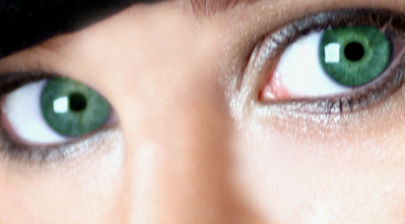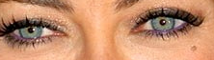  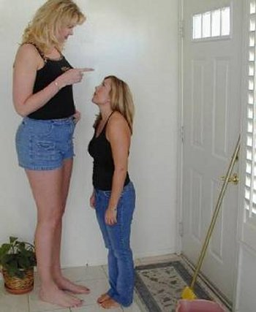  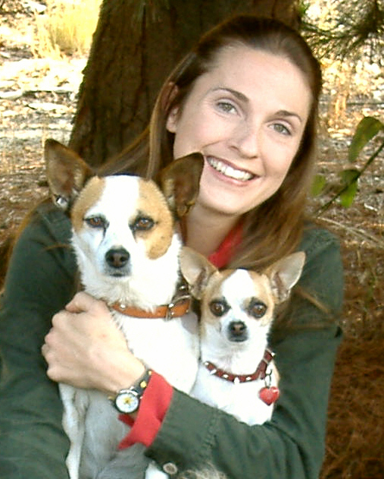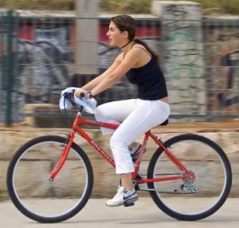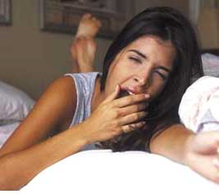  - Who has handed in Jacob’s phone? Listen to the text and identify the person. Then, write a 1 sentence to describe each one of the following persons.    ___________________________________________________________________________  ___________________________________________________________________________  ___________________________________________________________________________  ___________________________________________________________________________  ___________________________________________________________________________  ___________________________________________________________________________  ___________________________________________________________________________  ___________________________________________________________________________  ___________________________________________________________________________  ___________________________________________________________________________  ___________________________________________________________________________  ___________________________________________________________________________  ______________________________________________________________________________________________________________________________________________________  ___________________________________________________________________________  ___________________________________________________________________________  ___________________________________________________________________________  ______________________________________________________________________________________________________________________________________________________  ___________________________________________________________________________  ___________________________________________________________________________  ___________________________________________________________________________  ___________________________________________________________________________  ___________________________________________________________________________  ___________________________________________________________________________  ___________________________________________________________________________  ___________________________________________________________________________  ___________________________________________________________________________  ___________________________________________________________________________  ___________________________________________________________________________  ___________________________________________________________________________  - Respuestas  I.  - 15  - Vietnam  - yes, she is very pretty  - yes, she has an open personality and is a lot of fun  - she loves animals and enjoys talking to people  II. Se debe elegir las fotografías que corresponden a la descripción: delgada, joven, pelo negro liso y largo, ojos café, alta, alegre, etc.  III. El segundo personaje
 | Reading  Inicio  Se pide a un alumno describir algunas de sus características físicas y psicológicas. Luego, se pide a otros alumnos agregar otras características sobre el mismo alumno: Can you describe yourself? What’s your hair/eyes/skin color? Can you describe your best friend? Am I tall/blond/etc?  Desarrollo  Se explica a los/las estudiantes que leerán un pequeño párrafo en el que se describe al alumno popular de la semana en una escuela y que posteriormente deberán responder algunas preguntas sobre el texto: You are about to read a short text in which the popular student of the school is described. Pay attention to the details and answer the questions.  Cierre  Para evaluar comprensión lectora y vocabulario se pide a los/las estudiantes realizar la última actividad de la guía y luego presentar sus dibujos a la clase: Now you are going to draw. You have to choose one of the descriptions and complete the picture with the appropriate features.
Guia de trabajo

- Read the following text and mark the correct answer with a circle.


This week’s new pop star is Brian Brown, or Brownie, as his friends like to call him. He is twenty-one and is very cute and good-looking. He isn’t very tall but he’s slim. He’s got short, curly, black hair, blue eyes and a big smile. He’s a bit quiet but he is friendly and confident. He likes pasta and coke and he loves his dog, Lucky. Every time he can, he watches TV, he loves the Warner Bros. series Friends.

  - Brian isn’t ___________
a) tall. b) shy c) cute. d) slim
  - His hair isn’t ___________
a) short. b) black c) straight. d) dark
  - He is ___________
a) young. b) old. c) blue eyes. d) shy
  - He isn’t ___________
a) friendly b) tall c) slim. d) quiet
  - He’s got ___________
a) brown eyes. b) black hair. c) straight hair. d) a cat
  - He hasn’t got ___________
a) straight hair. b).a pet c) good-looking. d) a dog
  - He’s ___________
a) noisy. b) shy. c) confident. d) a big smile
  - His nickname is ___________
a) Lucky. b) Brownie. c) Friends. d) Brian
  - He hasn’t got ___________
a) blond hair. b) friends. c) a pet. d) confident
  - He’s got ___________
a) pasta. b) coke. c) a dog. d) a TV series

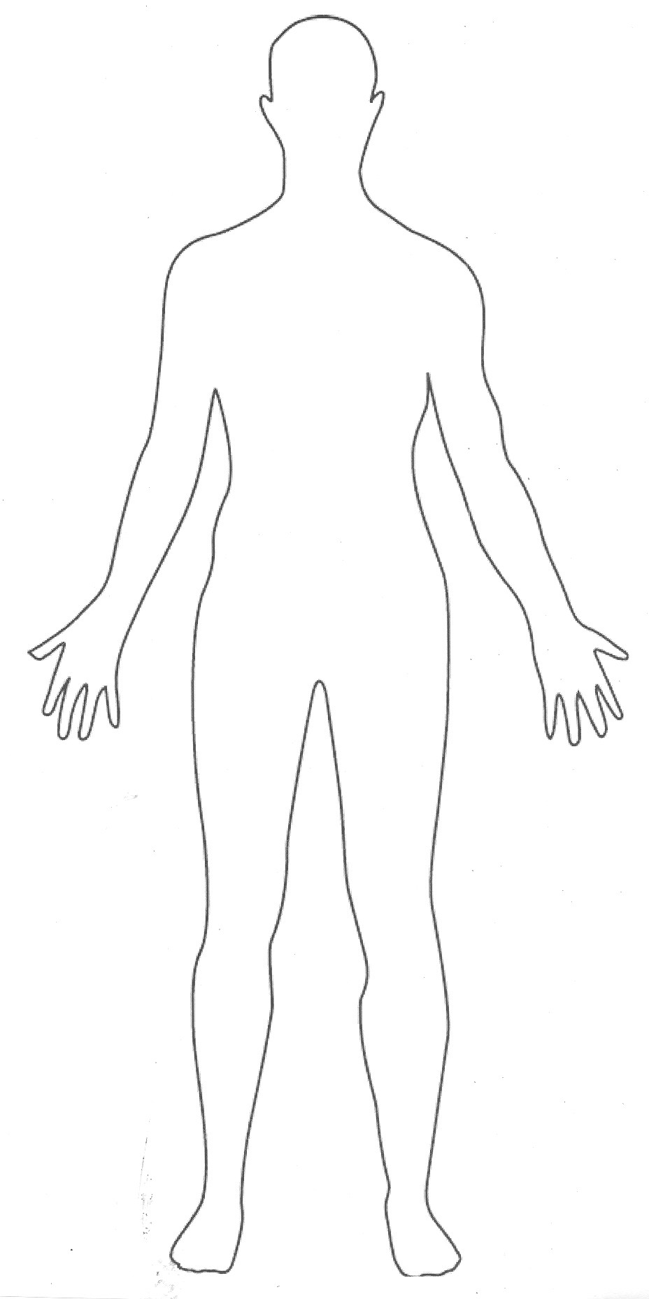
- Choose 1 of the descriptions and complete the picture. Paint it with the correct colours.

- She is young, about 15 or 16. She’s tall but she’s not slim. She’s got big green eyes and red, long and straight hair. She wears glasses and a pink dress.

- He’s very old and short. He’s bald but he has some grey wavy hair near his ears. He’s got brown small eyes and he wears a black shirt, red pants and black shoes.

 | Writing  Inicio  Se muestra a los/las estudiantes imágenes de distintas personas y se les hacen preguntas sobre las características físicas de las personas en las fotografías. What’s his hair color? Is he Slim? Etc.  Se explica a los/las estudiantes que desarrollarán una actividad en la que deberán describir apariencia física y personalidad: In the next activity you are going to describe make both physical and psychological descriptions of people.  Desarrollo  Proyecto: My Superhero  Se pide a los/las estudiantes crear un superhéroe. Se explica a los/las estudiantes que deberán realizar un afiche en el que ellos dibujen al superheroe y luego lo describan tanto física como psicológicamente.  Instrucciones:  You are going to make a poster with a superhero you are going to create. Your poster must include:  - 10 physical characteristics of the hero (personality, superpowers, etc.  - 10 psychological characteristics of the hero (eyes/nose /hair color, height, body shape, etc.)  - A picture of the hero. It must be similar to the description  Cierre  Los/las estudiantes realizan una pequeña exposición oral en la que presentan su superhéroe:  When you finish your Project you are going to present it to the class.
Pauta de evaluación
Esta pauta puede ser explicada y entregada a los/las estudiantes antes de comenzar el trabajo para que tengan claro en que consistirá a evaluación.

 | Beginning  1 | Developing  2 | Accomplished  3 | Exemplary  4 | SCORE
Information | No relevant / a little information is provided.  Does not include the required information. | Includes few details and some relevant information is provided. | Clear main idea. Includes some details and most of the information is relevant and accurate. | Clear main idea and secondary ideas. Includes many details and all the information is appropriate, relevant and clear.
Grammar | Many errors in agreement, number and tense. Does not use the appropriate structures. | Some errors in agreement, number and tense.  Uses some appropriate structures. | Few errors in agreement, number and tense. Uses an appropriate number of structures. | No errors in agreement, number and tense. Uses appropriate structures.
Organization | Ideas not ordered. A logical order is not followed. | Some order of ideas. A basic sequence of ideas is included. Some connectors to link sentences and paragraphs are used. | Clear order of ideas. A good sequence of ideas is included and some connectors are used to link sentences and paragraphs. | Good flow of ideas from topic sentence. All ideas are appropriately organized and a variety of connectors are used to link paragraphs and sentences.
Vocabulary | Very limited basic vocabulary is used. Does not include the required amount of appearance and personality adjectives. | Simple vocabulary is used correctly. Includes some appearance and personality adjectives. | Vocabulary is varied. Related words and ideas are correctly used. Includes most appearance and personality adjectives. | Varied and related words are used. Colourful, interesting words are suitable for topic and audience. Includes all the required personality and appearance adjectives.
Spelling | Many spelling errors | Some spelling errors | Few spelling errors | No spelling errors
Punctuation and case | Several punctuation and case errors | Few punctuation and case errors | Minor errors in case and punctuation. Variety used. | Correct case and punctuation. Variety used.
Visual aids | No visual aids | Visual aids do not match the description. | Visual aids match the description but are not always relevant. | Visual aids match and add meaning to the descriptions.

