Fidel Saavedra Bravo.  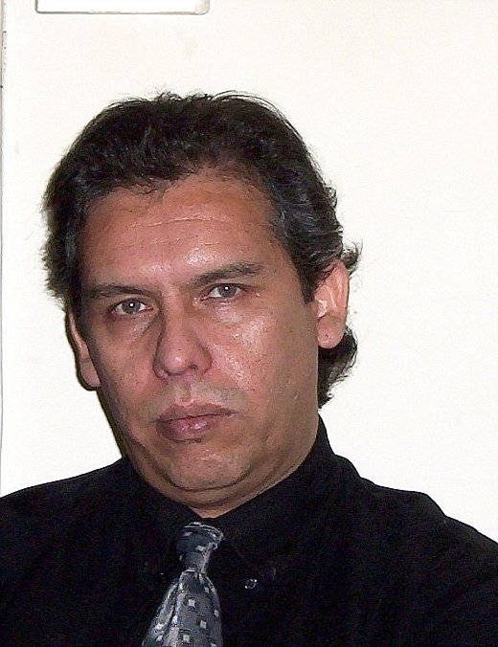 | Diagonal Cervantes 790  Apartment 308  Santiago  56-2-6649348  Mobile: 65892895  fsaavedrab@gmail.com

OBJECTIVE: |  |  | Teaching English as a Foreign Language in a friendly and challenging environment,  creating and applying new teaching methods, and using both tech tools and cultural  issues so as to make learning relevant for students.
SUMMARY OF QUALIFICATIONS:
- Twenty-five years’ experience in TEFL & ESP in universities and technical adult schools
- 15 years’ experience as a translator in diverse areas.
- 10 year’s experience as TOEFL and TOEIC Instructor.
- Design and maintenance of web sites for English teaching institutions.
- Experience in Operations Department of Shipping Agency.
- Advanced writing skills in both Spanish and English languages.
- Excellent interpersonal skills.

EDUCATION:
Elementary:
- Liceo Arturo Prat, Constitución: 1968-1974
- Colegio Santo Domingo, Santiago: 1965-1967
High School:
- Liceo Valentín Letelier, Santiago: 1974-1978

University: Diploma in English Language and Literature, July 1987
- Specialization: TEFL
- Thesis: “The Concept of Theme and Horizon in A Novel By Henry Fielding”
- Pontificia Universidad Católica de Valparaíso, Valparaíso, Chile.

COMPUTER SKILLS:
- Platforms: Windows XP/ Windows 7even/Fedora/Ubuntu
- Software: MS Word, MS Excel, MS Power Point, Open Office 2.0, GIMP 2, MS Front Page, TMPEGEnc, TMPEG DVD Author, Macromedia Dreamweaver, Flash..
- Programming: Knowledge of HTML Language

RELEVANT EXPERIENCE
EFL Teacher DUOC UC, Alonso Ovalle Branch; September 2008, December 2010
www.duoc.cl
- Taught EFL in English Language Program for the Institution.
- Contributed with new material for language enhancement activities
- Was in charge of leading Intermediate level teachers as back-up for Academic Coordination

EFL Teacher/Webmaster, IPREFOR Ltd. April 2007, December 2008
www.iprefor.cl
- Taught company executives for the institute.
- Designed, uploaded and maintained IPREFOR’s web site.

Free-Lance EFL Teacher/ TOEFL and TOEIC Instructor: January 2006, March 2007
- Taught EFL for company executives.
- Taught TOEFL and TOEIC for company executives and post-graduate professionals.

EFL Teacher, Universidad Arcis, March 2002- December 2005
www.universidadarcis.cl
- Taught EFL in English Language Program for the University
- Designed and applied new teaching material for the English Department
- Designed, uploaded and maintained English Department Web Site

EFL Teacher, Instituto Chileno Norteamericano, March 1998- November 2001 www.norteamericano.cl
- Taught EFL in English Language Program for the Institute
- Designed and applied new teaching material for the Institute
- Participated in the design of CAE for the Computer Language Lab.

Evaluator for EFL Minor, Elementary Education Program
Universidad de Playa Ancha, March 1996, December 1997
- Supervised and evaluated student’s professional training.

TRANSLATION EXPERIENCE:
- 2010: Translates into English the poetry book “Un Mar de Ausencia”,
by Marcia Lara Acuña, http://www.unmardeausencia.cl/h/en_index.html

- 2009,2010: Translates into English the articles: “Quantum Entanglement Between Classical Systems” and “Simulation of The First Growth Phase of Single-Walled Carbon Nanotubes”, for Departamento de Ciencias Básicas, Universidad Diego Portales.

- 2007,2008: Translates into English the articles: “Model Based On a Quantum Algorithm to Study the Evolution of an Epidemics” and “Implementing a Genetic Algorithm to Study Properties of Minimum Energy States in Spin-Ice Systems”, for Departamento de Ciencias Básicas, Universidad Diego Portales.

LANGUAGE SKILLS:
- English as Second Language, fluent in writing and speaking.
- Native Spanish, written and spoken.
- Intermediate level in Portuguese.
- Basic level in Italian.

OTHER:
- Resident in Edmonton, Canada, December 1978, January 1981.
- Writes poetry, fiction and comments on cinema, contemporary music, literature and current issues in http://palabraserrantes.blogspot.com, and http://vagabundeospoeticos.blogspot.com

SALARY EXPECTATIONS: To be agreed.

Santiago, Chile, February 2011.

