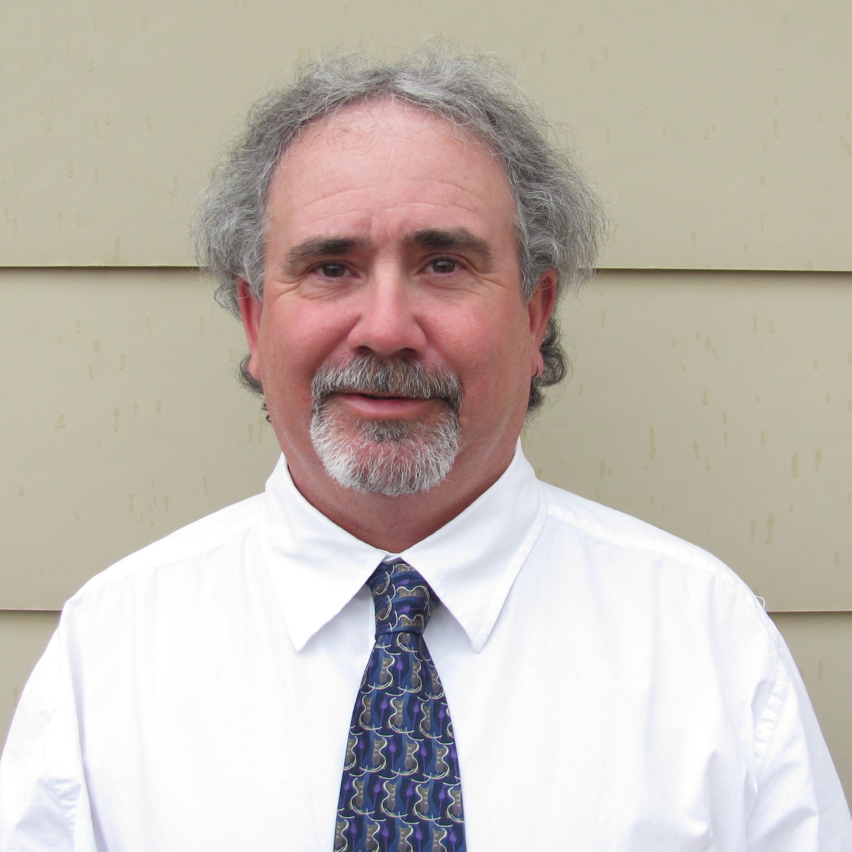

Jerry Duane Daniels
Post Office Box 1409
Cortez Colorado 81321 USA
001.970.759.3355
duende@frontier.net

Objective: To secure an ESL teaching position in Chile.

Highlight of Qualifications:

- Outgoing personality
- Adaptable and flexible work ethic
- Experienced educator in a multitude of settings

Education: 2010 Advanced TESOL Certificate (120 hours)
TESOL Training International
San Francisco, California USA

1987 BS (Outdoor Education/Psychology)
Appalachian State University
Boone, North Carolina USA

Education
Experience: 1988-1992 National Outdoor Leadership School
Mulege, Baja California Sur Mexico
Lander, Wyoming USA

Professional
Experience: 2010 Whitewater River Guide
Wild Rivers Expeditions- Bluff, Utah USA
Multi-day river trips focusing on natural
science, geology & archaeology

2000-2008 Owner/Manager
Canyon Sports LLC- Cortez, Colorado USA
Outdoor Specialty Retail Store

1994-2000 President
Outdoor Ed’s, Inc.- Cortez, Colorado USA
Sales & Wholesale Distribution

1992-1994 National Sales Manager
Osprey Packs, Inc.- Cortez, Colorado USA
Backpack Manufacturer

1988-1992 National Outdoor Leadership School
Mulege, Baja California Sur Mexico
Lander, Wyoming USA

Achievements: 2010 Wilderness Advanced First Aid
Wilderness Medicine Institute of NOLS
Moab, Utah USA

Hobbies: Foreign & Domestic Travel
Whitewater Rafting & Canoeing
Fishing
Surfing

