Jennifer Tenace
306 Cerritos Ave. Long Beach, CA 90802: (001)562.983.9957 jentenace@yahoo.com

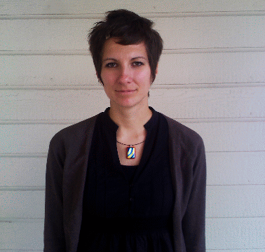

OBJECTIVE: To secure an ESL teaching position in Chile.

HIGHLIGHT OF QUALIFICATIONS:

- Experience in teaching English to international students in the United States.
- Experience teaching both children and adults of all ages.
- Experience conducting visual art workshops for children.

EDUCATION:

Advanced TESOL Certificate (120 hours) December 2009
TESOL Training International
San Diego, California, USA

Bachelors of Fine Arts September 1998 – June 2001
Laguna College of Art and Design
Laguna Beach, CA

University of the Arts September 1996 – June 1998
Philadelphia, PA

RELATED EXPERIENCE:

ESL Teacher/Administrative Assistant April 2010 - Current
SLK Learning Center
Torrance, CA
- Created personalized lesson plans
- Taught grammar, pronunciation, reading and conversation classes to both children and adults
- Assisted the director in implementing curriculum for adult ESL program
- Implemented Mommy and Me ESL class for mothers and their children
- Implemented Art for English Learners class for children learning both English and art

ESL Teacher April 2010 - Current
BYB English Group
Torrance, CA
- Taught Intermediate English to Japanese speakers, both adults and children
- Adult focus on conversation and idiom usage

ESL Instructor August 2010 - Current
Language Systems International
Torrance, CA
- Taught English to adults in full sized classrooms
- Taught Pronunciation/Vocabulary/Reading Comprehension to people of all nationalities
- Taught private students with focus on conversation, pronunciation and business English

ESL Tutor January 2010 – April 2010
South Bay Literacy
Wilmington, CA
- Taught beginning English to adult Spanish speakers
- Focus on vocabulary and conversation
- Participated in an 18 hour ESL Tutor Training course

Program Assistant January 2009 – July 2009
Mental Health America
Long Beach, CA
- Assisted with classes in training people in the mental health field at California State University, Dominguez Hills
- Scheduled trainers for trainings
- Design of all flyers for workshops and employment manual

Administrative Assistant November 2007 – January 2009
Global Student Experience
Irvine, CA
- Processed applications and sent out acceptance packets to students
- Processed invoices and student payments
- Processed all Financial Aid paper work
- Recruited Students to study abroad

Freelance Visual Artist and Art Teacher January 2000 - Current
Long Beach, CA
- Conducted Art Workshops for groups of kids our of my own studio
- Private lessons for kids learning art
- Exhibited artwork in galleries throughout the United States
- Participation in Community Projects and Public Art
- Completed Several Murals for the City of Long Beach
- Set design for Laguna Playhouse in Laguna Beach, CA
- Installation of Exhibits for Laguna Art Museum in Laguna Beach, CA
- Assistant to the Director of Diane Nelson Fine Art Gallery in Laguna Beach, CA

Computer Proficient In: Adobe Photo Shop, Adobe Illustrator, Page Maker, Microsoft Word,
Microsoft Excel, Microsoft Access, Quick Books, Microsoft Power Point, Microsoft Visio

