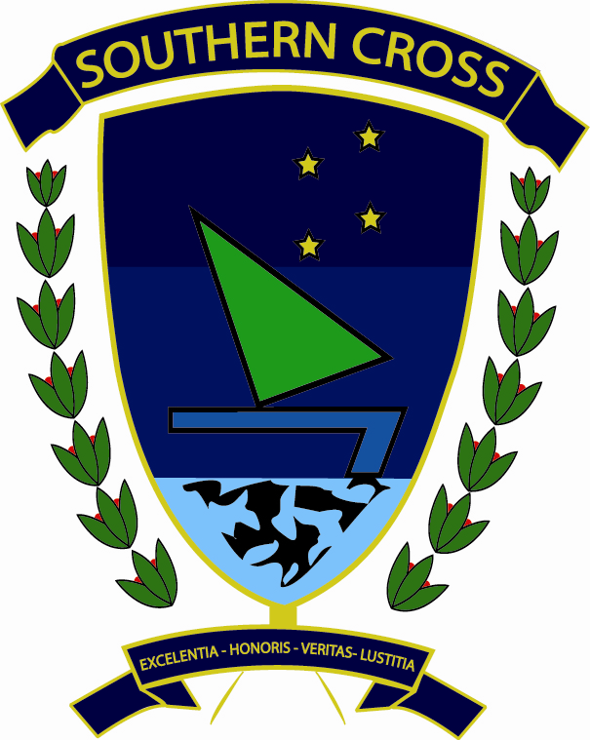

Southern Cross Teacher Training
Avenida Luis Orrantia, Mz 110, Solar 7,
Kennedy Norte
Guayaquil, Ecuador

To whom it may concern

This is a letter of recommendation for Jamie Davidson, who attended the University of Cambridge CELTA course held at Southern Cross Teacher Training in Guayas, Ecuador in 2010. Jamie was an active, enthusiastic, and successful participant in the course, beginning with the precourse organisation some months in advance of the initiation of classes. She impressed me with her determination, her willingness to try new things, her creativity, and her excellent rapport with her classes. Jamie is a teaching professional who manages the difficult balance of holding her learners accountable to high standards of achievement while encouraging and supporting them with sensitivity and warmth. She is demonstrably attentive to the needs of the learners in her classes.

Jamie worked very hard to analyse the language she was teaching and present it clearly for learners. She also demonstrated clear understanding of the principles of skills development and was competent in teaching classes with these aims. Her well-staged, detailed planning showed that she understands both the principles underlying task-based learning and its limitations.

She is technically competent in the classroom. Her performance on the Southern Cross CELTA course, which is considerably more comprehensive than typical CELTA courses and holds candidates accountable to higher levels of achievement, was admirable.

I am confident Jamie will prove a key asset to any staffroom, just as she was a key member of the teaching team on the course. I am happy to offer my recommendation of her as a teacher of English as a Foreign Language. Please feel free to contact me for more information.


Kind regards

Jáem Heath ÓRyan, MA TESOL
Head of Teacher Training,
Southern Cross Teacher Training
www.celtaecuador.com
southern.cross.teacher.training@gmail.com

