RESUME

Ross Parry
Melbourne, Australia.
Age 51.

Email: ozlisteners@gmail.com

AVAILABLE TO WORK: from January 2011. Currently saving for airfare to travel.

Available for interview on skype or phone on request.

QUALIFICATIONS AND EDUCATION

Bachelor of Education(Music, Film and Television, Drama) 3 years. Melbourne Teachers College 1977 to 1980.
Majoring in Music,
Woodwind instruments: Clarinet, Saxophone, also Guitar,

Bachelor of Nursing, 1990, One year of course, Deakin University, Geelong, Australia.

International English Teacher Licence, October 2011
Australasian Training Academy, Sydney Australia, reg no. 033854.

I am currently enrolled at ATA to complete 5 further electives. Completion of the first elective(teaching children) will give me an Advanced certificate which I shall complete before travel.
3 electives= Professional certificate
5 electives= Professional diploma.
All electives are studied online should I travel to Chile before completion, so I can increase my skills.
Electives: Teaching English to Children
Teaching English to Teenagers
Teaching English to Adults
Private Tuition
IELTS and TEOFL preparation

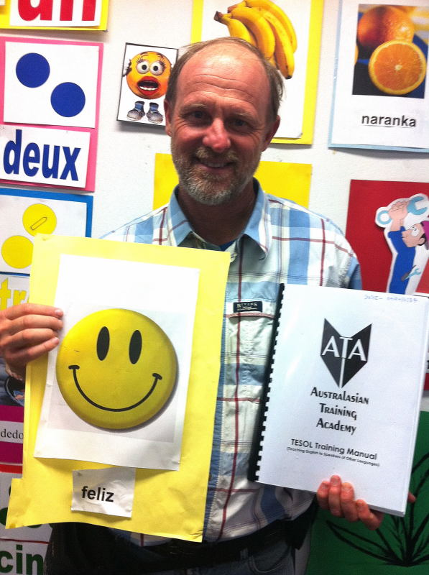

EXPERIENCE

In 1984 I travelled to India. I wanted to work in development work. I started to work in urban slum projects. In Bangalore, and Chennai. This involved a wide variety of tasks such as:
Planting trees, cleaning toilets, Volleyball games for slum children, playground construction, and wound dressing in a primary health care clinic.
I was also involved in teaching regular English classes with poor children.
All this work was volunteer and from 1984 to 2000 I would work in Australia, save, and return to India to continue to work in slum development projects. I went to India 8 times for periods of six months.
At this time I did not have formal qualifications to teach English, but the work was all voluntary.

In 2005 I taught English classes to refugee Adults in Parramatta, Sydney, one hour a week for one year as a volunteer.

While in Australia I taught music as a private tutor.

In 2009 I went to Kenya to teach English for three months in a rural development project.

TEACHING PHILOSOPHY

Since deciding to gain formal qualifications I have been encouraged to develop a teaching philosophy for the teaching of English as a second language.
I have been attracted to the RASSIAS techniques in which the teacher aims to engage the students with emotion, rhythm and movement in order to enhance memory retention of language.
Given my background in music and drama, I aim to incorporate these elements into my classroom material.

The other element of my teaching philosophy is that I want to be able to treat each student as an individual, to be like a personal mentor to each student, and to show concern for their whole life and not only on the subject of English. English studies are a means of personal growth and development for the student. Students are more likely to be motivated to learn if they believe the teacher cares about them personally.

HOBBIES AND INTERESTS

Geography, Travel and culture, hiking and camping, nature, development work, World Peace, refugees,
Spirituality(I am a Christian)
I am interested in living in Chile, learning Spanish, Latin American culture, and developing cross cultural friendships between Australia and Chile.

STRENGTHS

I speak in Native Australian English. I have travelled widely in Australia and have lived and worked in the USA and the UK. I have an understanding of the language differences in these English speaking cultures. Along with this is my long experience in development projects in India. This has helped me understand the world as a whole and why there are such disparities in wealth and opportunity from developing to developed countries. I read widely about Globalisation, and climate change, and resource depletion
All these experiences will enable me to give my students an extensive understanding of Western Countries that they may wish to visit or study in future.

REFERENCES

Olga Calderón
Profesora de Educación media mención Inglés
Master of English as an International Language
Fundación Instituto Indígena
Carrera 607
Temuco
Chile
24 October 2011
To Whom it May Concern,
I am writing this reference at the request of Ross Parry who is applying for the ESL teaching position at your college.

I have known Ross Parry for two years in my capacity as a student of the Master of English program at the education faculty of Melbourne University.

Ross Parry helped me with my informal English conversation classes. He was a reliable, disciplined and good communicator in his task. He helped me to improve my communication skills and fluency in the English Language.
In conclusion, I would highly recommend Ross Parry for this academic program. If his teaching performance to my class is any indication of how he will succeed, Ross Parry will be a positive addition to the program. If you should need any additional information you can feel free to contact me by email at fcalderon2002@gmail.com anytime.
Sincerely,
Olga Calderón
Teacher, Liceo Intercultural Guacolda

On 31 October 2011 12:38, <Bettina.Schieferstein@aue.salvationarmy.org> wrote:
Bettina Schieferstein
5-19 Mary St.
Surry Hills, NSW,2010
Phone 61 2 82181211
Re: Ross Parry
To whom it may concern,
I have known Ross Parry for 11 years, we met while he was working in Sydney.
During this time I have worked with him on a number of occasions and at present he volunteers with the Salvation Army.
My position at the Salvation Army is as a caseworker, working mainly with the vulnerable and homeless men.
During this time I have found Ross very trustworthy and reliable, going out of his way to help and be of service to the community.
I have no hesitation to recommend Ross as a teacher of English as a second language. He has had a number of experiences in teaching students
of all ages and has always been very professional, patient and conscientious with his students and staff.
If you would like to know anything else please contact me.
Bettina Schieferstein
Case worker
Salvation Army

Leonie Bolton
Sydney Streetlevel Mission
Derby Lane
(PO Box 349
Darlinghurst NSW 2010)
Surry Hills NSW 2010
Monday 31st October 2011

To Whom It May Concern,

My name is Leonie Bolton and I am the Centre Manager at the Streetlevel Mission, The Salvation Army in Surry Hills.

I have now known Ross Parry for 12 months. In my experience Ross is a man of integrity, honesty and good character. He has a natural ability to engage with people from many different cultures and backgrounds. He has excellent self-motivation skills and can work as a team or an individual.

If you have any further questions or queries, please call me on either: +612 9360 1710 or email: Leonie.Bolton@aue.salvationarmy.org

Thank you and kindest regards

Leonie Bolton
Centre Manager
Sydney Streetlevel Mission

