JOHN KEOGH

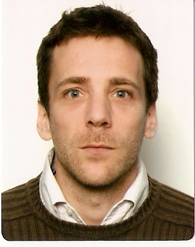

Santiago de Chile
Email: eh.john@gmail.com
Phone: 66839487
Date of birth: 29.01.69
Passport: 706659831 (exp. 15.12.2018)
Nationality: British
Country of birth: England

ENGLISH TEACHING

- Native English speaker
- Cambridge CELTA qualified (Grade B with International House in Buenos Aires)
- Over 2,000 hours of real teaching experience with adult students at all levels.
- Mature, enthusiastic, communicative EFL teacher with a lively attitude and a desire to develop further his teaching skills and knowledge.

CAREER HISTORY

Southern Cross British Language Centre Guayaquil, Ecuador May – November 2011
Senior Teacher with full time classroom hours. Additional responsibilities: designing new final evaluation tests, giving input sessions and assisting new teachers.

English For Life Santiago, Chile August – December 2009
Teaching to adults at all levels.

The Canadian House Center Loja and Machala, Ecuador February – August 2009
Teaching to students of all ages and levels.

Positions previous to English Teaching:

Independent Accounts Manager May 2004 – March 2008
Sales and servicing of Warner Music Group product to 70 key independent accounts in London & surrounds.
National accounts manager November 1998 – April 2004
Responsible for sales, marketing and servicing of independent music label product to retail sector.
Retail Store Manager 1994 – November 1998
Responsible for all aspects of the day to day running of a large independent recorded music retailer.

ACADEMIC QUALIFICATIONS
Cambridge CELTA certified (grade B, January 2009, International House Buenos Aires)
‘A’ levels in English (grade A) and Communication Studies (grade B).
5 GCSE’s including English & Mathematics.

INTERESTS
Film, music, literature, football.

REFERENCES
Lee MacKenzie (DOS Guayaquil) leeemac1@hotmail.com +593 4 268 4404
Justine Robertson (English For Life) jrobertson@englishforlife.cl +56 2 415 0416
Gloria Benstead (DOS Loja) gloria@canadianhousecenter.com +593 7 258 4334
Kate French (CELTA course tutor) +54 11 4785 4425 katefrench05@hotmail.com

