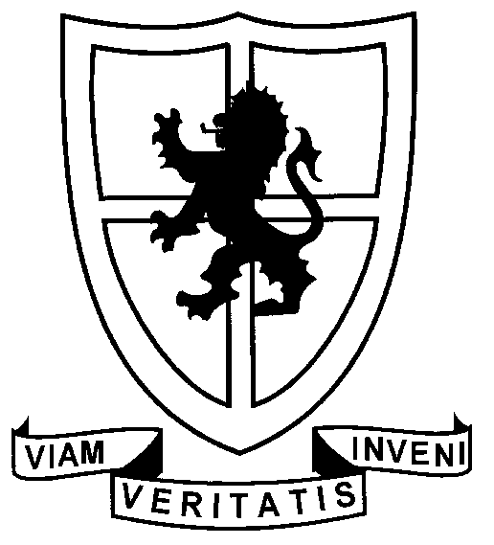 ST PAUL’S SCHOOL VIÑA DEL MAR

C E R T I F I C A T E

To whom it may concern

We hereby certify that Jerome Lucas has been an English-speaking assistant at our school, St. Paul’s School, Viña del Mar, Chile, from September to December of 2010, forming part of our English Department during this period.
His activities involved carrying out and assessing conversation sessions with school pupils from Grades 5 to 12, ages 10 to 17, who thoroughly enjoyed this opportunity of practising their spoken English outside the classroom. He also followed guidelines set by the teacher in charge so as to provide personalised speaking practice for the Speaking component of the Cambridge First Certificate in English Exam, which our final year, 17 to 18 year-old students sit in December. Jerome also took part in our school anniversary English contest, and was a great help to the English Department.
We are very grateful for the enthusiastic way in which he carried out these sessions, showing commitment, initiative, responsibility, willingness to cooperate and a true intercultural disposition to exchange and share ideas of varied nature. We wish him the best in the future, knowing that whatever his goal, he will be extremely successful in whatever he undertakes.

Christine Evans Nicolás Gana V.
Supervising Teacher Rector St Paul’s School
Viña del Mar, November 17th, 2010

Casilla 347 Merced Oriente 56 Viña del Mar Teléfonos: (32) 3142200
Fax: (32) 3142233 www.stpaul.cl e-mail: secretaria@stpaul.cl

