Alexandra Zelinskaya  Date of birth (D/M/Y) : 12/10/1988  e-mail: Zalexa12@gmail.com | 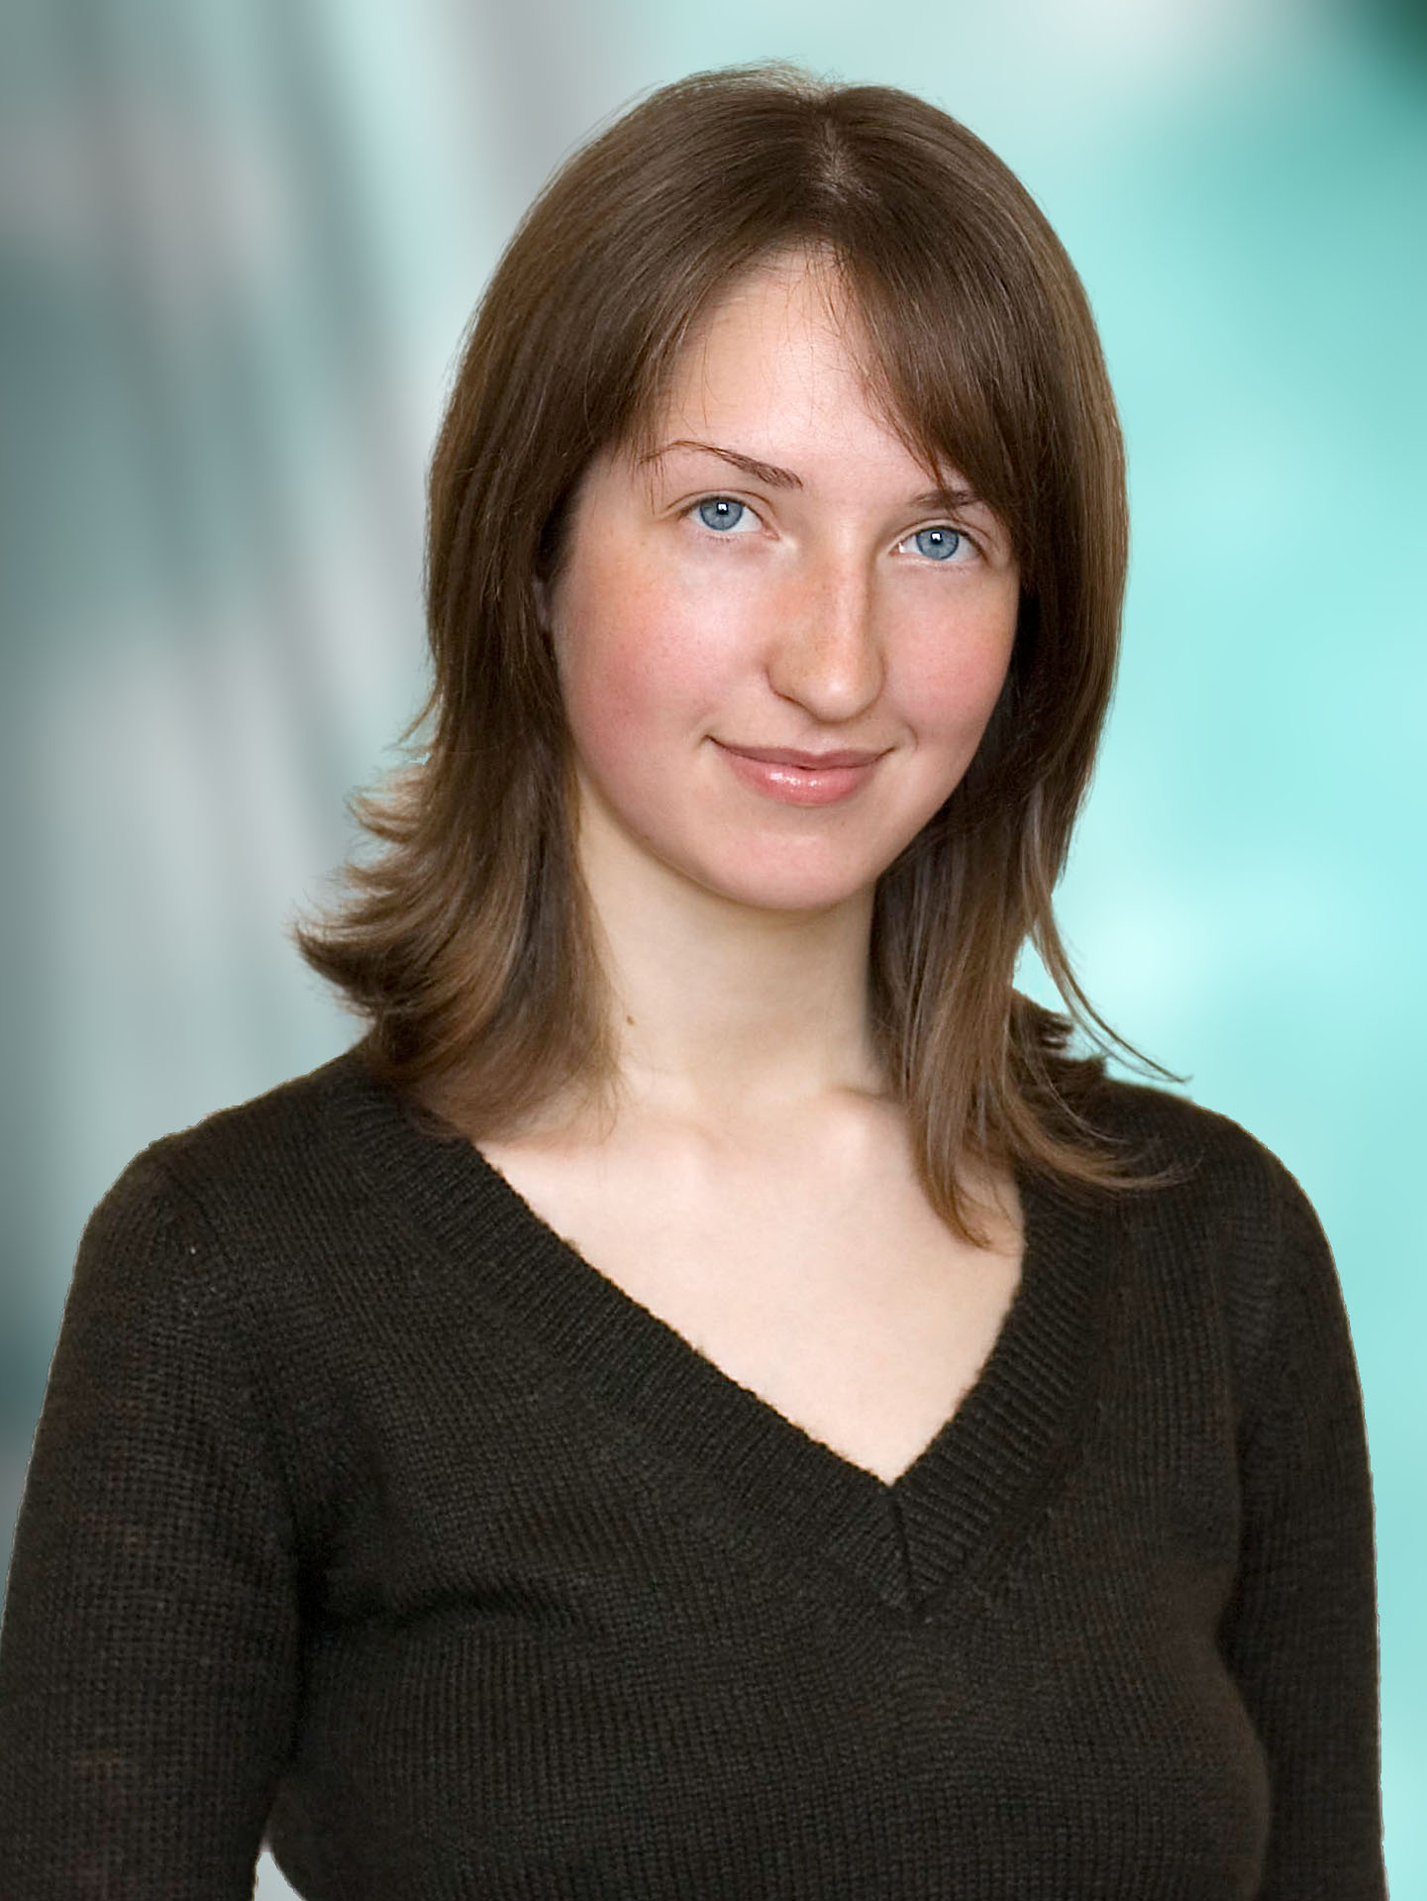

EDUCATION__________________________________________________________________

2005-2010 | Far Eastern National University,  Institute of Foreign languages, Faculty of Romanic Languages,  Special subject – Translation from English and French. Diploma cum laude.

EXPERIENCE_________________________________________________________________

December 2010 – May 2010 | Teacher of English and French in LCentral, Hangzhou, Zhejiang province, China, Singaporean branch of LCentral private schools of foreign languages. Teaching young children of 4 years old, teenagers and adults.  Contact details: Sophia Lou  e-mail: sophiazhejiang@lcentral.net  www.lcentral.net
July 2010 – December 2010 | Teacher of English in Zhijing #3 Middle School, Guizhou province, China.  Contact details: Susan Su  e-mail: suliyunlove@gmail.com
January 2009 –  June 2010 | Teacher of math on English for Korean students in primary and middle international school and teacher of French in Vladivostok State University of Economics and Service Boarding school for gifted children.  Contact details: headmistress Olga Shevchenko.  E-mail: gifted.school@vvsu.ru, tel:+7 (4232) 31-61-36
2006 - 2009 | Tutor of English and French, usual language, preparatory college courses.
09.12.2008 – 11.12.2008 | Interpreter at the French Cinema festival, Vladivostok.
12/2007 -04/2008 | Assistant at the department of Lexicology, Stylistics and English language teaching methodology, Institute of Foreign Languages, Far Eastern National University.

ADVANCED TRAINING COURSES
AND COMPLEMENTARY EDUCATION__________________________________________

7 October 2009 – 28 October 2009 | Intensive Course “Integrating Technology into ELT” at Far Eastern National University.
26-28.06.2008 | International Conference organized by FEELTA (Far Eastern English Language Teachers Association), “Making bridges between languages and cultures”
30.03. – 02.04 2009 | International Conference for teachers of French from Eastern Siberia and Far East.
10/2004 | “World School” international program for students learning English language. London, Great Britain. Reine, Germany.

