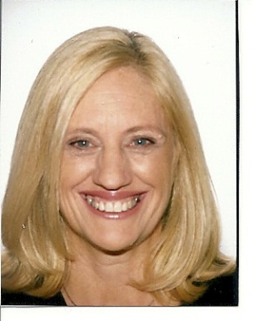Debra Dickson

debdickson@live.co.uk • Padre Alonso de Ovalle 791, depto. 313, Santiago

m: +56 + 9 95 17 23 53

Overview

DOB: 21st April 1961 NATIONALITY: Australian M6292383

EDUCATION: BA. Dip Ed. Grad Dip App Ling. MA (ongoing).

EXPERIENCE: 27 years Secondary Teacher Education Queensland and 1 year Sessional teaching Griffith University. Subjects: English, ESL, History, Drama, Philosophy. Ages taught: 13years – adult.

Key Strengths

∙Ability to communicate well ∙Wealth of experience ∙Enthusiastic

. Native English speaker ∙Professional approach ∙Flexibility

Education

2009 – ongoing Masters of Arts in Philosophy, University of Queensland.

1993 – 1996 Graduate Diploma of Applied Linguistics, Charles Darwin University

(formerly Northern Territory University). Specializing in TESOL.

1983 Diploma of Education, University of Queensland. Secondary Education.

English and History

1979 – 1981 Bachelor of Arts, University of Queensland. Subjects: English, History, Philosophy.

Courses and Training

2009 Authorized and Accredited Marriage Celebrant in Australia

2007 Certificate IV in Training and Assessment (TAA), teaching vocational education

Experience

03/2010 – 06/2010 Sessional Teacher, Griffith University. First Year Bachelor of Education (Primary) Subject: Introduction to Education (Sociology of Education)

07/2010 – 11/2010 Modern History Teacher, Hubbard’s School. Age level: 15 – adult

01/1984 – 05/2011 Secondary Teacher, Education Queensland. Queensland Australian Curriculum. Subjects: Drama, English, History, TESOL, Philosophy. Age levels: 13 - adult

Acting HOD (Head of Department) of Humanities for 4 years (01/2004 – 12/2007). Support and mentoring of teachers, designing and implementing History and Studies of Society Work Programs. Working on Queensland Studies Authority (QSA) Syllabus committees for Modern History, Drama and English.

Current Queensland College of Teachers Registration

08/1996 – 01/1997 ESL Teacher, International Business School, Gold Coast, Queensland.

02/1996 – 07/1996 ESL Tutor, private ESL lessons to Portuguese students while living in Tavira Portugal.

References:

Ms Cathy Terry, HOD English, Coorparoo Secondary College, crn Cavendish Rd and Old Cleveland Rd, Coorparoo, QLD, AUS 4152, +61 +7 3394 8888, [cterr1@eq.edu.au](mailto:cterr1@eq.edu.au)

Ms Alyson Innis, HOD English, Upper Coomera State College, 37 Reserve Rd, Upper Coomera, QLD AUS 4209, +61 +7 5580 7555 [ainni2@eq.edu.au](mailto:ainni2@eq.edu.au)

Ms Helen Stevens, Principal, Hubbard’s School, Level 1/ 15 Lang Parade, Auchenflower, QLD AUS 4066, p: +61+7+33715999, f: +61+7+33715044, [admin@hubbards.com.au](mailto:admin@hubbards.com.au)