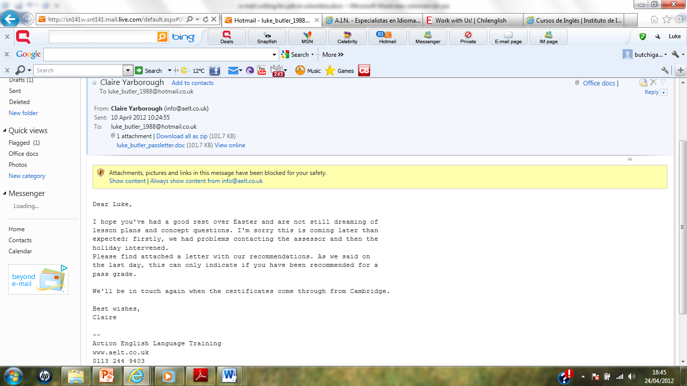

I haven’t yet received my official CELTA certificate as I only completed the course 3 weeks ago. However, here is the e-mail confirming my passing of the course and I can also send a scanned copy of my degree certificate if you are interested in taking my application further.