**Michaël Dorsan**

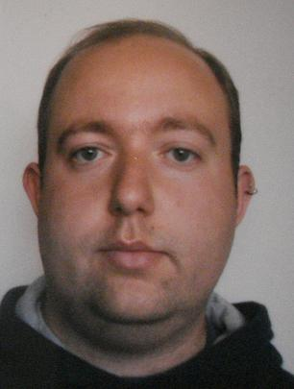

1, Rue Vau Leroy

89700 Dannemoine

France

Phone : 0044 78050 48819

E-Mail: [michael.dorsan@gmail.com](mailto:michael.dorsan@gmail.com)

Birthday: May 26th, 1984

Native language: French

**S K I L L S**

**Organizational and technical skills:**

* Advanced level of Microsoft Office use
* Able to create original PPP and TBL lesson
* High level of professionalism and strictness in my work
* Quick adaptation and flexible in new environment
* Huge capacity of learning, good visual and aural memory
* Professional in appearance and presentation
* Motivated and enthusiastic about developing good relations
* Effective working alone or as a cooperative team member

**Languages:**

French *native speaker*

English *fluent, level C1, CAE : 74%*

Spanish *fluent*

**S C H O L A R E D U C A T I O N**

**Certificate of TESOL,** [**www.linguaedge.com**](http://www.linguaedge.com)**, ACTDEC certified.**

Septembre 2010

**Faculty of Biology, University, Geneva, Switzerland**

2001-2006

Bachelor

**Scientific College degree, Lycée Saint-Bernard, Troyes, France**

1998 - 2001

**W O R K E X P E R I E N C E**

Customer Technical Agent for Msn, Microsoft| **Gem, Belfast, UK**

(11/2009 – 10/2010)

* Provide a positive customer experience through, efficient, friendly, high quality response
* Take part in, and encourage active participation in team discussion activities
* Translation from English to French and from French to English
* Coaching new staff to help them in understanding the job and the expectations of the customer

Cashier| **Carrefour, Ségny, France**

(06/2008 – 02/2009)

* Serving customers at the cash register
* Meeting and greeting customers face to face
* Dealing with queries on clothes and food
* Booking concert tickets for customers
* Training the new employees to teach them how to use the different tools and the different job duties

Education Assistant | **College Abel Minard, Tonnerre, France**

(09/2007 – 12/2007)

* Minding children aged 10-14 years
* Administration tasks
* Helping children with their homework

Teacher| **Collège, Ancy-Le-Franc, France**

(06/2007)

* Preparing material for mathematics classes for children aged 10-14 years.
* Correcting homework
* Helping them in learning the class’ content

Basic secretairial skills‘ Teacher | **Geneva’s University, Geneva, Switzerland**

(10/2004 – 06/2006)

* Teaching typing skills to university students
* Teaching Word and Excel skills
* Teaching people with limited PC skills
* Preparing tutorials and exams for the students
* Correcting exams and preparing the diplomas for the student

Private Teacher | **Geneva, Switzerland**

(11/2001 – 06/2004)

* Teacher with French, Mathematics, Physics, Chemistry
* Helping children in learning their classes
* Helping them with their homework

**References**

Available on request.