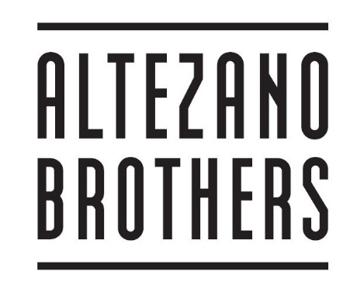

**Our coffees are crafted using Altezano Brothers’ Bold blend. All components of this blend are individually roasted and sourced by us. They are specialty grade, traceable to farm or co-op, current-crop, and unique to us in New Zealand.**

**BOLD**

**Varietals: Bourbon, Typica, and Ethiopian heirlooms**

**Preparation method: Wet-milled**

**Grading: Gourmet**

**Altitude: 1200–1800 m above sea level**

**Notes: Full bodied cup showing clean, bright acidity with citrus and black-currant high notes.**

**Single Origin Coffees**

***We are always showcasing a single origin coffee from***

***our stable. Please ask a team member for today’s***

***featured coffee or refer to the page in this menu.***

***All our espresso beverages are served as doubles, or how you like it***

**Coffee**

**Ristretto $3.50**

**Short black**

**Macchiatto**

**Long black $4.00**

**Americano**

**Piccolo $4.00**

**Cortado**

**Flat White $4.20 $4.50 $4.70**

**Cappuccino $4.20 $4.50 $4.70**

**Latte $4.50 $4.70**

**Mochaccino $4.70 $5.20**

**Affogato $6.00**

**Iced Coffee $6.00**

***We use organic dairy milk for all milk based coffees***

**In addition we have:**

**Organic Soy $0.80**

**Notmilk Almond Milk Sm $1.50**

**Med $2.00**

**Large $2.50**

***Raw coconut sugar available on request***

**Single Origin: Fazenda Roseira - Santos, Brazil**

**Hailing from the fertile fields of the Fazenda Roseria in Brazil, this delicious pulped natural coffee is fresh off the boat. This offering is full bodied with a hazelnut & smooth toffee finish. Also to be enjoyed with milk**

**White**

**Butterscotch - Licorice**

**Black**

**Hazelnut - Malt – Toffee**

**Altezano Brothers Cold Brew $4.50**

**Red Honey El Guamo with a dash of Agave**

**Belgian Hot Chocolate: rich and dark $4.50**

**Iced Chocolate: $6.00**

**Icecream, milk and Belgian Chocolate**

**Harney & Sons Teas $4.00**

**English Breakfast**

**Earl Grey**

**Japanese Sencha**

**Peppermint**

**Lemon Verbena**

**Hakanoa Spicy Chai $4.70**

**Hakanoa Lemon Ginger Honey $4.70**

**Sodas, Tonics and Juices**

**Six Barrel Sodas $4.50**

***Small batch, classic soda fountain style sodas made using real ingredients.***

**Cola Six**

**Cherry Pomegranate**

**Celery**

**Orange Dandelion**

**Aotea Tonics $5.00**

***Inspired by traditional Maori herbal remedies, Aotea Tonics are made by brewing native herbs and leaves from Great Barrier Island and sweetening with Manuka Honey.***

**Kumarehou –with ginger, turmeric and lemon**

**Kawakawa with peppermint, chamomile and nettle**

**Soul Organics $8.50**

***Organic, raw, cold pressed living juices***

**Green is Mean – apple, kale, silverbeet, cavolo & lime**

**Super Juice – apple, carrot, lime, ginger & turmeric**

**Energiser Bunny – apple, carrot, beetroot & ginger**

**Zesty Kick – apple, orange, lime, ginger & turmeric**

**Antipodes Water $5.00**

**Still**

**Sparkling**

**Coaqua $5.00**

***Pure, naturally sweet coconut water harvested in South Vietnam with no added sugar or preservatives***

**Lemmy $4.50**

***Fairtrade organic cane sugar and organic lemons***