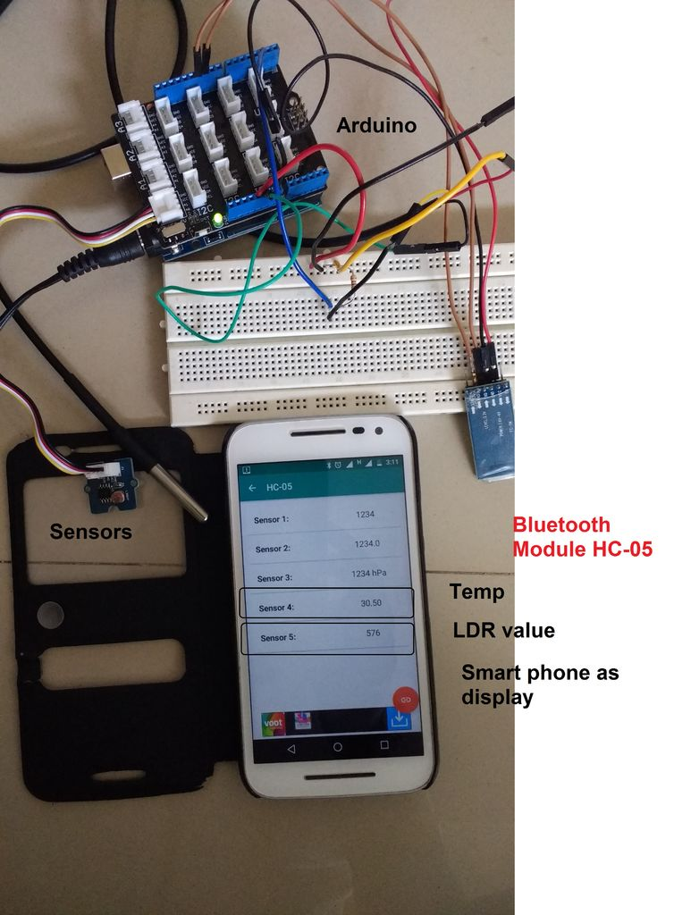

USING BLUETOOTH MODULE

TO receive DATA ON YOUR ANDROID.

AUTOMATED_FOOD_PROTECTION| RISC IITBBS

In default the Arduino is not equipped with a display to visualize measuring-data, for example from your temperature or your pressure Sensor. If you want to get the data shown you need a PC, printing the data to the console or mounting a display directly to the Arduino. So, there is no simple way to WIRELESSLY visualize measuring-data.

THIS IS A BRIEF show, how to transfer measured Sensor-data in real time from your Arduino- Microcontroller to your Android-Smartphone via Bluetooth.

REQUIREMENTS

# ARDUINO

# BLUETOOTH MODULE

# ANDROID

# APP-ARDUTOOTH (play store)

# HOW TO SET UP WIRING.

1.GND ARDUINO TO GND HC MODULE

2.VCC HC TO 3.3 V OR 5 V IN ARDUINO

3.RX OF HC TO TX OF ARDUINO

4.TX OF HC TO RX OF ARDUINO

NOTE: the next step after wiring is to upload code , see it to that you disconnect TX AND RX pins while uploading ,otherwise it shows COM PORT IS BUSY.

CODE IS PROVIDED IN ANOTHER FILE.

THE FINAL 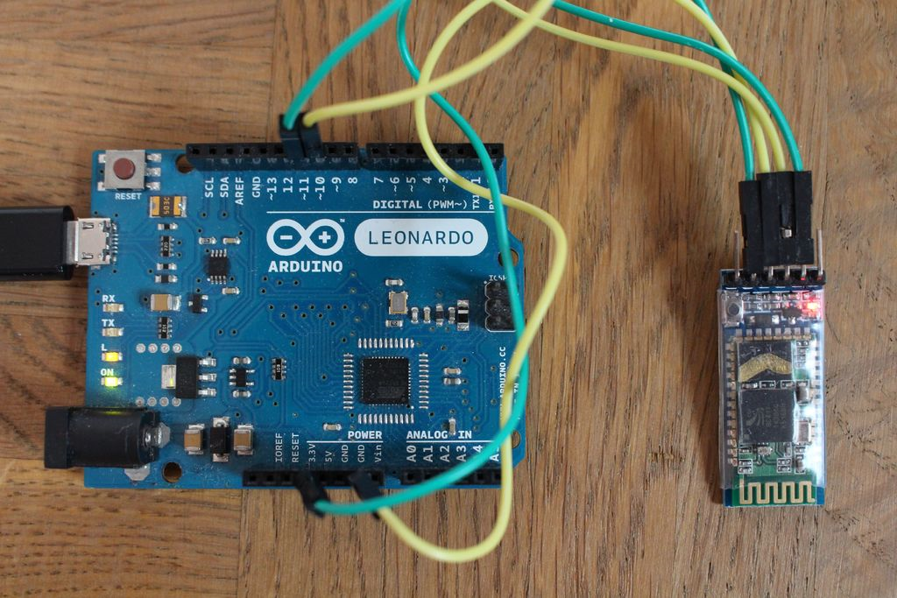OUT PUT IN THE APP LOOKS LIKE;

