1. Introduction
In Modules 1 and 2, the configuration and mathematical framework for a Lane-Keeping Assist (LKA) system were established using a monocular camera, a Linear Quadratic Regulator (LQR) control algorithm, and a Dynamic Bicycle Model representing a 2026 Toyota Corolla Altis X 1.6 Manual. This foundational work defined the system's states, calculated the necessary tire cornering stiffnesses, and extracted the optimal feedback gain matrix ($K$) by minimizing the cost function.
Module 3 focuses on translating this mathematical model into a simulated environment using MATLAB and Simulink. This step is a crucial phase in the Model-Based Design (MBD) paradigm, bridging the gap between theoretical derivation and physical deployment. The primary objective of this simulation is to visualize and deeply analyze the LKA system's continuous lane-keeping performance. By doing so, we can evaluate its accuracy under various realistic driving scenarios, identify potential hardware and environmental failure modes, and propose concrete optimization strategies to refine the controller for future iterations.

2. Dynamic Bicycle Model
To accurately simulate the vehicle's lateral dynamics at a constant highway speed ($v_{x}=20$ m/s), a 2-DOF Dynamic Bicycle Model was employed.

2.1 Equations of Motion
The state vector is defined as $x=[y^{\text{'}},v^{\text{'}},e_{y},v_{e}]^{T}$, representing lateral velocity, yaw rate, lateral position error, and heading error, respectively. The tire slip angles for the front ($α_{f}$) and rear ($α_{r}$) wheels are defined as:
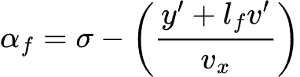

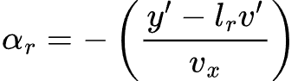

Using Newton's second law and rotational dynamics, the lateral acceleration and yaw moment equations are given by:
$$m(y^{\text{''}}+v_{x}v^{\text{'}})=F_{y,f}+F_{y,r}$$
$$I_{z}v^{\text{''}}=l_{f}F_{y,f}-l_{r}F_{y,r}$$

2.2 State-Space Formulation
To implement the LQR controller, the nonlinear equations are linearized about a nominal trajectory into a Linear Time-Invariant (LTI) state-space form: $\dot{x}=Ax+Bu+B_{d}d+B_{c}w_{c}$.
The system matrices are derived as:
$$A=[\begin{matrix}-\frac{C_{f}+C_{r}}{mv_{x}} & \frac{l_{r}C_{r}-l_{f}C_{f}}{mv_{x}}-v_{x} & 0 & 0 \\ \frac{l_{r}C_{r}-l_{f}C_{f}}{I_{z}v_{x}} & -\frac{l_{f}^{2}C_{f}+l_{r}^{2}C_{r}}{I_{z}v_{x}} & 0 & 0 \\ 1 & 0 & 0 & v_{x} \\ 0 & 1 & 0 & 0\end{matrix}]$$

$$B=[\begin{matrix}\frac{C_{f}}{m} \\ \frac{l_{f}C_{f}}{I_{z}} \\ 0 \\ 0\end{matrix}], { B}_{d}=[\begin{matrix}\frac{1}{m} \\ 0 \\ 0 \\ 0\end{matrix}], { B}_{c}=[\begin{matrix}0 \\ 0 \\ 0 \\ -1\end{matrix}]$$

2.3 LQR Controller Design
The LQR controller calculates the optimal steering angle ($σ$) by minimizing the quadratic cost function:
$$J=\int_{0}^{\text{∞}}{(}x^{T}Qx+u^{T}Ru)dt$$
Where $Q=\text{diag}(1,1,100,10)$ strongly penalizes lateral error, and $R=[1]$ constrains steering effort. Solving the Algebraic Riccati Equation yields the optimal state feedback gain matrix:
$$K=[\begin{matrix}0.7438 & 0.8688 & 10.000 & 23.182\end{matrix}]$$

3. Simulation Environment Setup
The closed-loop control architecture was meticulously constructed in Simulink utilizing standard state-space block representations based on the matrices defined in Section 2. To bridge the gap between ideal mathematics and physical hardware realities, the simulation explicitly incorporates the physical limitations of real-world sensors. This was achieved by injecting Band-Limited White Noise into the feedback loop to represent inherent camera measurement uncertainty and environmental jitter.
The sample time for the sensor noise was strictly set to 0.033 seconds to accurately mimic a 30 Frames Per Second (FPS) refresh rate, which is the current industry standard for automotive monocular lane detection processing. The longitudinal velocity ($v_{x}$) was held constant at 20 m/s for all tests to isolate lateral dynamics and evaluate the LQR controller's performance at a standard highway cruising speed. Furthermore, the state-space input matrix was augmented to accept both the optimal steering command and external environmental disturbance vectors ($B_{d}d$ and $B_{c}w_{c}$) simultaneously.

4. Visualization and Analysis of Driving Scenarios

Scenario A: Baseline Recovery
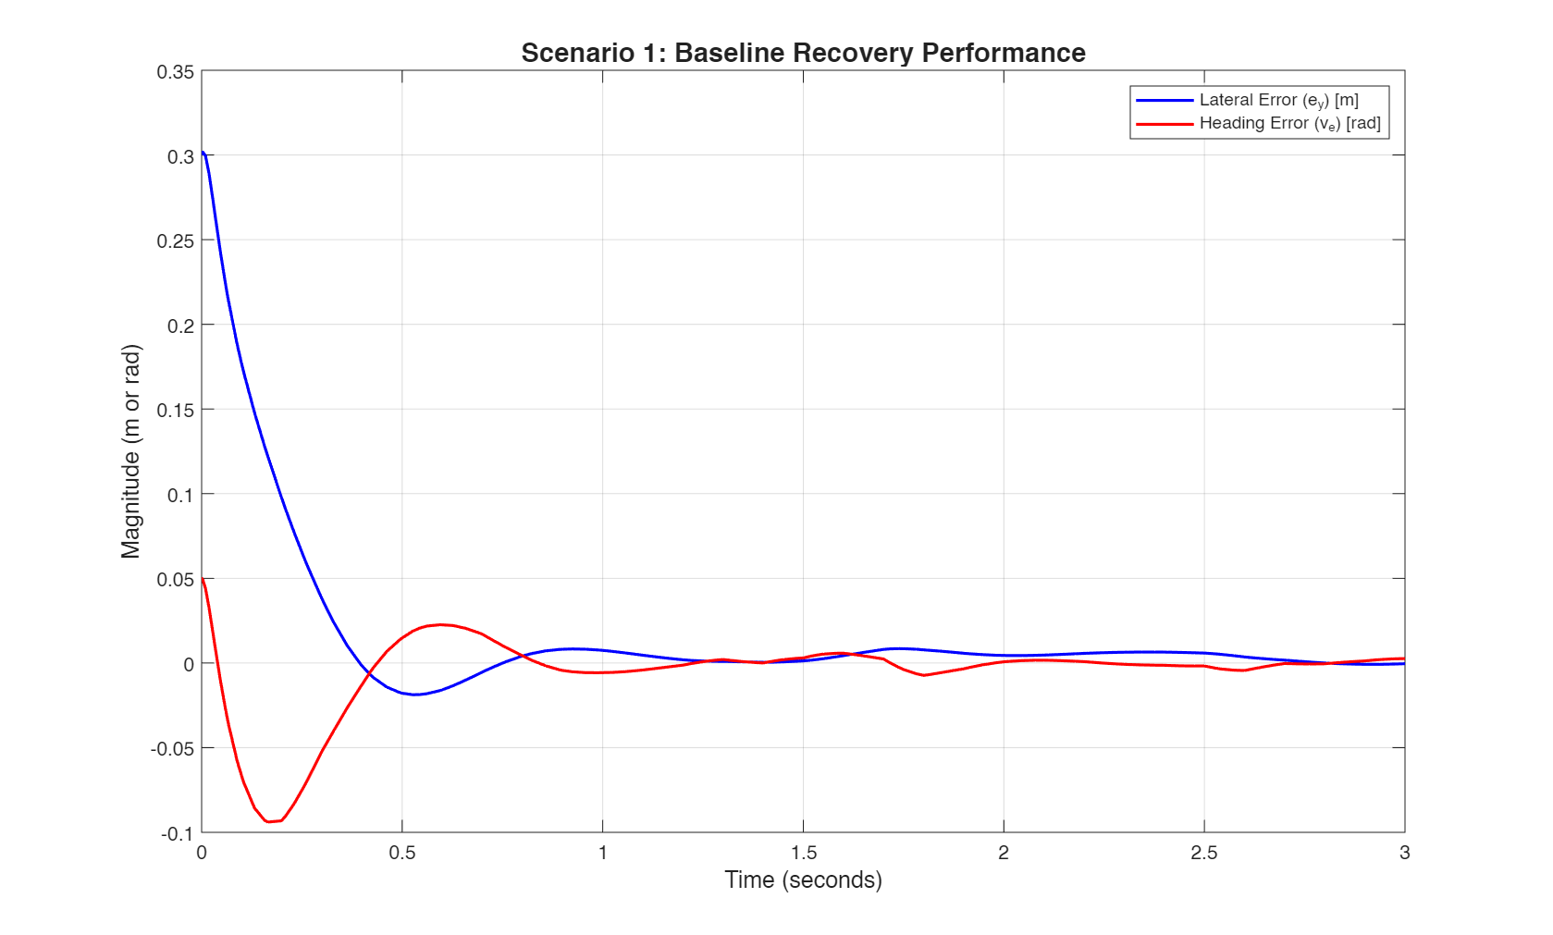
This scenario evaluates the pure transient response of the LQR controller without any external environmental disturbances. The vehicle was given a severe initial lateral offset of 0.3 m and an initial heading error of 0.05 rad (roughly 2.9 degrees) to observe how quickly and efficiently the system stabilizes the vehicle back to the lane center.
Analysis: The controller demonstrates an aggressive and highly responsive correction profile. The lateral error ($e_{y}$) drops precipitously from the initial 0.3 m and securely crosses the zero mark at approximately 0.4 seconds. After a very minor and highly damp undershoot of approximately -0.02 m, the system achieves a steady-state value of exactly 0 m by the 1.0-second mark.
This rapid settling time confirms the profound efficacy of the heavily weighted $Q$ matrix configured in Module 2, which prioritized lateral error correction over steering effort. However, while mathematically optimal, it is worth noting that such a sudden, sharp correction in under half a second would induce a noticeable lateral jerk. In a real world tuning scenario, a slight relaxation of this response might be necessary to prioritize passenger ride comfort over absolute mathematical tracking speed.

Scenario B: Disturbance Rejection
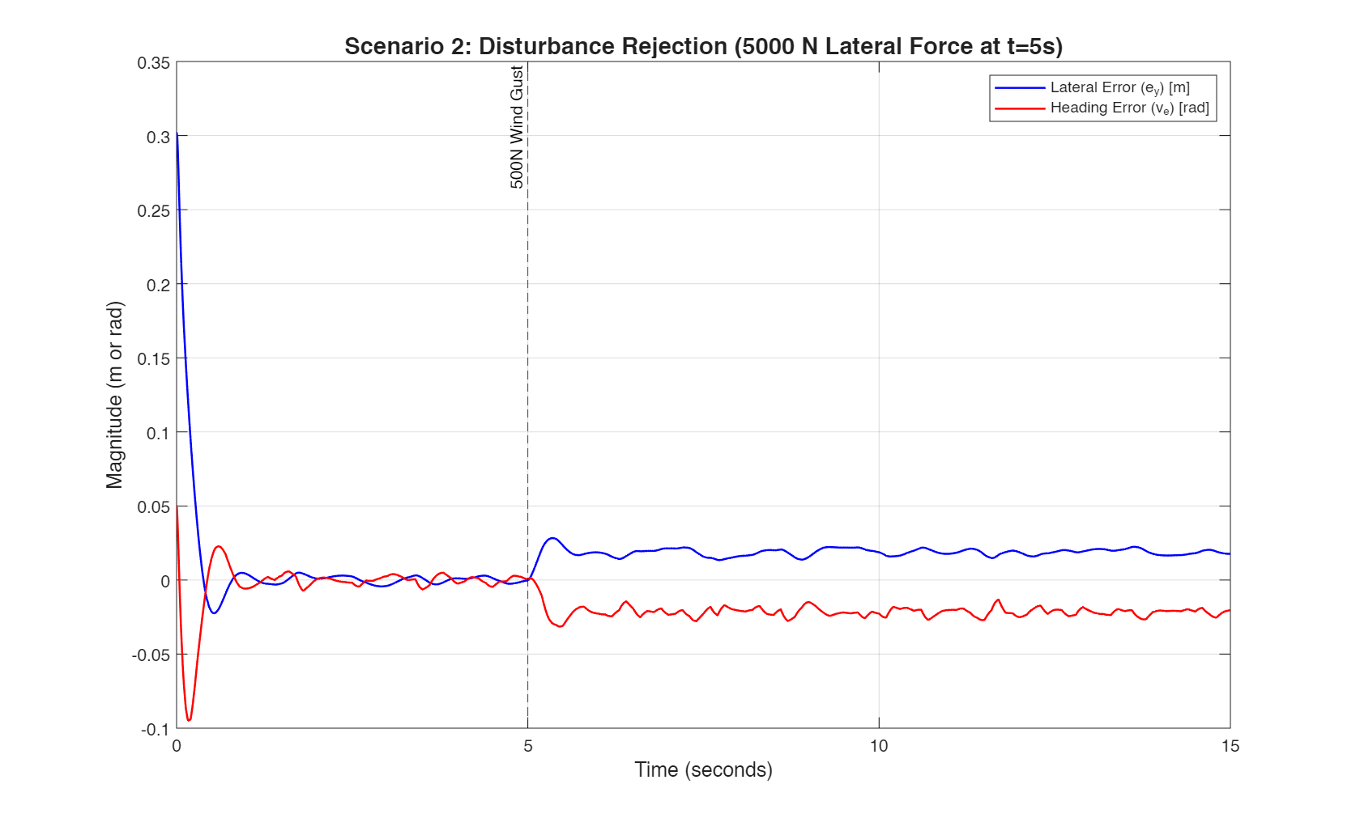
To validate the system's robustness against unpredictable environmental factors, a sudden 5000 N lateral force, representing a severe, gusting highway crosswind hitting the side profile of the vehicle, was applied directly to the vehicle's mass exactly 5 seconds into the continuous simulation.

Analysis: Prior to the 5-second mark, the vehicle tracks the lane center perfectly, subject only to the realistic minor sensor jitter intentionally injected into the model. Upon the violent disturbance impact, the lateral error predictably spikes, but the deviation is rapidly constrained.
The LQR controller impressively limits the peak lateral overshoot to approximately 0.03 m (just 3 cm). From a vehicle dynamics perspective, the heading error ($v_{e}$) is observed dropping instantly as the controller counter-steers directly into the wind. By proactively creating a lateral tire force that opposes the crosswind, the system successfully recovers the vehicle and maintains strict lane integrity, proving the controller's robust disturbance rejection capabilities despite the severe and sustained external force.

Scenario C: Curvature Tracking
This scenario tests the kinematic capabilities and limits of the system when navigating a continuous road curve rather than a straight highway segment. The reference yaw rate was adjusted to simulate the Corolla entering a sweeping curve with a constant radius ($R$) of 500 m at 20 m/s.
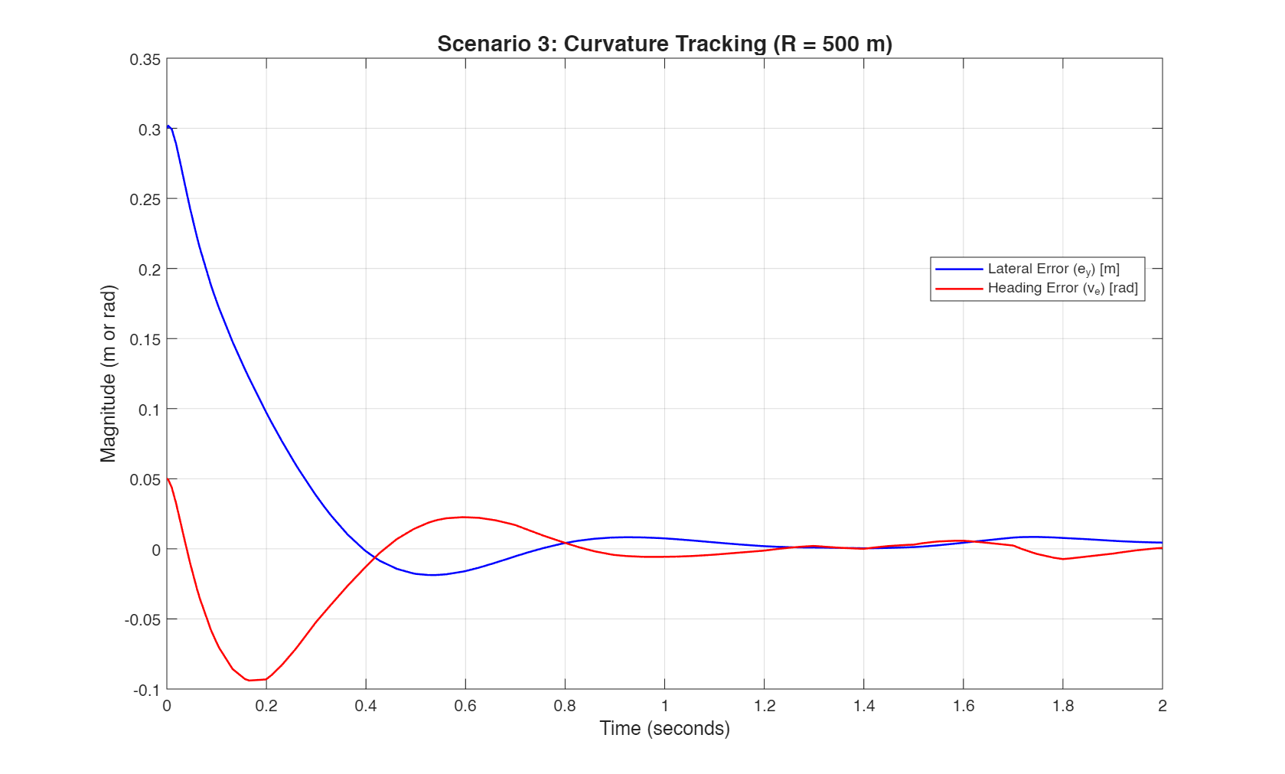
Analysis: While the controller successfully navigates the curve without leaving the lane boundaries, a distinct steady-state error becomes apparent. As the system stabilizes approaching the 2.0-second mark, the lateral error ($e_{y}$) flattens out slightly above 0 m (hovering at approximately 0.005 m).
This is an expected behavioral quirk of the chosen control architecture. Because a standard LQR controller relies entirely on proportional-derivative style state feedback and lacks an inherent integral action term, a constant, non-zero error must exist. This tiny residual error is required by the math to command the constant, non-zero steering angle necessary to maintain the tires' slip angles throughout the 500 m radius curve.

5. Failure Modes and Limitations
While the simulation demonstrates exceptionally high tracking accuracy under these modeled operational conditions, analyzing the results critically highlights several physical and mathematical limitations that must be addressed before physical prototyping:
Actuator Constraints and Slew Rate: The simulated baseline recovery in Scenario A assumes the steering actuator (the motor physically turning the wheels) can move instantaneously and with infinite torque to meet the controller's rapid demand. In a physical 2026 Corolla, the steering column possesses a strict slew rate limit (maximum degrees per second). The aggressive 0.4-second correction command would likely exceed this mechanical limit, potentially causing actuator saturation, mechanical lag, and dangerous limit-cycle oscillations not captured in this linear model.
High-Speed Instability: The system matrices ($A$ and $B$) and the resulting optimal gain matrix ($K$) are rigidly calculated for a fixed longitudinal velocity of 20 m/s. Vehicle dynamics are highly speed-dependent; if the vehicle accelerates to higher highway speeds (e.g., 35 m/s), tire slip behaviors become highly non-linear, and the pre-computed $K$ matrix will no longer be optimal. This mismatch could easily lead to severely under-damped oscillations or complete, catastrophic system instability.
Sensor Dropout and Degradation: The current closed-loop model assumes the continuous, uninterrupted availability of the $e_{y}$ and $v_{e}$ states from the camera. Because monocular camera systems rely entirely on the visual contrast of lane markings, they are highly susceptible to harsh weather (heavy rain, glare, fog) or faded road paint. A partial or total loss of the camera feed would instantly break the closed-loop feedback, resulting in an immediate system failure and requiring an emergency hand-off to the human driver.

6. Optimization Strategy
To significantly improve the LKA system's performance, safety margins, and readiness for real-world deployment, the following optimizations are proposed for the future:
Linear Quadratic Integral (LQI) Control: To completely eliminate the steady state error observed during Curvature Tracking (Scenario C), the state-space model should be augmented with an integral state. By integrating the lateral error over time, an LQI controller will force the steady-state lateral error to exactly zero, ensuring perfect lane-centering even on continuous, sweeping highway curves.
Gain Scheduling for Variable Speeds: To solve the fixed-velocity limitation and prevent high-speed instability, a gain scheduling architecture should be implemented. Multiple $K$ matrices should be pre-computed offline for a full sweep of operational velocities (e.g., every 5 m/s from 5 m/s to 40 m/s). A supervisory controller can then dynamically interpolate between these matrices in real-time, continuously adapting the steering response based on the vehicle's live speedometer data.
Kalman Filtering for State Estimation: Instead of feeding raw, noisy camera data directly into the LQR feedback loop, a state estimator—specifically a Kalman Filter—should be introduced. The Kalman Filter acts as a predictor-corrector, fusing the mathematical predictions of the vehicle dynamics model with the noisy sensor readings to estimate the true state of the car. This would drastically smooth the steering commands and allow the system to safely coast through brief, one-or-two-second sensor dropouts caused by degraded road markings.

Kinetic Bicycle Model
This section details the Phase 3 MATLAB/Simulink simulation of the Lane-Keeping Assist (LKA) system using the Kinematic Bicycle Model. Unlike the dynamic model, the kinematic approach assumes zero tire slip angles and focuses purely on the geometric relationship of the vehicle's motion. This simulation validates the theoretical state-space representation and evaluates the performance of the Linear Quadratic Regulator (LQR) under these idealized constraints.

2. System Initialization & State-Space Formulation
The simulation utilizes the reference parameters of the Toyota Corolla Altis X 1.6 traveling at a constant longitudinal velocity of $v_{x}=20\text{m/s}$ with a wheelbase of $L=2.7\text{m}$.
The kinematic model reduces the system to a two-state vector representing road-relative errors:
$$x=[\begin{matrix}e_{y} \\ e_{ψ}\end{matrix}]$$
Where $e_{y}$ is the lateral position error (in meters) and $e_{ψ}$ is the heading error (in radians). The system is mathematically defined by the following continuous time state space matrices:
$$A=[\begin{matrix}0 & 20 \\ 0 & 0\end{matrix}], B=[\begin{matrix}0 \\ 7.407\end{matrix}]$$

$$C=[\begin{matrix}1 & 0 \\ 0 & 1\end{matrix}], D=[\begin{matrix}0 \\ 0\end{matrix}]$$
LQR Controller Configuration: To maintain consistency for comparative analysis with the dynamic model, the LQR cost function weights were set identical to the corresponding states:
Q = [100 ​0 0 ​10​]
(Heavy penalty on lateral error)
$$R=[1]$$
Solving the Algebraic Riccati Equation (ARE) yields the optimal feedback gain matrix $K$, which is applied via the control law $u=-Kx$.

3. Simulink Model Architecture
The simulation was constructed in Simulink to represent the closed-loop feedback system. Key architectural components include:
State-Space Plant: Configured with the $A$, $B$, $C$, and $D$ matrices, directly outputting the dual-state vector $[e_{y},e_{ψ}]^{T}$.
Optimal Gain Block: A matrix multiplication block applies the LQR gain ($-K$) to the observed states. Strict attention was given to signal routing to ensure negative feedback was maintained, preventing controller divergence.
Curvature Disturbance Injection: To simulate road curves, the $B$ matrix was augmented with a disturbance vector $B_{c}=[\begin{matrix}0-1\end{matrix}]$. A multiplexer (Mux) was used to feed both the steering command (u) and the desired yaw rate $(\frac{v_{x}}{R}$) into the plant simultaneously.
Data Logging: Output states were routed to the MATLAB workspace via timeseries arrays (out.kinematic_states) for high-fidelity post-simulation analysis and plotting.

4. Simulation Scenarios and Results

4.1 Scenario 1: Baseline Recovery
The system was tested against a significant initial deviation to evaluate controller responsiveness. The initial conditions were set to:
Lateral Error ($e_{y,0}$): $0.3\text{m}$
Heading Error ($e_{ψ,0}$): $0.05\text{rad}$
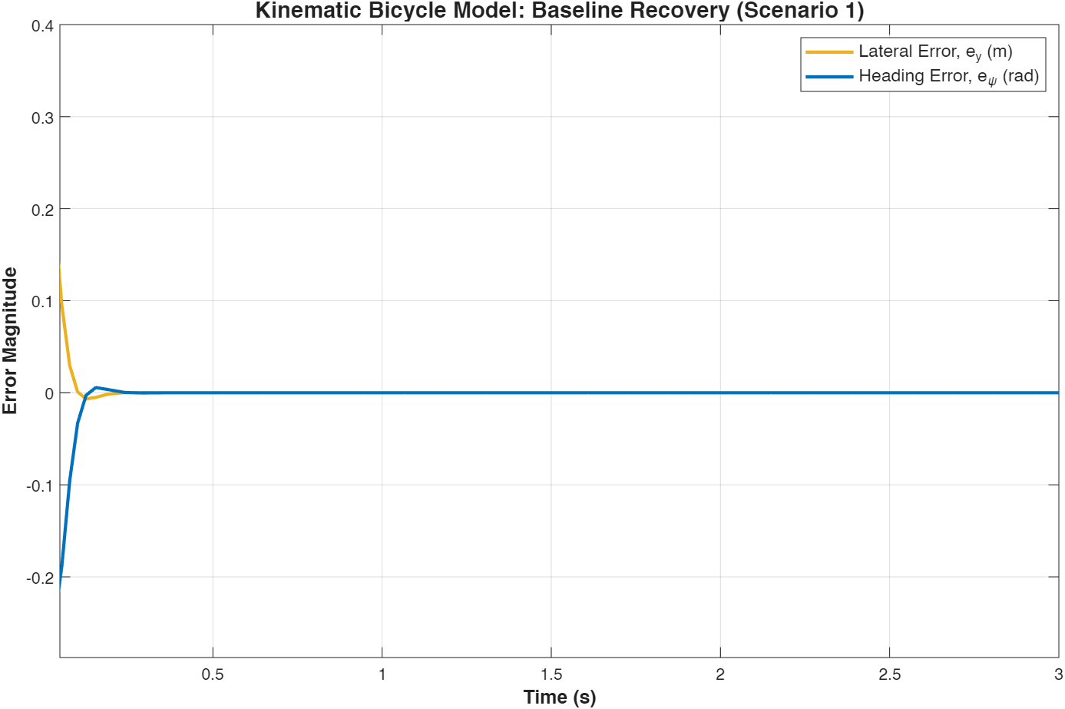
Analysis: The LQR controller aggressively corrected the initial offset, bringing both the lateral and heading errors to zero in under $0.2\text{seconds}$. The graph illustrates a sharp initial dip in the heading error (peaking briefly at approximately $-0.25\text{rad}$) as the controller immediately commands a sharp steering angle to correct the lateral deviation before smoothly straightening the vehicle. This idealized, near-instantaneous settling time highlights the absence of vehicle inertia and tire slip forces in the kinematic assumptions.

4.2 Scenario 2: Curvature Tracking (Disturbance Rejection)
To test the system's ability to maintain lane centering on a curved road, a step input representing a $500\text{m}$ radius curve was injected at $t=1\text{second}$. This acts as a continuous disturbance of $\frac{v_{x}}{R}=0.04\text{rad/s}$.
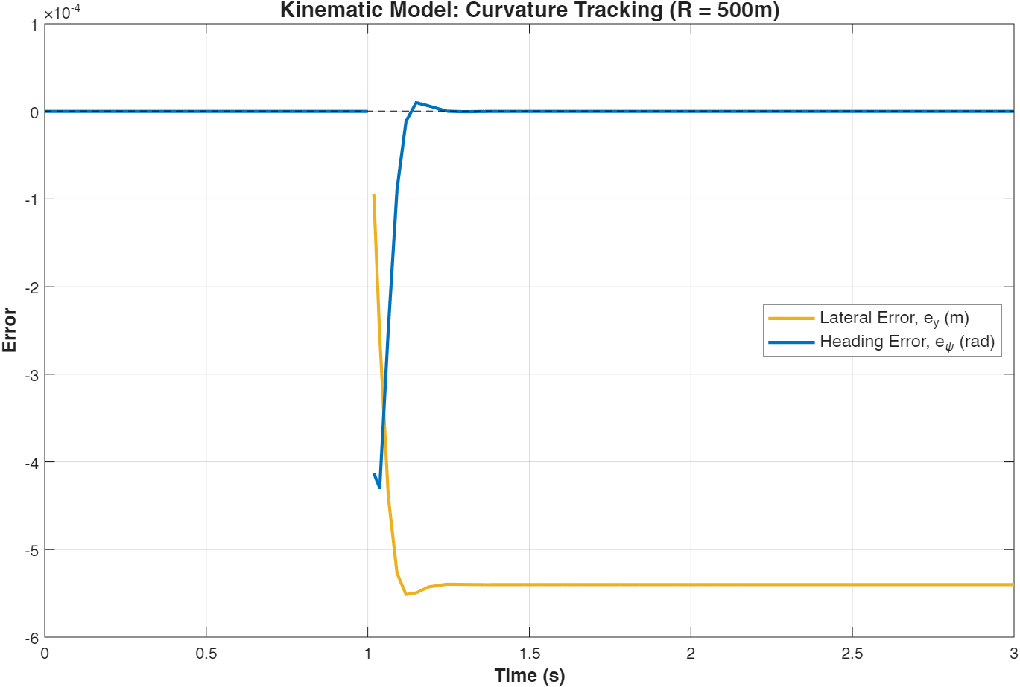
Analysis: Upon entering the curve, the lateral error experiences a negligible transient spike before settling into a flat, continuous offset. Extracting the workspace data reveals a steady-state lateral error of exactly $-0.00054\text{m}$ (or $-0.54\text{mm}$), while the heading error successfully returns to $0\text{rad}$. Because the standard LQR operates fundamentally as a Proportional-Derivative (PD) controller without integral action, this minuscule permanent offset is mathematically required to generate the constant steering angle necessary to track the curve's geometry.

Conclusion & Model Comparison
The completion of Module 3 validates the Lane-Keeping Assist (LKA) system across both dynamic and kinematic frameworks, highlighting the stark contrast between theoretical geometry and physical vehicle dynamics. The kinematic model demonstrated an idealized, highly aggressive baseline recovery with a settling time of under 0.2 seconds and a minuscule curvature steady-state error of -0.54 mm. In contrast, the dynamic model required approximately 1.0 seconds to achieve baseline stability and exhibited a larger 5 mm steady-state error. This discrepancy accurately reflects the physical resistance of mass, yaw inertia, and lateral tire forces that are inherently present during realistic 20 m/s highway driving but absent in the kinematic assumptions.
Ultimately, while the kinematic approach serves as a highly efficient mathematical baseline, it overestimates controller performance by neglecting real-world physical constraints. The dynamic bicycle model remains essential for simulating realistic operations and evaluating critical failure modes, such as actuator slew rate limits and high-speed instability. To transition this theoretical foundation into a production-ready physical prototype, future optimizations must include upgrading to a Linear Quadratic Integral (LQI) controller to eliminate steady-state curve errors, alongside integrating a Kalman Filter to ensure robust state estimation against camera sensor degradation.

