Requirements

By making a web page for a startup dating company, you will gain experience in HTML and CSS.

**The Task**

A startup company wishes to build a web site for their online dating business. They have employed a designer who has produced the following design using desktop publishing software. The software used by the designer only produces an image, and does not produce HTML.

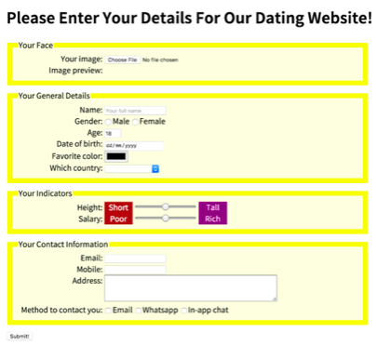   
The company has now contracted you to implement the design i.e. build the web page. This includes a working *form* component. The company thinks the designer has done a great job and wants you to implement the design without altering the style.

**Technical Overview**

From a technical point of view, the web page is constructed using HTML and CSS. Most of the HTML content are form elements. All the style parameters are handled in a style section, at the top of the same page.

**Interactive Features**

The company requires you to have two interactive features in the web page.

1. When the mouse is moved over any *label* or *input* or *select* element, the text in that element is shown larger. When the mouse moves away from the element, the text returns to its normal size.

2. Immediately after the user selects the image of his/her face, the image is shown in the web page. A small piece of JavaScript will be made available to you to help with this functionality. However, you are not expected to understand the JavaScript code at this stage in the course and should not create any further JavaScript for this assessment task.

**Discussion Video**

Please watch the accompanying video, which shows and discusses the completed task.

**What to Submit**

There are 3 parts of this assessment. You will need to submit 3 files in total, one for each part. Each subsequent part builds upon the previous part.

For Part 1, you need to create the web page content without style. Make sure you save a copy of this as, for example, part1.html, before you move on to the next part.

For Part 2, take your part 1 file and extend it by applying style. Make sure you save a copy of this as, for example, part2.html, before you move on to the next part.

For Part 3, take your part 2 file and extend it to include the interactive features. Save this as part3.html.

For Parts 2 and 3, please note that all style rules are to be included in the style section, and there should be no use of inline style.

**Further Notes**

You can only submit one single HTML file. Note that all style rules are to be included in the *style* section, and there is no use of inline style for this assessment.