**CHARLI XCX ANNOUNCES NEW ALBUM**

**'how i'm feeling now'**

**ALBUM TO BE WRITTEN, RECORDED AND RELEASED IN SELF-ISOLATION**

**TO RELEASE 15TH MAY 2020**

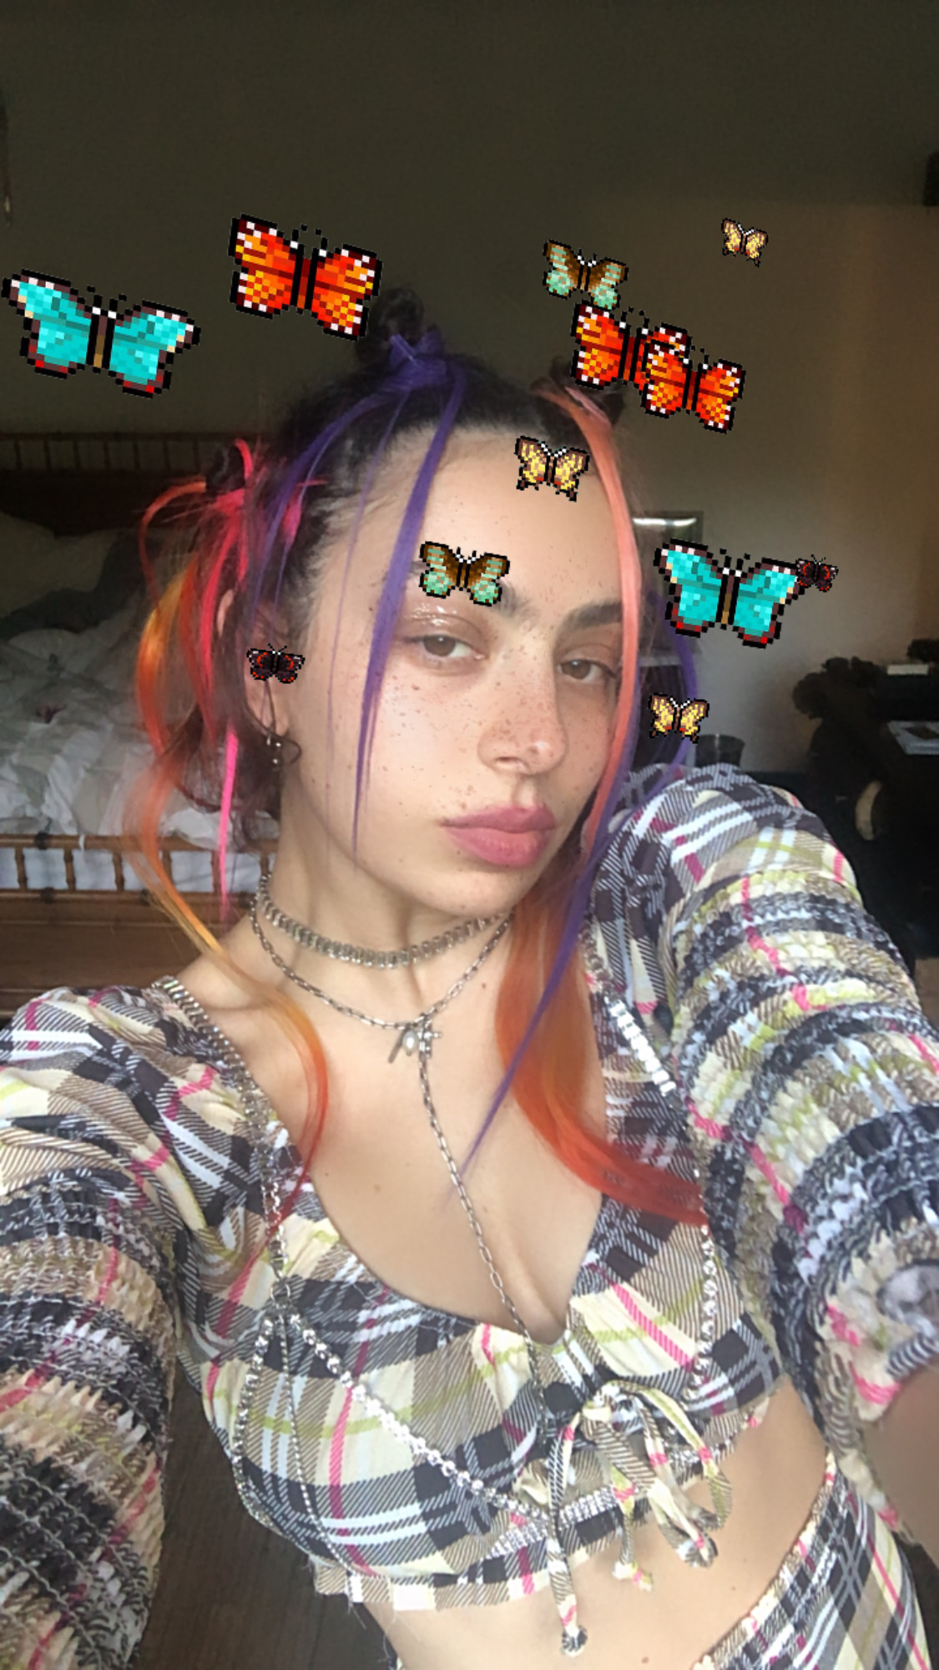

[Watch Announcement](https://www.instagram.com/tv/B-pnfvLHarc/?igshid=rguhzi9ln0xn)

Announcement transcript [here](https://docs.google.com/document/d/1x1DNSrLFNGbShsoS3yIxpMNOJLTf5PV15ccHytIxNiw/edit?usp=sharing) and hi-res press image [here](https://www.dropbox.com/s/z88ahoty8uyymmw/Charli%20XCX%20HIFN%20Press%20Shot%20hi-res.jpg?dl=0).

Charli XCX announced her new album to 1000 fans live on Zoom at 11:30am PT // 2:30pm ET // 7:30pm BST - watch via the 'how I'm feeling now' YouTube channel [here.](https://www.youtube.com/watch?v=JDlubOmyZOs&feature=youtu.be)

To support those suffering with the effects of COVID-19 if you are in a position to, please consider donating to the following charities:

[LA Alliance](https://www.la-alliance.org/)

An organisation that fights for the rights and protection of homeless peoples in Los Angeles who are currently campaigning for their protection from COVID-19. More info on their action [here](https://www.latimes.com/homeless-housing/story/2020-03-17/coronavirus-homeless-emergency-hearing-housing-shelter-federal-judge-los-angeles) and what they do [here](https://www.la-alliance.org/).

[LA Food Bank](https://www.lafoodbank.org/coronavirus/)

A food bank in LA that is in urgent need of donations as quarantine is affecting their food stock and volunteer time. People in the USA can find their local food banks [here](https://www.feedingamerica.org/find-your-local-foodbank), and in the UK [here](https://www.trusselltrust.org/get-help/find-a-foodbank/).

Charli XCX: [Facebook](https://www.facebook.com/charlixcxmusic/) | [Twitter](http://twitter.com/charli_xcx) | [Instagram](http://instagram.com/charli_xcx)

**For more information please contact Huxley: anna@huxley.world / mitch@huxley.world / jemma@huxley.world**