**WICSCC AWS challenge 2025 Team Matador**

In this challenge, team Matador of Texas Tech university took on the challenge of optimizing the Conus 12km weather simulation model with WRF. Despite various challenges, our team was able to produce results that improved the price-performance of the simulation and reduce runtime.

**Infrastructure as Code**

Included this the YAML file that was used to build our cluster for our best price-performance run.

To build a cluster using this configuration file, one must navigate to the Parallel Cluster UI provided by AWS. Here, click “Build Cluster” then “create from template”. When the File Explorer pops up, select the given YAML file and continue. Every window should already have the right configurations. On the first page, you will need to make a selection from the VCP dropdown menu, in which there is only one option. Also, on the “step 2” page, ensure to choose the “az2” option from the subnet ID dropdown.

When at the last page, click “dry run” to test the setup, then build the node.

**Setting Up Cluster**  
Once the cluster is done building, open up the cluster shell. Change to the ec2-user and navigate to the home directory.

sudo su ec2-user

cd ~

Given are the cluster-setup.sh and wrf-setup.sh files, which configure the cluster and configure, WRF, and the conus 12 km model to run. Copy these into your home directory and run them using the source command:

source cluster-setup.sh

cd ~

source wrf-setup.sh

This step also creates your best-run.sh file, which can now be used to simulate the conus 12k model. The batch script as well as the output for this run is also included with this submission.

cd /fsx/conus_12km

sbatch best-run.sh

**Price and Performance**

The table recording our performance and cost for various configurations is given below. It is also included in the excel sheet with the submission file.

Three graphs, the configuration vs performance (simulation time), the configuration vs the simulation cost, and the price to performance are included below.

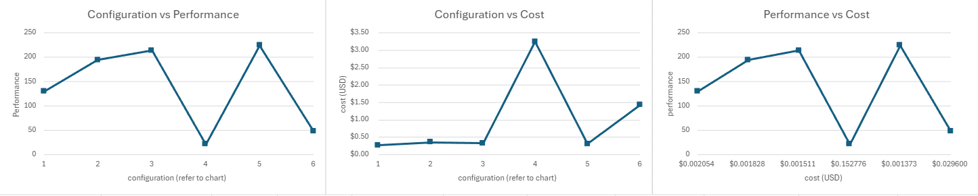

Overall, our best configuration was configuration 3, which gave us our best price to performance as well as our best runtime. This gave us a simulation cost of $0.31 and a price to performance of $0.001511.

Due to failing nodes and quota limitations, we were unable to test many different hardware configurations. Instead, we tuned the number of instances, the tasks per node, and the OMP number of threads used for the simulation to get our best result.

**Renderings**

The output renderings from the conus 12km are included below:

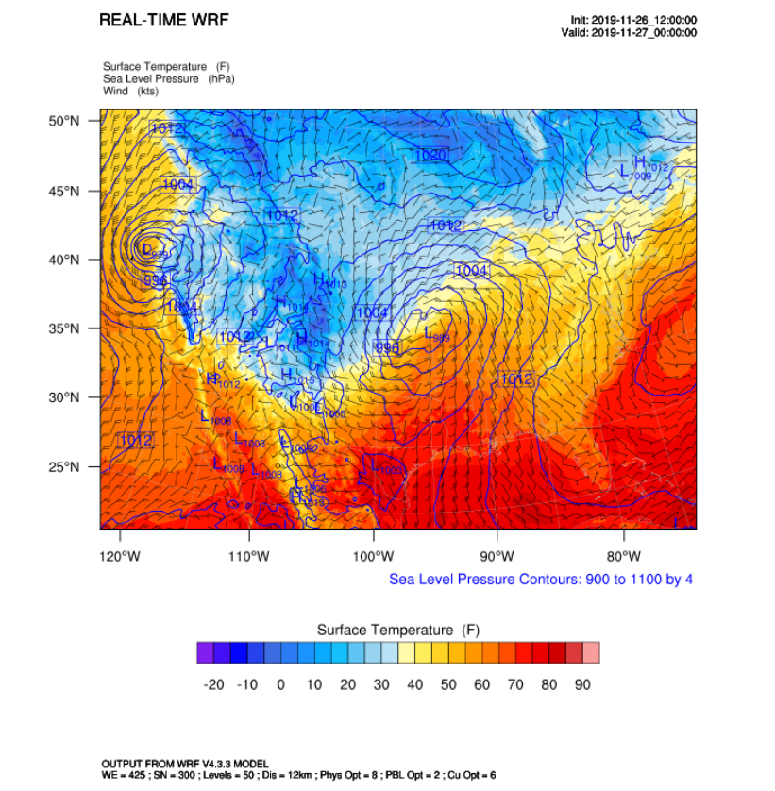

**Proof of Cluster Building**

Below is proof that clusters were built by two team members, Graysen Gould and Batuhan Senser, on 2-26-25 and 3-1-25 respectively. More screenshots and videos are included in the submission file.

Proof of Graysen building cluster on 2-26-25:

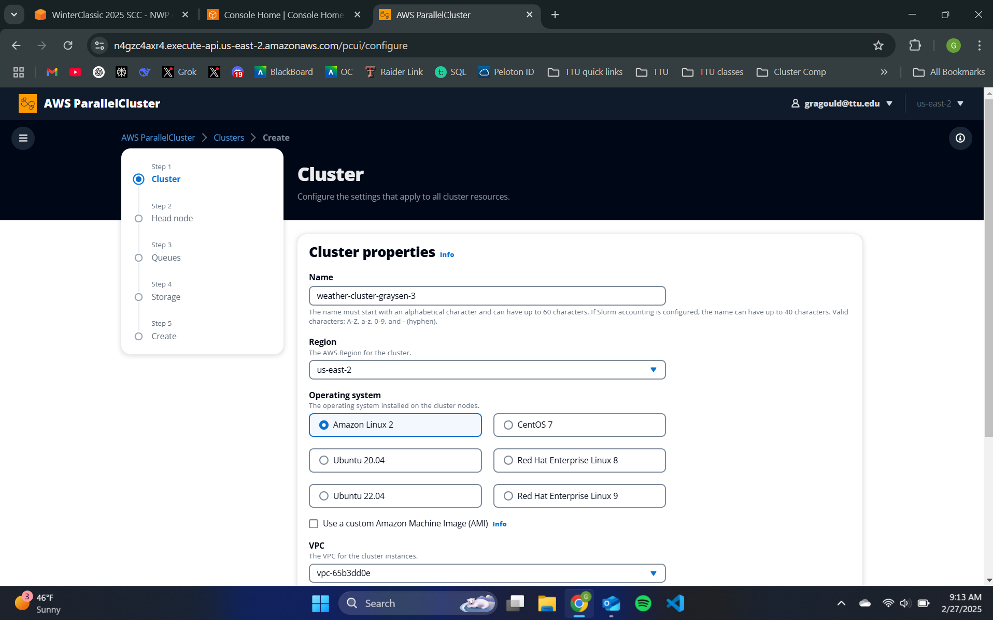

Proof of Batuhan building a cluster on 3-1-25:

