Grayson Giles

CIS241 Fall 2022

Site Specification

This project contains 5 webpages

* home.html
* interest.html
* reflections.html
* guestbook.html
* resume.html

An external CSS file name myStyle.css

And various images

Home.html is meant to introduce user to the website and give a brief overview of myself and some of my interests. At the top of this and all other pages are buttons to easily navigate to other webpages on the website as well as a link to return to the top of the webpage.

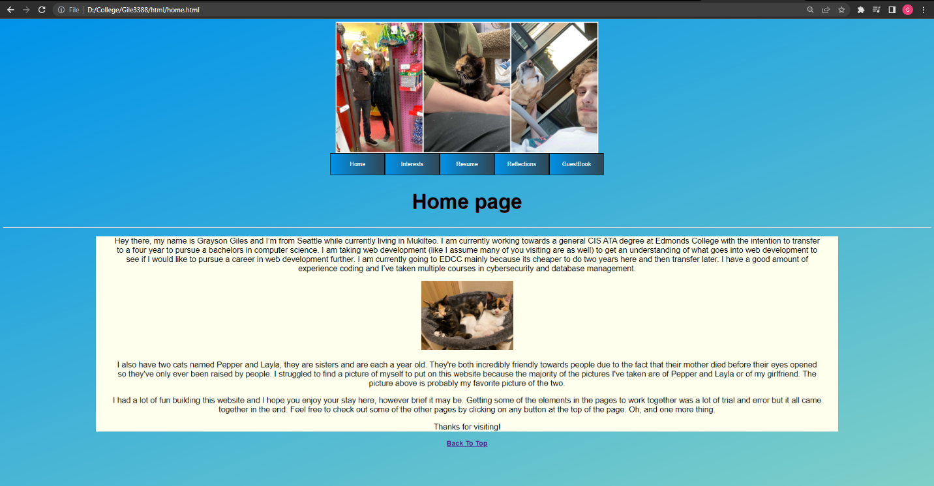

Interest.html is meant to expand upon some of my interests mentioned in the home page and provide clickable links to other websites pertaining to said interests.

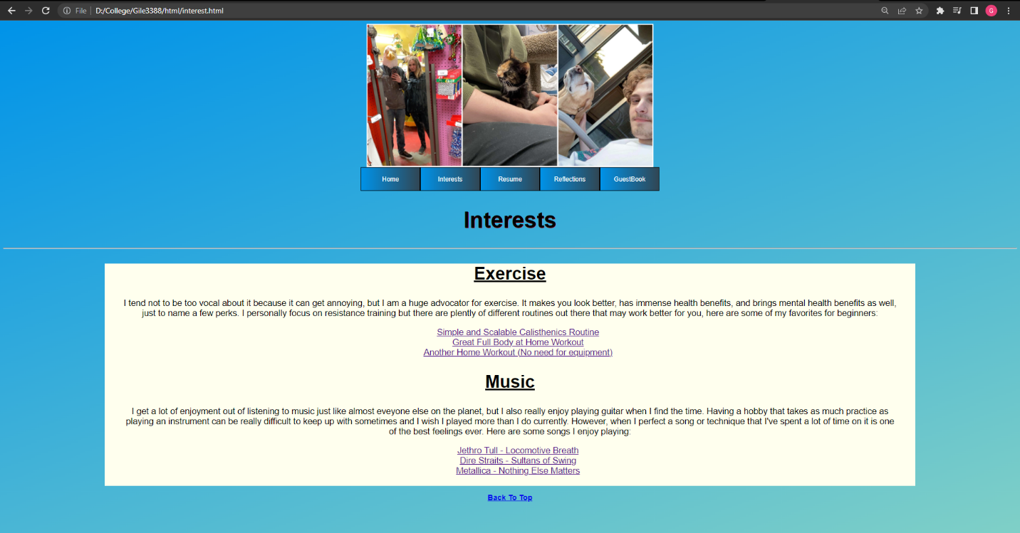

Reflections.html is meant to document my thoughts on CIS242 Web Development when looking back at the end of the fall quarter.

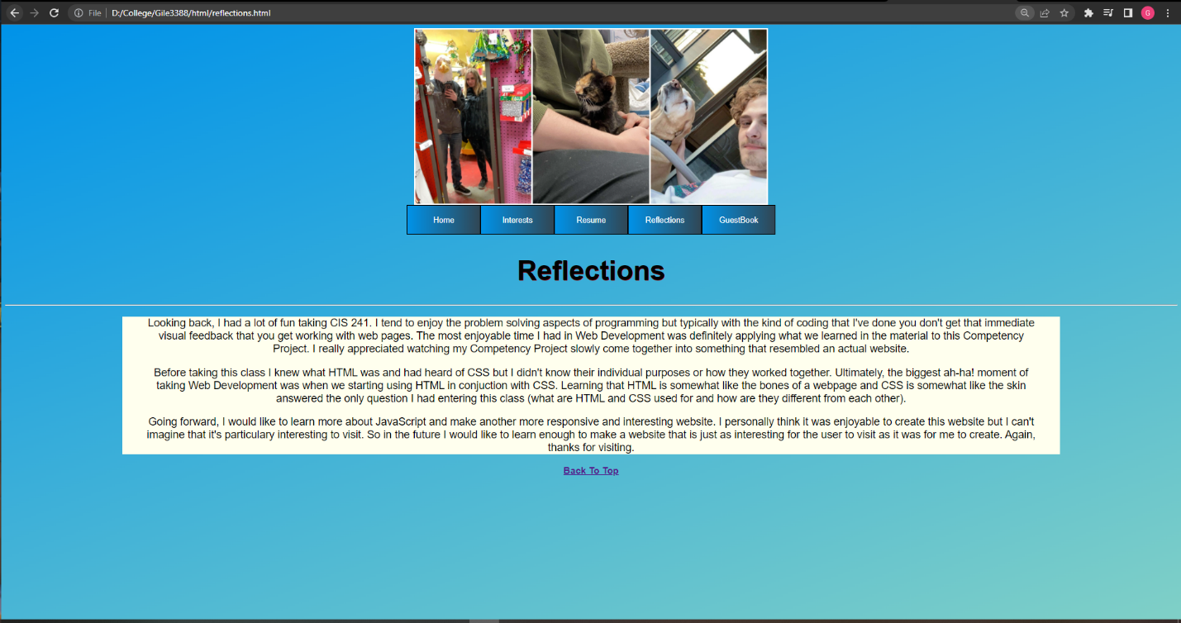

Guestbook.html is meant for users to leave information about themselves and comments they have about the website. The information is entered via text areas, radio buttons, checkboxes, and select options. The form may also be reset with a button.

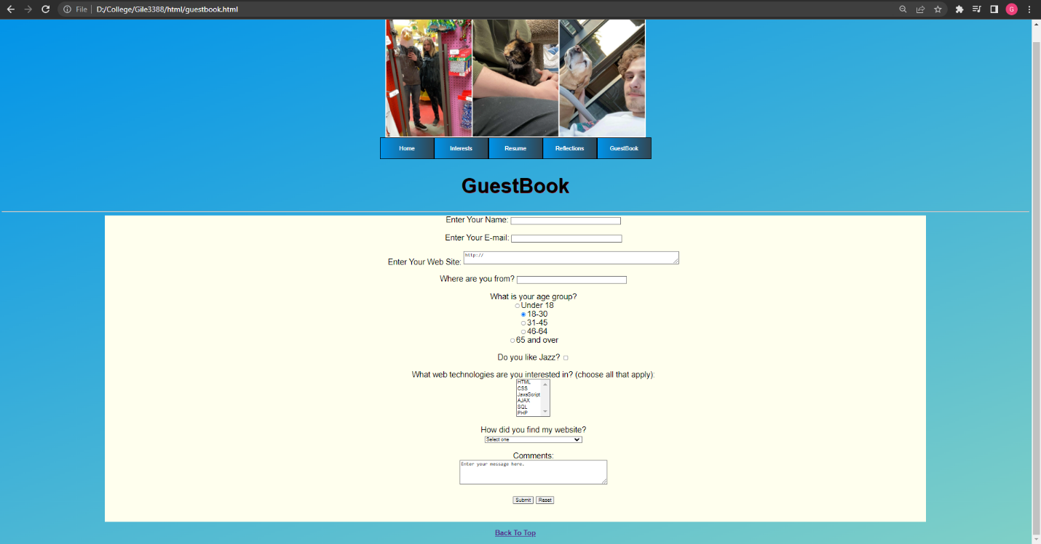

Resume.html is to display my current resume containing a desired job description, current skills, education, and employment history for the user.

