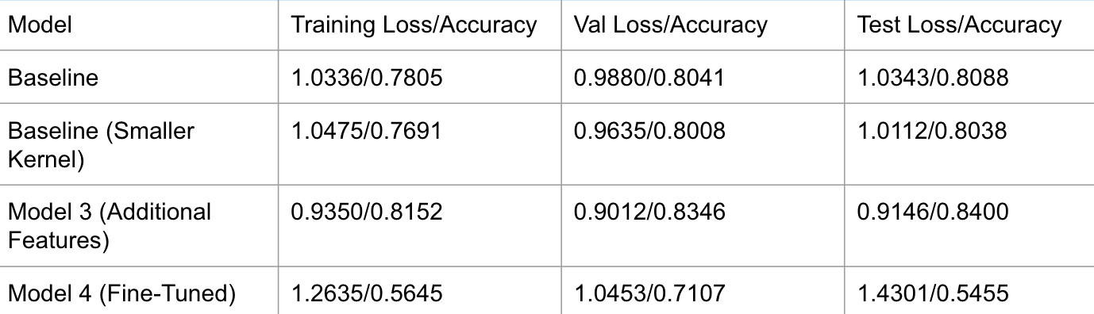

Model

Training Loss/Accuracy Val Loss/Accuracy

Test Loss/Accuracy

Baseline

1.0336/0.7805

0.9880/0.8041

1.0343/0.8088

Baseline (Smaller

1.0475/0.7691

0.9635/0.8008

1.0112/0.8038

Kernel)

Model 3 (Additional

0.9350/0.8152

0.9012/0.8346

0.9146/0.8400

Features)

Model 4 (Fine-Tuned)

1.2635/0.5645

1.0453/0.7107

1.4301/0.5455