Лекция 1:

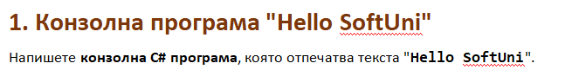

using System;

public class Program

{

public static void Main()

{

Console.WriteLine("Hello SoftUni");

}

}

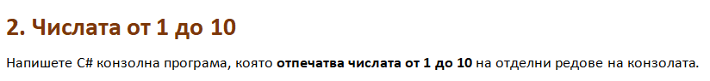

using System;

public class Program

{

public static void Main()

{

Console.WriteLine(1);

Console.WriteLine(2);

Console.WriteLine(3);

Console.WriteLine(4);

Console.WriteLine(5);

Console.WriteLine(6);

Console.WriteLine(7);

Console.WriteLine(8);

Console.WriteLine(9);

Console.WriteLine(10);

}

}

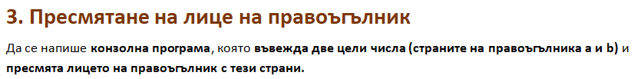

using System;

public class Program

{

public static void Main()

{

int a = int.Parse(Console.ReadLine());

int b = int.Parse(Console.ReadLine());

Console.WriteLine(a\*b);

}

}

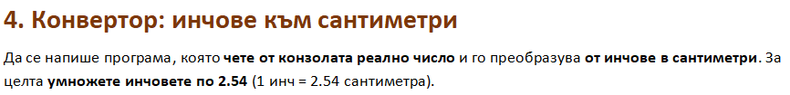

using System;

public class Program

{

public static void Main()

{

double a = double.Parse(Console.ReadLine());

double b = a\*2.54;

Console.WriteLine(b);

}

}

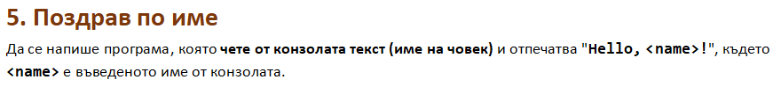

using System;

public class Program

{

public static void Main()

{

string name = Console.ReadLine();

Console.WriteLine($"Hello, {name}!");

}

}

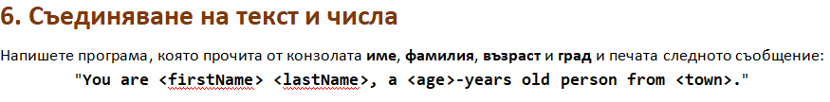

using System;

public class Program

{

public static void Main()

{

string name = Console.ReadLine();

string lastName = Console.ReadLine();

int age = int.Parse(Console.ReadLine());

string town = Console.ReadLine();

Console.WriteLine($"You are <name> <lastName>, a <age>-years old person from <town>.");

}

}

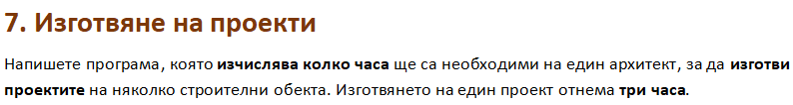

using System;

public class Program

{

public static void Main()

{

string name = Console.ReadLine();

int projectsNum = int.Parse(Console.ReadLine());

int hours = projectsNum \* 3;

Console.WriteLine($"The architect {name} will need {hours} hours to complete {projectsNum} project/s.");

}

}

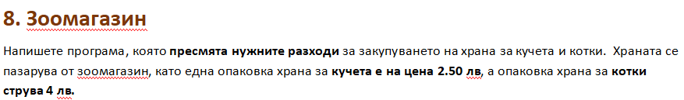

using System;

public class Program

{

public static void Main()

{

int dogFood = int.Parse(Console.ReadLine());

int catFood = int.Parse(Console.ReadLine());

Console.WriteLine((dogFood\*2.5) + (catFood\*4) + " lv.");

}

}

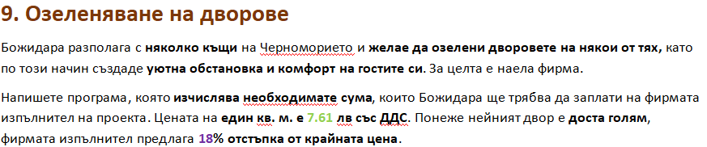

using System;

public class Program

{

public static void Main()

{

double area = double.Parse(Console.ReadLine());

double price = area \* 7.61;

double discount = price \* 0.18;

double finalPrice = price - discount;

Console.WriteLine($"The final price is: {finalPrice} lv.");

Console.WriteLine($"The discount is: {discount} lv.");

}

}