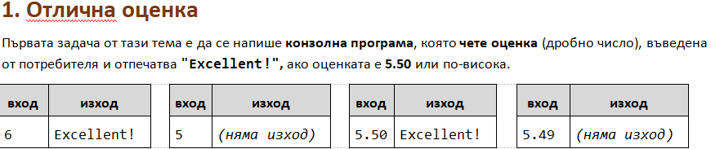

using System;

public class Program

{

public static void Main()

{

double grade = double.Parse(Console.ReadLine());

if (grade >= 5.5){

Console.WriteLine( "Excellent!" );

}

}

}

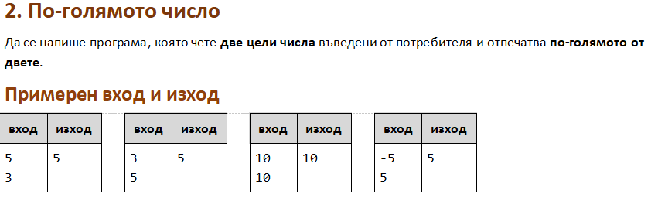

using System;

public class Program

{

public static void Main()

{

int a = int.Parse(Console.ReadLine());

int b = int.Parse(Console.ReadLine());

if (a >=b ){

Console.WriteLine(a);

}

else if (b >=a ){

Console.WriteLine(b);

}

}

}

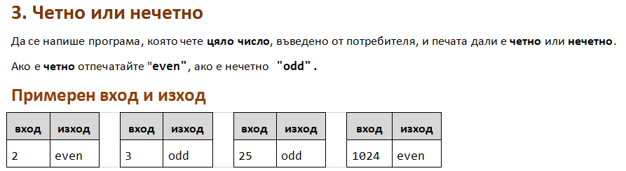

using System;

public class Program

{

public static void Main()

{

int num = int.Parse(Console.ReadLine());

if ((num % 2) == 0){

Console.WriteLine("even");

}

else{

Console.WriteLine("odd");

}

}

}

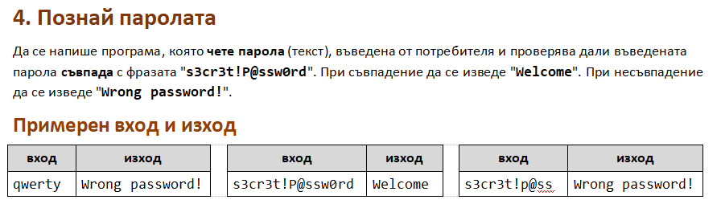

using System;

public class Program

{

public static void Main()

{

//int num = int.Parse(Console.ReadLine());

string password = "s3cr3t!P@ssw0rd";

string input = Console.ReadLine();

if (password == input){

Console.WriteLine("Welcome");

}

else{

Console.WriteLine("Wrong password!");

}

}

}

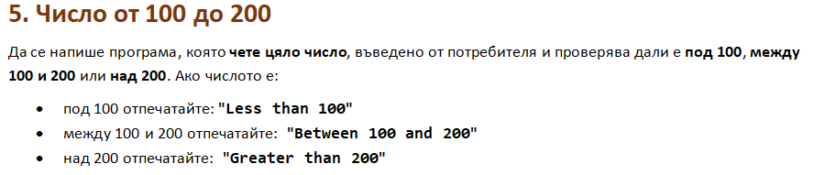

using System;

public class Program

{

public static void Main()

{

int num = int.Parse(Console.ReadLine());

if (num < 100) {

Console.WriteLine("Less than 100");

}

else if (num > 200) {

Console.WriteLine("Greater than 200");

}

else{

Console.WriteLine("Between 100 and 200");

}

}

}

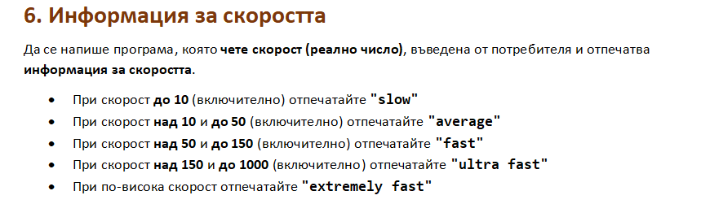using System;

public class Program

{

public static void Main()

{

double speed = double.Parse(Console.ReadLine());

if (speed <= 10) {

Console.WriteLine("slow");

}

else if ((speed > 10) && (speed <= 50)) {

Console.WriteLine("average");

}

else if ((speed > 50) && (speed <= 150)) {

Console.WriteLine("fast");

}

else if ((speed > 150) && (speed <= 1000)) {

Console.WriteLine("ultra fast");

}

else if (speed > 1000) {

Console.WriteLine("extremely fast");

}

}

}

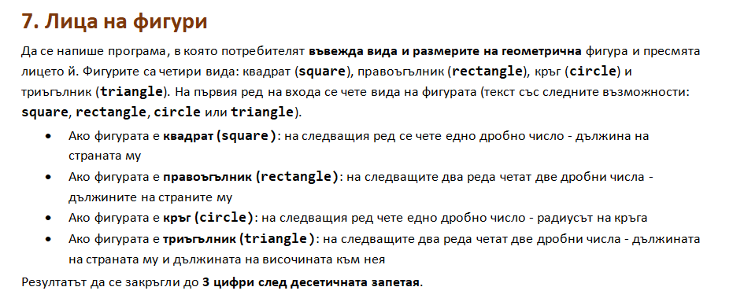

using System;

public class Program

{

public static void Main()

{

string figure = Console.ReadLine();

if (figure == "square"){

double side = double.Parse(Console.ReadLine());

Console.WriteLine("{0:F3}", (side \* side));

}

else if (figure == "rectangle") {

double side1 = double.Parse(Console.ReadLine());

double side2 = double.Parse(Console.ReadLine());

Console.WriteLine("{0:F3}", side1 \* side2);

}

else if (figure == "circle") {

double radius = double.Parse(Console.ReadLine());

Console.WriteLine("{0:F3}", radius \* radius \* Math.PI);

}

else if (figure == "triangle") {

double side1 = double.Parse(Console.ReadLine());

double side2 = double.Parse(Console.ReadLine());

Console.WriteLine("{0:F3}", (side1 \* side2) / 2);

}

}

}