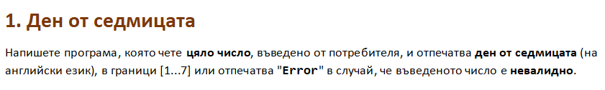

using System;

public class Program

{

public static void Main()

{

int day = int.Parse(Console.ReadLine());

switch (day){

case 1:

Console.WriteLine("Monday");

break;

case 2:

Console.WriteLine("Tuesday");

break;

case 3:

Console.WriteLine("Wednesday");

break;

case 4:

Console.WriteLine("Thursday");

break;

case 5:

Console.WriteLine("Friday");

break;

case 6:

Console.WriteLine("Saturday");

break;

case 7:

Console.WriteLine("Sunday");

break;

default:

Console.WriteLine("Error");

break;

}

}

}

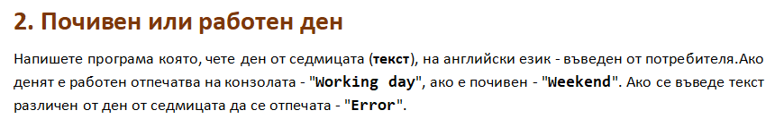

using System;

public class Program

{

public static void Main()

{

string dayOfWeek = Console.ReadLine();

switch (dayOfWeek){

case "Monday":

case "Tuesday":

case "Wednesday":

case "Thursday":

case "Friday":

Console.WriteLine("Working day");

break;

case "Saturday":

case "Sunday":

Console.WriteLine("Weekend");

break;

default:

Console.WriteLine("Error");

break;

}

}

}

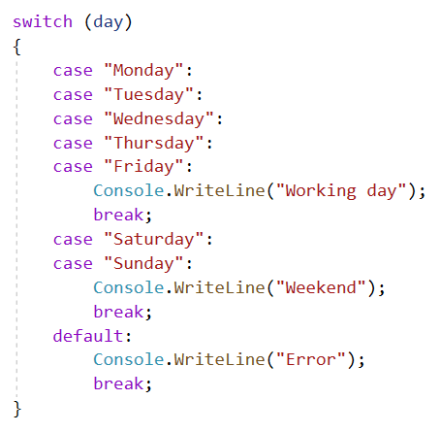

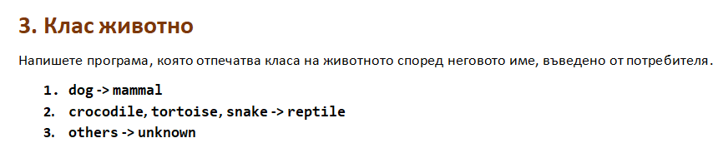

using System;

public class Program

{

public static void Main()

{

string animal = Console.ReadLine();

switch (animal){

case "dog":

Console.WriteLine("mammal");

break;

case "crocodile":

case "tortoise":

case "snake":

Console.WriteLine("reptile");

break;

default:

Console.WriteLine("unknown");

break;

}

}

}

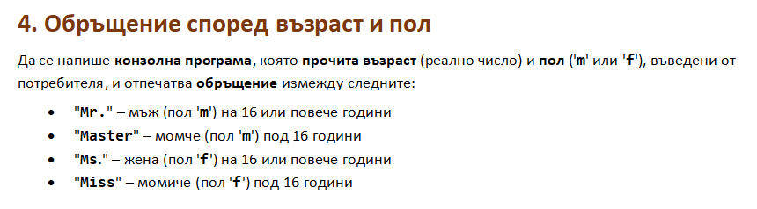

using System;

public class Program

{

public static void Main()

{

double age = double.Parse(Console.ReadLine());

char sex = char.Parse(Console.ReadLine());

if (sex == 'f'){

if (age < 16){

Console.WriteLine("Miss");

}else if (age >= 16){

Console.WriteLine("Ms.");

}

}else if (sex == 'm'){

if (age < 16){

Console.WriteLine("Master");

}else if (age >= 16){

Console.WriteLine("Mr.");

}

}

}

}

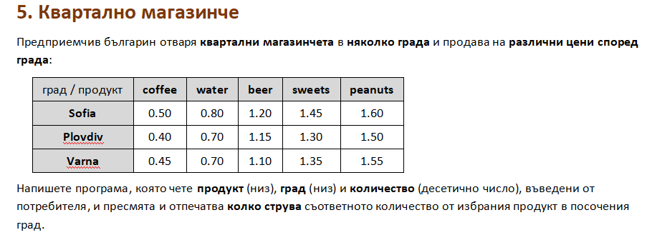

using System;

public class Program

{

public static void Main()

{

string product = Console.ReadLine();

string town = Console.ReadLine();

double quantity = double.Parse(Console.ReadLine());

if (product == "coffee"){

if (town == "Sofia"){

Console.WriteLine(quantity \* 0.5);

}else if (town == "Plovdiv"){

Console.WriteLine(quantity \* 0.4);

}else if (town == "Varna"){

Console.WriteLine(quantity \* 0.45);

}

}else if (product == "water"){

if (town == "Sofia"){

Console.WriteLine(quantity \* 0.8);

}else if (town == "Plovdiv"){

Console.WriteLine(quantity \* 0.7);

}else if (town == "Varna"){

Console.WriteLine(quantity \* 0.7);

}

}else if (product == "sweets"){

if (town == "Sofia"){

Console.WriteLine(quantity \* 1.45);

}else if (town == "Plovdiv"){

Console.WriteLine(quantity \* 1.30);

}else if (town == "Varna"){

Console.WriteLine(quantity \* 1.35);

}

}else if (product == "beer"){

if (town == "Sofia"){

Console.WriteLine(quantity \* 1.2);

}else if (town == "Plovdiv"){

Console.WriteLine(quantity \* 1.15);

}else if (town == "Varna"){

Console.WriteLine(quantity \* 1.1);

}

}else if (product == "peanuts"){

if (town == "Sofia"){

Console.WriteLine(quantity \* 1.6);

}else if (town == "Plovdiv"){

Console.WriteLine(quantity \* 1.5);

}else if (town == "Varna"){

Console.WriteLine(quantity \* 1.55);

}

}

}

}

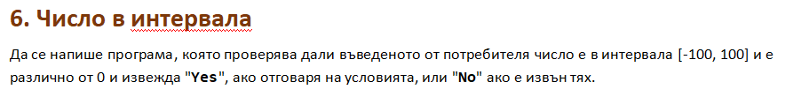

using System;

public class Program

{

public static void Main()

{

int num = int.Parse(Console.ReadLine());

if (num <= 100 && num >= -100 && num != 0){

Console.WriteLine("Yes");

}else {

Console.WriteLine("No");

}

}

}

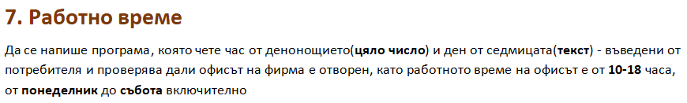

using System;

public class Program

{

public static void Main()

{

int hour = int.Parse(Console.ReadLine());

string day = Console.ReadLine();

if (hour <= 18 && hour >= 10 && (day == "Monday" || day == "Tuesday" || day == "Wednesday" || day == "Thursday" || day == "Friday" || day == "Saturday" )){

Console.WriteLine("open");

}else {

Console.WriteLine("closed");

}

}

}

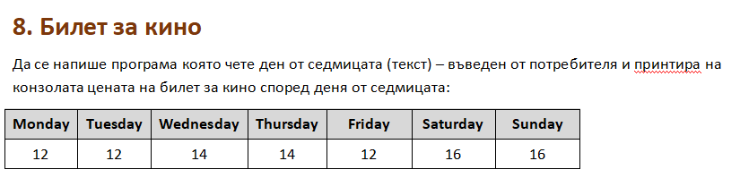

using System;

public class Program

{

public static void Main()

{

string dayOfWeek = Console.ReadLine();

switch (dayOfWeek){

case "Monday":

Console.WriteLine(12);

break;

case "Tuesday":

Console.WriteLine(12);

break;

case "Wednesday":

Console.WriteLine(14);

break;

case "Thursday":

Console.WriteLine(14);

break;

case "Friday":

Console.WriteLine(12);

break;

case "Saturday":

Console.WriteLine(16);

break;

case "Sunday":

Console.WriteLine(16);

break;

default:

Console.WriteLine("Error");

break;

}

}

}

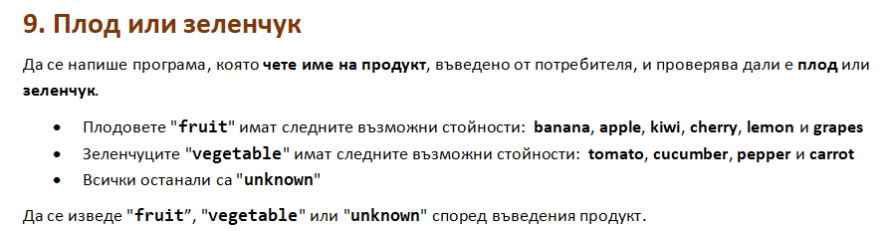

using System;

public class Program

{

public static void Main()

{

string product = Console.ReadLine();

switch (product){

case "banana":

case "apple":

case "kiwi":

case "cherry":

case "lemon":

case "grapes":

Console.WriteLine("fruit");

break;

case "tomato":

case "pepper":

case "cucumber":

case "carrot":

Console.WriteLine("vegetable");

break;

default:

Console.WriteLine("unknown");

break;

}

}

}

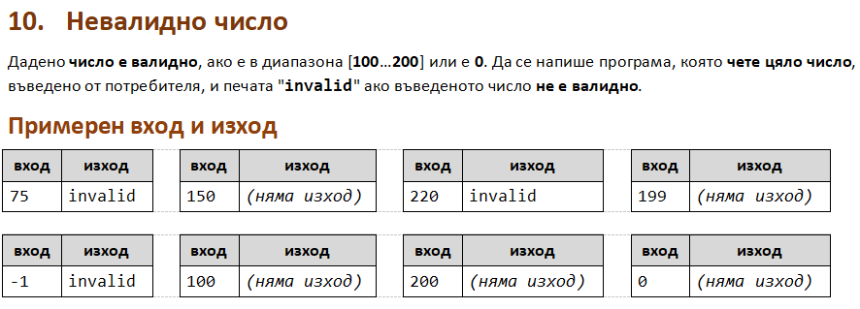

using System;

public class Program

{

public static void Main()

{

int num = int.Parse(Console.ReadLine());

if (num <= 200 && num >= 100 || num == 0){

}else {

Console.WriteLine("invalid");

}

}

}

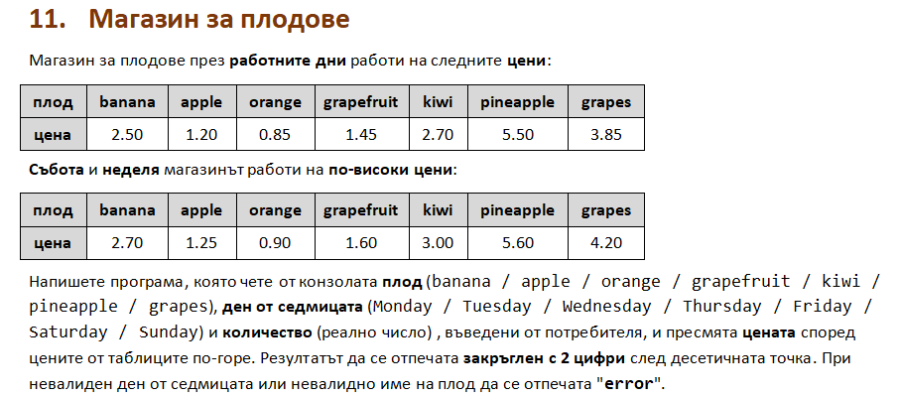

using System;

public class Program

{

public static void Main()

{

string product = Console.ReadLine();

string day = Console.ReadLine();

double quantity = double.Parse(Console.ReadLine());

double price = 0;

if (day == "Monday" || day == "Tuesday" || day == "Wednesday" || day == "Thursday" || day == "Friday" ){

if (product == "banana"){

price = quantity \* 2.5;

Console.WriteLine($"{(price):F2}");

} else if (product == "apple"){

price = quantity \* 1.2;

Console.WriteLine($"{(price):F2}");

} else if (product == "orange"){

price = quantity \* 0.85;

Console.WriteLine($"{(price):F2}");

} else if (product == "grapefruit"){

price = quantity \* 1.45;

Console.WriteLine($"{(price):F2}");

} else if (product == "kiwi"){

price = quantity \* 2.7;

Console.WriteLine($"{(price):F2}");

} else if (product == "pineapple"){

price = quantity \* 5.5;

Console.WriteLine($"{(price):F2}");

}else if (product == "grapes"){

price = quantity \* 3.85;

Console.WriteLine($"{(price):F2}");

} else{

Console.WriteLine("error");

}

} else if (day == "Saturday" || day == "Sunday"){

if (product == "banana"){

price = quantity \* 2.7;

Console.WriteLine($"{(price):F2}");

} else if (product == "apple"){

price = quantity \* 1.25;

Console.WriteLine($"{(price):F2}");

} else if (product == "orange"){

price = quantity \* 0.9;

Console.WriteLine($"{(price):F2}");

} else if (product == "grapefruit"){

price = quantity \* 1.6;

Console.WriteLine($"{(price):F2}");

} else if (product == "kiwi"){

price = quantity \* 3;

Console.WriteLine($"{(price):F2}");

} else if (product == "pineapple"){

price = quantity \* 5.6;

Console.WriteLine($"{(price):F2}");

}else if (product == "grapes"){

price = quantity \* 4.2;

Console.WriteLine($"{(price):F2}");

} else{

Console.WriteLine("error");

}

} else {

Console.WriteLine("error");

}

}

}

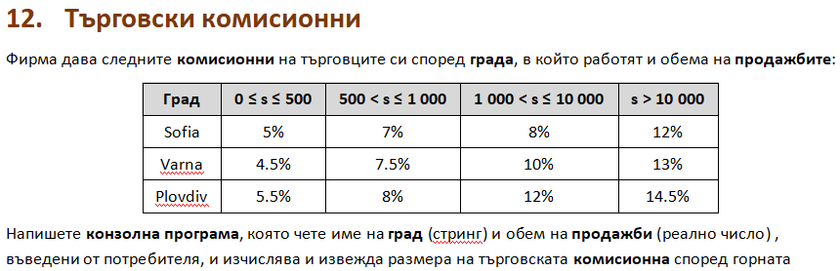

using System;

public class Program

{

public static void Main()

{

string town = Console.ReadLine();

double quantity = double.Parse(Console.ReadLine());

double commition = 0;

if (quantity >= 0 && quantity <= 500){

if (town == "Sofia"){

commition = quantity \* 0.05;

Console.WriteLine($"{(commition):F2}");

}else if (town == "Plovdiv"){

commition = quantity \* 0.055;

Console.WriteLine($"{(commition):F2}");

}else if (town == "Varna"){

commition = quantity \* 0.045;

Console.WriteLine($"{(commition):F2}");

}else {

Console.WriteLine("error");

}

}else if (quantity > 500 && quantity <= 1000){

if (town == "Sofia"){

commition = quantity \* 0.07;

Console.WriteLine($"{(commition):F2}");

}else if (town == "Plovdiv"){

commition = quantity \* 0.08;

Console.WriteLine($"{(commition):F2}");

}else if (town == "Varna"){

commition = quantity \* 0.075;

Console.WriteLine($"{(commition):F2}");

}else {

Console.WriteLine("error");

}

}else if (quantity > 1000 && quantity <= 10000){

if (town == "Sofia"){

commition = quantity \* 0.08;

Console.WriteLine($"{(commition):F2}");

}else if (town == "Plovdiv"){

commition = quantity \* 0.12;

Console.WriteLine($"{(commition):F2}");

}else if (town == "Varna"){

commition = quantity \* 0.1;

Console.WriteLine($"{(commition):F2}");

}else {

Console.WriteLine("error");

}

}else if (quantity > 10000){

if (town == "Sofia"){

commition = quantity \* 0.12;

Console.WriteLine($"{(commition):F2}");

}else if (town == "Plovdiv"){

commition = quantity \* 0.145;

Console.WriteLine($"{(commition):F2}");

}else if (town == "Varna"){

commition = quantity \* 0.13;

Console.WriteLine($"{(commition):F2}");

} else {

Console.WriteLine("error");

}

} else {

Console.WriteLine("error");

}

}

}