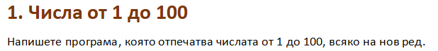

using System;

public class Program

{

public static void Main()

{

for (int i = 1; i <= 100 ; i++){

Console.WriteLine(i);

}

}

}

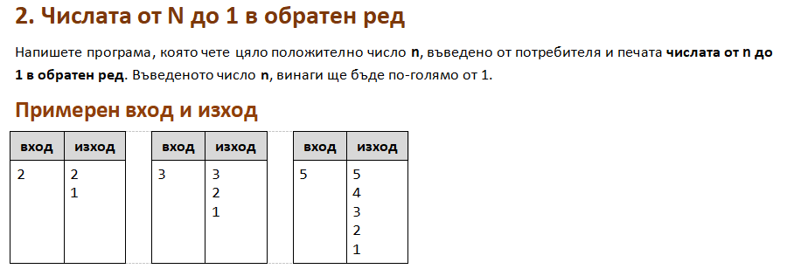

using System;

public class Program

{

public static void Main()

{

int n = int.Parse(Console.ReadLine());

for (int i = n; i >= 1 ; i--){

Console.WriteLine(i);

}

}

}

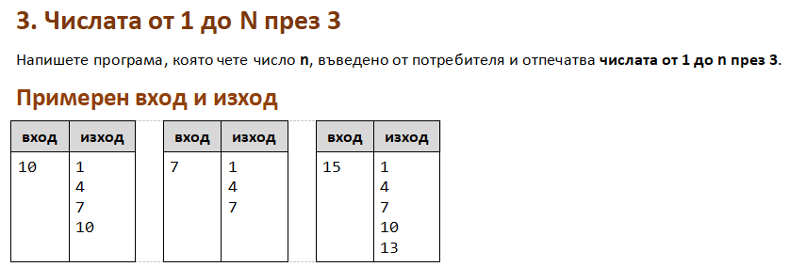

using System;

public class Program

{

public static void Main()

{

int n = int.Parse(Console.ReadLine());

for (int i = 1; i <= n ; i+=3){

Console.WriteLine(i);

}

}

}

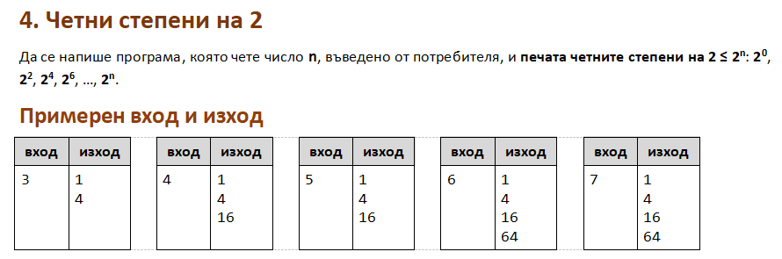

using System;

public class Program

{

public static void Main()

{

int n = int.Parse(Console.ReadLine());

for (int i = 0; i <= n ; i+=2){

Console.WriteLine(Math.Pow(2, i));

}

}

}



using System;

public class Program

{

public static void Main()

{

string inputText = Console.ReadLine();

for (int i = 0; i <= (inputText.Length -1) ; i++){

Console.WriteLine(inputText[i]);

}

}

}

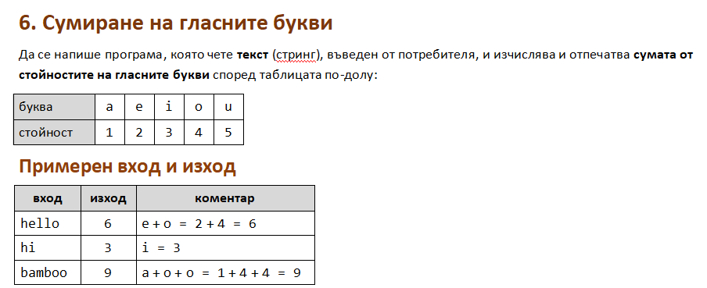

using System;

public class Program

{

public static void Main()

{

string inputText = Console.ReadLine();

char letter;

int sum = 0;

for (int i = 0; i <= (inputText.Length -1) ; i++){

letter = inputText[i];

if (letter == 'a'){

sum = sum + 1;

} else if (letter == 'e'){

sum = sum + 2;

}else if (letter == 'i'){

sum = sum + 3;

}else if (letter == 'o'){

sum = sum + 4;

}else if (letter == 'u'){

sum = sum + 5;

}

}

Console.WriteLine(sum);

}

}

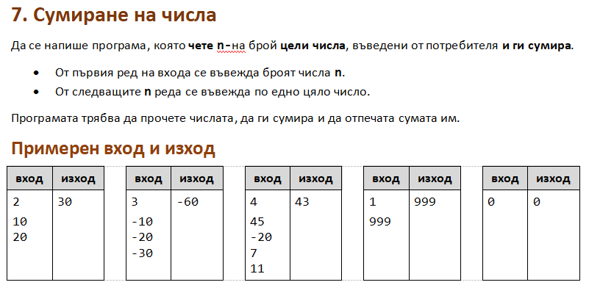

using System;

public class Program

{

public static void Main()

{

int n = int.Parse(Console.ReadLine());

int min = int.MaxValue;

int max = int.MinValue;

int num = 0;

for (int i = 0; i < n ; i++){

num = int.Parse(Console.ReadLine());

if (num > max){

max = num;

}

if (num < min){

min = num;

}

}

Console.WriteLine("Max number: " + max);

Console.WriteLine("Min number: " + min);

}

}

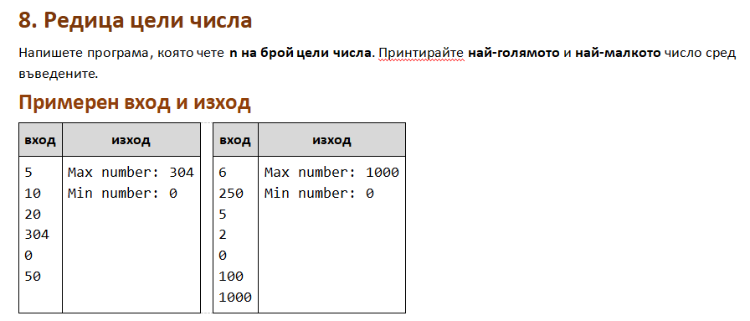

using System;

public class Program

{

public static void Main()

{

int n = int.Parse(Console.ReadLine());

int min = int.MaxValue;

int max = int.MinValue;

int num = 0;

for (int i = 0; i < n ; i++){

num = int.Parse(Console.ReadLine());

if (num > max){

max = num;

}

if (num < min){

min = num;

}

}

Console.WriteLine("Max number: " + max);

Console.WriteLine("Min number: " + min);

}

}

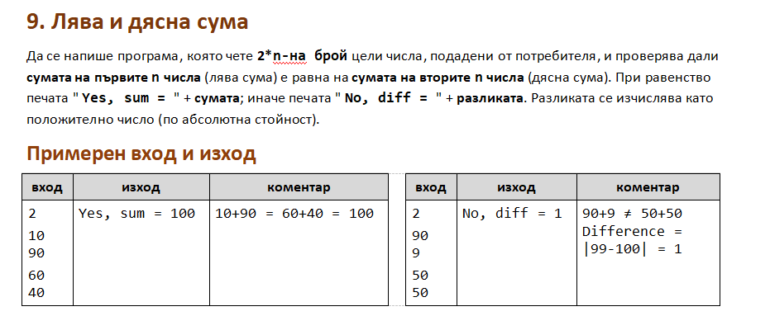

using System;

public class Program

{

public static void Main()

{

int n = int.Parse(Console.ReadLine());

int leftNum = 0;

int rightNum = 0;

int sumLeft = 0;

int sumRight = 0;

for (int i = 0; i < n ; i++){

leftNum = int.Parse(Console.ReadLine());

sumLeft = sumLeft + leftNum;

}

for (int i = (n+1); i <= (2\*n) ; i++){

rightNum = int.Parse(Console.ReadLine());

sumRight = sumRight + rightNum;

}

if (sumLeft == sumRight){

Console.WriteLine("Yes, sum = " + sumLeft);

} else {

if (sumLeft > sumRight){

Console.WriteLine("No, diff = " + (sumLeft - sumRight));

} else {

Console.WriteLine("No, diff = " + (sumRight - sumLeft));

}

}

}

}

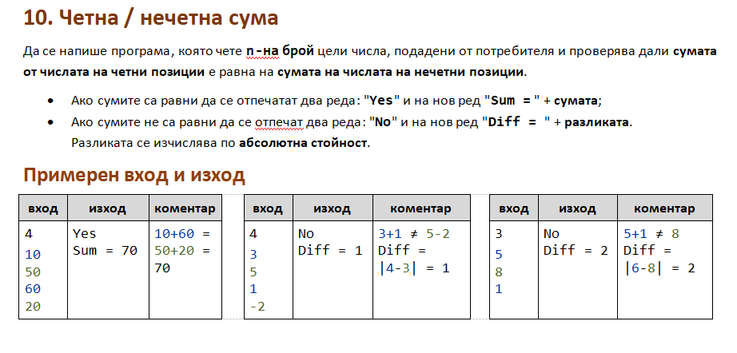

using System;

public class Program

{

public static void Main()

{

int n = int.Parse(Console.ReadLine());

int sumOdd = 0;

int sumEven = 0;

for (int i = 1; i <= n ; i++){

int num = int.Parse(Console.ReadLine());

if (i % 2 == 0){

sumEven += num;

} else {

sumOdd += num;

}

}

if (sumEven == sumOdd){

Console.WriteLine("Yes");

Console.WriteLine("Sum = " + sumOdd);

} else {

Console.WriteLine("No");

Console.WriteLine("Diff = " + (Math.Abs((sumEven - sumOdd))));

}

}

}