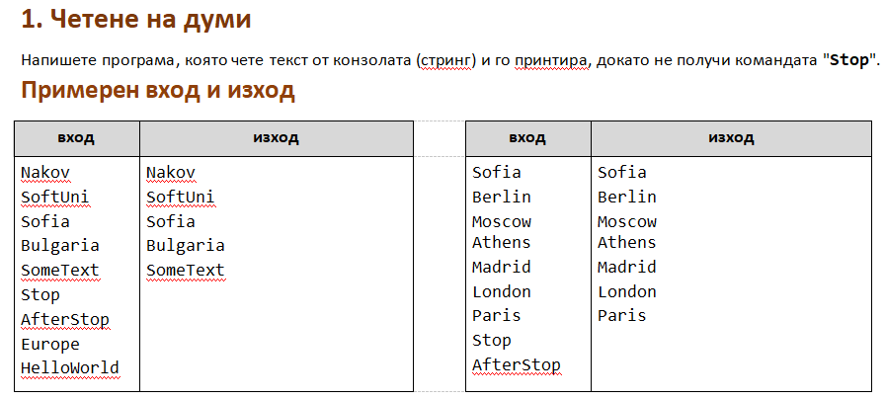

using System;

public class Program

{

public static void Main()

{

string command ;

while((command = Console.ReadLine()) != "Stop") {

Console.WriteLine(command);

}

}

}

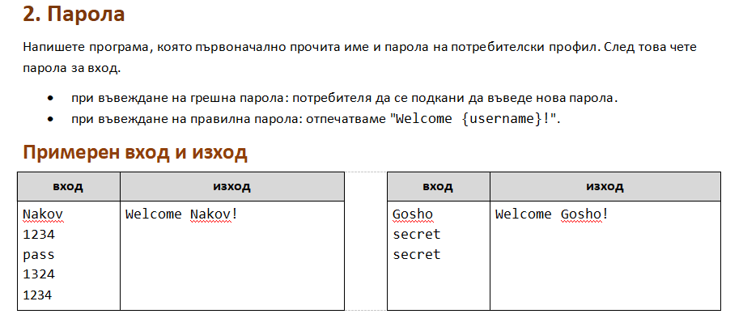

using System;

public class Program

{

public static void Main()

{

string username = Console.ReadLine();

string password = Console.ReadLine();

string enteredPassword;

while((enteredPassword = Console.ReadLine()) != password) {

}

Console.WriteLine($"Welcome {username}!");

}

}

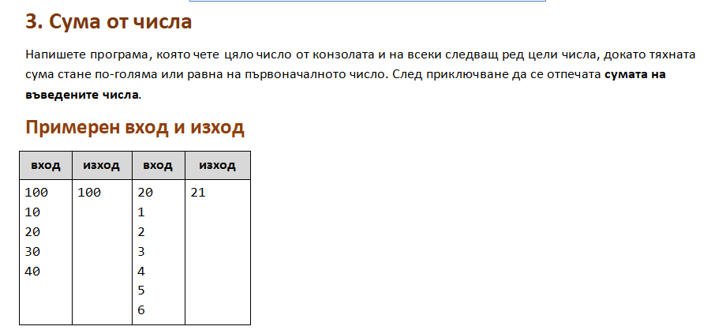

using System;

public class Program

{

public static void Main()

{

int desiredSum = int.Parse(Console.ReadLine());

int sum = 0;

while(true) {

int num = int.Parse(Console.ReadLine());

sum += num;

if (sum >= desiredSum){

break;

}

}

Console.WriteLine(sum);

}

}

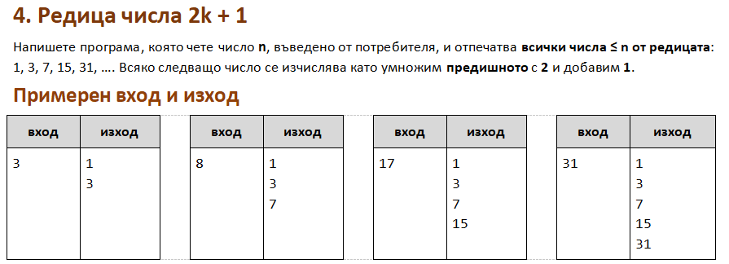

using System;

public class Program

{

public static void Main()

{

int n = int.Parse(Console.ReadLine());

int num = 1;

while(num <= n) {

Console.WriteLine(num);

num = (num\*2) +1;

}

}

}

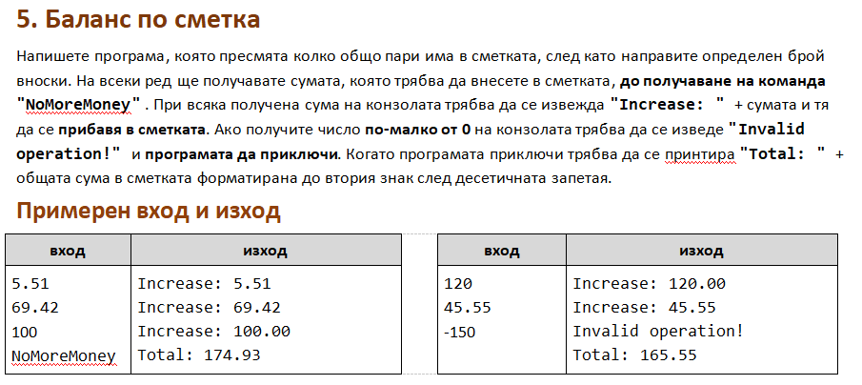

using System;

public class Program

{

public static void Main()

{

double sum = 0;

string command;

while((command = Console.ReadLine()) != "NoMoreMoney") {

double moneyToIncrease = double.Parse(command);

if (moneyToIncrease < 0) {

Console.WriteLine("Invalid operation!");

break;

}

sum +=moneyToIncrease;

Console.WriteLine($"Increase: {moneyToIncrease:f2}");

}

Console.WriteLine($"Total: {sum:f2}");

}

}

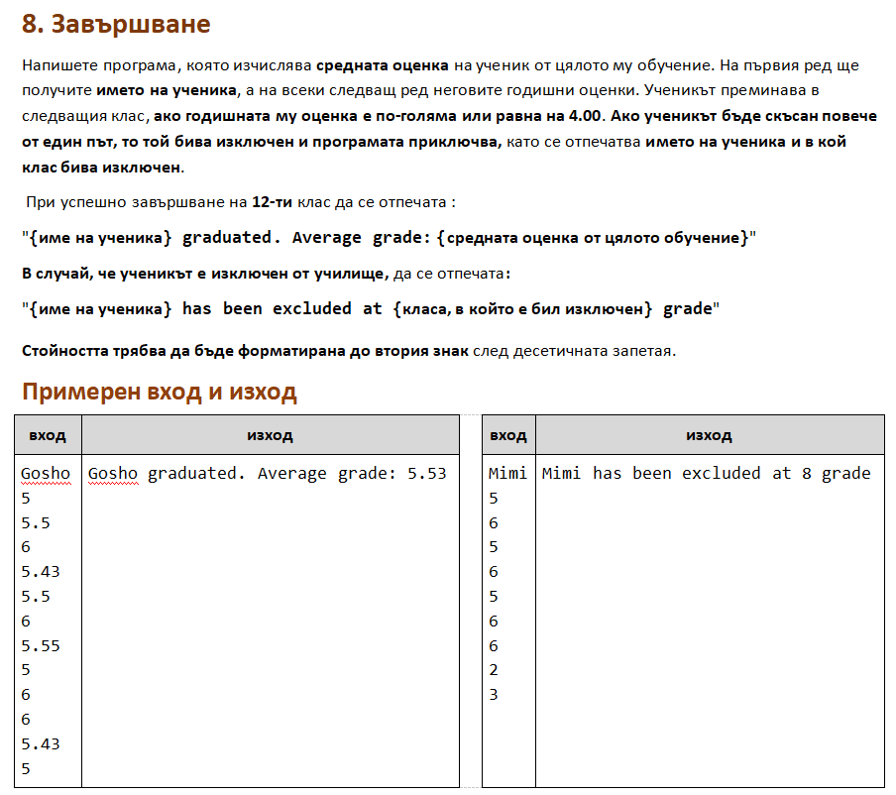

using System;

public class Program

{

public static void Main()

{

string name = Console.ReadLine();

double totalGrades = 0;

int currClass = 1;

int repeatCnt = 0;

while (currClass <= 12)

{

double currClassGrade = double.Parse(Console.ReadLine());

totalGrades += currClassGrade;

//If the grade is under 4 we repeat the same class

if (currClassGrade < 4)

{

repeatCnt++;

if (repeatCnt > 1)

{

//If we repeat the same class more than once we are expelled

break;

}

continue;

}

//If the grade is higher than 4 I go into the next class

currClass++;

}

//If we repeat a class more than once we are expelled

if (repeatCnt > 1)

{

Console.WriteLine($"{name} has been excluded at {currClass} grade");

}

else

{

double averageGrade = totalGrades / (currClass - 1 + repeatCnt);

Console.WriteLine($"{name} graduated. Average grade: {averageGrade:f2}");

}

}

}